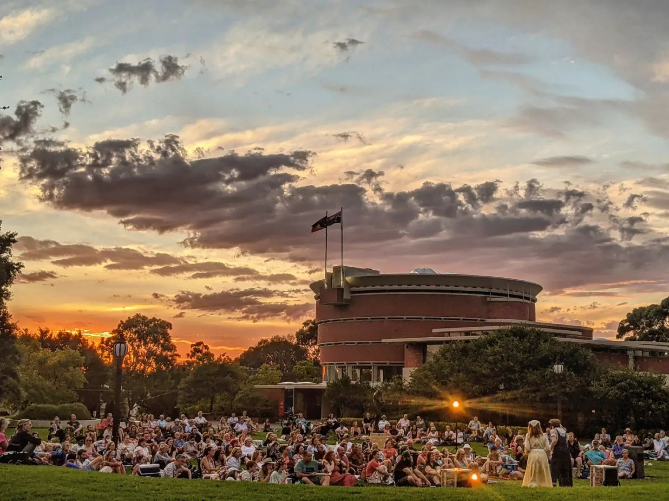

Bayside Arts, Culture and Libraries Strategy
2023—2027

Contents
Executive Summary 3
Bayside Community 2050 Vision Statement 5
Underlying Principles and Concepts 5
Our Commitments 5
Strategic Overview 5
Bayside Community Profile 7
How this Plan was Developed 8
Key Findings from Community Consultation 8
Government Policy and Legislative Context 11
Strategic Priorities 12
Priority 1 – Seen and Recognised 12
Priority 2 – Safe, inclusive and activated spaces 13
Priority 3 – Increased and diverse engagement 14
Priority 4 – Working with and through others 15
Priority 5 – Pillars of community wellbeing 15
Strategic Enablers 16
Enabler 1 – Skilled and engaged workforce 16
Enabler 2 – Council-wide recognition and involvement 16
Enabler 3 – Strong feedback loops from the community 16

Bayside City Council proudly acknowledges the Bunurong People of the Kulin Nation as the Traditional Owners and Custodians of this land, and we pay our respects to their Elders past, present and emerging.

Executive Summary
Bayside City Council seeks to nurture creativity, promote community wellbeing, and support lifelong learning by increasing community engagement with local arts and culture, and library services.
The Bayside Arts, Culture and Libraries Strategy 2023-2027 sets a vision and direction for both the arts and culture and library services in our city. It seeks to amplify the collective impact of these services by aligning them to the same strategic priorities and supporting greater coordination, knowledge sharing and collaboration.
This is an evidence-based, strategic document that will guide decision-makers in delivering initiatives that promote:
- Learning and literacy
- Artistic expression and enrichment
- Social connection
- Appreciation for the natural environment
- Mental health and wellbeing
The Plan has been developed in alignment with the Bayside City Council Plan 2021-2025 and the Bayside 2050 Community Vision.
The Bayside Arts, Culture and Libraries Strategy 2023-2027 has been developed in close consultation with the local community, partners, and stakeholders.
Implementation of the Strategy will be driven by two Action Plans which will be delivered with and through key internal and external stakeholders. These Action Plans will outline the projects and initiatives that the arts and culture and libraries teams will deliver to move toward the realisation of the 2050 Community Vision for Bayside. Progress against the Action Plans will be monitored, with annual reports made to Council and the community.
NOTE: This strategy is a four-year plan that begins in 2023 and concludes 30 June 2027.

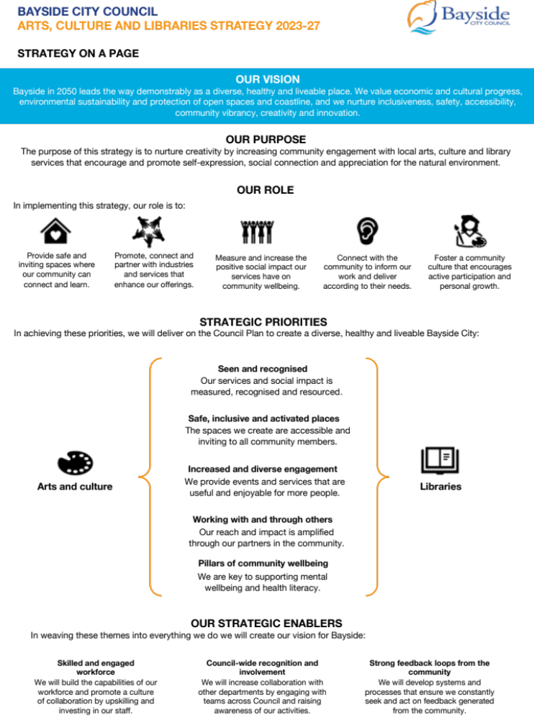

Bayside Community 2050 Vision Statement

The Bayside 2050 Community Vision Statement articulates the desired future state for our city. It is designed to inform strategic planning processes across Council to ensure all departments are striving to meet the same aspiration. This strategy adopts the Bayside 2050 Vision Statement to support the alignment of the strategic priorities with the community’s ideal Bayside.

Bayside in 2050 leads the way demonstrably as a diverse, healthy and liveable place. We value economic and cultural progress, environmental sustainability and protection of open spaces and coastline, and we nurture inclusiveness, safety, accessibility, community vibrancy, creativity and innovation.

Underlying Principles and Concepts
The following principles underpin the strategic priorities and enablers in the Arts, Culture and Libraries Strategy and will guide the implementation of the Action Plans:
- We are committed to inspiring and empowering our community.
- We are committed to broadening our reach within the community.
- We seek to create positive impacts via our services.
- We will create an environment where creativity is encouraged and celebrated
- We support Council initiatives to build a resilient Bayside community that can respond and adapt to the climate emergency.
- We value the role of partnerships in improving the quality and reach of our services.
- We value the opportunity to collaborate across Council departments to explore new initiatives.

Our Commitments
We will bring together the strengths of our arts and culture, and library services to leverage spaces, partnerships, and community connections in order to achieve the following intended impacts:
- Provide safe and inviting spaces where our community can connect and learn.
- Promote, connect and partner with industries and services that enhance our offerings.
- Provide access to current, relevant, and vibrant collections.
- Increase opportunities for positive social connections to improve community wellbeing.
- Engaging with our community to inform our priorities and deliver according to their needs.
- Foster a community culture that encourages active participation and personal growth.
- Support our community in an evolving digital landscape.
- Partner with our community to address climate action.

Strategic Overview

Strategic Priorities
The following strategic priorities outline the outcomes Council seeks to achieve as a product of this strategy.
Priority 1: Seen and recognised
- There is increased awareness of and appreciation for our arts and culture and library services amongst our community, creative sector and within Council
- Relationships between Council departments are successfully activated.
- Successful initiatives are promoted, and their measurable impact is demonstrated.
- Curated collections are current, relevant, and accessible.

Priority 2: Safe, inclusive and activated spaces
  - Community members are empowered to make full use of our arts and culture and library services.
  - Arts and culture and library services are delivered throughout Bayside in appropriately designed, and visually appealing places.

Priority 3: Increased and diverse engagement
  - Community feedback is used to inform activities that increase participation and engagement with arts, culture and library services.
  - Services are accessible to all residents regardless of age, ability, gender or economic status.

Priority 4: Working with and through others
- Council relationships with partners in the community enable improved engagement.
- Strong partnerships drive the delivery of diverse and creative events and programs that require resources and knowledge not held in-house.

Priority 5: Pillars of community wellbeing

Increase community awareness of the importance of social, emotional, mental and physical health.

Council provides opportunities for social connection that supports wellbeing.

Strategic Enablers
The following strategic enablers identify the capabilities, processes and systems that can support Council in achieving the strategic priorities.
Enabler 1: Skilled and Engaged Workforce
- We will build the capabilities of our workforce and promote a culture of collaboration by upskilling and investing in our staff.

Enabler 2: Council-wide recognition and involvement
  - We will increase collaboration with other departments by engaging with teams across Council and raising awareness of our activities.

Enabler 3: Strong feedback loops from the community
  - We will develop systems and processes that ensure we constantly seek and review feedback from the community.

Bayside Community Profile

The City of Bayside is located 16km south-east of Melbourne along the coastline of Port Phillip Bay. The municipality is characterised by its stunning foreshores, beautiful parks, open spaces and vibrant retail centres.
Bayside’s 102,337 residents enjoy the leafy surrounds of the municipality and have identified the close proximity to the beach, access to open space and a strong sense of community as key factors for living in Bayside.
Many Bayside households are family households (35.2 per cent) comprising couples with children. This is followed by couples without children (26 per cent) and lone person households (24.4 per cent) with this number expected to increase over the next four years with an ageing population.
Bayside is an ‘older’ community compared to metropolitan Melbourne. There is a substantially higher percentage of those aged over 50 years in Bayside when compared to metropolitan Melbourne. However, Bayside has fewer younger adults (25 to 34 years) residing in the area, as reports show those aged 25-34 tend to leave Bayside seeking more affordable housing or areas closer to work and entertainment opportunities.
Overall, the Bayside community is relatively advantaged in socio-economic terms with 41.4% of households earning $3,000 or more per week. However, it is recognised that Bayside has small scattered areas experiencing substantial disadvantage, which are masked by the affluence across the municipality. There are 813 government managed households in Bayside
It is anticipated that there will be an increase in the number of people with a disability over the next four years in Bayside. Over 14,000 people living in Bayside have a disability.4,734 reported that they needed assistance in their day-to-day lives due to a disability. Currently12,136 Bayside residents are also providing unpaid assistance to a person with a disability, long term illness or old age.

How this Plan was Developed
The Bayside Arts, Culture and Libraries Strategy 2023-27 was developed following extensive consultation with the Bayside community. This included:
- Workshops with Arts and Culture and Libraries Council Staff
- Focus Groups with Council committees including:
- Bayside Arts & Gallery Advisory Committee
- Bayside Disability Access and Inclusion Committee
- FReeZA Committee
- Reconciliation Advisory Committee
- Bayside Healthy Ageing Reference Group
- Have Your Say survey that was completed by 920 community members
- Victorian Public Library survey that was completed by 772 library users
Traffic was driven to these data collection points through pop-up events at Bayside Farmers Markets, survey points at libraries and at the Bayside Gallery.
This was supported through a digital marketing campaign that reached:
- 41,100 households via Let’s Talk Bayside
- 36,000 people via Facebook and News Corp digital advertising
- 57,000 through the Friendly Librarian, Have your Say and This Week in Bayside email lists

Key Findings from Community Consultation

Arts and Culture

Demographics
73% of respondents were over the age of 50.
70% of respondents were female.

Usage
The most common arts or cultural activities that residents have participated in were Bayside Gallery exhibitions and cultural events (music, food, art, festivals).
There was continued interest in these activities with 68% of respondents expressing an interest in attending a Bayside Gallery exhibit and 85% in attending a cultural event.

Engagement
71% of respondents had participated in art or cultural activity in Bayside in the last three years.
Roughly half of the respondents felt connected to Bayside’s representation of arts and culture while 35% felt minimally connected and 10% did not feel represented or included at all.

Opportunities for Improvement
Respondents felt that arts and culture benefit the community by creating avenues for:
- Sharing stories, experiences and history from different cultures
- Building friendships and strengthening community connection
- Entertainment and recreational activities
- Education and employment opportunities

Key themes that emerged around potential improvements to local arts and culture included:
- Providing free and accessible arts and culture through activating spaces within the community
- Increasing focus on interactive activities that promote skill development, creativity and connection with others
- Facilitating opportunities for local creative industry partners, community groups and cross-sector organisations to collaborate
- Improved promotion of activities and events beyond the Bayside Gallery, such as the library network and social media
- Increased focus on performing arts such as music, theatre and dance
- Creating activities for all age groups as most are targeted toward children

Libraries

Demographics
75% of library users are over the age of 50.
The majority of library users are not employed full-time and 47% of users are retired.
90% of library users speak English as a first language and do not speak a second language at home.

Usage
In the last year, 88% of library users visited the library to borrow books or magazines, 67% to search the catalogue or reserve an item and 63% to ask the library staff for help.
Library users reported high levels of satisfaction with the library service with 55% of users indicating that they were very satisfied.

Engagement
Most users visit the library at least every 2-4 weeks, with 19% attending more than once a week.
82% of library users visit the library by themselves.
89% of people felt that the library welcomes people from all walks of life.
More than half of respondents felt the library was very important to them personally, and to their community.

Opportunities for Improvement
Users felt that libraries provided value to their community through:
- Providing access to knowledge and learning opportunities
- Provision of a safe and welcoming space
- Creation of events where people can connect socially
- Connecting community members to other resources and services

Key themes that emerged around potential improvements to the library service included:
- Expanding collections across all libraries, including multiple copies of popular items
- Longer opening hours to allow greater access for full-time workers
- Promotion of libraries as community hubs
- Improved visibility of library events and services through advertising and marketing to increase the use of library spaces and the uptake of services
- Creation of comfortable, inviting and engaging spaces
- Engagement with the community beyond the library doors
- Providing new services and reaching new audiences through partners

Government Policy and Legislative Context
The strategic priorities included in the Bayside Arts, Culture and Libraries Strategy 2023-27 are all areas of public policy. These priorities have different levels of responsibility, funding and regulation by all tiers of government as well as private sector and not-for-profit community sector involvement.
Victorian government legislation places particular emphasis on the role of local government in advocating and planning for the economic recovery of the creative industries and broader community health and wellbeing.

Creative State 2025
Creative State 2025 is a four-year creative industries strategy that is designed to place arts and culture at the centre of Victoria’s economic recovery post-COVID-19. It recognises that the industries surrounding arts and culture have suffered due to restrictions that were made necessary due to the pandemic. In the face of ongoing uncertainty, it seeks to provide stability and stimulate growth. Supported by a four-year budget of $288 million, the strategy seeks to create “a state where creative people, ideas and enterprises thrive, and where everyone has equitable access to and benefits from a rich creative culture.” Bayside City Council is committed to supporting this vision by targeting traditionally disengaged cohorts, spreading arts and culture across the local government area and ensuring events and exhibitions are welcoming and accessible to all.

Libraries for Health and Wellbeing
The Libraries for Health and Wellbeing Strategic Framework recognises the role that public libraries play in strengthening the health and wellbeing of communities by empowering, supporting and connecting communities and health partners. Libraries can assist community members in overcoming challenges to navigating the healthcare system such as discrimination, disadvantage, language barriers, cultural inappropriateness and disinformation. Bayside City Council seeks to target and improve the determinants of health across the community, in particular, social connection, mental wellbeing and physical health. Libraries will achieve this by providing information and resources, connecting community members to health and welfare providers and creating opportunities for social connection. This will involve training library staff and connecting them to referral points within Council.

Climate Change Act
Bayside City Council is committed to creating a sustainable and resilient community. In December 2019, Council declared a Climate Emergency with significant community support and a Climate Emergency Action Plan was adopted in September 2020. The Action Plan aims to mobilise the community, protect and enhance our natural environment and transform it into a climate responsive built environment. Council is taking a leadership role in ensuring the health, safety and resilience of the community. The Bayside Arts, Culture and Libraries Strategy 2023-26 supports the Action Plan by prioritising the use of art, literature, cultural products and events and libraries as tools to raise awareness among the community of climate change and the pending threat to Bayside’s natural environment. In creating and activating inviting and accessible spaces, this strategy recognises the importance of adopting environmentally sustainable practices and materials.

Victorian Gender Equality Act
The Victorian Gender Equality Act (2020) was recently launched and requires the Council to develop a Gender Equality Plan for its own practices and for the services it delivers. Section 9 of the Gender Equality Act requires councils employing 50 or more staff to undertake a Gender
Impact Assessment when developing or reviewing any policy, program or service that has a direct and significant impact on the public. Bayside City Council will have a standalone Gender Equality Action Plan which will primarily focus on ways the organisation can drive gender equality, including through improving workforce processes, cultural change and building internal capability that will, in turn, assist the community. The Bayside Arts, Culture and Libraries Strategy 2023-27 acknowledges the Gender Equality Act and programs will be informed by Council’s Gender Equality Action plan.

Strategic Priorities

Priority 1 – Seen and Recognised

Our services and social impact are measured, recognised and resourced.

Objectives
  - There is increased awareness of and appreciation for our arts and culture and library services amongst our community, the creative sector and within Council.
  - Relationships between Council departments are successfully activated.
  - Successful initiatives are promoted, and their measurable impact is demonstrated.

We will do this by:
- Developing a Marketing Plan for Arts, Culture and Libraries that will increase access, awareness and visibility of programs
- Consolidating, managing, preserving, promoting and growing the arts and heritage collection
- Developing processes and guidelines for measurement and data collection from programs and services
- Working with Council departments to deliver partnership programs
- Ensure the best value and quality library collection.

We will track and assess our performance through the following indicators:
- Reach and impact of activities
- Delivery of key actions from the Council Plan, Reconciliation Action Plan and Health and Well Being Plan
- Monitoring and delivering Libraries Action Plan.
- Annual progress report to Council.

Priority 2 – Safe, inclusive and activated spaces

The spaces we create are accessible and inviting to all community members.

Objectives
  - Community members are empowered to make full use of our arts and culture and library services.
  - Arts and culture and library services are delivered throughout Bayside in appropriately designed and visually appealing places.

We will do this by:
- Providing opportunities for local artists to develop their practice and contribute to programs
- Commission public art that is appropriately designed, and visually appealing
- Identify alternative venues across the municipality for the presentation of public art and/or performance works
- Create programs that incorporate the natural landscape promoting greater appreciation for Bayside’s open spaces and coastline
- Review spaces across all libraries to develop long-range plan of projects.
- Pursue cost effective options, piloting increased access to the library outside traditional service models.
- Develop plan for expanding and streamlining home library service, ensuring fit-for-purpose for customer needs.

We will track and assess our performance through the following indicators:
- At least 3 exhibiting opportunities at the Bayside Gallery for local artists per year
- Commissioning of one public artwork (permanent or ephemeral) per year
- Develop and present an annual art and cultural material/performance/event at a non-traditional arts venue or location
- Hold a public program/event at an outdoor space which increases appreciation of Bayside’s natural environment
- Library monthly statistics of library visitors, collection usage and program attendance

Priority 3 – Increased and diverse engagement

We provide events and services that are useful and enjoyable for more people.

Objectives
  - Community feedback is used to inform activities that increase participation and engagement with arts, culture and library services.
  - Services are accessible to all residents regardless of age, ability, gender or economic status.
  - Library collections are well-maintained and curated to reflect the changing needs and interests of community members.

We will do this by:
- Managing and delivering a multidisciplinary exhibition program at the Bayside Gallery including presentation of the Bayside Art & Heritage Collection at the Corporate Centre
- Delivering Arts and Cultural events in local areas to create social connection and access to Arts and Culture locally
- Supporting and promoting Aboriginal and Torres Strait Islander arts and culture.
- Providing grants to individuals and groups to nurture creativity in the arts
- Develop an annual plan for Library programs and events
- Be a community leader in promoting childhood literacy
- Undertaking a Gender Impact Assessment of our Action Plan to meet the different needs of women, men and gender diverse people.

We will track and assess our performance through the following indicators:

6 free Arts and Cultural events are delivered across the municipality per year

The Ellen José Art Award for female artists (Indigenous and non-Indigenous) 35 years and under is presented every three years

Ensuring a review of the Criteria for assessing Community Grants is undertaken in Year 1

Develop a plan informed by community consultation to guide libraries programming and events

Offer weekly early years programs and offer vibrant and engaging collections to support early literacy development

Embedding Diversity, Equity and Inclusion as a Leadership performance measure in Annual Staff Performance and Development Plans

Priority 4 – Working with and through others

Our reach and impact is amplified through our partners in the community

Objectives
  - Council relationships with partners in the community enable improved engagement across certain cohorts.
  - Strong partnerships drive the delivery of diverse and creative events and programs that require resources and knowledge not held in-house.

We will do this by:
- Delivering the Arts Learning Program at Bayside Gallery with local schools
- Working with local artists/arts organisations develop events that build professional skills
- Support the Community Wellbeing Plan
- Support the Reconciliation Action Plan by maintaining relevant Library Indigenous Collections and delivering Library events for Reconciliation Week and NAIDOC Week including the Ellen José Student Reconciliation Award presented annually at the Corporate Centre

We will track and assess our performance through the following indicators:
- 1 Artists-in-School residency delivered annually
- Maintain current levels of engagement with kindergartens in line with resources available
- 3 professional development workshops for local artists presented annually
- Support the Volunteer Recruitment, Retention and Recognition Plan.
- Minimum of 2 Library Indigenous events per year

The Ellen José Student Reconciliation Award presented annually at the corporate centre

Priority 5 – Pillars of community wellbeing

We are key to supporting health and wellbeing

Objectives
  - There is increased community awareness of the importance of social, emotional and physical health.
  - Council provides opportunities for social connection through events that provide a sense of achievement for participants.
  - Bayside’s natural environment is recognised and celebrated through arts and culture and libraries as a public good that supports overall wellbeing.

We will do this by:
- Delivering the Arts and Dementia Connections Program at Bayside Art Gallery
- Presenting opening events for exhibitions that are free for everyone to attend
- Implementing a Volunteer Recruitment, Retention and Recognition Plan to increase, support and celebrate council’s volunteers
- Build community resilience through social connection.
- Support vulnerable populations through programs, collections and free digital access.
We will track and assess our performance through the following indicators:
- Increase participation in Connections: Art and dementia Program onsite programs from local community by 10% (dependent on additional resources)
- Minimum 6 free opening events per year at Brighton Town Hall
- Volunteer plan implemented and new volunteers recruited
- Promote Libraries as places of social connection by delivering 1,000 events per year.

Strategic Enablers

Enabler 1 – Skilled and engaged workforce

Objectives
We will build the capabilities of our workforce and promote a culture of collaboration by upskilling and investing in our staff.

We will do this by:

Identifying skill gaps

Undertaking an annual employee engagement survey

We will track and assess our performance through the following indicators:

Ensuring staff attend a minimum of 1 external training event annually

Engagement scores increase by 25%

Enabler 2 – Council-wide recognition and involvement

Objectives
We will increase collaboration with other departments by engaging with teams across Council and raising awareness of our activities.

We will do this by:

Working with Community Services to promote and increase delivery of Connections Arts + Dementia

Working with Economic Development to improve patronage of our activity centres

We will track and assess our performance through the following indicators:
- Number of programs delivered in partnership with other Council areas

Enabler 3 – Strong feedback loops from the community

Objectives
We will develop systems and processes that ensure we constantly seek and act on feedback from the community.

We will do this by:
- Implementing an annual survey of library, arts and culture users
- Collecting data through Culture Count reports
We will track and assess our performance through the following indicators:
- Achievement of objectives as set out in the Strategic Plan
- Review/change the goals and objectives based on community feedback

Implementation, monitoring and evaluation
The arts, culture and libraries have an important role to play in the life of all residents in Bayside. This Strategy provides direction for these services to benefit the whole community. While actions will be led principally by the Arts & Culture and Library Services it will be supported by a wide range of internal and external stakeholders, including: various council departments, community and volunteer groups.
Council’s role in implementing the Plan and associated Action Plans will include:
- Direct programs and services
- Facility planning and coordination
- Partnerships and strengthening community capacity
Bayside Arts, Culture and Library Strategic Plan and Action Plans will operate in conjunction with other key Council strategic documents to guide work across Bayside to improve health and wellbeing.
Action Plans
Two Action Plans will be developed:
  - Arts and Culture Action Plan; and
  - Libraries Action Plan
The Action Plans will include high level strategic activities that will be taken to Council and other partners to achieve the goals and objectives set out in the Bayside Arts, Culture & Libraries Strategy.
Progress against the Action Plans will be monitored, with annual reports made to Council and the community against progress indicators. Quarterly reports will also be provided to the Bayside Arts and Gallery Advisory on Arts & Culture activities.
Implementation and partnerships
Bayside Arts, Culture & Libraries Strategy and Action Plans will be implemented in partnership with organisations and groups who contributed to its development, and with the broader community, in line with Council’s Community Engagement Policy.
Monitoring and evaluation
Bayside Arts, Culture & Libraries Strategy will be reviewed annually, in conjunction with the Action Plans and will inform the Council’s service delivery planning cycle. The annual review will consider the relevance of the Plan and respond to any changes in environment or circumstances that directly effect the delivery of the service.
A detailed evaluation will be conducted in 2027 at the end of the four-year strategy and will be used to inform the next four-year plan.

Bayside City Council
Postal Address PO Box 27
Sandringham VIC 3191
Telephone (03) 9599 4444
Email enquiries@bayside.vic.gov.au
Website www.bayside.vic.gov.au

