Bespoke welcome signage for Bay Street and Martin Street
Community engagement summary report
July 2026

Background

1.1 Introduction
Bayside City Council is delivering a placemaking project to create two artistic welcome signs for the Bay Street and Martin Street activity centres. The signage will function as gateway elements that reflect the distinct character, identity and sense of place of each shopping strip. The signs will be located in front of the post office in Bay Street and within the roundabout on Martin and Asling Streets.
Conversation Co was engaged by Bayside City Council to undertake targeted early engagement to inform the development of initial design concepts for each street, followed by broader community consultation to test the level of support for proposed design options at each site. This engagement gathered feedback to inform Council’s selection and refinement of a preferred welcome sign design for each location.

1.2 Engagement Objectives
The engagement process sought to:
Stage 1:
- Engage with local businesses and traders in each activity centre to help shape the draft welcome sign concepts.
- Understand the unique character, identity and sense of place that stakeholders wanted the welcome signage to reflect.
- Gather insights on the preferred look and feel of the welcome signs to inform the draft designs.
Stage 2:
- Test community response to the proposed welcome sign design options developed in response to stage 1 feedback.
- Identify community preferences, levels of support and any concerns relating to the design options.
- Inform Council's selection and refinement of the preferred welcome sign design for each activity centre.

Consultation process

2.1 Consultation methodology
This engagement program was conducted over two stages.

Stage 1:
Targeted engagement was undertaken with local businesses and traders in both the Martin Street and Bay Street activity centres to generate ideas and inform the development of the draft welcome sign concepts. This included:
- Two intercept sessions conducted within each activity centre using a short questionnaire to capture feedback from traders and business owners. Facilitators visited businesses along both high streets filling in short postcard surveys or handing flyers with links to the online survey activity for those who were not able to contribute on the spot.
- The questionnaire was also distributed via email to local businesses to contribute to in their own time.
- During intercepts, a pop-up interactive activity invited passersby to share ideas about the character, identity and desired look and feel of the welcome signage.
Stage 2:
Once concept designs were prepared, broad community engagement was used to test community member’s preferred options for the welcome signs.
- An online survey and submission portal hosted on Bayside City Council's Have Your Say page from 9 to 29 June.
- Community pop up sessions held in both Martin Street and Bay Street on Saturday 13 June, providing an opportunity for local residents, businesses and visitors to view the design options, vote for their preferred choice and provide feedback while visiting the activity centres and going about their daily business.
- Facilitators visited businesses along Martin Street and Bay Street during the pop-up sessions, using printed postcards to gather design preferences from business owners and local workers within the activity centres.

Table 1 below, displays the engagement activities undertaken throughout the engagement program.

Table 1. Engagement Activities
Dates | Activity
Thursday, 16 April | Community pop-ups
9- 24 April | Trader online survey
15- 29 June | Online survey via Bayside Have Your Say
Saturday, 20 June | Community pop-ups
Wednesday, 15 July | Bay Street traders meeting
Thursday, 20 August | Martin Street traders meeting

3. Participation

3.1 Participation by engagement activity
A total of 344 participants took part in this engagement overall. During stage one a total of 56 people were engaged during the first community pop-up questionnaire and 288 took part in the stage two community pop ups and the online community survey. Table 2 presents participation across all engagement activities.

Table 2. Participation by engagement activity
Engagement Activity | No. of participants | %
Stage 1
Pop-ups | 42 | 12
Trader online survey | 14 | 4
Stage 2
Pop-ups | 140 | 41
Online survey | 142 | 41
Submissions to Council | 6 | 2
TOTAL | 344 | 100
Data source: trader survey, intercept demographic cards, community pop-up demographic cards, ball and tube voting exercise, online survey.

It is important to note that participation in the intercept and pop-up activities across both stages was recorded only where participants completed a demographic card or engaged with the ball-and-tube prop, in which participants placed a ball in the tube to vote for their preferred design for each street (pictured below). Many participants also provided comments and feedback on the welcome sign designs without completing a demographic card or recording a vote. As a result, the actual level of participation was higher than the recorded total.

Image 1. Ball and Tube votes at Bay Street
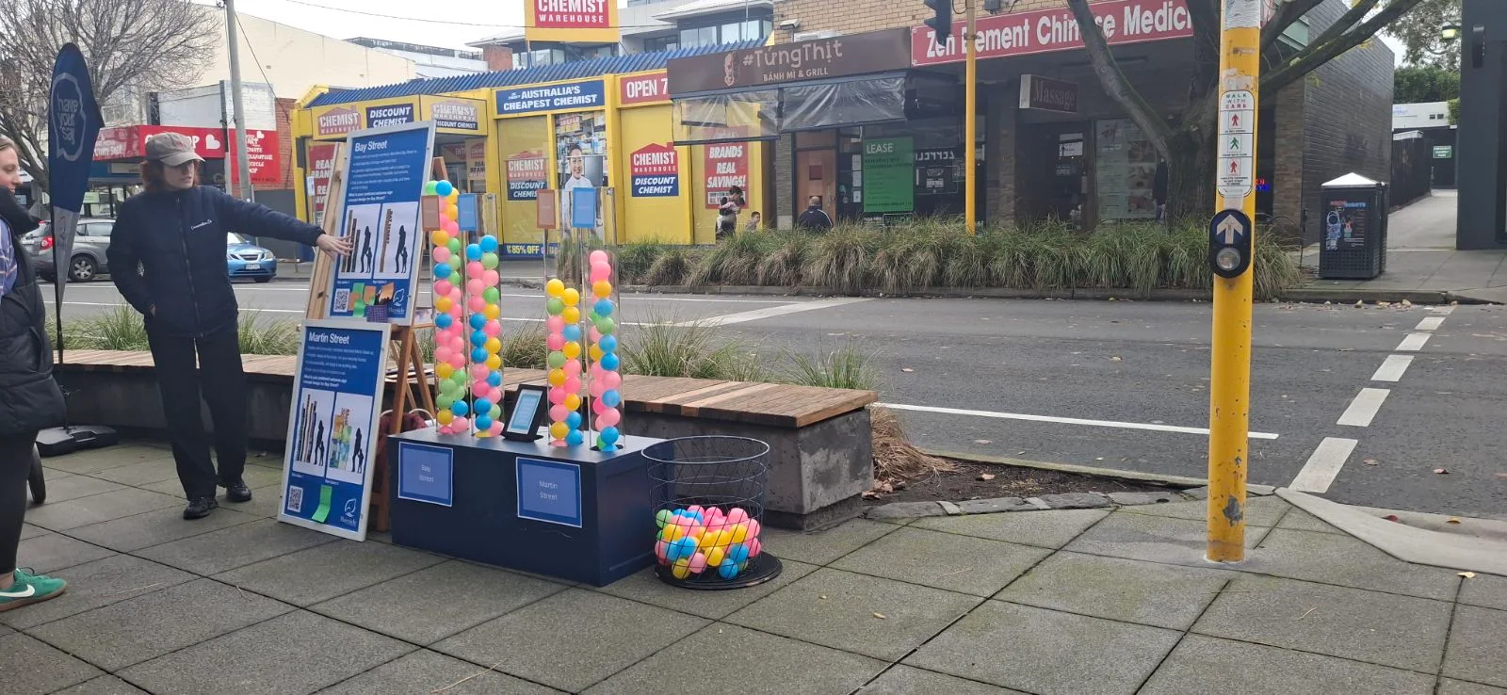

3.2 Connection to the project
Participants were asked to identify their connection to the project to better understand the range of stakeholder groups represented in the engagement.

3.2.1 Stage 1- Early targeted engagement
Participants in the surveys and those who filled in a demographic card at intercepts provided their connection to the project. Participants were able to provide multiple connections. Bay Street (n=39) had higher participation than Martin Street (n=19). The most common connection was those who lived on or near Bay Street (n=14), followed by those who worked in Bay Street (n=11) and those who owned/operated a business in Bay Street (n=9). Workers from Martin Street had the highest participation for this street (n=8). Figure 1 shows the breakdown of participants’ connections to the project.

Figure 1. Stage 1 participants connection to the project
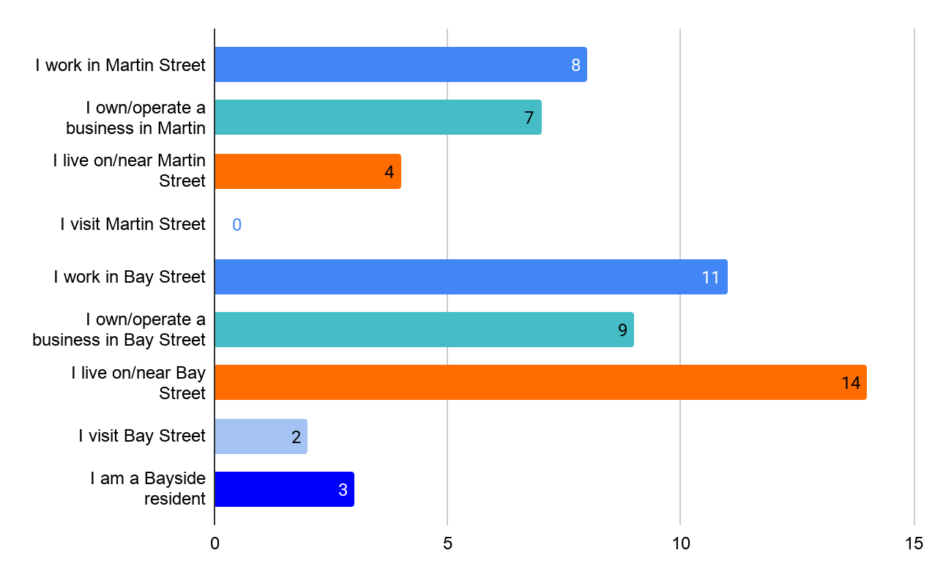
Data source: traders survey, intercept demographic cards

3.2.2 Stage 2- Broad community engagement
At pop ups sessions, facilitators visited businesses along Martin Street and Bay Street to gather design preferences from business owners and local workers within the activity centres. Demographic cards were largely used for business visits and intercepts, whereas passersby were encouraged to use the ball-and-tube prop and not asked for their connection to the project. Participants filling in demographic cards at pop ups provided their connection to the project. Participants were able to provide multiple connections. Overall, the most common connection at pop-ups was participants who worked in Bay Street (n=14) and Martin Street (n=9), Martin Street business owners (n=9) and Bay Street business owners (n=5). Figure 2 shows this breakdown.

Figure 2. Stage 2 participants connection to the project
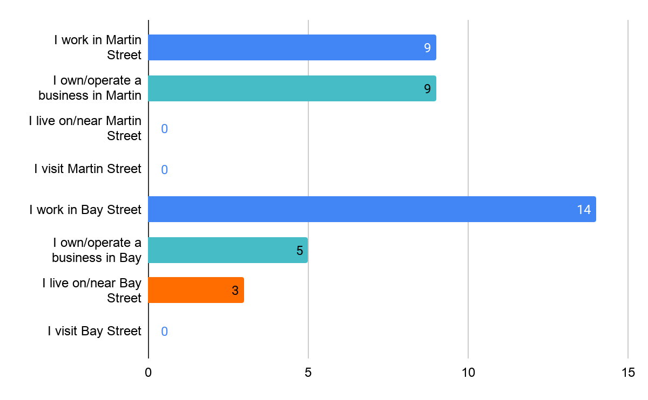
Data source: pop-up demographic cards only

4. Consultation findings
The next section presents findings from both stages of the community engagement program. Findings are presented by location (Bay Street and Martin Street).

4.1 Support for actions

4.1.1 Preferred welcome sign designs overall (Stage 2)
Participants in stage two were presented with the choice between two different design options for each street.

Images 2-5 welcome sign design options
Bay Street Option 1 | Bay Street Option 2
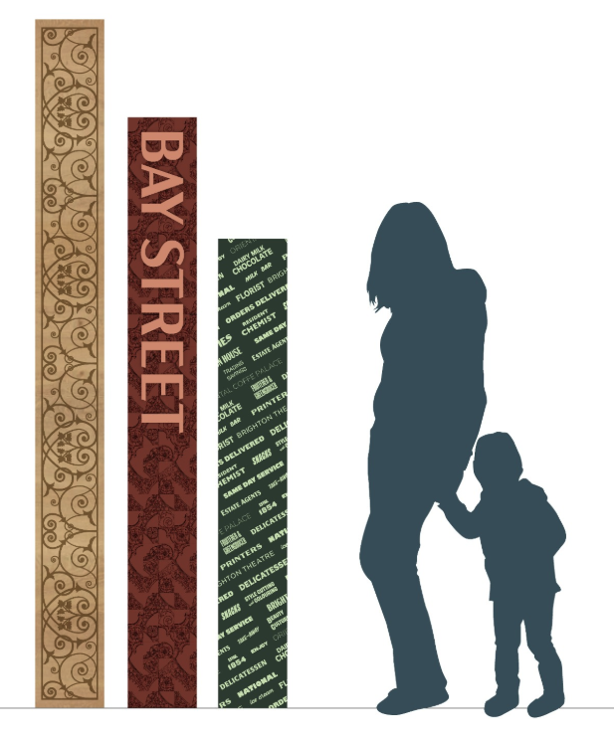 | 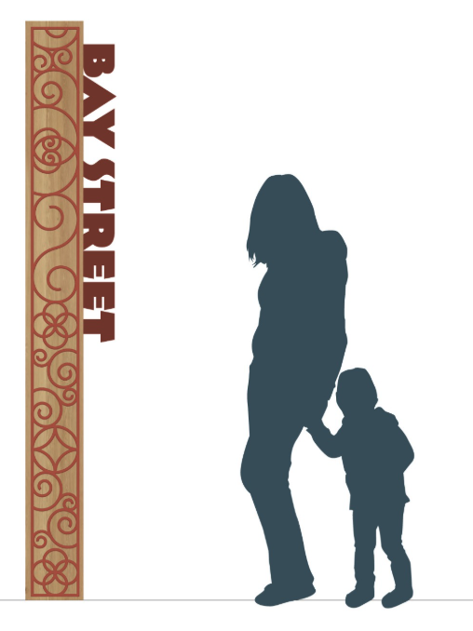
Martin Street Option 1 | Martin Street Option 2
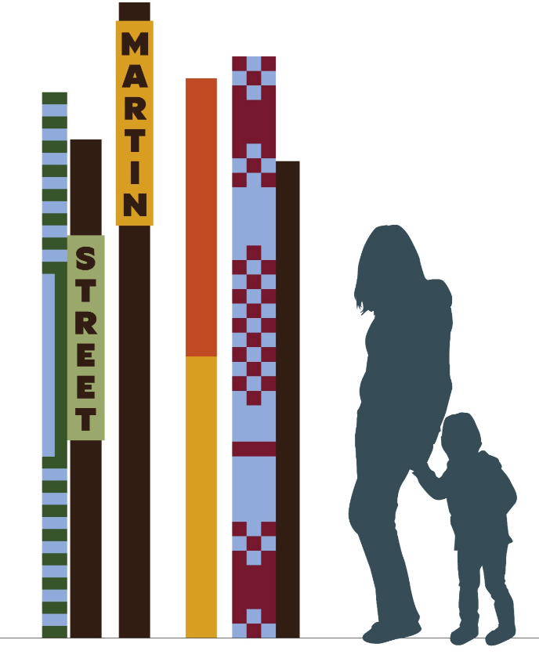 | 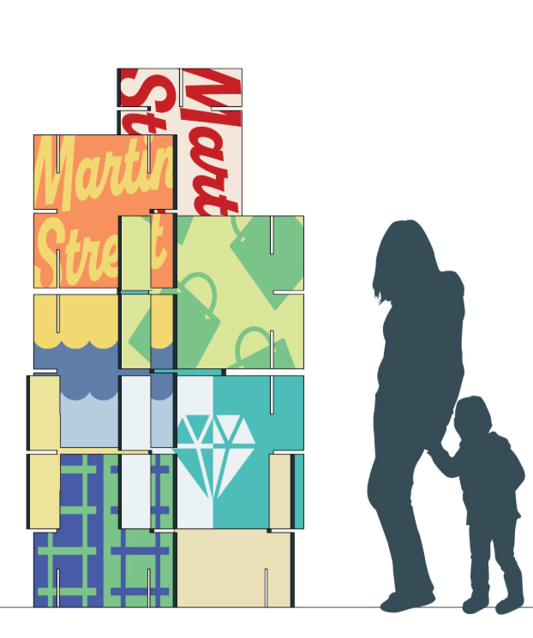

There was a total of 881 responses to this exercise. At both locations, Option 1 was the preferred design, although results were relatively close. The preferred option for Bay Street was Option 1 which received 107 selections (56%) with Option 2 receiving 84 selections (44%). The preferred design for Martin Street was also Option 1 with 103 selections (54%), with Option 2 receiving 87 selections (46%). These findings indicate that there was a slight preference for the Option 1 designs at both locations, however preferences were generally quite evenly split between the two designs, suggesting all options were relatively well received. Figure 3 presents this breakdown.

Figure 3. Preferred welcome sign options overall
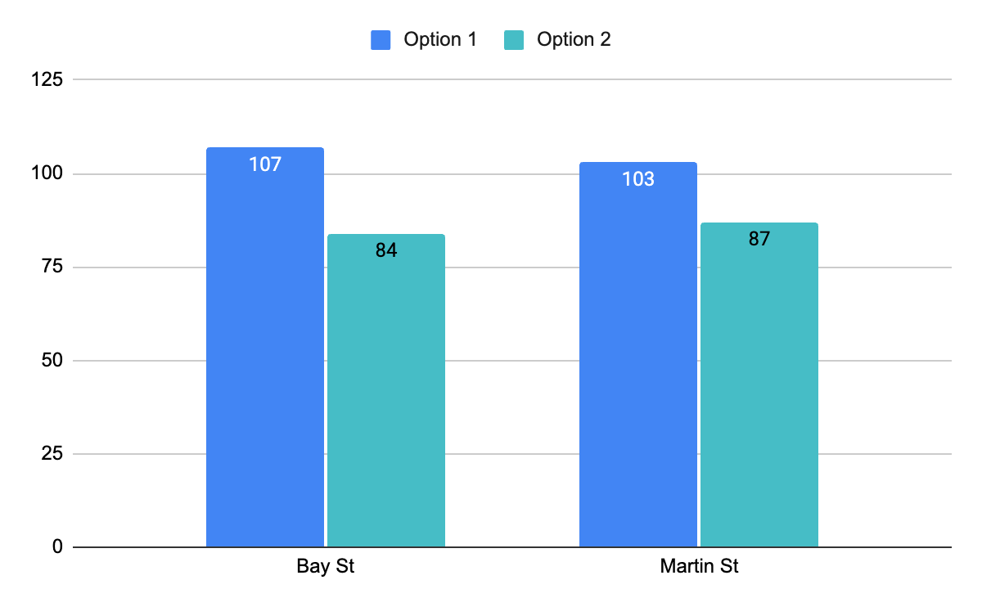
Data source: Stage 2 pop up voting, demographic postcards.

4.1.2 Preferred design approach (Stage 1)
In stage 1, both Martin Street and Bay Street participants were presented with mood boards to demonstrate design concept inspiration for the welcome signs to help generate ideas. The mood board images are presented below.
Images 6-9. Mood board options
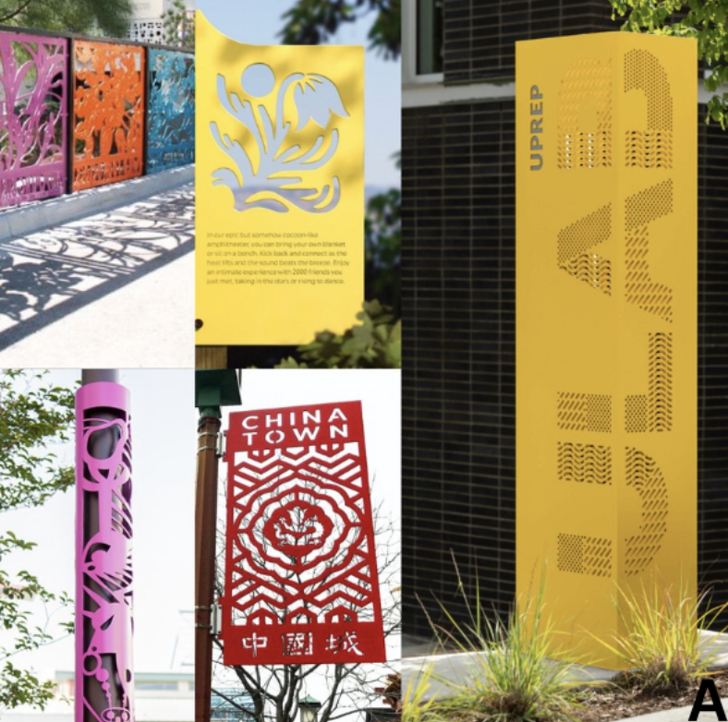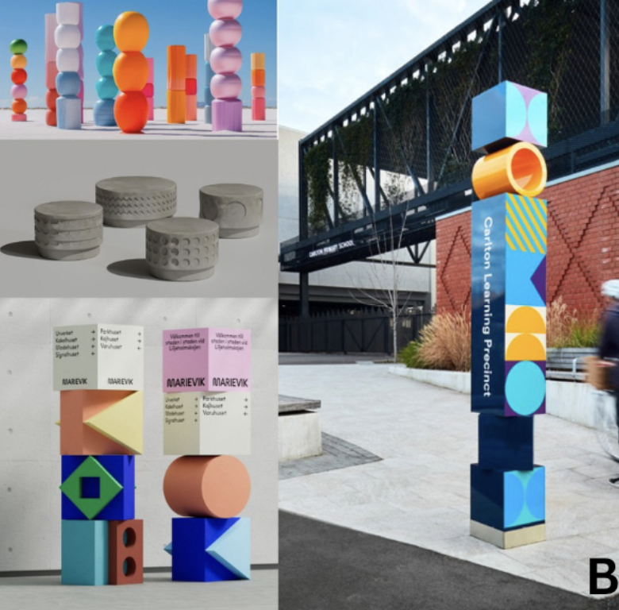

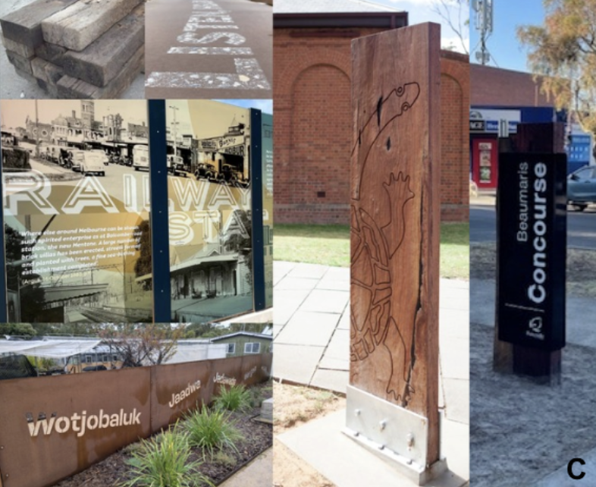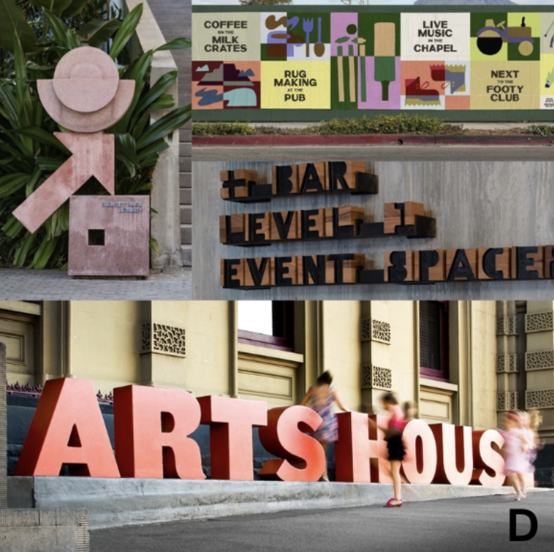

Trader’s survey participants were asked which their preferred option was. Results are presented overall, as there was low participation across both surveys, particularly for Martin Street. Overall participants preferred Option D (n=6) followed by Option B (n=4), Option A (n=1) and Option C (n=1). One participant selected ‘none of the options’. Figure 4 shows this breakdown.

Figure 4. Preferred design moods overall
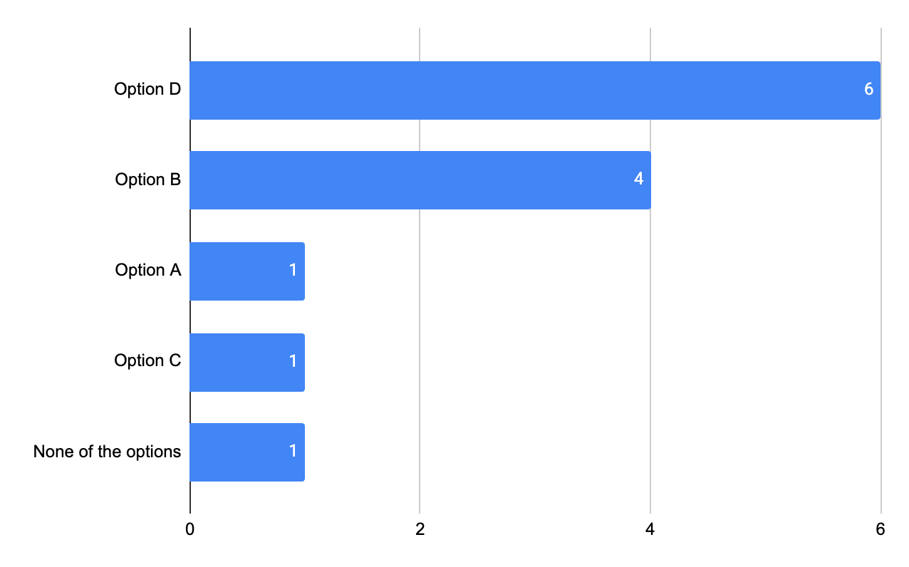

Data source: Stage 1 traders survey

Looking at preferences by street, a total of three participants selected Option B and one participant chose Option C for Martin Street. Among Bay Street traders, a total of six participants selected Option D, one participant selected Option B and another selected Option A.

During the community pop-ups, facilitators asked passers-by and traders visited at their businesses to share their thoughts to help initiate the design process. Participants were asked; ‘What makes this street special or unique?’ to understand features that locals would like to see celebrated in the welcome sign. Participants from Bay Street noted the top themes:
- Specialty, local businesses(n=10)
- Village feel(n=7)
- People, community and dogs (n=7)
For Martin Street, the strongest themes were:
- Diversity of local businesses(n=21)
- People/community(n=13)
- Familiar and friendly(n=8)
- Aesthetic and identity(n=8)
Looking at the findings overall from stage one engagement, the key suggestions for welcome signage at each location are shown in the table below.

Table 3. Key suggestions for welcome signs
Bay Street | Martin Street
- Reflect the coastal village, beachside, feel.  - Highlight the strong sense of community, local connection and pride.  - Showcase diverse mix of independent cafes, shops, and services.  - Celebrate the convenience and accessibility, walkability, nearby amenities, and easy transport connections. | - Celebrate, small, local village feel  - Community values Martin Street as: calm, diverse, down-to-earth and lively at night  - Present Martin Street as a slower-paced, community-focused shopping strip.

4.2 Bay Street Feedback
This section summarises community preferences for the two proposed Bay Street welcome sign concepts and the key themes that emerged from participant feedback in the first stage to develop design concepts.

4.2.1 Initial feedback to shape the design concepts - Stage 1 engagement
The final design options that were voted on in stage 2 were based on initial engagement with community members to understand the local areas, the unique characteristics of the street, and initial community ideas and themes for design directions.
Unique qualities of Bay Street
Participants were asked the following question: ‘What do you think makes this shopping strip special or unique?’ A total of 30 participants answered this question in relation to Bay Street. The word cloud below shows the common words or themes mentioned by participants.
Image 10. Word cloud: What makes Bay Street special or unique
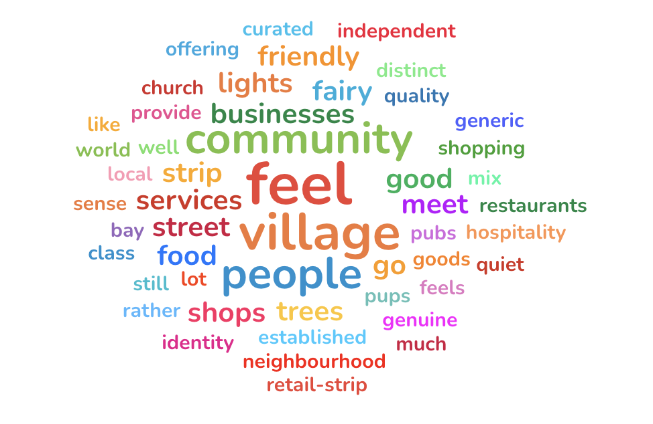
Data source: traders survey, intercepts
Table 4. shows the breakdown of the common themes that participants mentioned when describing what was special or unique about Bay Street. Responses are supported by verbatim quotes.
Table 4. What makes Bay Street special or unique
Theme | Community feedback
Specialty, local businesses  (n=10) | ‘Great selection of shops and fresh food.’  ‘We have a lot of well-established businesses that provide quality goods or services.’
Village feel  (n=7) | ‘It has a village feel rather than a generic retail-strip feel.’  ‘Village country town feel.’
People, community and dogs  (n=7) | ‘This is the most friendly strip, people smile and there's lots of dogs.’  ‘Friendly traders invested in the community.’
Aesthetic and identity  (n=4) | ‘Bay Street feels distinct because it still has a genuine neighbourhood identity while offering a curated mix of independent businesses, hospitality and services.’
Welcome sign  (n=2) | ‘Station location is good for the sign - the midpoint where people go to meet people.’
Data Source: trader surveys, intercepts
When responses were filtered by participants’ connection to Bay Street, it is worth noting that participants who worked/owned a business had comments that emphasised the importance of local business to the uniqueness and identity of the area.
Level of support for proposed welcome sign location
Bay Street survey participants were asked the question: ‘The design team is considering locating the welcome sign near the centre of the shopping strip to maximise visibility and create a sense of connection between the two retail areas. What is your level of support for this location?’ A total of 9 participants responded to this question. Overall, the bulk (n=6) of participants supported this location choice for the sign. Figure 5 provides this breakdown. Traders confirmed their support of the location in the 15 July meeting with Council.

Figure 5. Level of support for the location of the Bay Street welcome sign
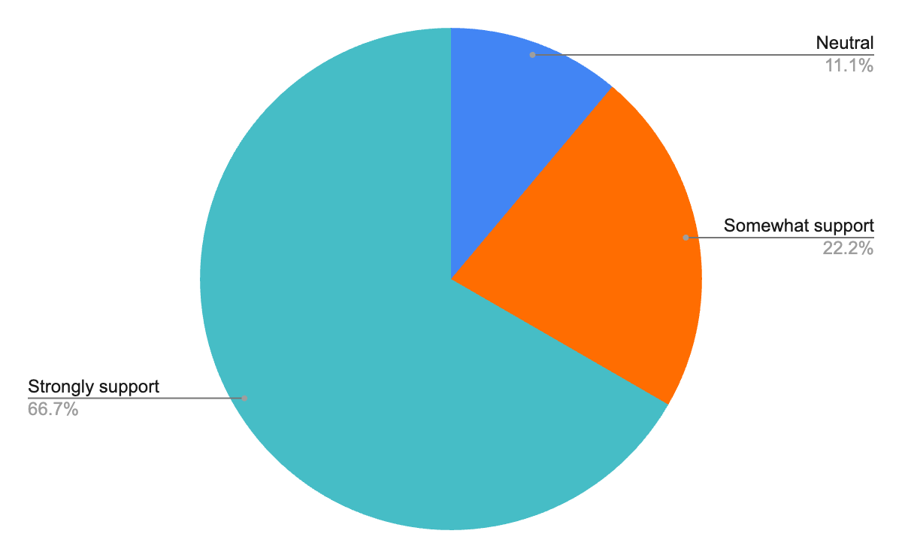

Data source: Trader surveys (Bay Street only)

Bay Street taglines
In order to understand local identity and source ideas for text or taglines for the welcome signage, participants were asked: ‘In a few words, how would you describe Bay Street shops to someone who has never visited before?’ A total of 36 participants answered this question. The following word cloud highlights common responses.

Image 11. Word cloud: How participants describe Bay Street 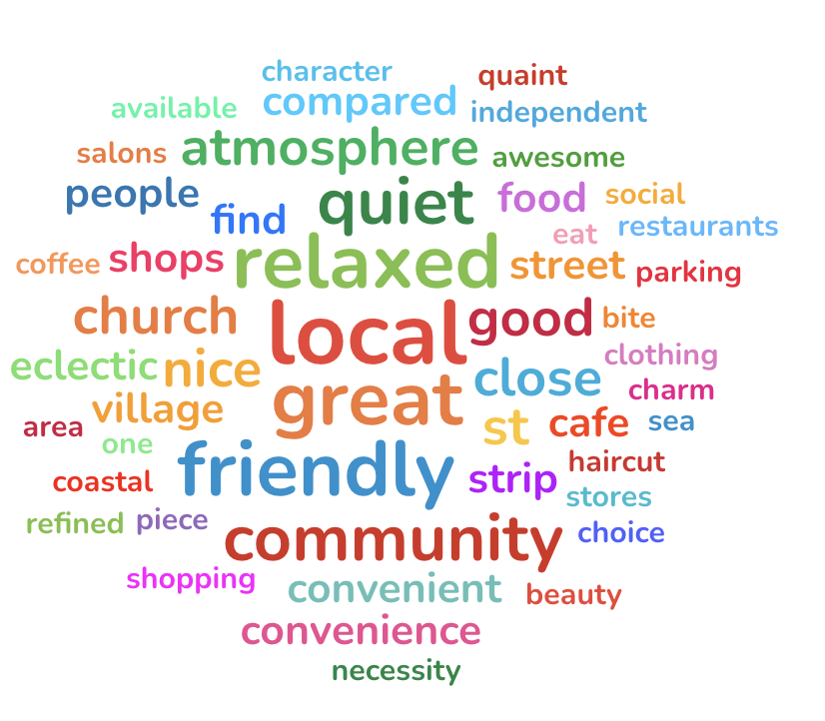
Data Source: traders survey, intercepts

The following image showcases a selection of verbatim quotes to show the themes raised when describing Bay Street.

Image 12. Bay Street taglines
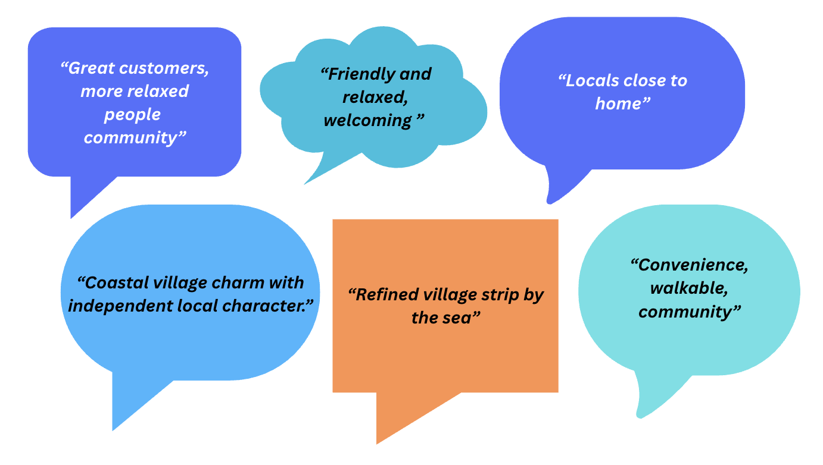
Data Source: survey, intercepts

Welcome sign themes
Participants were asked; ‘What key themes best represent this shopping strip and should be celebrated in a welcome sign?’ and were able to select as many as applied from a list of options. There was a total of 27 responses to this question. The most common themes participants wished to celebrate at Bay Street. were ‘Food scene and cafe culture’ (n=19), followed by ‘Local community’ (n=12), ‘Nature and environment’ (n=8), ‘Local history and heritage’ (n=6) and ‘Multiculturalism’ (n=3). When asked if there were any other aspects that should be celebrated in the welcome sign, there were a total of 14 free text responses. Participants mentioned:
- Celebrating Bay Street as a destination for fresh food, wine and dining.
- Celebrating the local heritage, coastal and beach culture.
- Celebrating the area as a wellness destination.
- Community centred place, dog friendly, relaxed atmosphere.
- Support for local businesses and local shop tenancy.
- Participants who supported getting welcome signage but did not have preferences for what the design looked like.
Other considerations
Survey and intercept participants were also asked the question: ‘Is there anything else Council should consider when planning for welcome signage at Bay Street shops?’ There were 11 participants who responded via free text comments. Participants articulated that the precinct should feature well-designed, timeless signage that is illuminated at night and enhances the street without overpowering it. Durable materials and thoughtful placement to create a clear sense of arrival was also suggested.

There was also a desire for promoting a lively, welcoming atmosphere with elements like fairy lights and more live music, while addressing concerns about empty and closing shops by revitalising retail spaces. At the same time, any improvements should respect and preserve historic facades while supporting appropriate new development. One participant suggested emphasis should be placed on promoting the area as North Brighton rather than Bay Street, highlighting the proximity to the train station as a natural meeting point.

Recommended next steps for the design
Stage 1 analysis presented the following key suggestions for the design:
- Reflect the area’s relaxed coastal village charm in the welcome sign design, using language and visuals that convey a friendly, beachside atmosphere
- Highlight the strong sense of community, local connection and pride.
- Showcase Bay Streets’ mix of independent cafes, shops, and services to emphasise its vibrant, yet local character
- Celebrate the convenience and accessibility, walkability, nearby amenities, and easy transport connections.

4.2.2 Preferred welcome sign design option- stage 2 engagement
Participants in surveys and pop-ups were presented with the two welcome sign design options and asked: ‘What is your preferred welcome sign concept design for Bay Street?’. There was a total of 191 responses to this question.
Image 13. Option 1. | Image 14. Option 2.
Overall, the preferred option was Option 1 (n=107, 56%) with Option 2 receiving (n=84, 44%) selections. Although Option 1, the three-pillar design was favoured by a majority of respondents, the relatively small difference between the two options indicates that support was reasonably balanced, with both options receiving substantial community support.
Figure 6. Bay Street- Preferred welcome sign
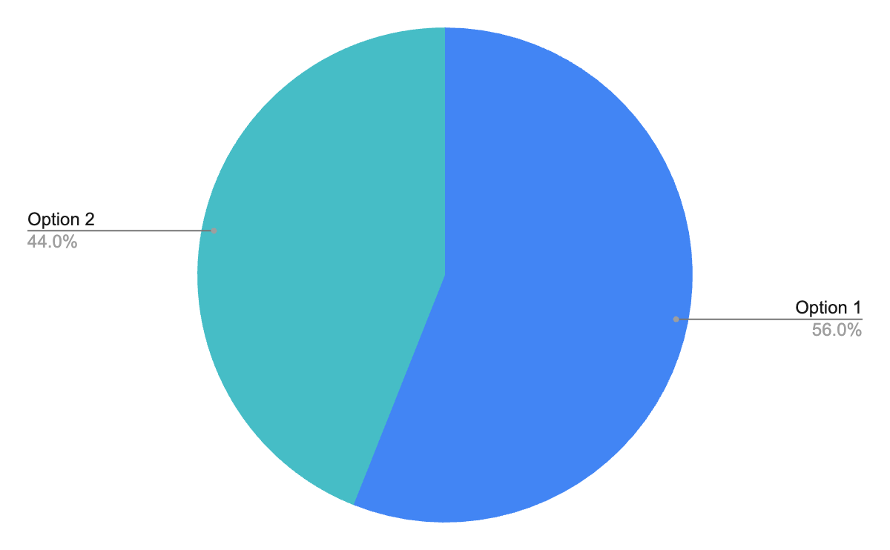
Data Source: survey, pop ups
Participants at pop-ups and participants who made online submissions were able to leave detailed feedback on the proposed designs. This additional feedback across both engagement methods has been analysed together using a coding framework to identify common themes. Some participants mentioned more than one theme and these mentions have been counted accordingly. Looking at the additional feedback for Bay Street, the key themes that emerged and verbatim quotes are presented in Table 5 below.

Table 5. Additional feedback about the Bay Street welcome sign
Topic | Community feedback
Alternative ideas for welcome signage (n=7) | “Can we get surfboards or sea related things like penguins? More beachy”.  “I think some nice First Nations design would be good on the sign”.  “I would prefer something modern. We need more modern designs to attract young people”.
Alterations to the options provided (n=4) | “Use the Option 1 central pillar only”.  “Option 1 but just the first pillar”  “I don’t have a problem with the general design of the new signage except for the lettering in the horizontal rather than what is normal vertical”.
Preference for neither option (n=4) | “All the options are really daggy”.  “Martin street designs are more contemporary, the lacework on the Bay Street option is fussy and daggy”.
Opposed to welcome signs (n=2) | “...Rather than spending money on decorative signs, Council should concentrate on its fundamental responsibilities…”  “Can you please let me know how putting up new signage on Martin Street and Bay Street is going to help the traders increase business. Neither option conveys the spirit of the words that came before”.
Data Source: Submissions, pop-ups

A meeting with traders and businesses owners who operate on or near Bay Street was conducted on 15 July to present the designs. The only feedback traders provided about the initiative was that they approved of the location.
Overall participants showed a moderate preference for Option 1. Participant comments suggest that while many respondents appreciated the proposed design, there was room for further refinement and preferences for alternative ideas. The most common criticism of the design was that it did not reflect Bay Street’s identity as it lacked coastal elements, contemporary aesthetic or First Nations artistic influence. Participants who made suggestions to alter designs, most commonly suggested removing the lacework pattern. There were also a small number of participants (n=6) who preferred neither design or were opposed to installing a welcome sign for Bay Street.

4.3 Martin Street Feedback
This section summarises community preferences for the Martin Street welcome sign concepts and the key themes that emerged from initial participant feedback.

4.3.1 Initial feedback to shape the design concepts- Stage 1 engagement
Unique qualities of Martin Street.
Participants were asked the following question: ‘What do you think makes this shopping strip special or unique?’ A total of 53 participants answered this question in relation to Martin St. The following word cloud demonstrates the common themes from participants' responses.

Image 15. Word cloud: What makes Martin Street. special or unique
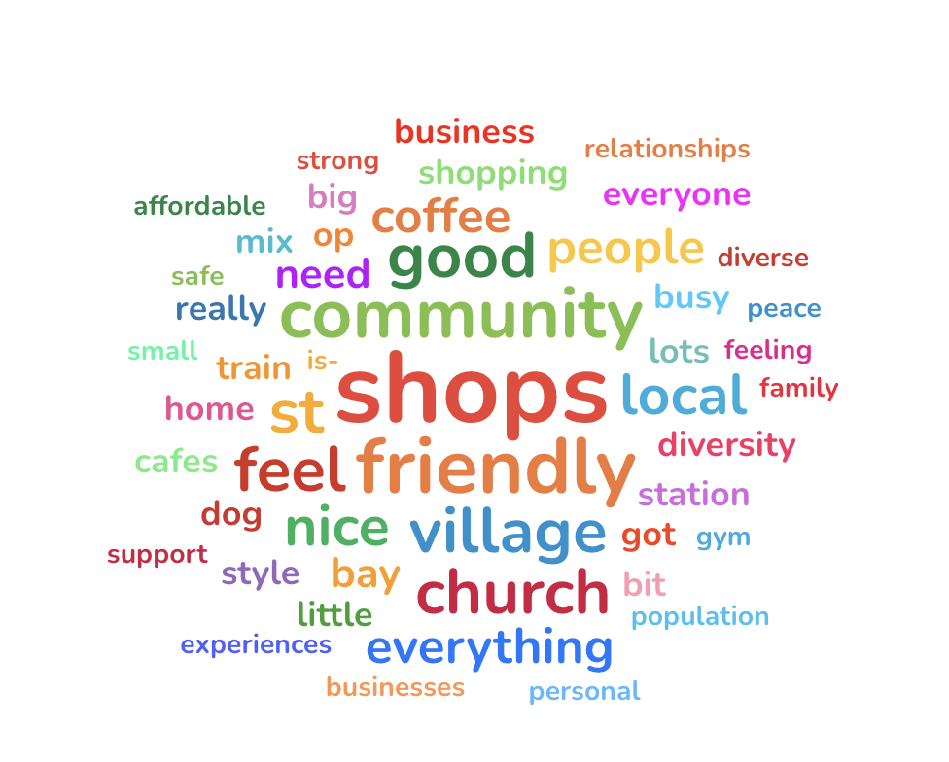
Data Source: traders survey, intercept demographic cards

Table 6 shows the breakdown of the common themes that emerged when participants described what is special and unique about Martin Street, supported by verbatim quotes.

Table 6. What makes Martin Street special or unique
Theme | Community feedback
Diversity of local businesses  (n=21) | ‘Eclectic nature of the shops, not your everyday brands.’  ‘Good mix of shops and places to eat.’
People/community  (n=13) | ‘Personal experiences. Strong relationships.’  ‘I like having older/younger people all walking dogs- everyone knows everyone.’
Familiar and friendly  (n=8) | ‘People feel really at home here.’  ‘Really nice people, good vibes.’
Aesthetic and identity  (n=8) | ‘Local personality, not trying to be anything else.’  ‘The proposed end for the sign we call the Paris end- it’s a very European style.’
Accessibility and transport  (n=6) | ‘The value of it is accessibility/transport.’
Quiet/small scale  (n=5) | ‘Peaceful, nice and quiet, good shops.’
Village feel  (n=5) | ‘Village feel, friendly atmosphere.’
Data Source: trader surveys, intercepts

Martin Street taglines
Participants were asked: ‘In a few words, how would you describe Bay Martin Street shops to someone who has never visited before?’ A total of 20 participants answered this question with the most common themes shown in the word cloud below.

Image 16. Word cloud: How participants would describe Martin Street to someone who had never been before
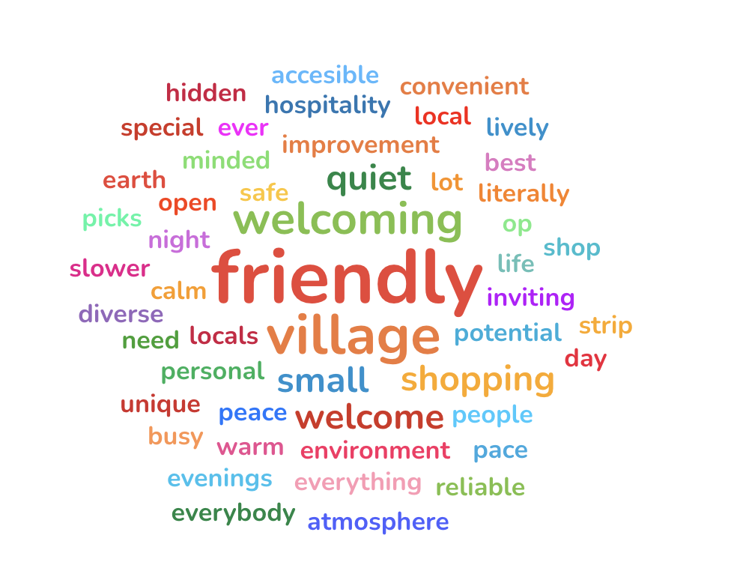
Data source: traders survey, intercepts
The following image showcases a selection of participants’ verbatim quotes to show the themes raised when describing Martin Street.

Image 17. Martin Street taglines
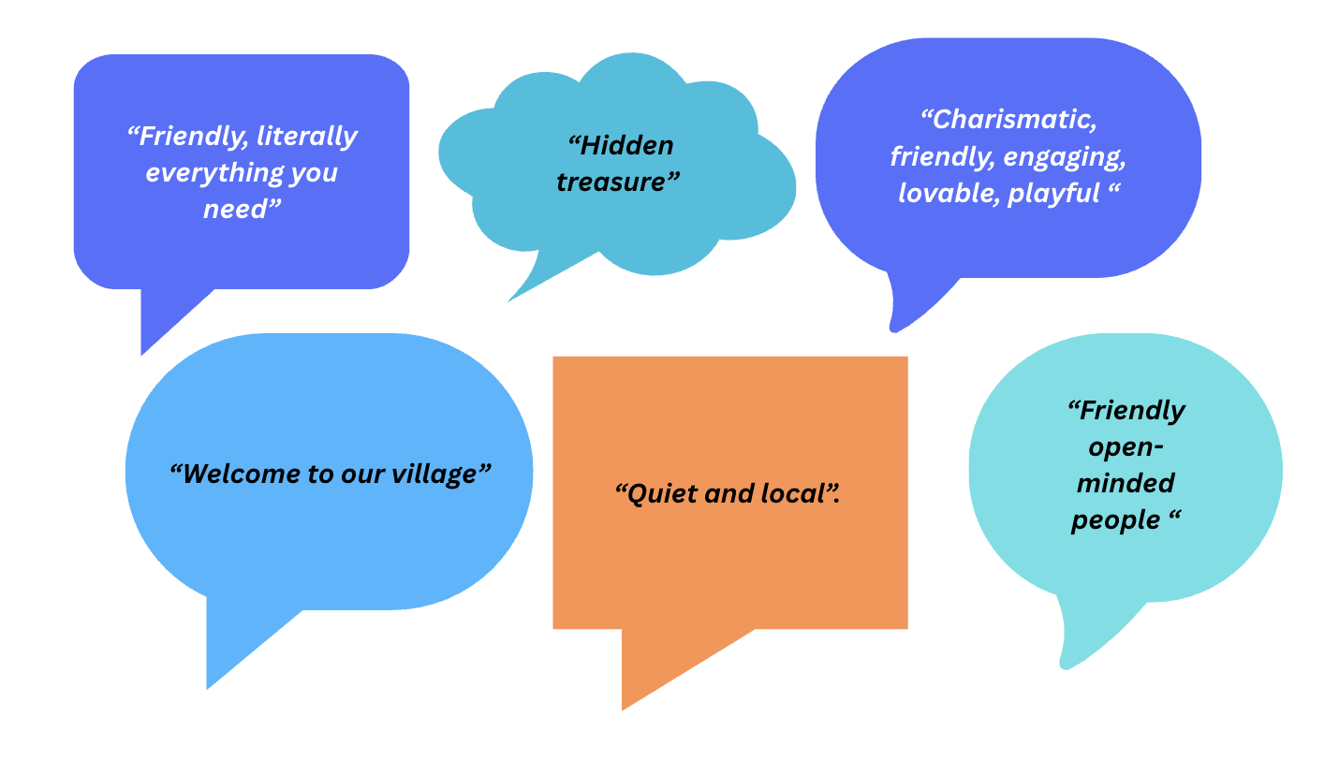
Data source: traders survey, intercepts
Welcome sign themes
Participants were asked; ‘What key themes best represent this shopping strip and should be celebrated in a welcome sign?’ and were able to select as many as applied from a list of options. There were a total of 15 responses to this question. The most common themes participants wished to celebrate at Martin Street. were the ‘Local food scene and cafe culture’ (n=8) and the ‘Local community’ (n=10), followed by ‘Multiculturalism’ (n=4) and ‘Local history and heritage’ (n=4). One participant mentioned ‘Nature and environment. Participants were then asked whether there were any other aspects that should be celebrated in a welcome sign. There was a total of 12 free text responses to this question. Participants mentioned:
- Acknowledging Martin Street as the gateway to Bayside.
- The local heritage, building look and feel, plantings and plane trees.
- Integrating the local school.
- Celebrating and including the businesses on the Nepean Highway side of the strip.
- Celebrating local Polish, Jewish and Italian cultures.
- Supporting local businesses and maintaining public spaces in the high street.
Other considerations for welcome signage
Survey and intercept participants were also asked the question: ‘Is there anything else Council should consider when planning for welcome signage at Martin Street shops?’ There was a total of 18 participants who provided free text responses. Participants suggested that the signage should be bright, colourful, and have visually engaging elements, such as photo-friendly features. Participants largely supported the placement of the sign at the east end of the strip, but also suggested signage archways, placement on the rail bridge or placed near high-traffic areas like the station and Nepean Highway. Participants wanted a welcome sign that would celebrate the area’s history and strong local community and direct visitors to the shopping strip. One participant suggested that the signage should highlight “Martin Street Shopping Village - the Gateway to Bayside with a Council logo”.
Other improvements were also highlighted to address maintenance issues like potholes, fallen trees, cycling infrastructure and the rail bridge’s appearance, while exploring opportunities to enhance underutilised spaces (e.g. the roundabout and rail bridge) and integrate community features like school markets.
Next steps for Martin Street Signage
Based on the analysis of the activities from Martin Street, the following are suggestions for the welcome sign specific to the location:
- Celebrate local identity as a ‘village’; highlighting warmth, friendliness, and a small, local feel. Phrases like “Welcome to our village” and “hidden treasure” strongly resonate and can anchor the tone of all signage.
- Highlighting community values (friendly, calm, diverse, down-to-earth, lively at night) into visual elements that communicate both daytime calm and evening vibrancy.
- Communicating that the precinct is not a large commercial hub but a unique, slower-paced, community-focused shopping strip.
- Celebrating what makes the area special; such as its diversity, accessibility, and convenience.

4.3.1 Preferred welcome sign design option- Stage 2 engagement
Participants in surveys and pop ups were presented with the two welcome sign design options and asked’ ‘What is your preferred welcome sign concept design for Martin Street?’. There was a total of 190 responses to this question.

Image 18. Option 1. | Image 19. Option 2.
Overall, the preferred option was Option 1 (n=103, 54%) with Option 2 receiving (n=87, 46%) selections. Figure 7 provides this breakdown. As shown in Figure 7 respondents expressed a slight preference for Option 1; however, the results indicate that community opinion was largely evenly divided, with both options receiving strong support.

Figure 7. Martin Street - Preferred welcome sign
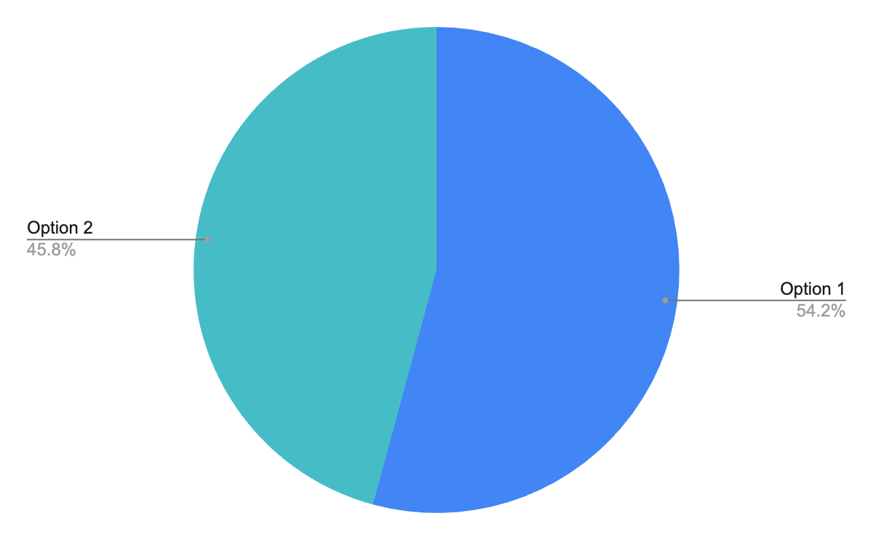
Data source: survey, pop ups
Participants in pop-ups were able to make free text comments on the proposed designs. Visitors to the online project page were able to make a submission with more detailed feedback. The themes that emerged from additional feedback are shown with verbatim quotes in Table 7 below.

Table 7. Additional feedback about the Martin Street welcome sign
Topic | Community feedback
Alternative ideas for welcome signage (n=7) | “Put something on the highway to bring people in. The other side where the sign is going is more local. The highway would be better for new customers”.  “I would like to see an Indigenous design or nightlife and funky vibrancy captured. Needs colour”  “Solar powered fairy lights are strung across the street linking each shop for the length of the shopping precinct with signs at both ends…”
Preference for neither option (n=4) | “Both Martin Street options are way too busy”.  “What are they supposed to represent? The message is very unclear and too busy”.
Positive feedback for design options (n=2) | “Option 1 for Martin Street is more clear. It's telling you where it is. I prefer it”.  “Option 2 is more neighbourhood street vibes”
Data Source: Submissions, pop ups
A meeting with traders and businesses owners who operate on or near Martin Street was conducted on 20 August to present the designs. The common feedback traders raised about the designs were:
- 2 traders liked Option 1
- 1 trader did not have a preference
- 1 trader did not like either design
- General consensus that the roundabout at Asling and Martin Street was the ideal location, but the second preference was the northwest corner of the intersection
Overall participants preferred Option 1 slightly more than Option 2 for Martin Street, largely as it was considered more legible and easier to understand as a welcome sign. Participants enjoyed the colours of both designs but commonly suggested that designs could be less busy or show a greater connection to Martin Street identity.

5. Next Steps
The preferred designs from community engagement will be constructed at each street. Council anticipate installing the welcome signs in September 2026.

