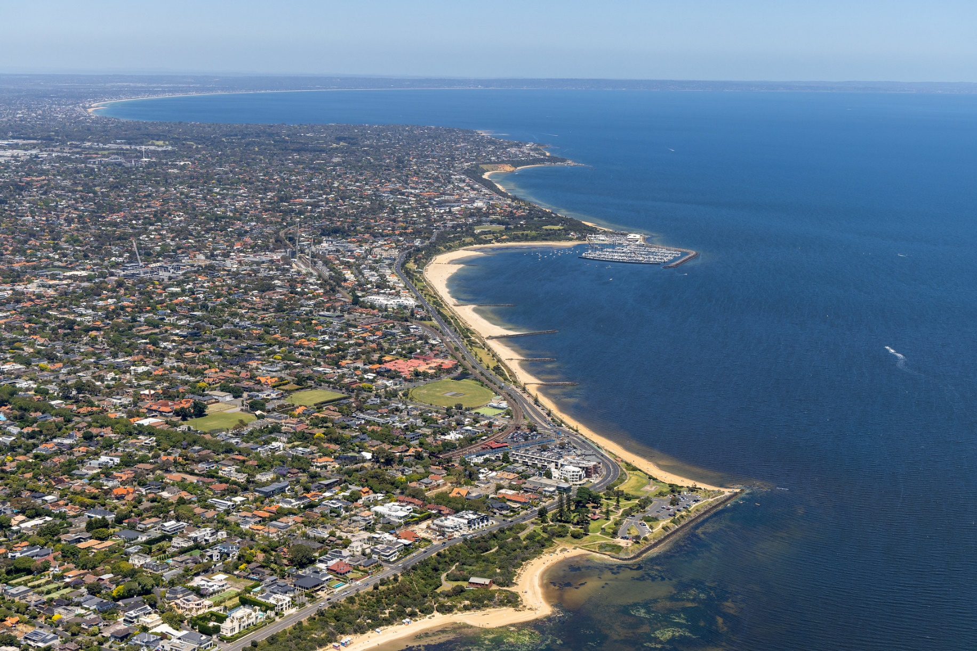

Activation of Council Land Policy Community Engagement Summary Report

June 2024
Contents
Overview 3
Key findings 3
Next steps 4
1 Background 4
2 Definitions and scope 4
2.1 Related Council documents and consultations 5
3 Consultation process 5
3.1 Consultation purpose 5
3.2 Consultation methodology 5
3.2.1 Table 1: Engagement methods 6
3.2.2 Table 2: Communication methods 6
4 Participant profile 7
5 Consultation findings 7
5.1 Additional mobile vending locations in Bayside 7
5.1.1 Table 3: Comments from respondents who expressed support or were neutral 8
5.1.2 Table 4: Comments from respondents who were opposed or expressed concerns 9
5.2 Previous experience of mobile vendors and frequency 10
5.2.1 Table 5: Comments from respondents who have not previously used a mobile vendor 11
5.2.2 Frequency of purchasing goods/services from a mobile business 11
5.3 Areas that would benefit from mobile vendors, what kind of services and during what season 12
5.3.1 What area would benefit from new mobile vendor sites 12
5.3.2 Mobile vendor services 12
5.3.3 Seasonal mobile vending 13
5.4 Item-specific feedback 13
5.4.1 Table 6: Support and neutral feedback for mobile vending 13
5.4.2 Table 7: Opposition or concern for mobile vending 14
5.5 Areas of interest for new mobile business locations 15
6 Project evaluation 16
6.1.1 Performance summary charts 16
7 Appendix 17
7.1 Written statements 17
7.1.1 Written statement 1: Bayside resident 17
7.1.2 Written statement 2: Bayside resident 20
7.1.3 Written statement 3: Bayside resident 23

Overview
This report provides a summary of community feedback to help inform the draft Activation of Council Land Policy.
Council currently licenses four mobile vending sites along the Bayside foreshore. Frequently, Council receives enquiries from vendors with an interest in operating mobile businesses in the municipality. Reports of unlicensed mobile vendors around reserves and roadside locations are also occasionally received.
Council has identified an opportunity to formalise additional mobile vending activations on Council land.
Between 19 March and 30 April 2024, we consulted with the community to help inform the draft policy. The community were asked about their support or opposition to additional mobile vending sites in Bayside. The community were also asked to provide feedback on suitable new locations for mobile vendors, and the services they would like to experience at the new sites.
More than 400 community members visited the project webpage, and 113 contributions were received from 76 individuals.
Feedback gathered through the consultation included:
- 60 online survey contributions
- 43 social map contribution
- 3 written statements
- 2 direct submission to Council officers
- 3 phone calls

Key findings
Additional mobile vending locations were generally well received with 62% of respondents either strongly or somewhat supporting the initiative. 32% of respondents either strongly or somewhat opposed, with the remaining 7% either neutral or not sure. Strongly support was the most frequent response with 40% (24 respondents).
Majority of the respondents 75% (45) had previously purchased food, drinks or an experience from a mobile business and predominantly use mobile vendors on weekends with 55% (33 respondents) and 23.33% (14 respondents) on public holidays. Food & beverage was the most popular service 86.67% (39) previously used and ice cream the second most popular choice 71.11% (32).
The current most favoured services were also the 3 most popular services respondents wanted to experience from mobile vendors in Bayside: food & beverages 68.33% (41), coffee 66.67% (40), and ice cream 46.67% (28). The feedback suggested respondents would use a vending service in all seasons: summer 80% (48), winter 71.67% (43), autumn 66.67% (40), and spring 65% (39).
The survey feedback outlined that the 5 most popular areas for mobile vending sites as along the foreshore, around sportsgrounds, close to playgrounds or older adults equipment, in commercial/industrial areas and near dog parks.
Participants also had the opportunity to drop a pin on a social map on the consultation’s HYS page to identify locations they would like experience mobile vendors. Many suggestions were focused along the foreshore between Brighton to Sandringham 70.73% (29). Bayside reserves were also popular locations 29.26% (12).
Respondents expressing concerns or were opposed to the proposal were concerned that litter will increase, and that the proposal will draw away costumers from existing local businesses. Some were opposed to commercialisation of public open space and stated that the quality of the open spaces will be reduced.

Next steps
We’re reviewing community and stakeholder feedback to help inform the draft policy. We will undertake the phase 2 community consultation in early 2025 to seek feedback on the draft policy. We anticipate Council will consider the Activation of Council Land Policy for adoption at a meeting early – mid 2025.

Background
The popularity of food trucks, coffee carts, pop-ups and other mobile services has risen in recent years. Mobile businesses can provide services in locations where it may not be possible (or very costly) to build infrastructure, and vendors can operate seasonally and based on demand.
Council frequently receives enquiries from vendors interested in applying for a permit to operate in Bayside. Currently, four mobile vending sites are licensed along the foreshore, and Council has identified an opportunity to introduce mobile vending at additional locations.
The new policy will help to address the growing interest from vendors and increase mobile trading opportunities in the local area. The policy will be a first point of reference for interested vendors, outlining the application criteria, and establishing a framework for processing applications. The policy will provide information about managing impacts on the environment and Council amenities and will also include vendor considerations for the types of mobile businesses and trading locations.
The proposed Activation of Council Land Policy will help to:
- establish the principles and intent for commercial activity across Bayside
- outline a process for establishing short or longer-term mobile vending sites
- create a framework for assessing applications.
Between 19 March and 30 April 2024, we consulted with the community to help inform the draft policy. The community were asked about their support or opposition to additional mobile vending sites in Bayside. The community were also asked to provide feedback on suitable new locations for mobile vendors, and the services they would like to experience at the new sites.

Definitions and scope
Within this document, reference is made to stakeholders. These stakeholders are:
- Mobile traders
- Bayside business owners
- Bayside residents
- Visitors to bayside
- Bayside Tourism Network
Item | Definition
HYS | Have Your Say
Stakeholders | As listed above

Related Council documents and consultations
- Bayside 2050 Community Vision
- Council Plan 2021 – 2025, Goal 2 (Our people)
- Property Strategy 2022-2026, Goal 3 (Use Council-controlled property to optimise commercial returns)
- Lease and License Policy 2023
- Bayside Open Space Strategy
- Economic Development Strategy
- Climate Emergency Action Plan

Consultation process

Consultation purpose
The consultation was designed to provide stakeholders and the broader community with the opportunity to provide feedback to help inform the draft Activation of Council Land Policy.
The consultation was conducted to understand community sentiment about mobile vendors trading in Bayside. Feedback tools were designed to seek ideas for new vendor locations and the types of mobile businesses to operate in the new locations. The consultation also provided the opportunity for contributors to raise concerns and identify constraints for consideration when drafting the policy.
Community engagement was conducted in accordance with Council’s Community and Stakeholder Engagement Policy 2021. An engagement plan overview was published and is available to view on Council’s Have Your Say engagement website.

Consultation methodology
The tools and techniques selected for this project were informed by the project content,
stakeholders and type of feedback sought.
Community engagement was conducted between 19 March and 30 April 2024.
More than 400 community members visited the Have Your Say project webpage, and 113 contributed, from 76 unique contributors.
Feedback gathered through the consultation included:
- 60 online survey contributions
- 43 social map contribution
- 3 written statements
- 2 direct submissions to Council officers
- 4 phone calls
The communications program is estimated to have reached more than 20,000 residents, while targeting residents.
The consultation materials were available in accessible formats on request.

Table 1: Engagement methods
Details | Activity
19 March – 30 April 2024  400 Visits  492 Views  319 Visitors  113 Contributions | Have your say website  - Online survey (62 responses)  - Social map (43)  - Capability to book a meeting with a Council officer  - Contact a Council officer via direct email  - Public online Q&A forum (12)
1 – 26 May 2024 | Direct correspondence  - 5 direct emails  - 4 phone calls

Table 2: Communication methods
Details | Engagement activity
19 March – 30 April 2024 | Council channels  - Council website: news story (19 March)  - This Week in Bayside (Council weekly e-news) feature article (21 March)  - This Week in Bayside (Council weekly e-news), featured in projects open for feedback (28 March, 4, 11, 18 and 25 April), 11,000+ subscribers  - Council social media channels (19 March)  - Inside Word (7 Councillors)  - In the Loop (760 recipients)
19 March – 30 April 2024 | Direct email  - HYS project subscribers: 4,278 unique subscribers (open rate 57.1%, 2.2% click-throughs to HYS page)  - Bayside Traders Associations, 21 March  - 2,480 recipients  - 2,092 (96%) delivered / 1,119 (54%) opened / 35 (1.67%) clicked link  - Bayside Tourism Network  - 13 recipients  - Mobile vendor list who have previously made license enquiries, 19 March  - 116 recipients  - Healthy Aging newsletter  - March/ April edition  - 680 recipients

Participant profile
The table below shows a comparison between survey participant demographics and the demographic profile of the whole Bayside community.
 | Demographic | Bayside  2021 Census | Participants (%)
Gender | Male | 47.8% | 44.07%
Gender | Female | 52.2% | 52.54%
Gender | Unknown | -
Gender | Prefer not to say | - | 3.39%
Age | 18-24 | 7.8% | 1.69%
Age | 25-34 | 7.8% | 3.39%
Age | 35-49 | 19.4% | 27.12%
Age | 50-59 | 15.7% | 11.86%
Age | 60-69 | 12.1% | 25.42%
Age | 70-84 | 12.2% | 18.64%
Age | 85+ | 3.4% | 0%
 | Prefer not to say | - | 11.86%

Survey respondents (62) were also asked to specify their connection to Bayside. All participants had a connection to Bayside, with some identifying with multiple options:
- Bayside resident or ratepayer (55)
- Bayside commercial property/business owner (10)
- Work in Bayside (12)
- Visitor to Bayside (1)

Consultation findings
The following section summarises the key themes which arose in community feedback regarding mobile vendors and the proposed Activation of Council Land Policy.
In the interest of stakeholder and community privacy, survey feedback has been anonymised. Where there was more than one mention of a topic or item, the number of mentions has been specified in brackets.
There were 62 contributions which are summarised as follows:

Additional mobile vending locations in Bayside
A majority of respondents were supportive of additional vending locations in Bayside (61.67%). 40% (24) of the respondents expressed strong support and 21.67% (13) were somewhat supportive.
31.67% of respondents were opposing additional sites with 11.67% (7) stating that they somewhat opposed and 20% (12) strongly opposed.
5% (3) were neutral and 1.67% (1) were not sure.
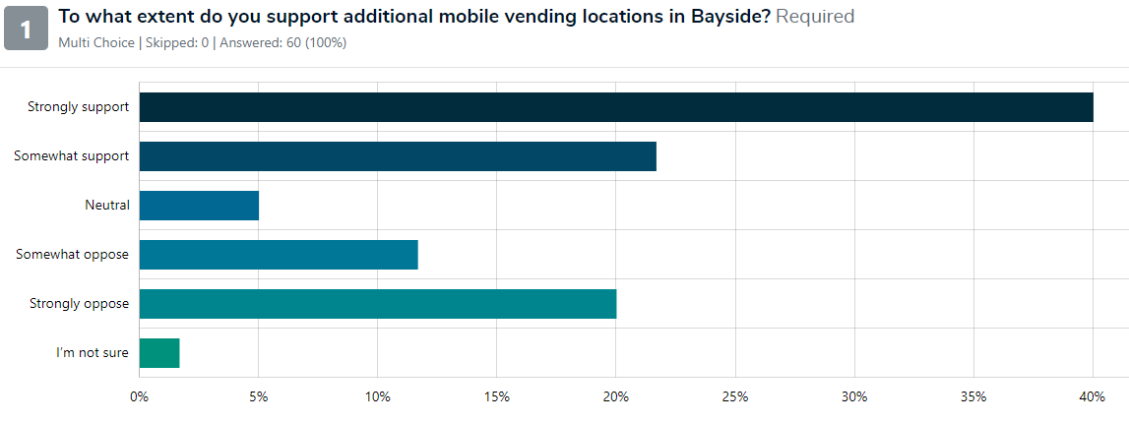
Comments provided regarding additional mobile vending locations are summarised by theme in the tables below:

Table 3: Comments from respondents who expressed support or were neutral
Topic | Community feedback
Foreshore | There is a need for additional food and service facilities along the foreshore, especially on warm weekend when the existing cafes struggle to cope with the demand.  Supportive but don’t want car parks and foreshore overcrowded with vendors.  Currently limited locations along the foreshore and many of the close by cafes close by mid-afternoon.  We need more coffee and refreshment vendors along Hampton beach.  Currently not enough service along the Bay area.  Additional amenities to make the most of the beautiful foreshore.  Extends trading hours and use of the underutilised foreshore without permanent structures.
Proposal | Provides people with convenient access to service and potentially a reason to visit such locations.  Has the potential of creating more opportunities for local events, businesses, and community.  Should be a limit on number of mobile vendors in one area.  Supportive of occasional mobile businesses in more areas.  Ensure access is available for people of all ages and abilities.  Would like to see more events to encourage more visitors to the area.  Supportive of more activity.  Only positive outcomes for the businesses and local community.  Provides service around the beaches and parks which is very popular among the increasing population.  Markets gets people outdoors.  Limit the number of additional vendors in already crowded areas.  Fantastic to add coffee carts at our parks and playgrounds.  Variety of service where foot traffic is high.
Mobile vendors | Adds vibrance and economic stimulus to Bayside. (5 mentions)  Adds flexibility and variety to the area (5 mentions).  Creates an atmosphere in any location and provided the community with new food outlets in convenient locations.  Opportunity for reasonably priced food to be available.  Ensure high quality of the vendors.  Adds more options for locations and extended opening hours.  Will enhance the experience of the area for visitors and locals.  Good to have a wider offering at busy locations.
Commercialisation | Promotes small local businesses. (2 mentions)  We are well served with cafes and ice cream shops but they all close before 3pm. (2 mentions)  Weekend trading is essential when the bricks and mortar shops are closed.  Don’t want to see bricks and mortar shops disadvantaged.
Litter | Supportive if the waste is managed properly.

Table 4: Comments from respondents who were opposed or expressed concerns
Topic | Community feedback
Proposal | Interrupts the flow of people and causes obstructions on pathways.  Will increase congestion.  This is a bad idea.
Litter | Concerned that rubbish and litter will increase. (3 mentions)
Commercialisation | Opposed to commercialisation of public open space. (2 mentions)  This will draw customers away from local shopping areas who are paying high rents and rates. (2 mentions)  No need for businesses in our limited open spaces.  Local businesses are struggling enough without further competition.  No need for further commercialisation in Bayside, particularly away from business areas and local shopping centres.  No need for more retail sites.  Protect existing local businesses.  Would be in favour if we can sell bathing box merchandise from our café.
Open space | The parks and reserves should remain for the public to enjoy (3 mentions).  Residents and visitors want to enjoy “free” activity away for commercial enterprises.  Opposed to mobile vendors using any space on the foreshore and around grass and shrub areas.  Proposal will reduce the quality of open space.  Residents need quiet and peaceful open spaces without the noise and activity associated with commercialisation.  Open space is for the community and is increasingly degraded by mobile vendors and other initiatives.
Foreshore | 40 years ago, Bayside Council promised no further building around the foreshore.  The land is for the community to use and not business venturers.  Strongly opposed to mobile vendors along the foreshore.
Car parks | Concerned that the mobile vendors will use the existing car parks.  Would be neutral if the vendors use the existing car parks.  Currently an issue with the limited amount of parking spots, mobile businesses should only be allowed if more public parking becomes available.
Traffic | To activate these spaces it is important to reduce speed limits and remove the major road status of Beach Rd as its currently unsafe to access the beach.

Previous experience of mobile vendors and frequency
Most respondents had previously purchased food, drinks, or an experience from a mobile business75% (45), while 25% (15) had not.
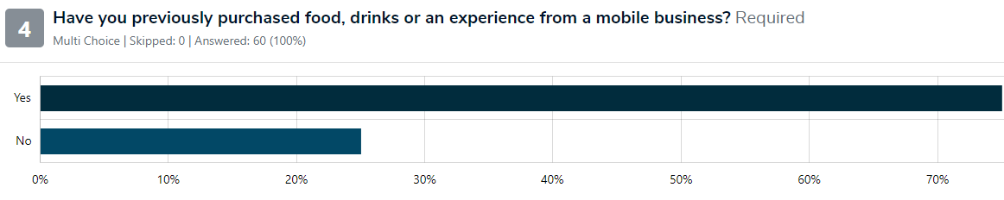
Respondents who had previously used a mobile vendor were asked what kind of service they previously used. Food & beverage was the most popular 86.67% (39), ice cream was the second most popular 71.11% (32). Other respondents had purchased pony rides 13.33% (6), and equipment hire 13.33% (6). One respondent selected “other”, and noted fresh fruit and vegetables.
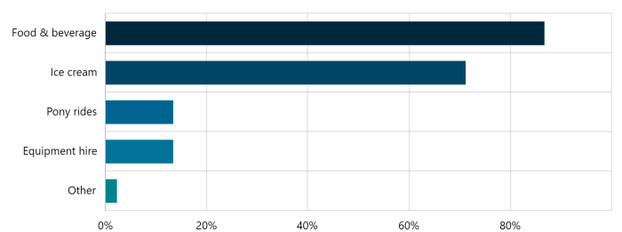
The respondents who indicated they had not previously used a mobile vendor were asked why. The feedback is outlined in the below table.

Table 5: Comments from respondents who have not previously used a mobile vendor
Topic | Community feedback
Reason for never using a mobile vendor | Have not seen any of the existing vendors. (2 mentions)  Usually provide inadequate goods. (2 mentions)  Don’t go to parks to buy takeaway food.  No need for mobile vendors.  Bad idea.  Only seen mobile dog wash service in the past.  We bring our own drinks and food and take the rubbish away.  Haven’t had the need to purchase from a mobile vendor apart from at festivals, events or markets.  Council has promised no more buildings or extensions of car parks along the foreshore.  These businesses reduce spaces for community use.  Generally opposed to pop-up businesses.  Prefer to support local businesses.  Mobile vendors do not belong in our open spaces.  Undermine the local traders.

Frequency of purchasing goods/services from a mobile business
Participants were asked how often they purchase goods/services from a mobile business. The majority of respondents used mobile vendors on weekends with 55% (33), 23.33% (14) on public holidays, 11.67% (7) on weekdays, 6.67% (4) 2-4 days per week and 1.67% (1) daily. 28.33% (17) of the respondents noted that they would not use mobile vending services.
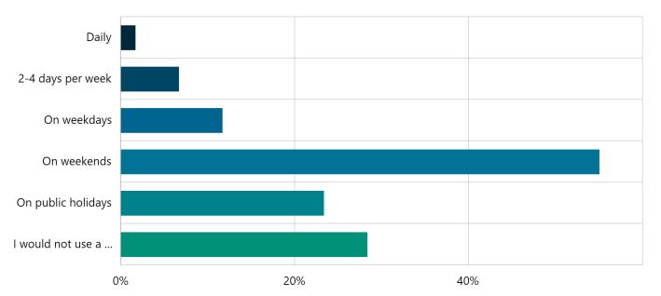

Areas that would benefit from mobile vendors, what kind of services and during what season

What area would benefit from new mobile vendor sites
Respondents recorded the 5 most popular areas for mobile vending sites as along the foreshore selected by 63.33% (38), around sportsgrounds 53.33% (32), close to playgrounds or older adults equipment 35% (21), in commercial/industrial areas 31,67% (19) and near dog parks 31.67% (19).
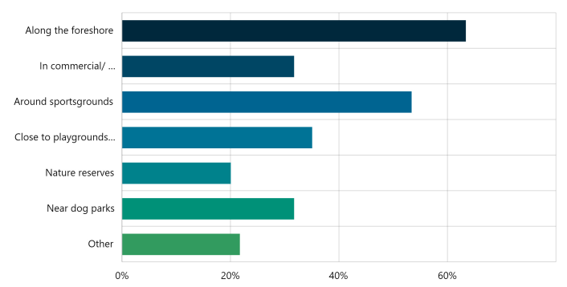

Mobile vendor services
The 3 most popular services respondents wanted to experience were food & beverages 68.33% (41), coffee 66.67% (40), and ice cream 46.67% (28).
Other suggestions included:
- Beach equipment - chairs and umbrellas.
- Something to encourage participation - pay to play games or equipment to learn a new skill.
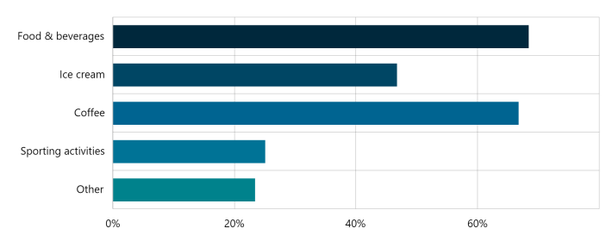

Seasonal mobile vending
Respondents suggested they would use a vending service in all seasons, summer 80% (48), winter 71.67% (43), autumn 66.67% (40), and spring 65% (39).
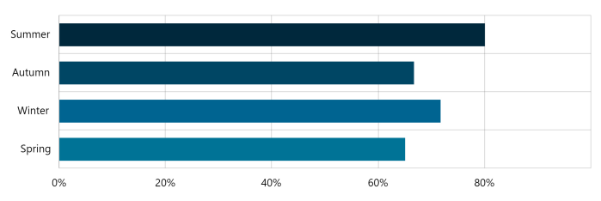

Item-specific feedback
Participants were given the opportunity to provide additional comments to help inform the draft of the policy. Comments provided by participants (62) and written statements (3) are themed and summarised below.

Table 6: Support and neutral feedback for mobile vending
Topic | Community feedback
Mobile vendors | Can be an excellent addition to events or places where events take place.  The mobile vendors will meld into existing facilities based off supply and demand.  Some cafes and facilities are closed during busy seasons, mobile vendors will provide goods and service when others are closed.  Services should only include food and beverages, not for other items such as equipment hire.  Vendors should be on rotation at the approved sites.  Should offer healthy choices.  A benefit as a resident to get to experience mobile vendors.  Currently not enough spaces for vendors to operate in.  A vendor near the Sandringham Life Saving Club would attract more people to this area.
Sporting clubs | The impact on sporting clubs revenue should be taken into consideration.
Litter | Important to ensure proper waste management. (3 mentions)
Proposal | Should allow vendors to include tables and chairs. (2 mentions)  The leases for the sites should be seasonal.  Power should be supplied at all sites as generators are loud and bad for the environment.  Vendors should be able to sub-let their spot when unable to attend the site.  Include disability parking adjoining the sites.  Include regular noodle markets or similar events in different locations.  Need flexibility to encourage mobile vendors to choose Bayside.  Traders should be allowed to set up mobile vending around activity centres.  The visual impact of the mobile units need to be considered.  Publish the locations of the mobile vendor sites on Council’s website.  Ensure that established vendors are not disadvantaged.  To activate these spaces, it is important to reduce speed limits and remove the major road status of Beach Rd as its currently unsafe to access the beach.  Avoid traffic congestion.  Ensure sites are not in residential areas.
Foreshore/Open space | Will improve the enjoyment of the beautiful parts of Bayside.  Coffee carts around parks etc would be fantastic.  More protected bike lanes.

Table 7: Opposition or concern for mobile vending
Topic | Community feedback
Proposal | Local business are already struggling and need support. (3 mentions)  There are already plenty of options for food and beverage in Bayside. (2 mentions)  What information influenced Council to consider using Council land this way.  To raise funds, most clubs run kiosk with voluntary staff.  Plenty of permanent food supplies with large overheads, Council should stick to their policies and support local traders.  Support local shops instead of mobile traders that don’t have large overheads.  Support local businesses instead of taking their income away.  Stop making it harder for the struggling traders.  An ice cream van or coffee cart is fine by the beach in summer, but we don’t need any more.  These vendors are attractive to day-trippers but not for residents living close by.
Foreshore/Open space | Leave our open spaces unspoiled. (2 mentions)  40 years ago, Council promised no more buildings or carparks on the foreshore.  Should consider how to extend and improve open space, not the reverse.  Don’t want to see open spaces and beaches commercialised.  The beach is for everyone and don’t need it cluttered up by vendors.
Survey | The season question should have included a “never” response. (4 mentions)  Make the survey neutral instead of inherently biased. (3 mentions)  The survey is poorly designed and doesn’t let residents have their say.  The survey assumes support and the available options didn’t allow to express my opinion.
Litter | Litter will increase. (4 mentions)

Areas of interest for new mobile business locations
Participants had the opportunity to drop a pin on a social map on the consultation’s HYS page to identify locations they would like experience mobile vendors. They also had the capability to identify what type of service they would like in that location.
41 social map submissions were received.
Many suggestions were focused along the foreshore between Brighton to Sandringham 70.73% (29). Bayside reserves were also popular locations 29.26% (12).
The 5 most popular services suggestion for the mobile vending locations were food & beverage 43.9% (18), ice cream 17.06% (7), sport equipment hire 9.75% (4), and dog wash 7.31% (3).
21.95% (9) respondents stated other, however there was no further data provided.


Project evaluation
The various consultation exercises that underpinned this community engagement were a useful set of tools to provide the community, key stakeholders, and other interested parties the opportunity to provide feedback to Council on drafting the Activation of Council Land Policy.
The consultation was widely promoted to the Bayside community with direct emails to HYS project subscribers, stakeholders, staff, and relevant community groups.
A campaign social media and an e-news story also promoted the campaign and the opportunity to provide feedback.
Of the 60 online survey respondents, 78% of those who provided a response reported that it was very or mostly easy to find and understand the information they needed to provide feedback for the drafting of the Activation of Council Land Policy. 7% of respondents reported the information was mostly hard or very hard to find and understand, and the remaining 15% reported the were unsure.

Performance summary charts
Chart 1: Overview of visitation and contributions during engagement period
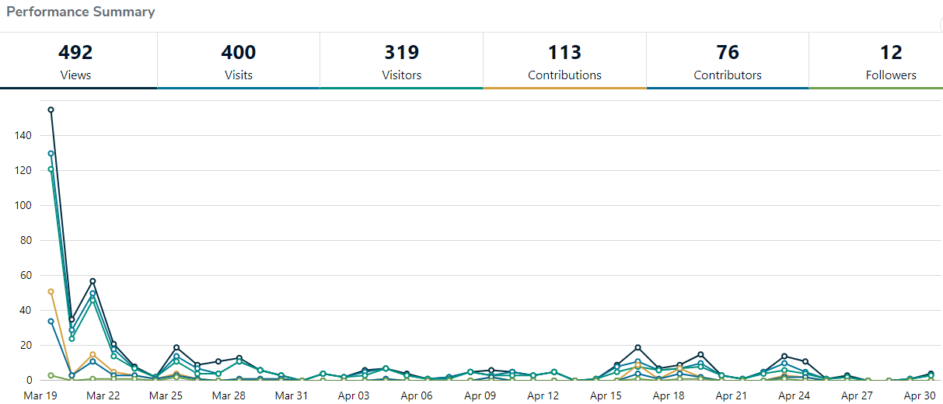
Chart 2: Conversions from visitation to engagement with the Have Your Say page
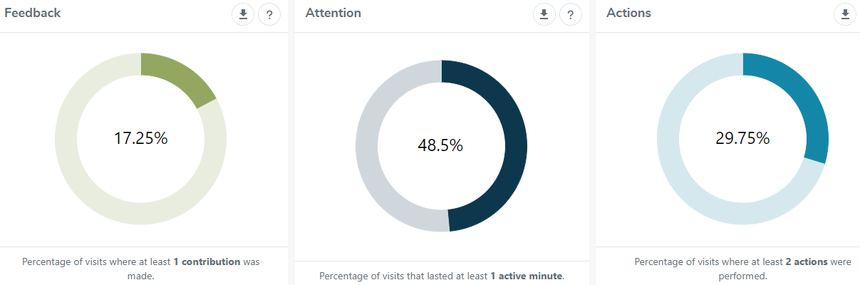
Chart 3: Acquisitions (how visitors found the Have Your Say page)
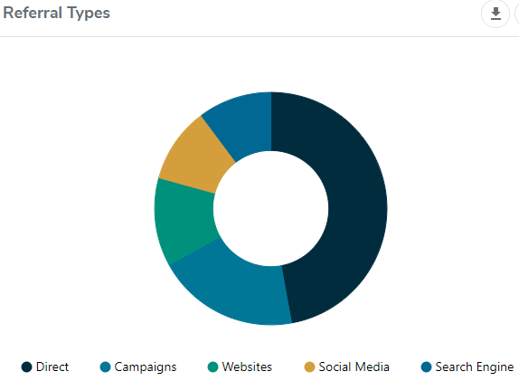
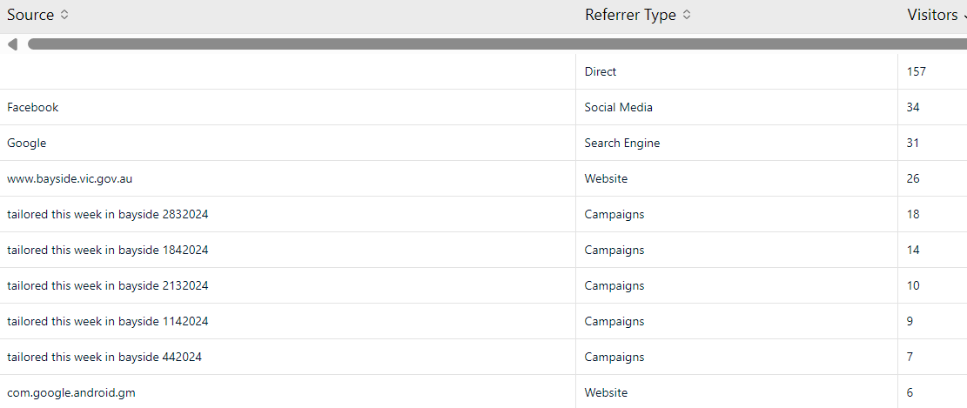

Appendix

Written statements

Written statement 1: Bayside resident
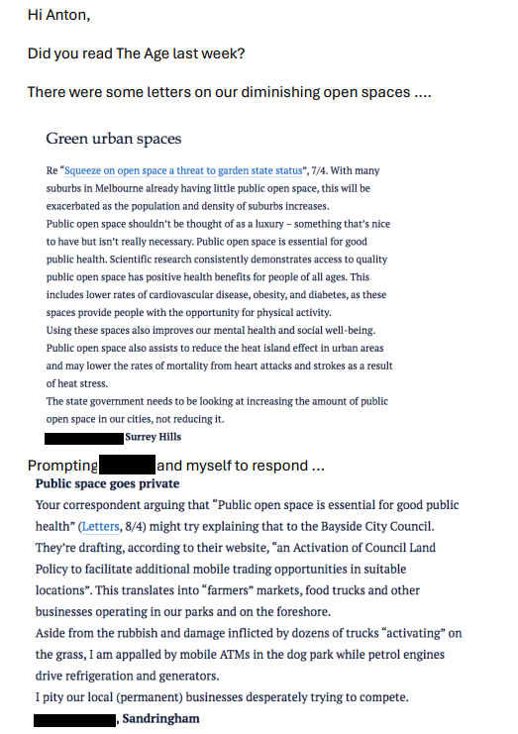
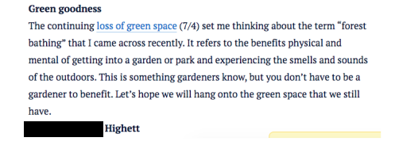
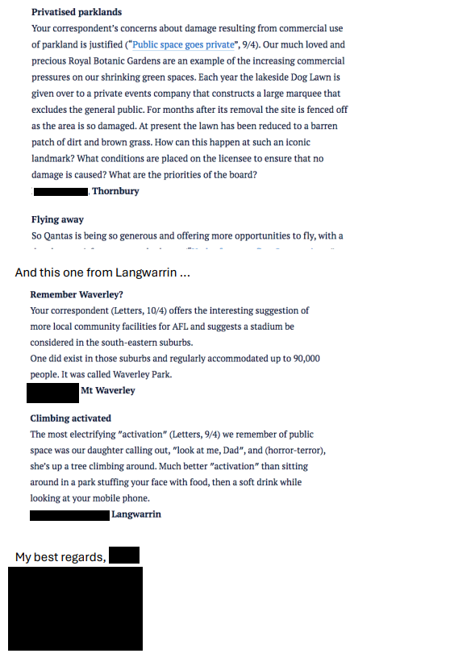

Written statement 2: Bayside resident
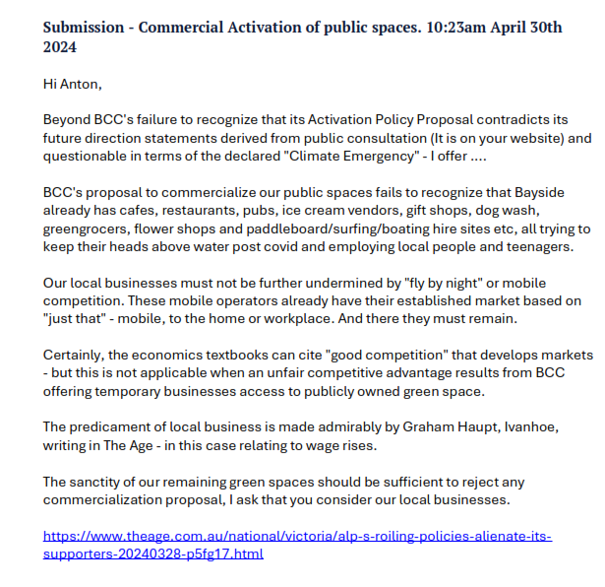
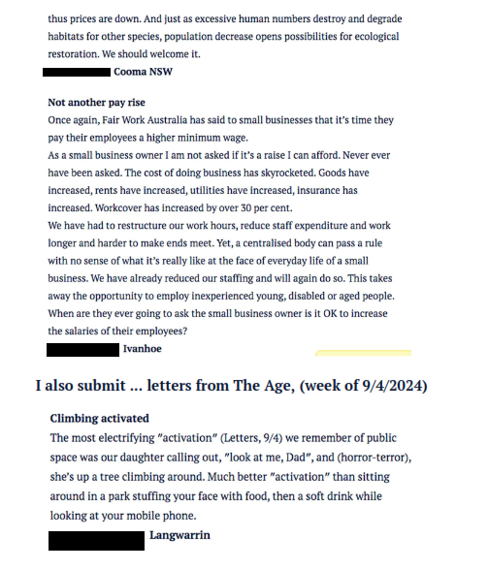
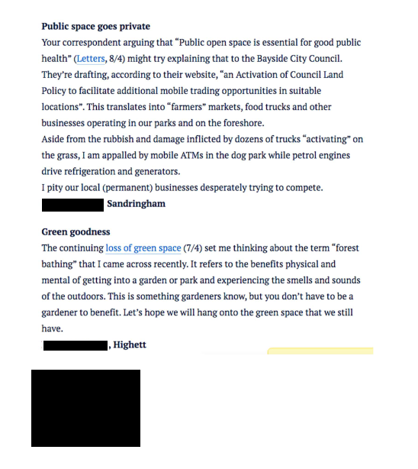

Written statement 3: Bayside resident
