Cheltenham Recreation Reserve playground

Community Engagement Report
August 2025

Background
This document provides a summary of stakeholder and community feedback on the concept design for the Cheltenham Recreation Reserve playground.
From Brighton to Beaumaris, Council is upgrading all 61 playgrounds in Bayside, guided by its Playground Improvement Plan.
Council seeks input from the community on how they would like to see playground(s) in their area improved or upgraded. We consult with the users of our playgrounds: the children and young people of Bayside, as well as local residents and clubs/groups. The feedback we receive helps develop a detailed design for construction.
Feedback is considered in line with available budget, site constraints, and recommendations of the Playground Improvement Plan.
About Cheltenham Recreation Reserve
We are upgrading the Cheltenham Recreation Reserve playground to create a fun, inclusive and nature-connected play space for children of all ages.
This district-level playground will serve a growing local community and reflect the distinctive character of the reserve. The design considers the broader passive recreation area and its connection to the rest of the reserve.
It will reimagine the current run-down playground, and incorporate existing features of local significance, including:
- Installing the relocated Cheltenham Station down building, which will provide shaded seating and views over the playground and sportsground.
- Restoring the historic steamroller, which will be integrated into the play space.
- Creating new seating and landscaping.
- Improving accessibility to encourage experiences that promote independence for people of all abilities.
- Use of natural materials to encourage an enhanced connection with nature.
- Planting indigenous plants to enhance biodiversity.
Early concept designs, which are the focus on community engagement, include a custom treehouse inspired by ewoks, misted water play, a climbing tower with slide, spinner bowl, spring rockers, sand play and two swing sets — including one designed to challenge older children.
Public toilets and car parking are not within the scope of this upgrade, though these elements have been considered in design planning to support future improvements.
The budget for the project is $935,000.
Next steps
The playground design will be refined using feedback from the community – particularly young local residents.
A Project Group, consisting of a cross-functional team of Council officers, evaluates and approves each final design against the objectives in the Playground Improvement Plan. Council will then tender for a playground builder.
Construction of this playground could commence in late 2025 – early 2026. Unless there are significant impacts to project scope, timing or budget, no formal decision-making by Councillors is anticipated given the project budget has already been approved through the budget process.

Consultation process

Consultation purpose
The purpose of this consultation was to:
- Gather community feedback on the draft concept design for the upgraded playground.
- Ensure inclusivity and accessibility, with features catering to children of all ages and abilities.
- Understand sentiment around the incorporation of heritage elements such as the historic steamroller and the relocated Cheltenham Station down building.
- Support genuine community influence on the final layout, features, and play elements.

Consultation methodology
Community engagement was undertaken between 14 July and 10 August 2025 to inform the playground design. Around 188 people participated.
A range of tools were employed including a quick poll for immediate feedback, a participatory budgeting “fund it” tool to select preferred design aspects, and an online ideas board. All tools were replicated for the in-person engagement sessions on site.
The tools and techniques selected for this project were informed by the project content, stakeholders and type of feedback sought. For this engagement, tools were selected to provide transparent, instantly visible results and ease of use for young people.
Details | Activity
14 July – 10 August  1,427 views  744 visitors  223 contributions from 136 contributors | Have Your Say website project page  Online engagement through Have Your Say, including interactive map of the proposed design.  Engagement tools included:  - Quick poll (79 contributions)  - Equipment preference selection tool (55 contributions)  - Ideas board (89 contributions)  - Q&A forum (0 contributions)  - Printed survey (0 contributions)
19 and 26 July  51 attendees | Onsite community drop-in sessions  Saturday 19 July: 9am – 10:30am (14 attendees)  Saturday 26 July: 10am – 11.30am (37 attendees)*  *Attended by Ward Cr Leigh
14 July – 10 August | Correspondence  - 1 direct email came through to Recreation Projects team.

Key tools for communicating the project
- Have Your Say project page including interactive map of the proposed design
- Signage (with QR codes linking back to the engagement activities) at the playground
- Flyer (800+) letterbox dropped to local residents
- Two drop-in sessions at the playground
- Social media, especially 'sponsored' posts to increase audience reach
- Council website news stories
- Council's e-newsletter This Week in Bayside
- Email notification to Have Your Say registered members, playground project subscribers and key stakeholders.
- Council's e-newsletter This Week in Bayside.

Participant profile
A high proportion of young people and families contributed to the ideas board (89) with 17% aged under 9; 7% between 10 – 15 years and 58% between 25 – 49 years. Gender was not asked as it was not considered relevant to this consultation.
Targeted communications ensured those with a connection to the site contribution to the engagement program.
Stakeholder / community | Impact | Interest | Influence
Playground users, considering children and their parents/guardians | H | H | Consult
Immediate local residents | M | M | Consult
Broader Cheltenham and Beaumaris residents | L | M | Consult
Users of the open space or community facilities surrounding the playground, including;  - Cheltenham Football Netball Club  - Cheltenham Cricket Club  - 4th Cheltenham Scouts & Cubs | H | H | Consult
People with disability | M | M | Consult
Local early years providers, including schools | L | M | Consult

Consultation findings
The following section summarises the key themes which arose in community feedback on the Cheltenham Recreation Reserve playground design. In the interest of stakeholder and community privacy, individual quotes are anonymised. Where there was more than one mention of a topic or item, the number of mentions has been specified in brackets and italics.

Support for actions
79 respondents participated in the quick poll activity, which measure overall sentiment about the concept design.
Overall support for the concept design was very positive with 67% (53) selecting it looked “Super fun – I can’t wait to play!” and a further 16% stating it’s “Pretty fun – looks like a great time. 14% thought “It’s okay – maybe needs more cool stuff, while just 3% said “Not very fun – I’d rather play somewhere else.
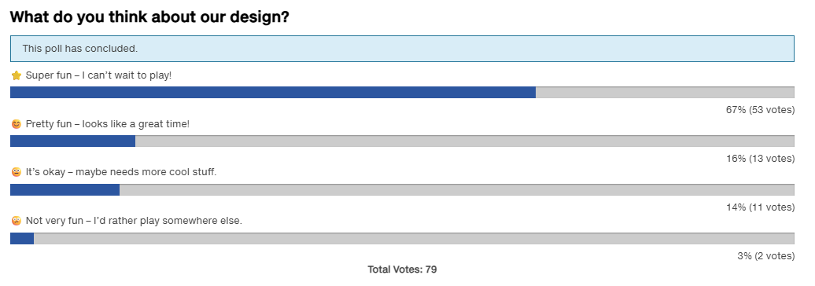
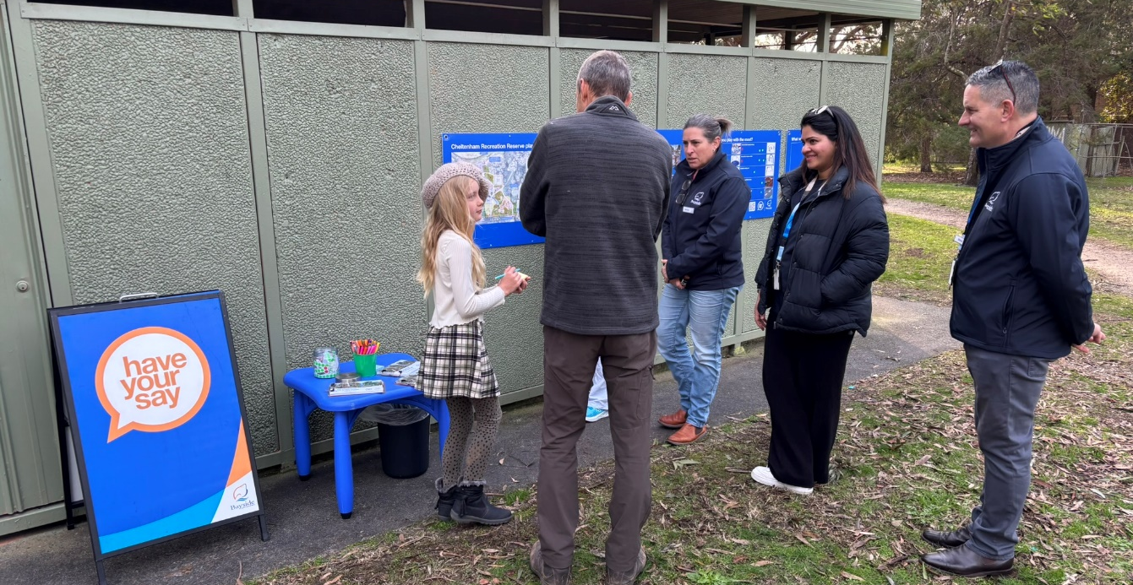
The drop-in sessions also recorded very positive feedback with 11 people participating in this activity: 10 participants said it was “super fun” while 1 participant said it was “pretty fun”.

Concept-specific feedback

Play elements
Online participants were invited to ‘like’ individual aspects of the concept design via a participatory budgeting “fund it” tool. Aspects tested were primarily play equipment, with 55 individuals participating. All elements were supported, with very strong support recorded for the treehouse play structure, incorporation of existing trees and water misting arches.
All participants selected at least half of the proposed equipment.
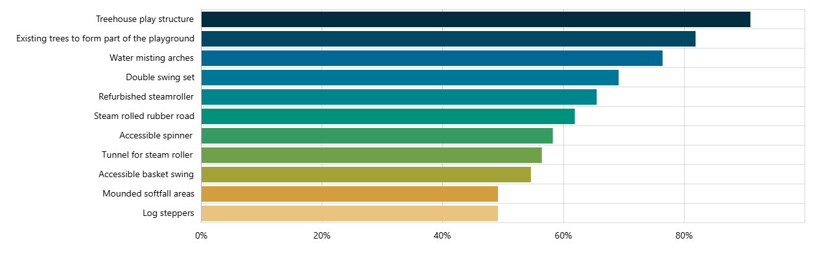
Results were similar during the two drop-in sessions:

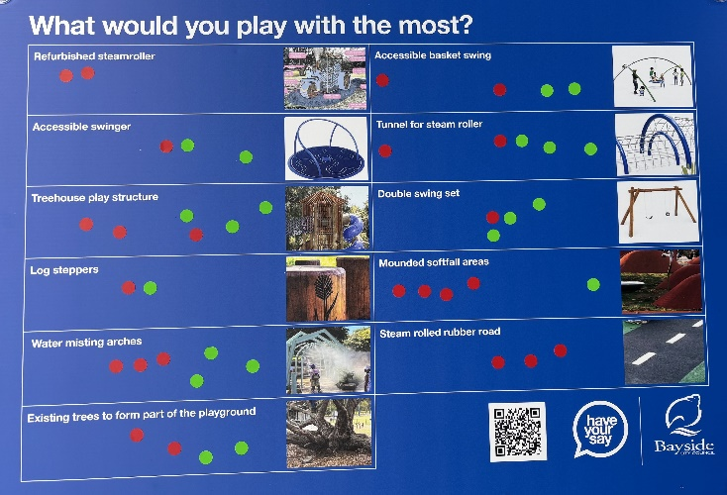
Left: Example of dotmocracy board at in-person sessions. Red dots were for adults and green dots for children.

Suggestions to improve the design
We received 102 suggestions for how to improve the design across engagement activities.
A digital ideas board enabled participants to provide suggestions of “What would make this playground even more fun”. The board attracted 89 posts from 70 contributors.
Posts were tagged against in three categories: ‘Equipment’ 56 (63%); Design/layout (30%, 27) Landscaping (7%, 6).
The most common theme was specifically advocating for bike infrastructure (25, 24%) such as a pump track with jumps, noting that Tulip St pump track needs upgrading and these facilities are seen as lacking in Bayside.
Participants (13) at the two face-to-face sessions also contributed ideas to a poster ideas board. These suggestions have been reported with online submissions in the tables below.
Table: primary theme of comments

A range of specific concerns were raised during the consultation regarding this item. All comments are included verbatim. Comments have been reported by primary theme but may reference several themes.
Topic | Community feedback
Bike infrastructure (25) | Scooter/bike pump track would be amazing!  Bike and scooter track. It’s much needed! Tulip st is unsafe 50 year old infrastructure.  We would love to see a pump track built like the one at Windsor siding. This would help prevent kids building their own dangerous jumps  A scooter pump track for younger to older kids.  What about kids bike infrastructure? My son would love a pump track.  A pump track is a great idea. High fences too please.  Kids want Bike Pump Track / MTB tracks or sim - note multiple responses supporting this option Bayside Council please listen this time  Seems one person has too much time and is downvoting it a lot. But bike/scooter facilities please!  Off-road cycling facilities are much needed in bayside. Wangara Rd was overlooked and Tulip st hasn't been upgraded. Please build something.  Space for kids to safely ride bikes and scooters with some more challenging areas like hills and bumps  For the love of god, please put in a pump track or mtb skills course.  A bike track with jumps etc  A bike pump track or a track for scooters  Walk over &amp; look at what the kids are building next to the girl guides hall, bike jumps, they are desperate for jumps and a pump/skills park  A bike pump track for kids  Bike track or a pump track.  A pump track or compact dirt bike riding section for kids to learn safe bike handling skills  A pump track would be really good, it really is something where kids and parents can play and be active together.  The steam rolled rubber track could easily be switched to a small pump track  Put a pump track in please!!!  A decent sized scooter/bike pump Track. There is nothing in the area like it and this would be a great location  It would be cool to have a bike pump track!  Please put some bike facilities in, like a pump track. The one is Windsor is amazing.  A pump track for kids to ride their bikes on. Bayside continually overlooks this as an option despite every other council putting one in.  Track for bikes
Older kids / Teens / Outdoor sport & fitness (12) | Bayside seriously lacks an outdoor gym (nearest is Reg Marlow, Kingston) &amp; beach volleyball court (nearest is Mordialloc, Kingston) for all ages  Ninja warrior course, rock climbing walls and a basketball court for older kids  Sue Kirkpatrick very close by for toddlers. This park draws older kids/ teens looking bored. Make it more challenging/ exciting for them pls  Parkour, Ninja, Exercise gym, Playground for youth not just early childhood., Big adventure, Most local playgrounds are for early years only  It would be fun to have some in ground trampolines and some parkour activities for older children/ tweens. A picnic area w sensory garden to  "My 11yo says: Pump track, rock climbing wall and ninja obstacle course.  Looks fantastic but older kids in area need more to do."  More play equipment for older children ie Ninja aspects to invite children to continue to immerse themselves in play beyond the early years.  Beach Volleyball court to make it a cross generational play area  Basketball hoop/netball hop with surfaced area, wheelchair accessible swing, multi-aged swings, water play.  What a waste of money. These funds should be put toward alternative forms of play geared toward other age groups. This park is perfect as is.  Two playgrounds connected  Chin up bars adults
Toilets, picnic/BBQ, shade & shelter  (12) | Picnic areas/seating areas with shade would be good.  It would be even better to have a rejuvenated picnic area with modern toilets, dining area and new dual BBQs, the outdoor area would be great  Why don't you use the Cheltenham train station heritage building as new toilets/change rooms? The current toilets are filthy &amp; need upgrade  Some additions: Trampoline; Undercover table for kids bday parties; sandpit integrated with water feature; zip line  Please upgrade the toilets! So that families and their children can actually use them.  more toilets and a flying fox please & lots more trees  A shelter just in case it rains.  I like the bicycle parking and the covered BBQ area and the toilets. These are great for people who want to walk and ride to the playground.  Please don't take away the flying fox! As much shade as possible and toilets.  Lots of shade canopies to keep us sun safe! So many local playgrounds are just too exposed in the Aussie Summer  Monkey bars, climbing frames/nets, lots of shade  Shade is desperately needed for summer accessibility
Specific play features (zip lines, trampolines, monkey bars, etc.) (12) | Spinning hamster wheel  My 7y.o says: I love the tree house! Can you please add a tree top walk too? And a zip line and wobbly bridge?  A zip wire would be great too  Add a Zip line, tremendous fun.  Monkey bars/hanging or climbing equipment, Bike track  Hard to tell from the pics but is there monkey bars? These are great for older kids and should have a little step up for the younger ones  Swimming pool  Big swing - if you fall backward you fall on cushion  Hamster wheel  Climbing wall  Love every bit of the design - it's perfect!  Consider muted pastel colours (not reflective) for neuro-diverse children
Toddler-friendly & creative play (11) | Love all the ideas from others to make this friendly for littlies. My two love the swings already and are excited by a tree house!  Not just a big novelty structure, but also congregational areas for children on the ground such as in Lincoln Square South, Hansen Reserve  We understand kids want pump track (my older son does). But we want a playground for little kids too. We waited 5 yrs for playground.  Safe climbing area for young toddlers with a small slide. A sandpit with trucks and diggers. A bridge. A music making area with xylophone.  Fenced enclosure; smaller slide and play gym for littlies; creative play area (shop/stall front); bbqs; shade sail  Agree with others, lots of bike infrastructure nearby (Tulip St &amp; Bay St jumps, foreshore bike path). e need creative play for littles here.  There are bike jumps on nearby Tulip Stthis area really needs more toddler-friendly play spaces, sandboxes, swings, slides, etc.  Wide slide for smaller age children, often slides are too high or feel too narrow that my little one will fall out.  It would be great to include a double slide like the park on Hanby Street, and a section that is more toddler friendly, not just bigger kids  enclosed area for toddlers/babies to be safe and away from the older children . Where parents can sit and watch them play safely.  It was hard to see in the images but making sure the lower slides can be accessed by a crawling baby.
Heritage preservation (Cheltenham Station, chimneys, plaques) (10) | I'm very pleased the 'old' Cheltenham railway station is coming back to where it belongs.  I almost missed the Down Bld was supposed to be the station - where are the heritage chimneys?  The design is good but as others have said the heritage station building must to be included and a plaque would be very useful.  Thanks for preserving our history for the next gen (steamroller, train station). Please put them together have a plaque explaining their sig  Please ensure the original Cheltenham Station building is looked after and appropriately signed with an added plaque.  Maybe it's the artist's impression, but the Down building looks more like the Up one. Where are the heritage-listed herringbone chimneys?  The Down Building looks nothing like the heritage-listed original. What happened to the chimneys? You promised a full restoration!  the station looks a bit basic. where are the original chimneys? it needs to be rebuilt as it was.  Where's the heritage Cheltenham station building in this design? Bayside Council said it would be included-really disappointed it's missing!  Wasn't the old Cheltenham station building meant to be part of this design? It's tie in nicely with the vintage steam tractor.
Water play (misting) (7) | Swing set with at least 4 swings, water play like a sprinkler version and not just mist for summer, flying fox and inground trampoline  Lots of water play activities and a water tap/fountain similar to Tjilatjirrin reserve that feeds into the sand pit. Well shaded please!  Swap the water mist with water play pumps and channels. Include a scooter track, trampoline and sand pit. Ensure fencing around perimeter.  Kids seem to enjoy running water more than mist spray which is only useful on a hot day. Could also include creative play eg sandpit  Water misters would be amazing to include! Such little water based playgrounds in Bayside.  Interactive combined sand &amp; waterplay area (water table, pumps, channels) would be far more beneficial &amp; engaging than misting arches.  Water play area like at Botanical gardens children’s garden
Natural environment (6) | Hopefully no trees or vegetation will be lost or destroyed. Keep toxic materials like that crumbed rubber surfacing that degrades quickly Please don't fell any mature trees like you did at the Yalukit Willam so-called 'Nature Reserve!  Make a dense, child-safe green barrier for the road pollution ( esp. NO) w/ Westringia, Little John &amp; Correa reflexa  Indigenous plans including tall shrubs to block wind  Wattle or Black Sheoak trees
Safety & fencing (4) | As I am a grandparent it is important that there is safety fencing and childproof gates especially as it is on a busy road.  Appropriate fencing along Weatherall is important (high enough and enclosed). Thank you for getting this 5 yr delayed upgrade started!  The design replaces the 2m fence to Weatherall Road with a low fence and large entry gap. This is dangerous next to busy Weatherall Road  Weatherall Road safety - need locked gates and secure pedestrian entrance
Dog management (2) | Forget the redesign: I won’t let my grandchild play here until Council enforces resp dog ownership. The amount of dog waste is disgusting!  Please allow places for dogs to be tied up (either inside or outside the enclosed area). please do not plant any of the spiky bush plants
Parking & access (2) | How is this supposed to work? There’s already no parking for miles on weekends because of the football, and you’re saying no new car parks??  Carparking is a concern

Ideas board voting
Participants were able to up or down vote other participant’s suggestions on the online ideas board. There was extremely high participation in this forum with 2,366 votes recorded – an average of 26 per post. This saw very strong support for the incorporation of the Cheltenham down station building, including preservation of its distinctive features.
Table: Top five posts by up votes

Table: Top five posts by total votes

Project Evaluation
The consultation for the Cheltenham Recreation Reserve playground upgrade successfully met its purpose of gathering community input on design improvements.
Engagement activities included online tools, pop-up sessions, and visual boards, which encouraged feedback on inclusivity and play features. While participation targets were not explicitly set, community interest was evident through contributions on the Have Your Say page and at in-person sessions.
Communications via social media and local networks were effective, and timing and coordination of pop-ups with sporting club activities at the site required careful planning.
The results from all digital engagement activities are published on the project homepage: https://yoursay.bayside.vic.gov.au/CRRplayground
Chart: Visitation to the Have Your Say project page during the consultation period.
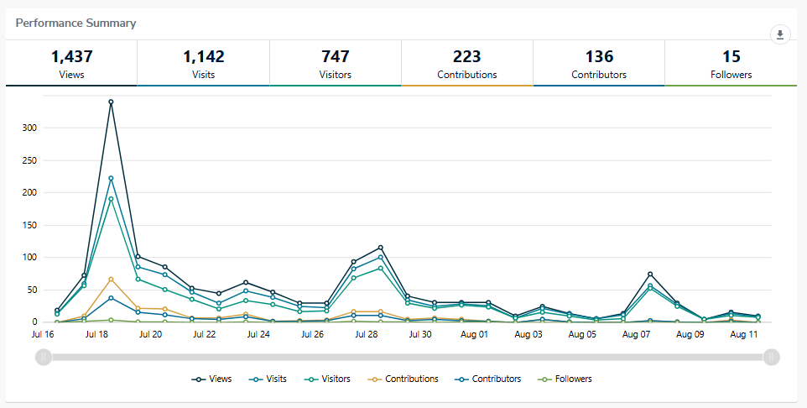

Chart: Engagement with the Have Your Say project page
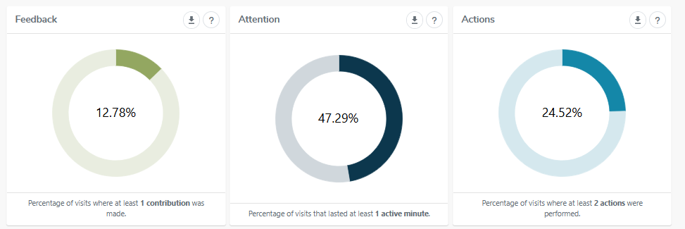

Below: Photo of in-person consultation sessions
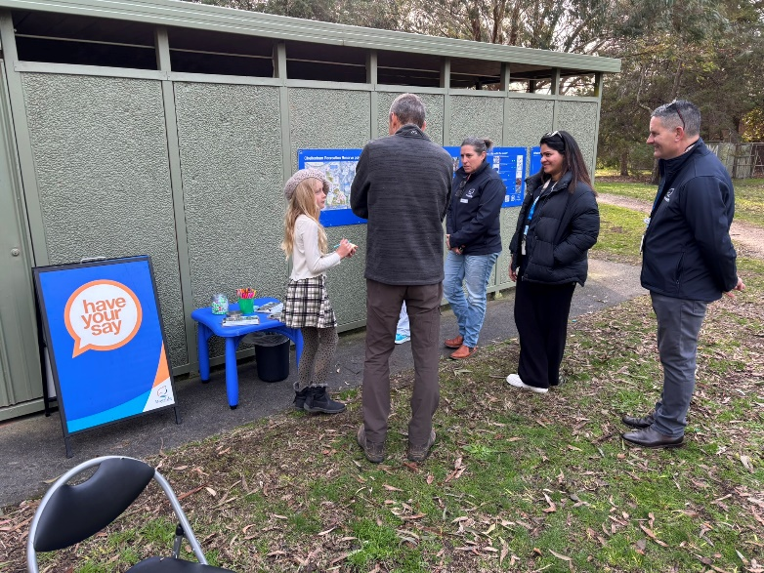
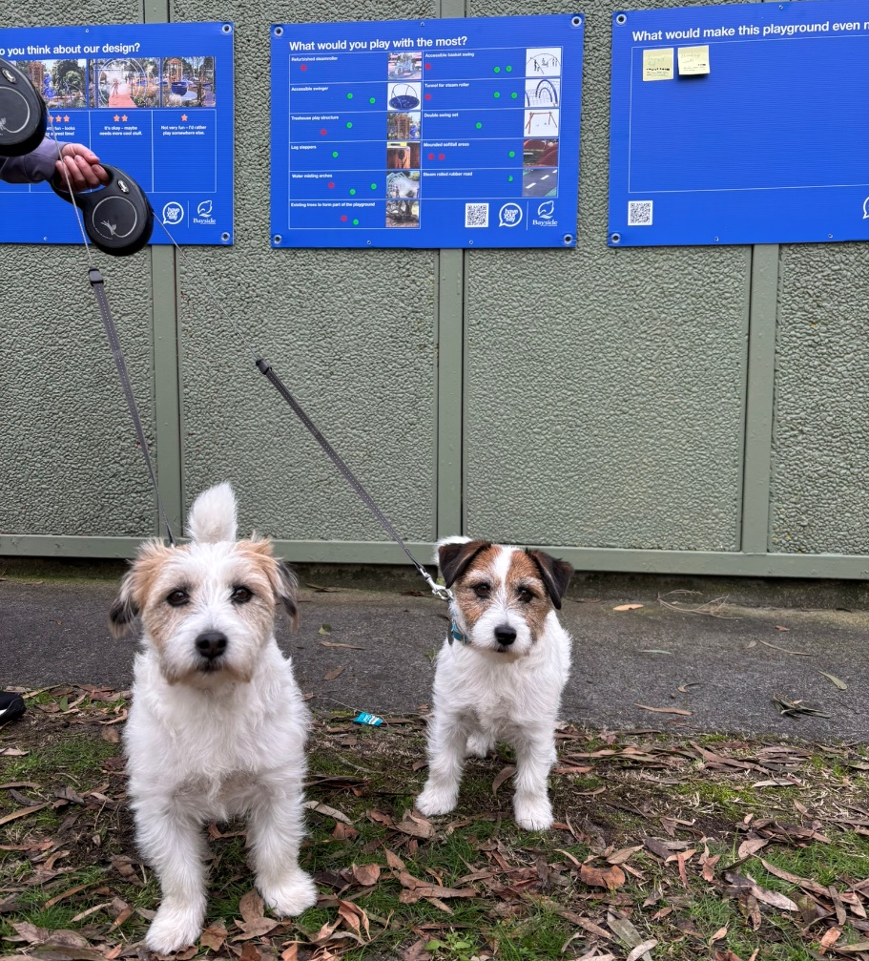
The pop-up session attracted quite a few local dog walkers, and many visitors to the public toilet.

