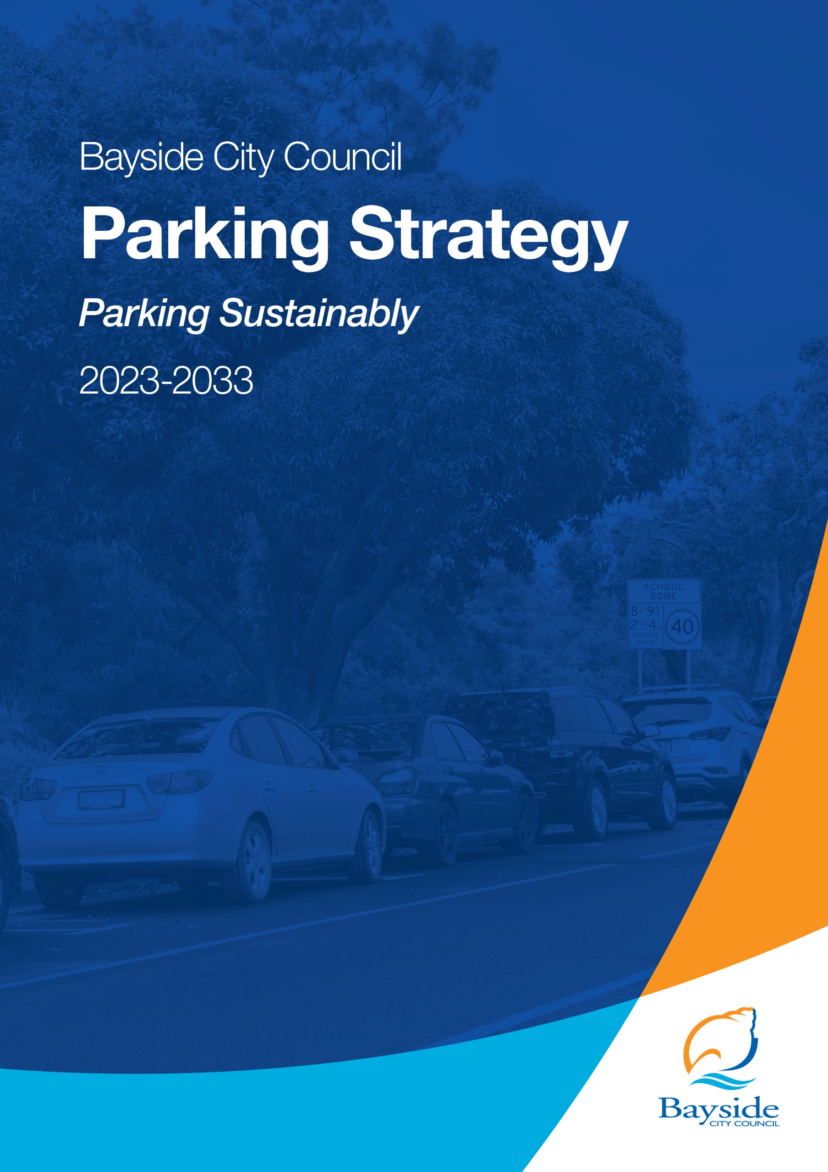
Parking Sustainably

Table of Contents
1. Executive Summary 4
Purpose 4
Scope 5
Key principles 5
Vision statement 6
Strategic objectives 6
2. Introduction 7
3. Scope 8
4. Background 10
5. Key Issues and Findings 19
6. Construction of New Car Parking Facilities 20
7. Managing Parking in Bayside 20
Overview 20
Parking Management 21
On-street User Hierarchy 21
Parking Management Options 30
Accessible Parking 33
Parking Permit Systems 34
Paid Parking 37
Efficient Operations 38
Enforcement 38
Smart Parking and Signage 39
Emerging Technologies 41
Electric Vehicles 41
Car Share 47
E-scooter/E-Bike Sharing 50
Bicycle Parking 54
Development Parking Provision 55
Car Parking Rate Requirements 55
Green Travel Plans 57
Place-making and Car Parking 59
Ownership of Parking (unbundling) 60
8. Action Plan 61
9. Cost to Deliver Strategy 67
10. Monitoring and Evaluation 67
11. Appendix 68

Bayside City Council proudly acknowledges the Bunurong People of the Kulin Nation as the Traditional Owners and Custodians of this land, and we pay our respects to their Elders past, present and emerging.

Executive Summary
Introduction
The Bayside Parking Strategy has been prepared to guide Council in the effective management of parking resources, both now and into the future, in line with Bayside 2050 Community Vision, Theme for Transport – “Bayside will support provision of effective, sustainable and inclusive transport services and infrastructure”.
It is recognised that this Strategy forms one of a suite of strategic documents implemented to address different modes of transport within Bayside and how they can collectively improve transport outcomes under the guidance of Council’s Integrated Transport Strategy 2018 – 2028.
Council has developed this Parking Strategy to ensure that it meets the needs of the community and provides the guidance that is needed to balance competing demands relating to transport, sustainability and the local economy.
Structure of the Strategy
The Strategy identifies the vision, principles and objectives that will guide the management of parking in Bayside. It also outlines the priority actions to be undertaken to achieve the objectives and the measures that will be used to assess the success of the strategy.

Purpose
Council does not currently have a Parking Strategy. As such, parking objectives and processes can be inconsistent and dependent on the context and issue. This impacts on parking operations, supply, enforcement, priorities, and the delivery of public infrastructure across the municipality.
The development of a Parking Strategy for Bayside will help to establish a coordinated, consistent, and transparent approach for the provision and management of car parking across the municipality both now and into the future. It also seeks to provide strategic support rather than reactive approach towards the management of parking in Bayside.
The development of the Bayside Parking Strategy is an action of:
- Bayside Integrated Transport Strategy (ITS), Action 62: Develop a municipal wide Parking Strategy, and
- Bayside’s Disability Action Plan, Action 4.3: Develop and Deliver Bayside’s Parking Strategy with a Review of Accessible Parking.
Additionally, parking is underpinned by various State and Local Policies.

Scope
This Parking Strategy provides an understanding of parking-related challenges and issues specific to Bayside and responds with a series of strategic objectives and actions which will guide the management of parking now and over the next 10 years.
Reference to existing data from the local area has been included to provide insight into the existing opportunities and constraints in relation to parking in Bayside. Examples of local and international best practice, including relevant case studies, have also been presented to provide context to the recommended actions in response to Bayside’s needs.
Council’s role
Parking is an asset that is managed both publicly and privately.
Council is responsible for managing local parking arrangements, including the management of public parking facilities, allocation of on-street space and parking restrictions, enforcement of parking regulations, management of parking permit schemes and administering the statutory planning process. Council is also responsible for advocating to external stakeholders, including the State and Federal Governments, on behalf of the community.
Parking provision rates associated with new and expanded developments are defined by the Bayside Planning Scheme Clause 52.06 – Car Parking. Any proposed amendments to the Bayside Planning Scheme to support new policy direction including variation to parking provision rates can be requested by Council but must be justified and follow a statutory process set by State Government. The Minister for Planning has the ultimate authority in approving changes to the Planning Scheme.

Key principles
This Strategy is based on the following guiding principles:

Manage parking as a finite resource
The supply of car parking is limited by the availability of public space (including adjacent land), and the need to provide for different uses within the road reserve. As such, the management of car parking will be approached as a shared and limited resource.

Protect the environment and amenity
Parking Policy will support a shift to sustainable travel modes and minimise the environmental impact of cars and car park facilities.

Ensure social equity
Car parking will facilitate access to places and people for Bayside’s community and will meet the needs of those who must travel by car, particularly people with special access requirements.

Balance modal priorities
Roads have a primary movement function, and on street car parking competes with this. People move in different ways and by a variety of modes including pedestrians crossing the road, bike riding, public transport and car. There is a need to dedicate space to important activities such as loading, bus stops or disabled parking.

Support the local economy
Car parking can play a supporting role in the success and vibrancy of the local economy, in particular within activity centres. On its own, parking management is not the answer, and should be considered as part of the broader economic, transport and liveability objectives for Bayside.

Vision statement
Council will maximise the utilisation of existing parking resources to ensure sufficient parking opportunities are available for those who need it whilst also promoting sustainable transport modes that are inclusive for all within the Bayside community.

Strategic objectives
Strategic Objective 1: Parking Management
The management of on-street parking resources will be maximised so that sufficient parking opportunities are available for those who need it.
Strategic Objective 2: Efficient Operations
Ensure parking operates efficiently through signage, enforcement and smart technology.
Strategic Objective 3: Emerging Technologies
Consider the impact that existing and emerging technologies will have on public parking space and make provision for incorporating these technologies across the municipality, including electric vehicles, car share, driverless cars and E-scooter/E-bike sharing.
Strategic Objective 4: Development Parking Provision
Ensure that new developments provide appropriate levels of parking whilst also having consideration for other modes of travel, including access to e-vehicle charging stations.

Introduction
Parking plays an important role in Bayside’s transport system, supporting trips that are required to be made by a wide range of vehicles, including private cars, delivery vehicles and tradespeople. Travel by car is the most common means of transport in Bayside with around 74% of residents travelling to work by car (ABS Census, 2016) and approximately 16% of households owning three or more cars (ABS Census, 2021).
A steady increase in population and affluence has led to an annual growth in private vehicle ownership in Bayside of 1.9% (on average) over recent years. If this trend continues, there will be an additional 20,000 private vehicles competing for road and parking space in Bayside over the next ten years (ABS, 2017).
As highlighted within Council’s Integrated Transport Strategy 2018-2028, providing additional capacity through more road space and parking is not a sustainable solution to this issue as the increase in trips arising from a growing population and increasing vehicle ownership will continue to outpace road capacity.
Bayside City Council acknowledges that car parking will need to continue to be provided within the municipality to support those who need to travel by car. However, a move towards a focus on ‘Parking Sustainably’ recognises that the management of car parking can play a key role in influencing car travel and contributing to sustainable transport goals, through:
- Avoiding over-provision of parking
- Managing the existing asset so it can be used by many users’ groups
- Encouraging turnover and prioritising other transport modes
- Improving the efficiency of the parking asset in its use through the provision of information, enforcement and technology.
The Bayside Parking Strategy – Parking Sustainably has been prepared to guide Council in the effective management of parking resources, both now and into the future, in line with Bayside’s 2050 community vision for transport, walkability and rideability – ‘Bayside will support provision of effective, sustainable and inclusive transport services and infrastructure’.
Council has developed this Draft Parking Strategy to ensure that it meets the needs of the community and provides the guidance that is needed to balance competing demands relating to transport, sustainability and the local economy.

Scope
This Draft Parking Strategy sets out the parking-related challenges and issues specific to Bayside and responds with a series of strategic objectives and actions which will guide the management of parking now and over the next ten years.
Reference to existing data from the local area has been included to provide insight into the existing opportunities and constraints in relation to parking in Bayside. Examples of local and international best practice, including relevant case studies, have also been presented to provide context to the recommended actions.
It is recognised that this Strategy forms one of a suite of strategic documents implemented to address different modes of transport within Bayside and how they can collectively improve transport outcomes under the guidance of Council’s Integrated Transport Strategy 2018 – 2028, as presented in Figure 3.1.
The Parking Strategy will guide future updates to the Policies and Guidelines which underpin the Strategy, including the Residential Parking Scheme Policy, Foreshore Parking Permit Policy, Managing On-street Car Parking Demand Policy and their relevant Guidelines.
Figure 3.1: Transport in Bayside
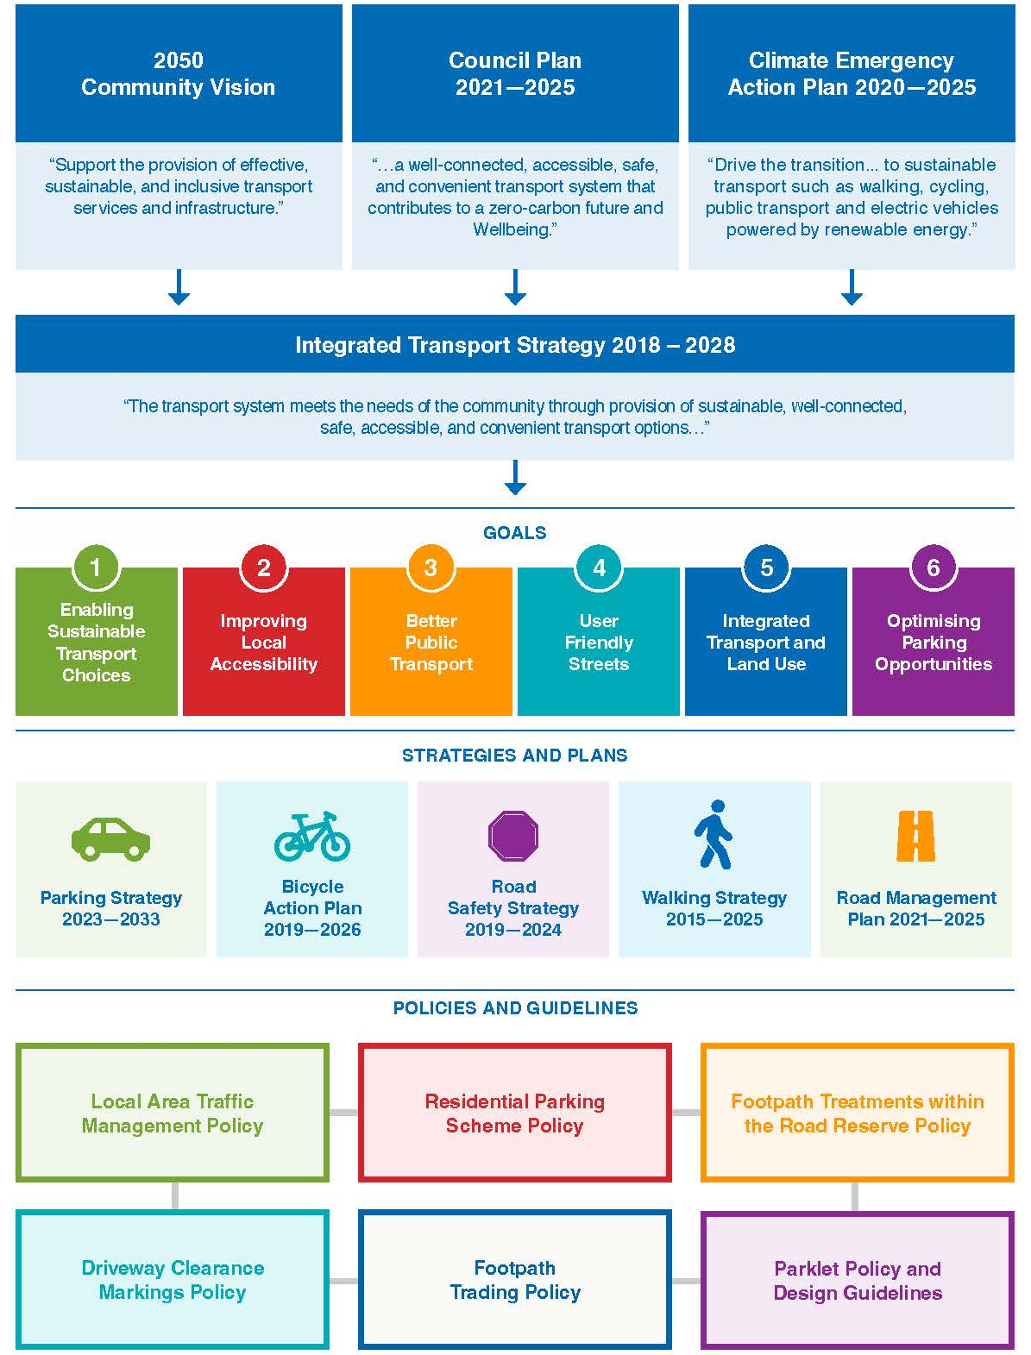

Background
Demographics
Australian Bureau of Statistics (ABS) census data can be used to provide an understanding of the population of the City of Bayside, including how old people are, how they live and how they travel.
How old are we?
As of 2021, the population of Bayside was 102,337 persons. The population of Bayside is expected to grow by about 10% between 2021 and 2033.
The current population includes a higher proportion of children (under 18) and a higher proportion of persons aged 60 or older than Greater Melbourne, with fewer young adults aged 25 to 34 years.
The demographic profile of Bayside is predominantly skewed towards older age profiles (median age of 44 years) with many residents consisting of older working professionals and retirees. As Bayside grows, the largest increase in population growth in Bayside (2016 to 2026) is expected to be in ages 75 to 79.
How do we live?
As of 2021, Bayside residents were living in 43,103 dwellings with an average household size of 2.5 persons per dwelling. This is a slightly higher average household size when compared to the nearby municipalities of Kingston (2.46) and Glen Eira (2.43). The proportion of medium and high-density dwellings in Bayside is 38.8%, which is lower when compared to each of the surrounding areas of Kingston (42.3%), Glen Eira (54.3%) and Port Phillip (90.9%).
Population density can influence the trip choices of residents of an area in that more densely populated areas are likely to have shorter travel distances to services and transport, making them more viable for active travel. In 2021, Bayside had a population density of 2,752 persons per square kilometre, which is significantly lower than the surrounding municipalities of Glen Eira (3,897 persons per square kilometre) and Port Phillip (5,029 persons per square kilometre), whilst Kingston has a lower density of 1,747 persons per square kilometre.
The Bayside Housing Strategy 2019 identifies that the City of Bayside will need to provide approximately 422-541 additional dwellings per year to support the forecast population growth. The largest growth is expected in Cheltenham and Highett, with growth of approximately 68% through to 2041. Hampton, Hampton East and Sandringham are the next largest, with over 40% expected growth during this time.
Between 2021 and 2033, the number of dwellings in the City of Bayside is expected to grow by approximately 13%.

How do we travel?
ABS Census data indicates 56% of households in City of Bayside have access to two or more motor vehicles with approximately 95% of all households owning at least one vehicle. There are 14,191 residential parking permits issued to eligible residents of Bayside, representing one permit for every three dwellings (noting that not all dwellings are eligible).
Figure 4.1 shows a comparison of car ownership characteristics with surrounding municipalities.
Figure 4.1: Car Ownership Characteristics

On Census Day 2016, 16.5% of journey-to-work trips by residents of Bayside were by public transport, which was higher than the results for Greater Melbourne (15.4% of trips by public transport). Other modes include 2.8% of people walked to work (walking as a single mode) and 2.3% travelled by bicycle.
However, most journey-to-work trips were made by a private vehicle, with 77% of trips undertaken as either a car driver or passenger. Public transport use is also higher for residents of Bayside when compared to workers where Bayside is the place of employment.
When compared with surrounding municipalities, vehicle travel for journey to work trips for Bayside residents and employees is lower than Kingston but higher than Glen Eira and Port Phillip as presented in Figure 4.2 and Figure 4.3.
Figure 4.2: Bayside Journey-to-work Place of Residence (Census 2016)
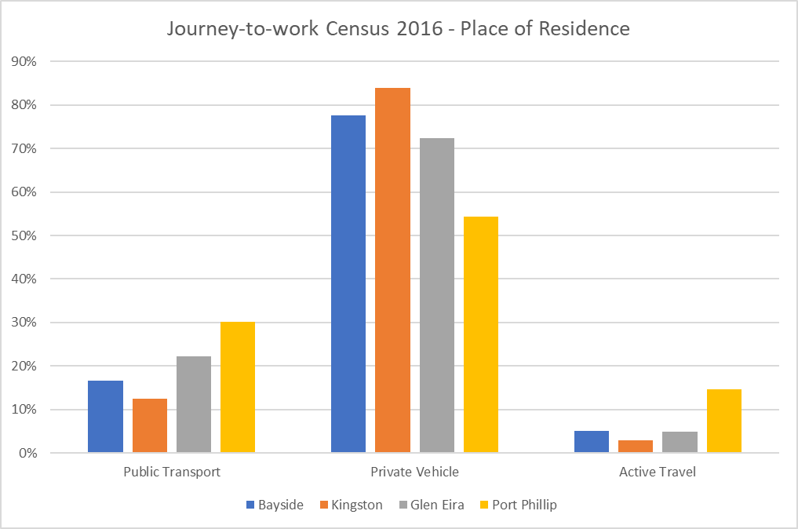
Figure 4.3: Bayside Journey-to-work Place of Employment (Census 2016)
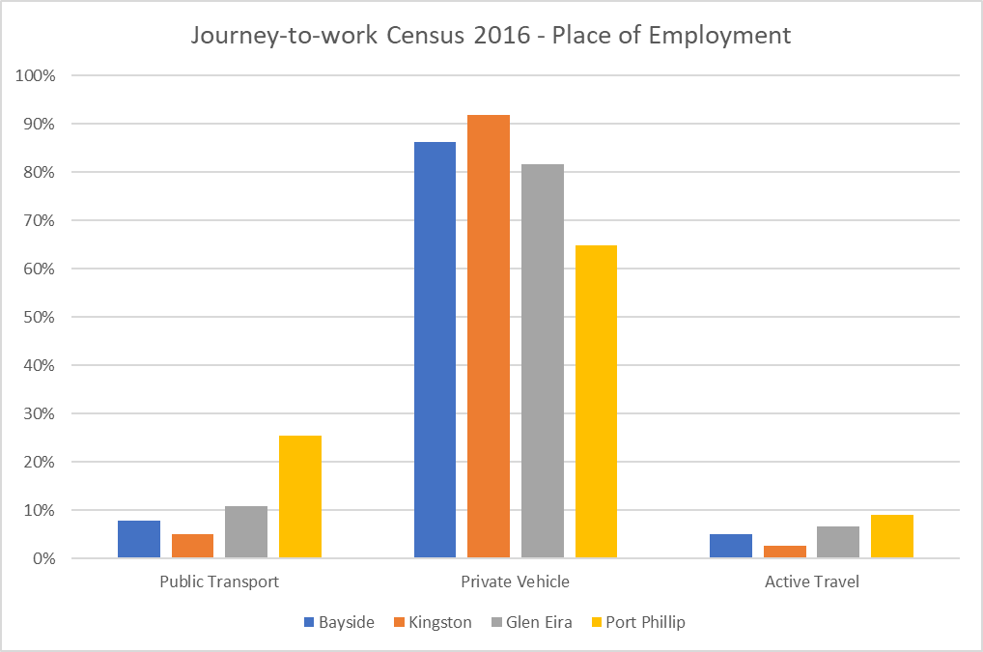

Current Parking Management Approach in Bayside
Traditionally Council has adopted several techniques to manage competing parking demands in Bayside.
In activity centres this has included:
- Reliance on timed parking restrictions supported by enforcement
- Short-term parking restrictions to increase parking turnover on-street within key activity areas with medium-term parking (2-4 hours) outside of the main streets, including off-street car parks.
- Trader parking has not typically been provided by Council with parking either required to be provided on-site or through a reliance on peripheral parking areas around the centres (for example, parking restrictions are applicable only on one side of the road and the other side of the road is left unrestricted to accommodate for other road users who may require longer duration parking needs).
- Commuter car parking is provided on VicTrack owned land with any overspill typically occurring into surrounding residential streets.
- Parking has remained free within Activity Centres
- Focus on giving priority to customers for access to on and off-street parking in activity centres.
- Technology has more recently been introduced within the Church Street Activity Centre to provide real time parking advice and guidance to drivers and collect occupancy data for Council.
Within residential areas this has included:
- Typically, on-street parking within residential areas is unrestricted (as a default setting)
- Some use of residential areas however does occur around activity centres for other long-term parking needs, including commuters and traders
- Paid parking is in place within foreshore carparks and sections of Beach Road
- Where necessary, residential areas have adopted parking controls to protect residential amenity and access. This has included:
  - A mix of parking restrictions with restricted parking along either one or both sides of the road.
  - The availability of parking permits to exempt residents from time-limited parking restrictions. Multi-unit developments (3 units or more) constructed after 1 July 2007 are not eligible to obtain parking permits.
  - Permits are also available for residents that preclude them from paid parking requirements in Beach Road paid parking areas.
Other localised parking restrictions exist around other land uses such as schools and recreational facilities to balance competing parking demands.

Behaviour Change
Behaviour change will occur when community attitudes shift towards walking, cycling and public transport being more convenient alternatives to private vehicular transport. To facilitate a change in community attitudes, Council needs to ensure that the community understands the dilemma it faces in terms of the continued growth in vehicle ownership and associated increases in traffic and parking congestion and also increase awareness of the transport options available that maintain mobility and assist in reducing transport related CO2 emissions. Additionally, the availability of parking is a contributing factor in determining whether an individual will choose to drive to their destination.
There are several factors that influence transport behaviour, including:
- The availability of viable and safe transport alternatives
- The perceived quality and safety of active transport routes and the destination as a place, including the accessibility of bicycle parking
- The distance required to travel to the destination
Bayside City Council implements a number of strategies, projects and plans to improve the uptake of sustainable transport across the City. This includes the introduction of new infrastructure, improving safety within the road network, promotion and education and maintaining a quality road and path network.
The Strategy outlines several initiatives that have the objective of reducing private car ownership and trips, including promotion of car share services, e-bike, and e-scooter use, increasing bike parking availability and a commitment to not introduce new parking assets unless robust criteria are met.
It is recognised that this Strategy forms one of a suite of strategic documents implemented to address different modes of transport within Bayside and how they can collectively improve transport outcomes under the guidance of Council’s Integrated Transport Strategy 2018 – 2028.
Parking Characteristics Within Activity Centres
Parking demand surveys were undertaken in July 2022 within seven Activity Centres. Occupancy data was collected between 12pm and 2pm on a Wednesday, Friday and Saturday. An overview of the surveyed areas, summary of the parking occupancy data and a summary of the survey findings is provided below.
Overview of the Surveyed Areas
Bay Street Activity Centre  - Weekday peak occupancy: 84% (1pm Fri)  - Weekend peak occupancy: 73% (1pm Sat)  - High demand in both the commercial centre and non-commercial surrounds, indicates some overspill  - Very high demand in unrestricted areas in residential streets, suggests use by commuters and traders  - Weekend demand lower than weekday | 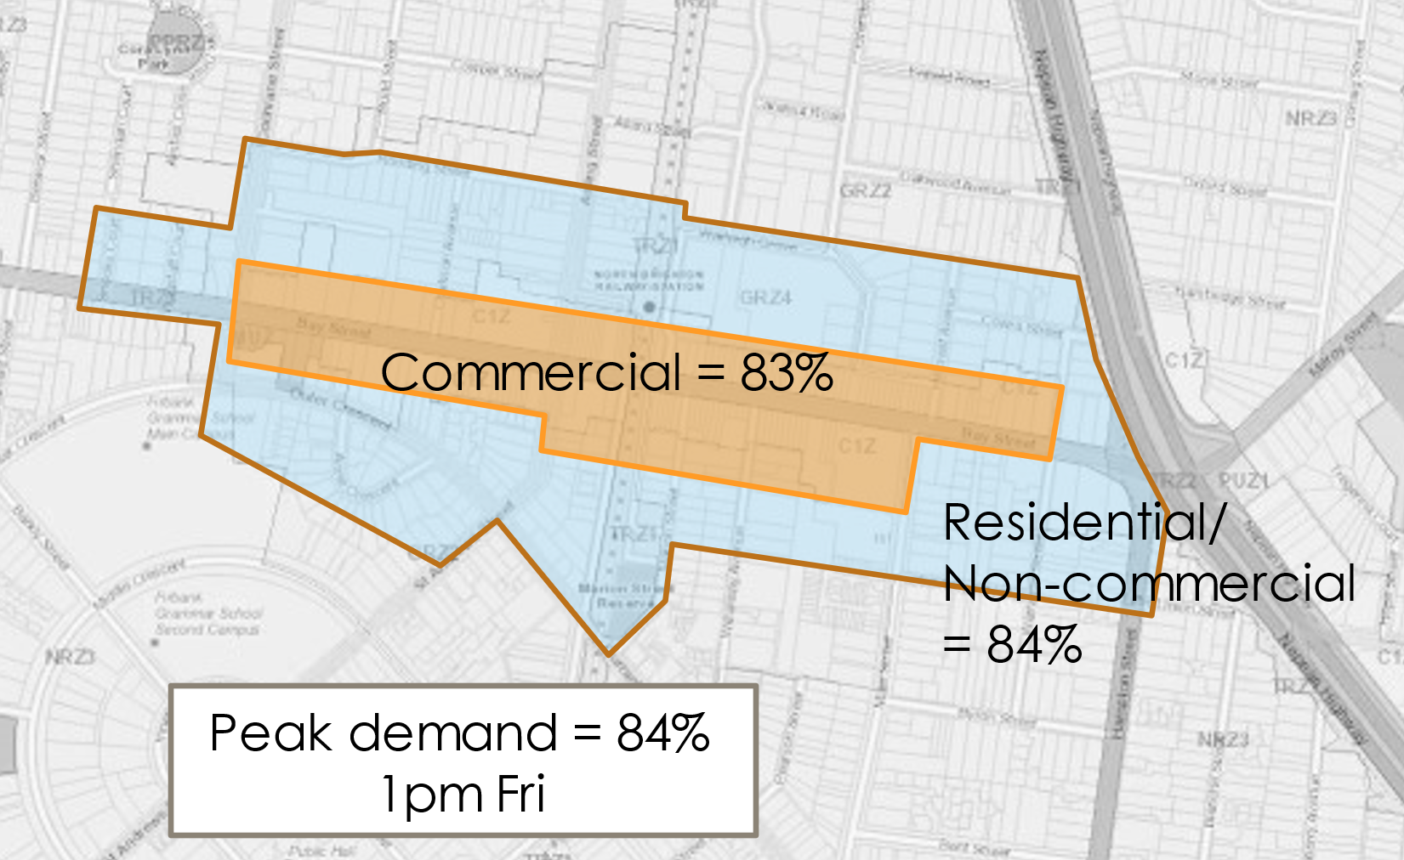
Church Street Activity Centre  - Weekday peak occupancy: 86% (12pm Fri)  - Weekend peak occupancy: 86% (2pm Sat)  - Very high demand in the commercial centre  - High demand in the non-commercial surrounds, indicates some overspill  - Very high demand in unrestricted areas in residential streets, suggests use by commuters and traders  - High demand during both weekday and weekend peaks | 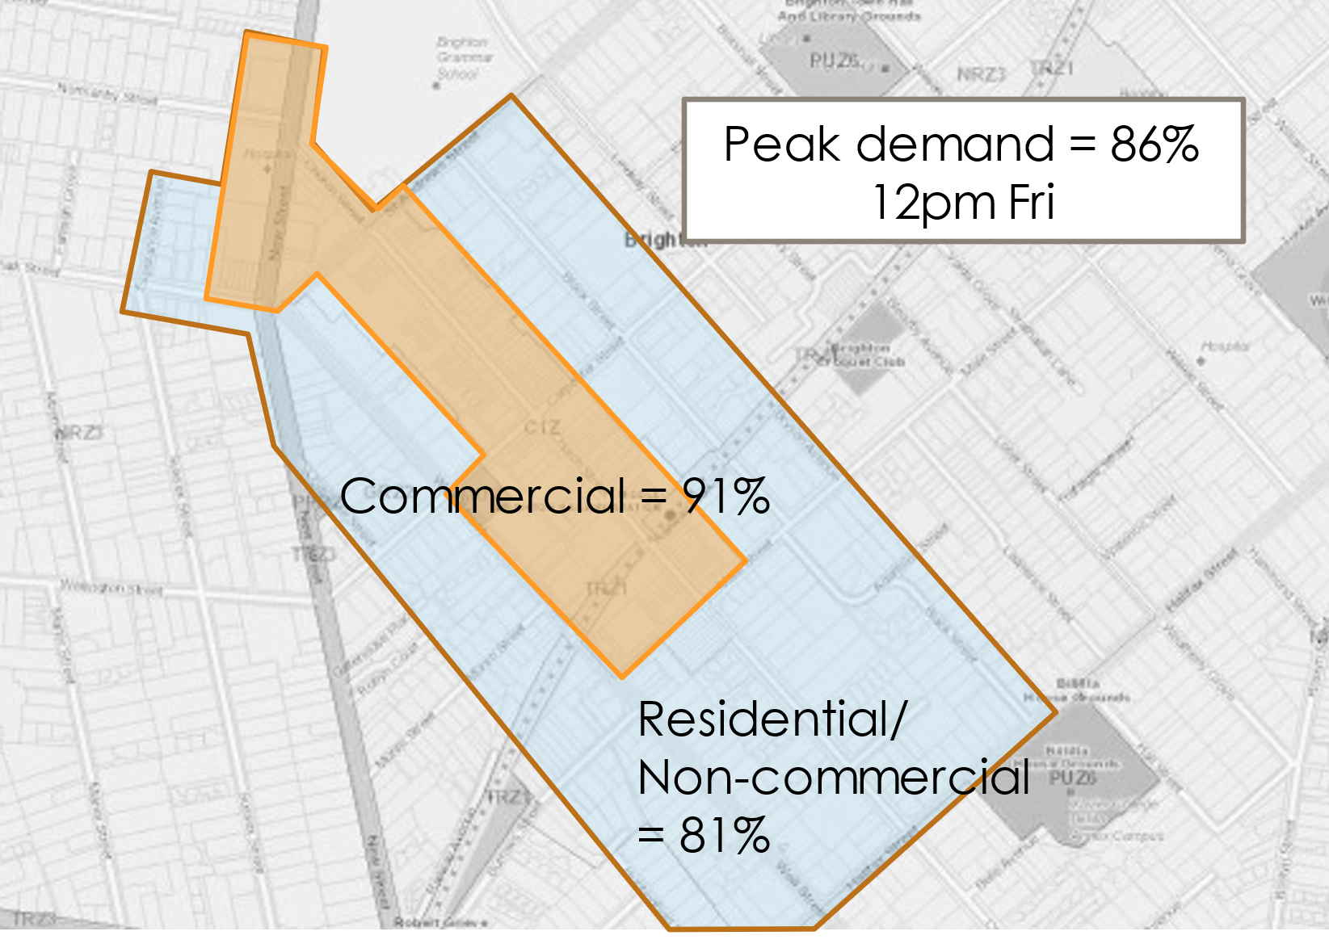
Hampton Activity Centre  - Weekday peak occupancy: 67% (12pm Wed)  - Weekend peak occupancy: 52% (12pm Sat)  - High demand in the commercial centre  - Low demand in the non-commercial surrounds, minimal overspill  - Weekday demand higher than weekend demands  - Moderate demands in unrestricted surrounds, some capacity in residential streets | 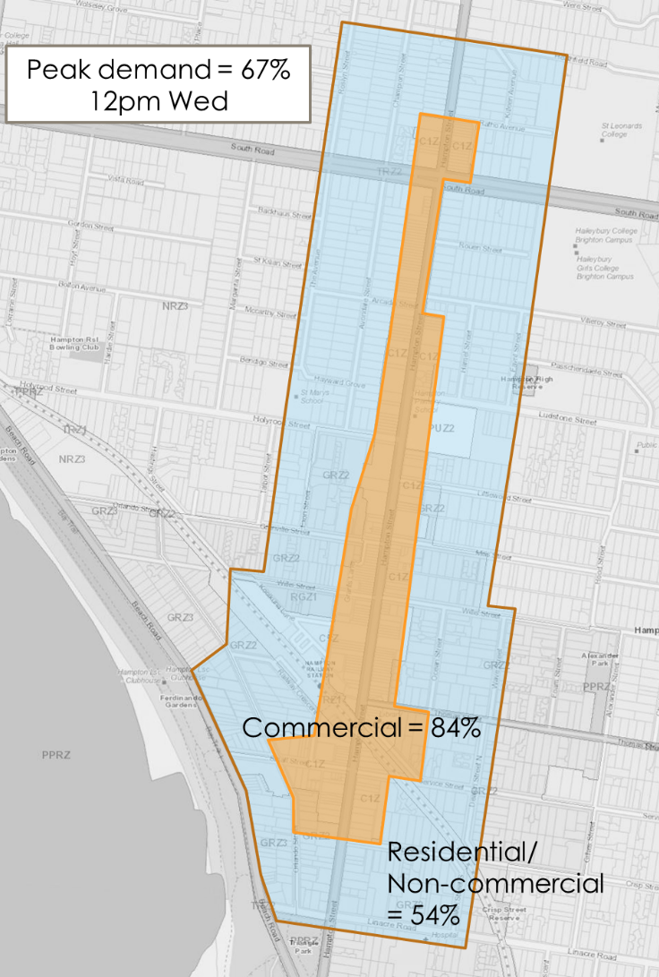
Sandringham Activity Centre  - Weekday peak occupancy: 77% (1pm Fri)  - Weekend peak occupancy: 70% (2pm Sat)  - High demand in the commercial centre  - Moderate demand in the non-commercial surrounds, indicates may be some overspill  - Weekday demand higher than weekend demands | 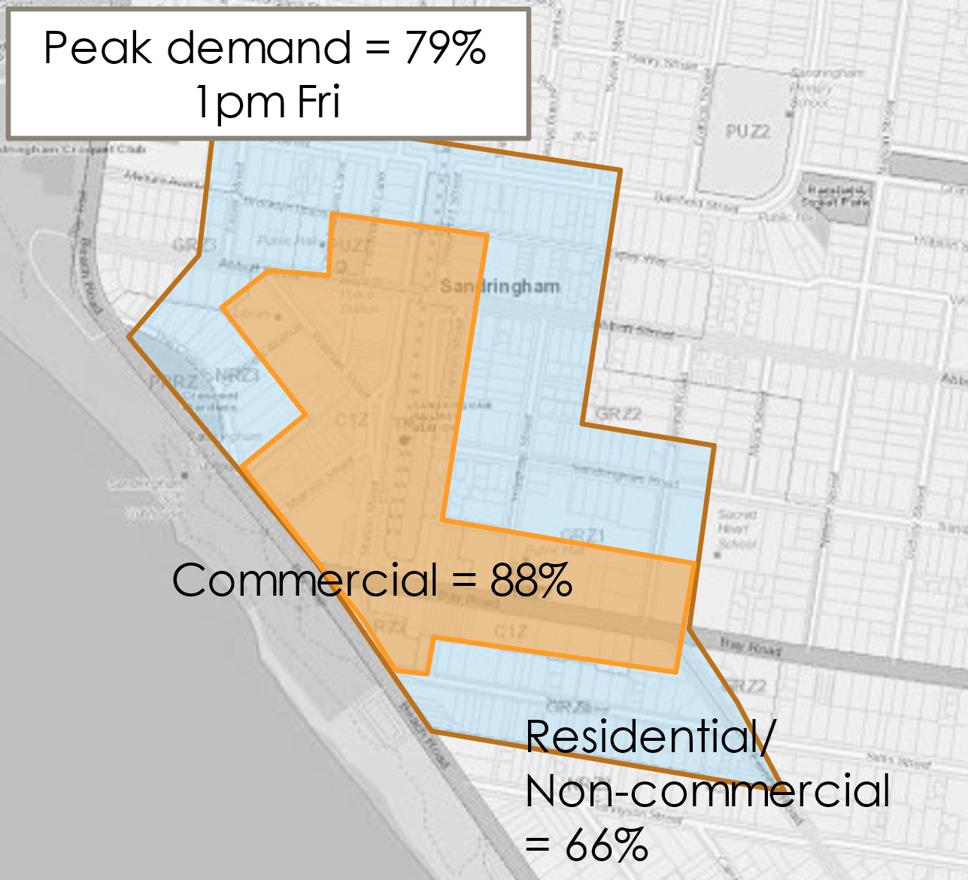
Beaumaris Concourse Activity Centre  - Weekday peak occupancy: 63% (12pm Wed)  - Weekend peak occupancy: 51% (12pm Sat)  - Very high demand in the commercial centre  - Low demand in non-commercial surrounds, predominantly unrestricted, minimal overspill  - Weekend demand lower than weekday | 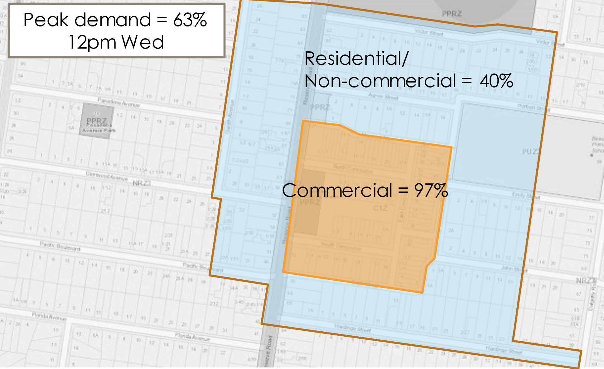
Black Rock Activity Centre  - Weekday peak occupancy: 65% (1pm Fri)  - Weekend peak occupancy: 66% (1pm/2pm Sat)  - High demand in the commercial centre  - Low demand in non-commercial surrounds, predominantly unrestricted, minimal overspill  - Similar weekend and weekday demand | 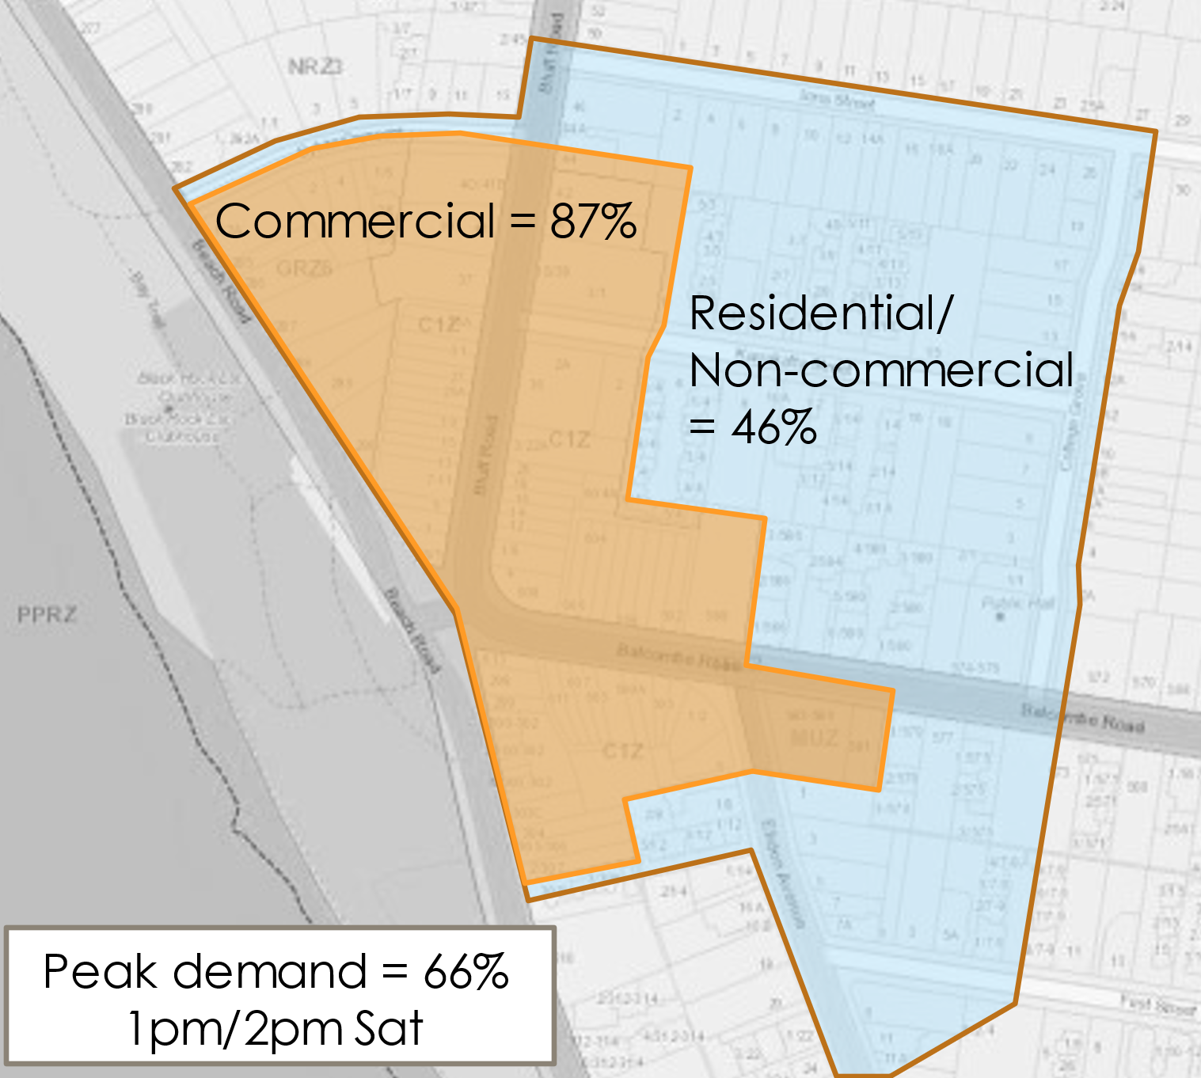
Highett Activity Centre  - Weekday peak occupancy: 53% (12pm Fri)  - Weekend peak occupancy: 67% (12pm Sat)  - Moderate demand in the commercial centre  - Low demand in non-commercial surrounds, predominantly unrestricted, minimal overspill  - Weekend demands higher than weekday demands  - Commuter car park has available capacity on both weekdays and weekends | 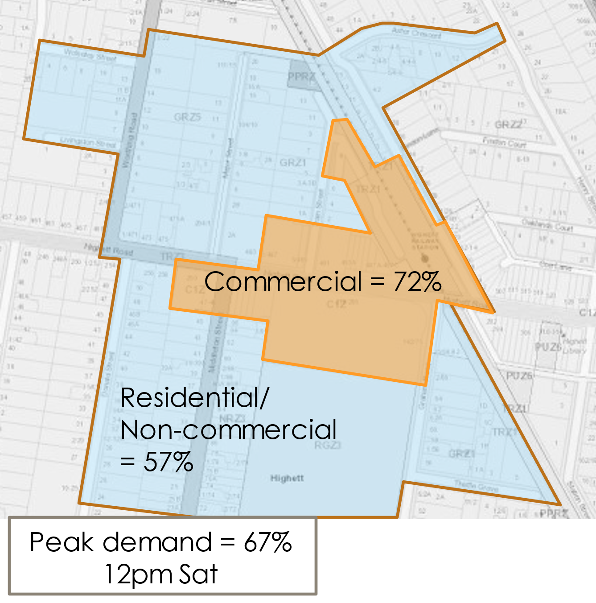
Summary of the Occupancy Data
 | Commercial |  | Residential/ Non-Commercial |  | Commercial + Residential/ Non-Commercial
 | Weekday | Weekend | Weekday | Weekend | Weekday | Weekend
Bay Street | 81% | 74% | 81% | 66% | 81% | 71%
Church Street | 90% | 90% | 75% | 78% | 82% | 84%
Sandringham | 87% | 68% | 64% | 62% | 78% | 66%
Hampton | 78% | 67% | 54% | 38% | 64% | 50%
Black Rock | 78% | 87% | 44% | 45% | 61% | 65%
Beaumaris | 95% | 86% | 37% | 25% | 60% | 49%
Highett | 59% | 69% | 38% | 48% | 52% | 61%

Data Findings
The parking demand and occupancy data showed that each of the activity centres are unique in their size and function, which is evident in the parking survey data.
- Church Street, Brighton experiences the highest demand of all the centres, with high demands on both weekdays and weekends within the commercial area/core and the residential surrounds.
- Bay Street, Brighton also experiences high demand on weekdays in both the commercial and non-commercial areas, but this reduces on a weekend.
- The Hampton and Sandringham Activity Centres have high demands in their commercial area/core but lower demands in the residential surrounds, suggesting lower instances of overspill of commercial parking demand in the surrounding residential streets.
- Beaumaris and Black Rock experience high demands in their commercial area/core but with low demand in the surrounding residential area, so it is unlikely there is any overspill.
- Highett experiences moderate demands in its commercial area/core, with higher demands on a weekend than a weekday and limited overspill into the surrounding residential streets occurs.
This data indicates that peak car parking demands in some of the surveyed centres have reached a level that would warrant the need to better manage existing parking resources to serve the needs of the existing land, with further investigation to be considered for an increased level of parking management control.
It is recognised that there are areas within every activity centre where demands are high, reflecting the most popular and convenient locations to park. However, capacity exists within many of the centres. Further commentary regarding the potential for new parking facilities is provided later in this strategy, under Heading 10.

Key Issues and Findings
Collated from a range of sources, including community consultation findings, demographic and parking demand data and Council plans and strategies, the following provides a summary of the key issues related to parking in Bayside:
- Car ownership is relatively high with only 5% of households not owning a car based on census data, with a trend of increasing car ownership in recent years.
- Indications of car dependency, with 77% of journey to work trips made by private vehicle.
- Public transport choice limited to buses in the southern suburbs of Bayside.
- Lower population density than other surrounding Councils, therefore longer trip distance to access services and transport.
- Community perception that it is difficult to get a car park in activity centres during peak times. Survey data indicates that this is true for the popular and most convenient parking locations, but as a whole there remains available capacity.
- Evidence of parking overspill into residential areas by commuters and long-term parking users for some of the centres surveyed.
- Management of parking associated with construction sites and development activity.
- The location and design of disabled parking is inadequate.
- Challenge of balancing the competing demands of different user groups and timed restrictions which meet their parking needs (15-minute vs 1P vs 2P vs 4P vs all-day parking for traders and commuters).
- The need for parking management policies to be in line with Bayside’s Integrated Transport Strategy and Climate Emergency Action Plan.

Construction of New Car Parking Facilities
The parking survey data collected in July 2022 indicates that peak car parking demands in some of the surveyed centres has reached a level that would warrant better management techniques for existing parking resources. In these locations, an increased level of parking management intervention needs to be implemented before considering the need for additional parking facilities.
It is recognised that there are areas within every activity centre where demands are high, reflecting the most popular and convenient locations to park. However, capacity appears to exist within many of the centres.
Bayside’s Integrated Transport Strategy states the following - ‘providing additional capacity through more road space and parking is not a sustainable solution to the steady increase in parking demand as the increase in trips arising from a growing population and increasing vehicle ownership will continue to outpace road capacity. Similarly, the provision of additional car parking will also be utilised by the growth in vehicle ownership, potentially leading to a repeat of the dilemma once again.’
New Council funded car parking facilities will only be considered when all the parking management tools (vigorous enforcement activities undertaken, smart parking technologies delivered, Parking Precinct Plan developed, and all relevant actions delivered) have been implemented and the desired results have not been achieved, meaning a persistent 85% parking occupancy threshold for a minimum of 4 hours over a 12-hour period remains.
A practical audit and measurement process will be underpinned using data from a biennial parking survey.

Managing Parking in Bayside

Overview
In response to the key issues, a range of parking techniques have been identified and underpin the delivery of the Strategy. There are four categories of parking management techniques:
- Parking management – allocation and management of on-street space, such as restrictions, user priority and permits
- Efficient operations – ensuring the available parking operates efficiently through signage, enforcement and smart technology
- Emerging technologies – consideration of existing and emerging technologies that will impact on public parking space, such as electric vehicles, car share, driverless cars and E-scooter/E-bike sharing
- Development parking provision – ensuring that new developments provide appropriate levels of parking, including access to e-vehicle charging stations.

Parking Management

On-street User Hierarchy
As the first step of establishing a parking management framework, a user hierarchy is required to set out how to prioritise the allocation of on-street parking.
Different user groups have differing priorities and needs from both a safety and amenity perspective. This can vary from street to street depending on the surrounding land use. The user hierarchy is not intended to suggest that each type of parking will exist on any given street, rather it provides the highest level of framework to guide the allocation of parking where competing demands exist. Council will need to consider all road users when making decisions on these matters to best meet the needs of the community.
As a general rule, the regulation and use of on-street parking should be prioritised to support those road users with needs for high levels of access such as bicycle riders, public transport, people with disabilities, emergency services and to enable and support pedestrian movement. This is consistent with the road user hierarchy and Street Space Management Framework that is to be developed by Council as part of the Integrated Transport Strategy, which places the movement needs of walking, cycling and public transport users above single occupancy vehicles.
The on-street parking hierarchy that applies for different land use environments is set out below.
Action 1: Implement the on-street parking hierarchy to guide the allocation of parking spaces where competing demands exist.

Activity Centre/Commercial Areas
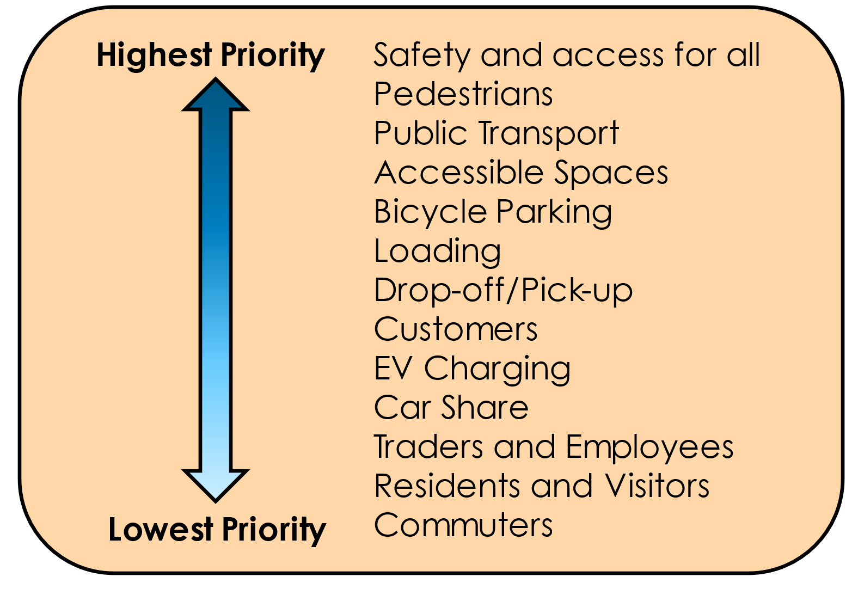
Mixed use commercial areas that accommodate a mixture of long stay and short stay parking generated by customers, visitors, traders and employees and often commuters when a railway station is located within the area.
Priority | User Group | Description
Highest | Safety and access for all | Avoid on-street parking from being a safety hazard for pedestrians, motorists and other road users.  Provide access for emergency vehicles, waste collection and street cleaning.  Apply “No Stopping” restrictions in line with road rules, including:  - within 20 metres of a signalised intersection  - within 10 metres of an intersection  - within one metre of various items such as a fire hydrant  - other locations determined by Council.  May include removal of parking as part of the provision of traffic calming devices and gateway treatments.
 | Pedestrians | Parking may need to be removed as part of the design of crossing facilities, such as through the provision of kerb outstands.
 | Public Transport | Provision for bus stops which meet community needs and operational requirements.  Legislation requires no stopping within:  - 20 metres before a bus stop  - 10 metres after a bus stop.
 | Accessible Spaces for Persons with a Disability | An area in the roadway for the exclusive use by a vehicle transporting a disabled person with a valid disabled permit, with or without a timed restriction.  Provision in accordance with AS2890.5 and AS2890.6.
 | Bicycle Parking | On-street space set aside for bicycle parking.  To be considered where space for footpath bicycle parking is not available.
 | Loading | Provision for the loading and unloading of goods and materials. Short-term parking restrictions during business hours.
 | Drop-off/Pick-up | Designated ‘drop off or pick up’ zones, including taxi zones.
 | Customers | Time-restricted parking across a range of time periods, typically:  - very short-term carparking: P5min – P30min  - short-term carparking: 1P, 2P  - medium-term parking: 3P, 4P
 | EV Charging | Allocation of bays in locations that align with Council’s implementation program.
 | Car Share | Appropriate where high scheme membership and demand in particular locations justify the allocation of bays.
 | Traders and Employees | Long-stay parking for employees, traders and other long-term parkers.  Note that no formal parking allocation will be provided along commercial frontages within activity centres. If necessary, the preference is for locations which are less convenient as compared to that provided for customers.
 | Residents and Visitors | Parking for residents and their visitors of households fronting the street section.  Eligibility for residential permits is set out in Council’s Residential Parking Permit Scheme Policy but are only applicable for parking in nominated residential streets.  Otherwise, residents and their visitors must abide by the relevant parking restrictions.
Lowest | Commuters | Long-stay parking provided to cater for people transferring to another mode of transport to complete their journey.  Commuters can park along commercial frontages provided they abide by the relevant parking restrictions. However, no formal allocation will be provided in these areas.

Residential
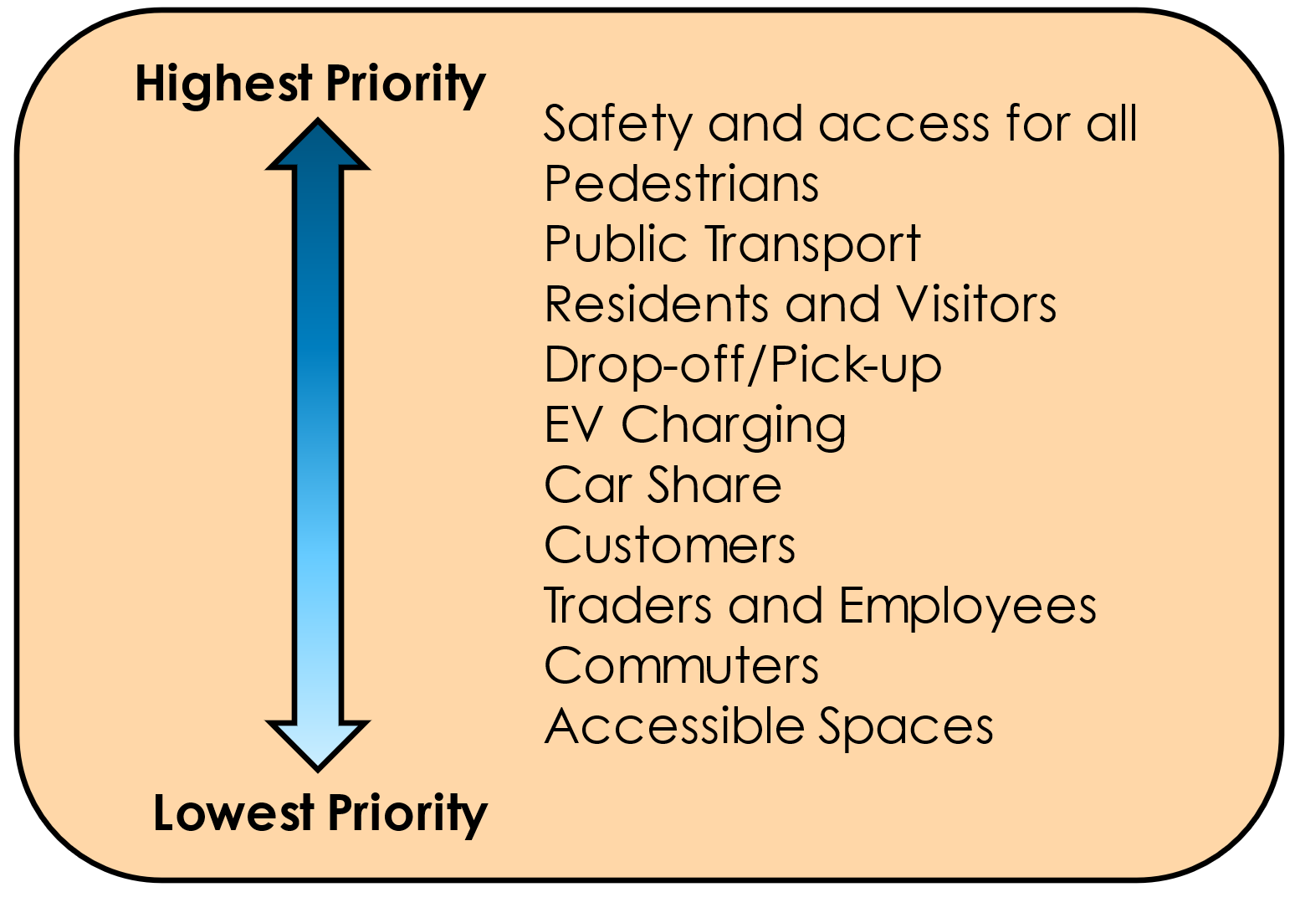
Primarily residential areas, including those surrounding an activity centre or commercial area. These areas often accommodate a mixture of customer, trader and commuter overspill parking from nearby commercial and transport hubs. These areas must balance overspill parking needs from the nearby land uses with the on-street parking needs of residents and their visitors.
Priority | User Group | Description
Highest | Safety and access for all | 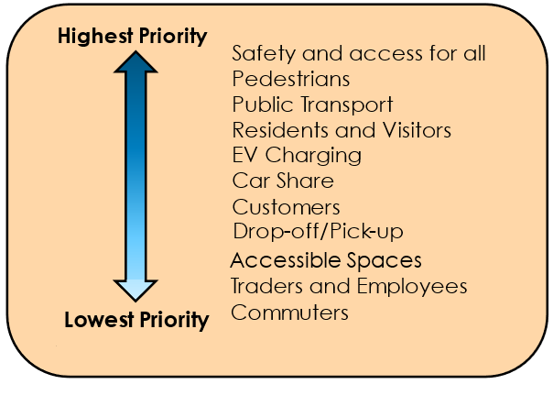  Avoid on-street parking from being a safety hazard for pedestrians, motorists and other road users.  Provide access for emergency vehicles, waste collection and street cleaning.  Apply “No Stopping” restrictions in line with road rules, including:  - within 20 metres of a signalised intersection  - within 10 metres of an intersection  - within one metre of various items such as a fire hydrant  - other locations determined by Council traffic engineers.  May include removal of parking as part of the provision of traffic calming devices and gateway treatments.
 | Pedestrians | Parking may need to be removed as part of the design of crossing facilities, such as through the provision of kerb outstands.
 | Public Transport | Provision for bus stops which meet community needs and operational requirements.  Legislation requires no stopping within:  - 20 metres before a bus stop  - 10 metres after a bus stop.
 | Residents and Visitors | Parking for residents and their visitors of households fronting the street section.  Residents may be eligible for residential parking permits in accordance with Council’s Residential Parking Permit Scheme Policy. This policy ensures that residents and their visitors have priority for all-day parking in high demand areas and/or areas that are subject to short-term parking restrictions on the fringe of commercial areas.
 | EV Charging | Allocation of bays in locations that align with Council’s implementation program. Spaces should be designated as public use and should not be for the exclusive use of any residential property that is located adjacent to a designated bay.
 | Car Share | Appropriate where high scheme membership and demand in particular locations justify the allocation of bays.
 | Customers | Time-restricted parking for business and retail needs covering short- to medium-term time periods (example: 1P to 4P).  Customers and shoppers are able to park along residential frontages provided they abide by the relevant parking restrictions. However, no formal allocation will be provided for in these areas.
 | Drop-off/Pick-up | Designated ‘drop off or pick up’ zones, including taxi zones. Can also include loading vehicles.
 | Accessible Spaces for Persons with a Disability | In residential areas, disable parking should be provided within off-street where possible.
 | Traders and Employees | Long-stay parking for employees, traders and other long-term parkers.  Traders and local employees are able to park along residential frontages provided they abide by the relevant parking restrictions. However, no formal allocation will be provided in these areas.
Lowest | Commuters | Long-stay parking provided to cater for people transferring to another mode of transport to complete their journey.  Commuters are able to park along residential frontages provided they abide by the relevant parking restrictions. However, no formal allocation will be provided in these areas.

Foreshore Carparking
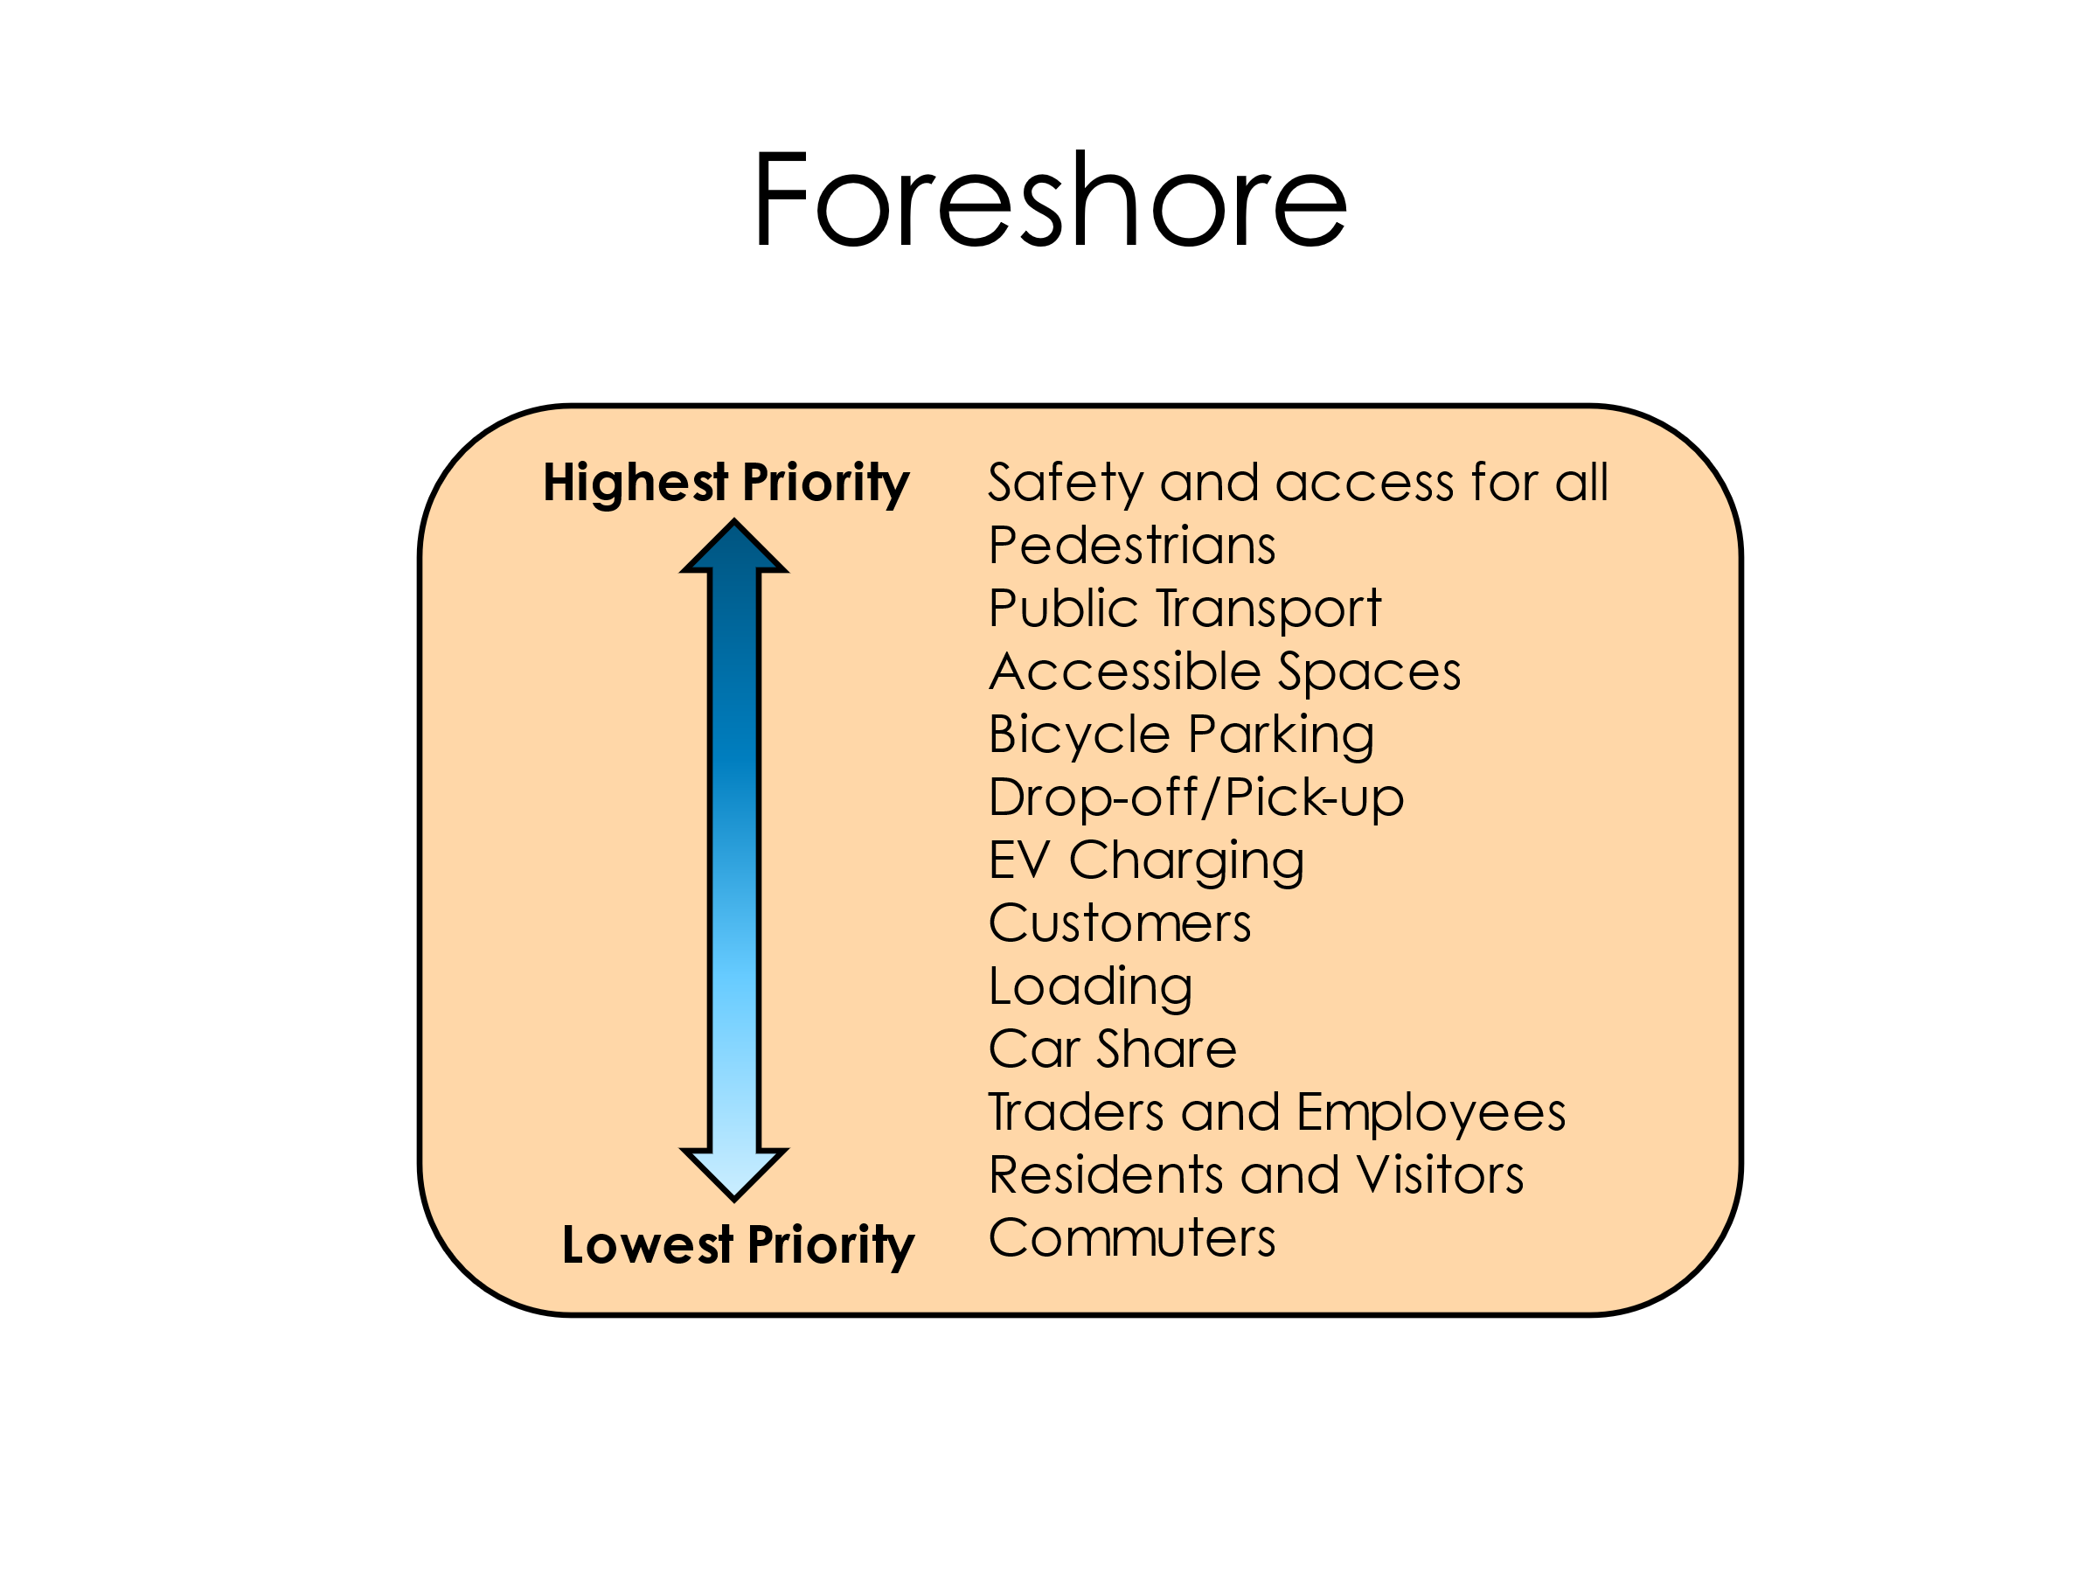
Foreshore areas provide specific parking to cater for access to the bay and beach. This heirarchy is applicable for foreshore public carparks and the kerbside parking immediately adjacent to the foreshore.
Bay and beach users
Priority | User Group | Description
Highest | Safety and access for all | Avoid on-street parking from being a safety hazard for pedestrians, motorists and other road users.  Provide access for emergency vehicles, waste collection and street cleaning.  Apply “No Stopping” restrictions in line with road rules, including:  - within 20 metres of a signalised intersection  - within 10 metres of an intersection  - within one metre of various items such as a fire hydrant  - other locations determined by Council traffic engineers.  May include removal of parking as part of the provision of traffic calming devices and gateway treatments.
 | Pedestrians | Parking may need to be removed as part of the design of crossing facilities, such as through the provision of kerb outstands.
 | Public Transport | Provision for bus stops which meet community needs and operational requirements.  Legislation requires no stopping within:  - 20 metres before a bus stop  - 10 metres after a bus stop.
 | Accessible Spaces for Persons with a Disability | An area in the roadway for the exclusive use by a vehicle transporting a disabled person with a valid disabled permit, with or without a timed restriction.  Provision in accordance with AS2890.6.
 | Bicycle Parking | On-street space set aside for bicycle parking.  To be considered where space for footpath or off-road bicycle parking is not available.
 | Drop-off/Pick-up | Designated ‘drop off or pick up’ zones, including taxi zones.
 | EV Charging | Allocation of bays in locations that align with Council’s implementation program. Spaces would still be designated as public use and would not be for the exclusive use of residents adjacent to a designated bay.
 | Bay and beach users | Bay and beach users are able to park in foreshore car parks and along the foreshore frontage provided they abide by the relevant parking restrictions.
 | Loading | Provision for the loading and unloading of goods and materials. Short-term parking restrictions during business hours.
 | Car Share | Appropriate where high scheme membership and demand in particular locations justify the allocation of bays.
 | Traders and Employees | Long-stay parking for employees, traders and other long-term parkers.  Traders and local employees are able to park in foreshore car parks and along residential frontages provided they abide by the relevant parking restrictions. However, no formal allocation will be provided in these areas.
 | Residents and Visitors | Residents may be eligible for residential parking permits in accordance with Council’s Residential Parking Permit Scheme Policy. This policy ensures that residents and their visitors have priority for all-day parking in high demand areas and/or areas that are subject to short-term parking restrictions on the fringe of commercial areas.
Lowest | Commuters | Long-stay parking provided to cater for people transferring to another mode of transport to complete their journey.  Commuters are able to park along these frontages providing they abide by the relevant parking restrictions. However, no formal allocation will be provided in these areas.

Community, recreational and educational facilities
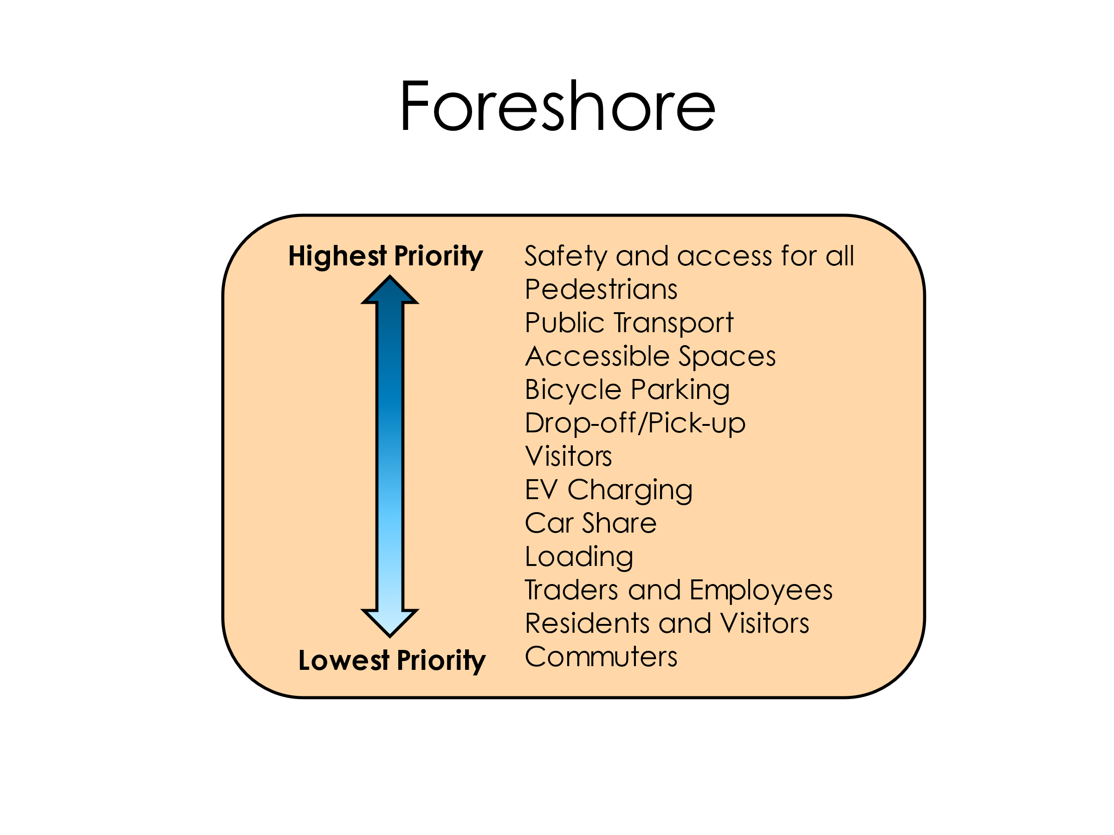
Community, recreational and educational facilities include schools, kindergartens, childcare facilities, community halls, parks, sporting fields, and any other recreational facility that services the community. These uses are typically located within a wider area that is predominantly residential or commercial, and subject to a potentially wide range of short- and long-term parking controls. However, the parking controls abutting these facilities will need to be consistent with their own unique operations and uses.
*
Priority | User Group | Description
Highest | Safety and access for all | Avoid on-street parking from being a safety hazard for pedestrians, motorists and other road users.  Provide access for emergency vehicles, waste collection and street cleaning.  Apply “No Stopping” restrictions in line with road rules, including:  - within 20 metres of a signalised intersection  - within 10 metres of an intersection  - within one metre of various items such as a fire hydrant  - other locations determined by Council traffic engineers.  May include removal of parking as part of the provision of traffic calming devices and gateway treatments.
 | Pedestrians | Parking may need to be removed as part of the design of crossing facilities, such as through the provision of kerb outstands.
 | Public Transport | Provision for bus stops which meet community needs and operational requirements.  Legislation requires no stopping within:  - 20 metres before a bus stop  - 10 metres after a bus stop.
 | Accessible Spaces for Persons with a Disability | An area in the roadway for the exclusive use by a vehicle transporting a disabled person with a valid disabled permit, with or without a timed restriction.  Provision in accordance with AS2890.5 and AS2890.6.
 | Bicycle Parking | On-street space set aside for bicycle parking.  To be considered where space for footpath or off-road bicycle parking is not available.
 | Drop-off/Pick-up | Designated ‘drop off or pick up’ zones, including taxi zones. For uses such as schools, kindergartens and childcare facilities, very short term on-street restrictions would typically apply only during the peak times for drop-off/pick-up activities.
 | Residents and Visitors | Parking for residents and their visitors of households fronting the street section.  Eligibility for residential permits is set out in Council’s Residential Parking Permit Scheme Policy but are only applicable for parking in nominated residential streets.  Otherwise, residents and their visitors must abide by the relevant parking restrictions.
 | Visitors | Time-restricted parking to meet the specific land use needs. Can include short- to medium-term time periods (example: 1P to 4P) and specific times of operation to match the peak demands of the adjoining uses.
 | EV Charging* | Allocation of bays in locations that align with Council’s implementation program. Spaces would still be designated as public use and would not be for the exclusive use of users/owners of the land uses adjacent to a designated bay. The provision of this infrastructure will only be considered within off-street parking only.
 | Car Share | Appropriate where high scheme membership and demand in particular locations justify the allocation of bays. The provision of this infrastructure will only be considered within off-street parking only.
 | Loading | Provision for the loading and unloading of goods and materials. Short-term parking restrictions during business hours.
 | Traders and Employees | Long-stay parking for employees, traders and other long-term parkers.  Traders and local employees are able to park along street frontages provided they abide by the relevant parking restrictions. However, no formal allocation will be provided in these areas.
Lowest | Commuters | Long-stay parking provided to cater for people transferring to another mode of transport to complete their journey.  Commuters are able to park along street frontages provided they abide by the relevant parking restrictions. However, no formal allocation will be provided in these areas.

Parking Management Options
There are a series of steps in the parking management process, ranging from uncontrolled or unrestricted parking (the simplest control suitable for a single land use and user type) through to paid parking (manages high demands, competing demands, and multiple users with different parking needs). Progression through the levels of parking management responds to increasing and competing parking demands and the need to allocate parking between different user groups. Inevitably the progression through the parking management steps sees increasing complexity in management of these issues and an increase in the cost of implementation. This is illustrated in Figure 7.1.
Figure 7.1: Parking Management Process (Activity Centres)
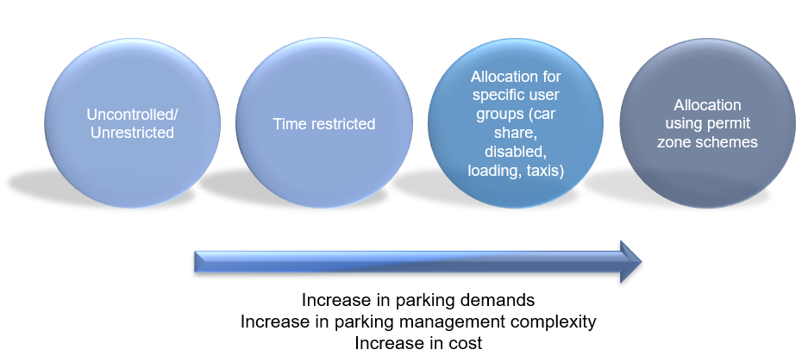
It is not sustainable nor in line with other policies for Council to provide an unrestricted supply of car parking to satisfy the unconstrained car parking demands of users. Council must focus on managing demand within a limited supply using the hierarchy of available tools.
To balance the highest use of a parking space while ensuring that the street is not congested with drivers circulating in search of a parking space, an ideal maximum car parking occupancy rate is typically targeted and seeks to represent about 1 out of every 7 parking spaces being available. This equates to an ideal maximum occupancy of 85%.
This occupancy level is recommended to be adopted as the ideal maximum occupancy for Activity Centres within Bayside. Parking areas in activity centres that currently experience demand above this level for a sustained period of time (more than 4 hours over a 12-hour period) should be considered for the next level of parking management. The aim being to increase turnover of parking and access for more people through lowering the peak demands while encouraging use of less utilised areas and increasing the use of more sustainable transport options.
Figure 7.2: The impact of on-street car parking occupancy on circulation time
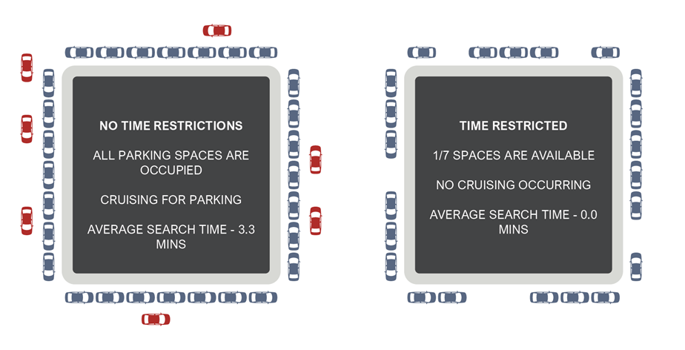
LIMITED CRUISING FOR PARKING
Council’s Managing On-Street Car Parking Demand Policy aims to provide consistent and transparent guidance for the introduction of new parking restrictions in areas where on-street car parking may be causing a road safety hazard or where on-street car parking spaces are in high demand which has resulted in car parking congestion.
This Policy has been developed to ensure a consistent, equitable and inclusive approach to the investigation, consultation, design, implementation and subsequent monitoring of parking restrictions. The Policy considers allocation of existing on-street parking spaces relevant to the demand. It does not consider the supply or number of parking spaces available.

Unrestricted Parking
Unrestricted or uncontrolled parking relates to parking that is not subject to any time limit, specific user allocation or price.
Unrestricted parking is suitable only when parking demands are low and is being used by a single user group.

Time Restricted Parking
Time restricted parking represents the first level of management that is used to balance competing user demands, such as short stay shopper and longer stay staff demands. The length of time for a single parking event is limited to reflect an appropriate turnover that suits the needs of the surrounding land uses, which can vary from very short-term (5 minutes) up to 4 hours or longer.
Time restricted parking can be used to create turnover of parking and spatially allocate where different users should park. The spatial allocation of parking will often be guided by the walking distance tolerance of users between their parking location and desired destination.

Specific User Group Allocations
Specific user group allocations relate to parking spaces reserved for particular user groups such as loading zones, taxi zones, works zones, bus zones, disability permit spaces and car share spaces.
The provision and allocation of parking for specific user groups should occur within areas where there is a demonstrated demand for these user groups and land use requiring these types of parking. The allocation of parking for specific user groups must be prioritised having regard for the on-street parking hierarchies outlined above.
Additional commentary specifically relating to accessible parking for persons with a disability is provided later in this strategy.

Parking Permit Systems
Parking permit systems allow exemptions from timed parking controls for permit holders, or allowance to park in specifically dedicated areas for permit holders only. Parking permit systems can be combined with time limits, pricing or special purpose zones.
Parking permit systems are most used in areas of high demand where specific user group needs are required to be prioritised.
Further commentary regarding parking permits in Bayside is provided later in this strategy.

Paid Parking (Foreshore and Beach Road)
Paid parking relates to parking that is subject to the payment of a range of time-based fees and can be combined with timed restrictions.
Paid parking is most used in areas of high parking demand where time limits alone do not achieve suitable parking turnover or availability.
Paid parking within Bayside is limited to sections of Beach Road and within foreshore carparks. Paid parking will not be considered for implementation within Activity Centres at this time.
Further commentary regarding paid parking in Bayside is provided later in this strategy.

Parking Precinct Plans
To best manage existing and future demands for specific locations, it is recommended that the scope, justification and needs assessment criteria to develop specific Parking Precinct Plans be identified, referencing Planning Practice Note 57 – The Parking Overlay.
It is not practical or financially viable to prepare all required Parking Precinct Plans at one time. Several factors can influence which area warrants the development of a Parking Precinct Plan, the priority order in which to undertake development of these strategies includes:
- Whether parking demands within the centre are nearing capacity (sustained demand of parking over 85% for 4-hours over a 12-hour period)
- Substantial change in the nature of land use or increase in land use floor area
- Planned infrastructure changes that could give rise to changing modes of travel
- Seasonal fluctuation that requires specific consideration.
Action 2: Develop an assessment criterion to establish when a specific Parking Precinct Plan is required to manage existing and future parking demands of a specific local area.

Accessible Parking
Council’s Disability Action Plan 2021-2025 states that over 14,000 people living in Bayside have a disability and over 4,000 people need assistance in their day-to-day lives. There is also a substantially higher percentage of older persons living in Bayside (85 years and over) when compared to Metropolitan Melbourne.
It is anticipated that there will be an increase in the number of people with a disability living in Bayside over the coming years, with one of the contributing factors being the increase in the proportion of residents aged 65 and older. A growing older population increases the demand for accessible parking facilities that support residents that have fewer transport options, including disabled parking spaces. The expected increase in the average age of the population will present challenges in terms of mobility and transport, particularly considering that there are already issues with the supply, location and design of disabled parking spaces across the municipality.
A proportion of off-street car parking spaces for a development must be allocated as car parking spaces for persons with a disability in accordance with the Building Code of Australia (this is typically 1–2% of parking spaces depending on the size of the car park) and designed in accordance with the Australian Standard: Parking facilities Part 6: Off-street parking for people with disabilities (AS 2890.6). The provision requirements of the Building Code of Australia will serve as a minimum requirement.
There are however no prescribed requirements for the provision of parking for persons with a disability within public on-street parking. Parking will therefore need to be provided by Council on a case-by-case basis having regard to following factors:
- The nature of the adjacent land use and users
- The demand for parking by persons with a disability throughout the day and week
- The provision of off-street parking associated with the land use
- The existence of existing parking spaces for persons with a disability within 50m and without the need to cross the road.
The provision of on-street parking for persons with a disability will typically be prioritised over standard customer or staff parking as identified within the on-street user hierarchy specified previously. An appropriate spread of parking for persons with a disability should be provided throughout an activity centre.
The design of parking spaces is important to enable suitable and safe access by persons with a disability in respect of gaining access to and from their vehicle and accessing adjacent path facilities. The suitable location of spaces must consider many factors including, but not limited to, road or footpath width, grade, service poles, trees, access ramps and road surface.
To ensure that parking spaces are provided to an appropriate standard, the design of accessible on-street parking spaces for persons with a disability will be guided by the Australian Standard: Parking facilities Part 5: On-street parking (AS 2890.5).
Council will review and audit the location and design of all on-street and off-street publicly provided parking spaces for persons with a disability to ensure that these spaces are appropriately located to meet user needs and designed to provide safe and appropriate access. Where improvements to the design of parking spaces are required, these will be prioritised and actioned having regard to available Council budgets and the timing of other streetscape works in the area.
Action 3: Council will review and audit the location and design of on-street and publicly provided parking spaces for persons with a disability to ensure that these spaces are appropriately located to meet user needs and designed to provide safe and appropriate access.
Action 4: Council will support parking for persons with disabilities through the provision of on-street accessible parking having regard to appropriate influencing factors.

Parking Permit Systems
Parking permit systems allow exemptions from parking controls for permit holders or allow permit holders to park in specifically dedicated areas for permit holders only. A number of permit types are relevant within Bayside as discussed in the following.

Residents
Council currently has mechanisms available through the form of parking permits to exempt residents from parking restrictions in certain circumstances, or to manage parking demand to protect residential amenity.
Residential permits however also result in less availability of on-street parking for other members of the community.
The perception by residents that the space in front of their house ‘belongs to them’ is a long-held perception which is not unique to Bayside. However, for residential streets including within the fringe of an activity centre, it is a shared community resource that can accommodate overspill from the activity centre and not be for the exclusive use of residents and their visitors.
Residential Parking Permits have a role in the parking management process in Bayside, to provide some level of protection of the residential frontages so that they may be available for long-term parking by residents. However, it must also be ensured that the permit policy aligns with strategic and sustainable transport goals to reduce reliance on private vehicle travel.
In circumstances where there is intensification of use of an area by factors such as high-density developments (including those approved by the Minister for Planning and/or the Victorian Civil and Administrative Tribunal (VCAT)), recreational activities or other, Council will consider introducing time limited and permit parking control measures to protect residential amenity and enable adequate parking opportunities for local residents.
Council will manage the availability of public parking spaces in line with the adopted kerbside parking hierarchy. The prescribed parking control interventions will be developed in consultation with the impacted property owners/occupiers.
The implementation process of these parking controls will be facilitated as per Council’s Managing On-Street Car Parking Demand Policy.

Resident Visitors
As part of the existing resident parking permit system, residents can purchase a visitor permit as one of their four allocated permits. In some instances, these permits are not being used for the purpose that they were purchased (for example, resale online).
An updated permit scheme will consider improvements to the visitor permit system, including:
- Restricting the use of visitor permits to limit potential misuse
- Introducing paperless electronic permits to help address illegal re-selling of visitor permits

Beach Road Permit Scheme
Paid parking exists along sections of Beach Road and residents are eligible to apply for resident and visitor parking permits if they live on Beach Road where there is paid parking, or in a side street off Beach Road that has short-term 1P parking restrictions due to paid parking along Beach Road.
Eligible residents can apply for either:
- Option 1 – 3 free resident parking permits issued for specific vehicles, plus 4 free visitor parking permits; OR
- Option 2 – 2 free resident parking permits, plus 4 free visitor parking permits, plus 1 visitor parking permit for an annual fee.

Works Zone (Construction Vehicles)
Developers can request a works zone be introduced at the front or side of the subject site by applying for a road occupation permit. An associated cost based on the length of road occupied and the duration of the works applies.
As per the road rules, Works Zones are to be used for vehicles engaged in construction work in or near the zone. However, in many cases, there is no consideration for the parking requirements of on-site workers and visitors, and as a result they make use of available parking supply in the surrounding street network, reducing the amount of parking available to residents. Whilst these activities are short term, they are an inconvenience for the surrounding properties, particularly when multiple developments are occurring simultaneously.
The implementation of permit zone restrictions in residential streets is generally not supported for short term works that are having minimal impacts on an area.
In circumstance where there are two or more developments occurring concurrently in the same street or local area, Council will consider introducing temporary time limited parking control measures and permit zones to protect residential amenity and enable adequate parking opportunities for local residents. Council will consider the type and complexity of the developments and the number and type of construction vehicles expected throughout the construction phases in its determination of the suitability of these interventions.
The implementation process of the above temporary parking controls will be facilitated as per Council’s Managing On-Street Car Parking Demand Policy.
One method of ensuring that works zones and their associated on-site workers are abiding by the restrictions of the area and meeting their permit conditions is by facilitating regular enforcement. Wherever possible, this will be incorporated into the daily activities of existing enforcement Officers to identify vehicles that are either illegally parked (for example, across driveways or in ‘No Stopping’ zone) or those that are overstaying in time-restricted areas.

Trader Parking
Trader permits give access to parking for select businesses and their employees which would otherwise be available for customers and other users.
In addition, trader parking is often misused. For example, businesses may have dedicated parking on-site, but this is being used for other uses such as storage. It is important to ensure that where off street parking is provided, it is used correctly by traders.
Safe and accessible car parking for people should be a universal consideration in the development of any parking precinct plan for activity centres and commercial areas within Bayside. Reducing public supply for specific users without providing alternatives will be problematic for Council.
The dedication of parking for long stay users’ conflicts with sustainability objectives, as these users are in a position to adopt alternate travels modes given the length of time they spend at their destination. Additionally, the Major Activity Centres are generally well connected with active and sustainable transport options.
The use of trader permits that provide exclusive use to parking on an ongoing basis will generally not be pursued. This will encourage traders to consider whether private car transport forms the most suitable mode of travel on any given day.
However, in locations where there is strong demand and the need for trader parking is justified and supported by the community, Council will consider implementation of a trader parking permit scheme at a cost to traders.
Action 5: Council will prepare an updated resident permit scheme that:
- Continues to provide access to parking permits for residential properties. Multi-unit developments (3 units or more) constructed after 1 July 2007 will not be eligible to obtain parking permits.
- Introduce paperless electronic permits to limit potential misuse.
Action 6: Council will support provision of trader parking as follows:
- In locations where there is strong demand and the need for trader parking is justified and supported by the community, Council will develop a Trader Parking Permit Scheme at a cost to traders
- If Council proceeds to enable a Trader Parking Permit Scheme, Council will develop a trader parking permit scheme policy
- Encourage employers to allocate on-site parking for customers and employees with specific needs where possible
- Provide safe and inclusive parking areas, including pedestrian routes to and from car parking.
- Ensure that on-site parking within businesses is not repurposed into storage or additional floor space.

Paid Parking
Paid parking typically sits at the end of a series of management methods within a process of parking management.
Paid parking is most commonly used in areas of high parking demand where time limits are not achieving suitable parking turnover or availability.
Paid parking is an effective demand management tool which can be used to influence the way people travel. It can encourage people to travel at different times, shift to alternative modes and provide the resource to those who value it enough to pay for it.
Paid parking will be maintained along section of Beach Road and within Foreshore carparks. Paid parking will not be considered for implementation within Activity Centres at this time.

Efficient Operations
Embedded within the parking management process are elements of enforcement and parking technology which enables more effective and responsive decisions to be made by Council and users of the system.

Enforcement
Effective enforcement is critical to any parking system to ensure it operates as designed. Adequate levels of enforcement can have the benefits of equitable use of spaces, improved turnover and reduced vehicle circulation. This in turn supports local business by allowing more customers to access businesses more easily. However, enforcement is often seen in a negative light as a form of punishment through the issuing of infringement notices to those who overstay and considered to be solely for the purposes of “revenue raising”.
An opportunity exists to flip the narrative so that the community can understand the role of enforcement and how it supports the parking systems positively. There should be an understanding that the role of enforcement is to discourage those who are doing the wrong thing and protect those who are doing the right thing. Improved compliance with parking restrictions enhances access to finite parking spaces.
There are some types of parking non-compliance where enforcement is expected, which relate less about overstay and more about road safety and specific user access, including:
- Parking in “No Stopping”, “No Parking” and “Bus” zones
- Parking too close to intersections and school crossings
- Vehicles parking over driveways or blocking footpaths
- Improper use of loading zones (e g non-loading vehicles or exceeding the posted maximum length of stay)
- Parking in parking spaces for people with disabilities without proper permission
There is already some positive awareness of Bayside’s parking enforcement service based on findings from the 2022 Community Satisfaction Survey, where satisfaction with the Council service "parking enforcement" increased by 3.8% to 6.91 (out of 10).
Regular enforcement can assist in identifying areas with repeated compliance issues where it may be necessary to review the appropriateness of existing controls. It can also be used as a parking management tool when demands in an area are high and an increased level of parking control is being considered.
Technology, particularly in high turnover areas such as the MACs, can be used to support the enforcement process by improving compliance and making enforcement less labor intensive. For example, in Church Street, the parking sensors installed as part of the Smart parking initiative can record the length of time a vehicle has occupied a space and trigger an alert to the parking officers once they have stayed beyond the allowable time.
The benefits of using the system specifically to enforce parking restrictions, included:
- Aid with monitoring the parking activity of areas to determine effective enforcement patrols where non-compliance most impacts turn-over rates and availability.
- Provide for efficiency of patrols allowing more time for officers to patrol other areas and respond to customer requests.
- Reduce infringement disputes for over-stay offences based on the quality of the data.
- Reduce OH&S hazards for officers associated with traditional patrols and mark-up of vehicles.
Active parking enforcement must therefore be maintained by Council, with messaging and education focusing on the benefits to those using the system. Technology should continue to be adopted to simplify and inform the enforcement task.
Case Study – Church Street MAC
In-ground vehicle detection sensors installed at the Church Street MAC are used to provide drivers with real-time information on parking availability. They also have the ability to collect information about the arrival and departure times for each vehicle and can identify when a vehicle has stayed beyond the signposted time.
Data from April and May 2022 found the following:
- Average number of overstay alerts per day = 300
- Average number of infringement notices issued per day = 30
- Approximately 10% of all overstays are being issued with an infringement notice

Smart Parking and Signage
Smart parking relates to the use of in-ground vehicle detection sensors (typically) to collect data about the parking activity of a space and communicate real-time information of parking availability to visitors as well as collect important usage data which will support Council decision-making and enforcement.
Smart parking technology, such as that which has been recently implemented in the Church Street MAC, provides several benefits to parking management including:
- Improving user experience in finding and using car parking within an activity centre.
- Enhancing the operational efficiency of existing parking supply to increase vehicle turnover.
- Reducing vehicle emissions caused by drivers searching for car parking.
- Maximising the use of existing parking capacity (vacancies) within the study area.
- Collecting real-time parking utilisation and duration data to inform future decision making in regard to parking restrictions and enforcement.
Council will continue to implement smart parking and signage technology across the major Activity Centres of Bayside to improve activity centre operation, maximise the use of existing parking assets and improve user experience where there are evident of sustained high parking demands. The potential benefits and costs for implementation will have to be weighed up on a case-by-case basis.

Case Study – Church Street MAC
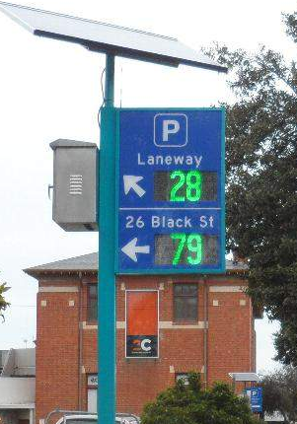
In-ground vehicle detection sensors were installed at on- and off-street locations in the Church Street MAC supported by dynamic parking guidance/availability signage. The signage guides drivers to available parking spaces using the data provided by the in-ground sensors. A total of 451 in-ground parking sensors were installed as well as 10 dynamic and 4 static parking guidance signs.
Post-implementation surveys found that the signage was viewed positively by the public, with most shoppers and traders finding them to be a helpful addition for them to find an available car park. However, there was less awareness and support for the mobile app – UbiPark – which was intended to supplement the parking guidance system.
Together with the positive feedback from the users of the system, Council officers have noted that the parking data collected by the sensors will be useful going forward to assist Council in making informed decisions on strategic planning, development applications and parking management.
Action 7: Council will continue to provide parking enforcement services which promote safety, compliance and respond to community parking needs.
Action 8: Council will seek to increase enforcement activity in the vicinity of worksites to ensure that workers are abiding by the restrictions of the area and meeting the conditions of the road occupancy permit.
Action 9: Subject to implementation requirements being met, Council will install smart parking technology (including in-ground vehicle detection sensors and dynamic and static wayfinding signage) at activity centre locations including Bay Street, Hampton Street, Sandringham Village, Martin Street, Beaumaris and Black Rock, in both on- and off-street spaces.
Action 10: Make use of smart parking technology to enhance enforcement operations.

Emerging Technologies
Conventional projections of parking demand assume that the current model of individual car ownership and use will continue. An alternative view is that emerging technologies and private travel alternatives, such as car share, e-bike/e-scooters and driverless cars, will obviate the need for households to own their own vehicles. Instead, a range of transport options would be made available to users through, for example, an app, which will give users the options based on their specific travel needs and circumstances.
Once fully automated electric vehicles (AEVs) reach the market, it is expected that they could drive further strong growth in the uptake of private travel alternatives (and decline in household car ownership), as they would be able to provide 24/7 on-demand travel at lower cost than buying one’s own vehicle.
Within the next 10-years, the impacts of these emerging technologies on private vehicle ownership are likely to be minimal. However, when considering the future of parking on Bayside, it is important to consider the best approach to creating resilient options that can adapt in years to come to the changing nature of transport.
As the intent of these technologies is to provide transport users with door-to-door transport options, and thus remove the need for household car ownership, the need for both residential and destination parking would decrease as more people shift to this model. While in the longer term AEVs are likely to be a key component of this service, for the immediate term the ‘offer’ will likely continue to include car-sharing (including peer-to-peer sharing), ride sharing (including in mini-buses), as well as bike-sharing. Once people feel confident that all their transport needs can be provided for by alternative means (whether this happens before or after the introduction of AEVs), they will likely move away from car ownership. This will enable car-spaces, both in the public and private realm, to be re-purposed (to higher value uses).
Details of some of the emerging technologies that are likely to influence the use of private vehicles and parking behaviour over the next 10 years are discussed in the following sections.

Electric Vehicles
Electric vehicles (EVs) are growing in popularity in Australia. Modelling undertaken by the Bureau of Infrastructure, Transport and Regional Economics (BITRE) suggests that the Australian EV share of new car sales is predicted to reach 8% by 2025 and 27% by 2030. The Victorian State Government has a target for half of new car sales to be zero emissions vehicles (ZEVs) by 2030. Furthermore, Victoria’s Zero Emissions Vehicle Roadmap predicts the total cost of ownership (TCO) of an EV is widely believed to reach price parity internationally by 2025 or earlier, driven largely by declining battery costs.
Against this backdrop, it is prudent for councils in urban areas such as Bayside to prepare for the expected growth in the number of EVs and their associated demands on the transport network. The use of electric vehicles will play a key role in achieving Council’s target of the community being carbon neutral by 2035.
Implementation of EV charging infrastructure is a fundamental step towards the wide-scale uptake of EVs. It is recognised that increasing the underlying electricity capacity to support the growth in EV charging is beyond the control of Council and is therefore not considered further as part of this strategy. However, Council will instead focus on the influence it can have on expanding the network of charging infrastructure in public and private buildings and public spaces, supporting the community and private industry and working with other Government organisations.

Existing Infrastructure
Currently there are very few public charging stations across Bayside, as shown in

Figure 7.3. An expansion of this network is required to support the desired increase in electric vehicle ownership and usage.

Figure 7.3: Public Charging Stations (Source: https://www.plugshare.com/)
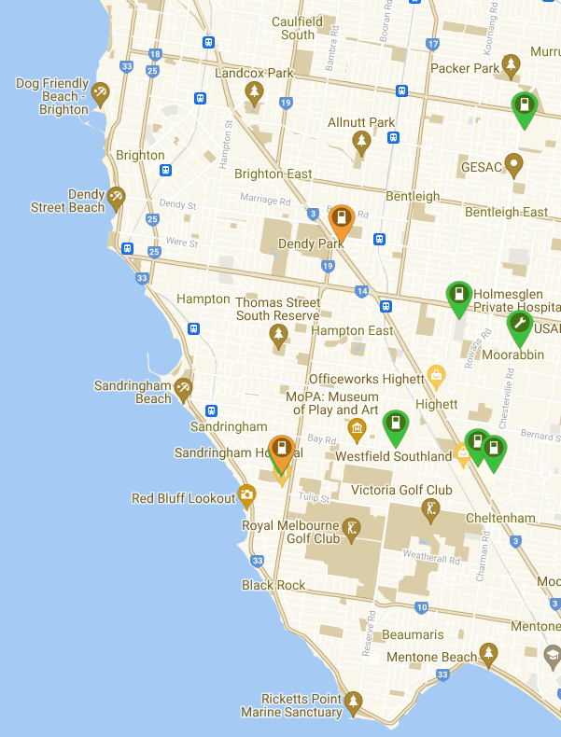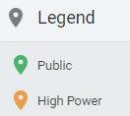

Facilities at Council buildings and within Public Spaces
Exploring the feasibility of recharging facilities at Council buildings and other public locations is consistent with Action 7 of the ITS and Action 3.1 of the Climate Emergency Action Plan. The existing facility provided at the Council’s Corporate Centre in Royal Avenue, Sandringham, is similar to what could be rolled out to other locations, with high-visitation locations to be prioritised for installation.
In 2021, Council identified strategic locations for EV charging station installation in Council’s owned carparks. The methodology for prioritising sites was based on factors such as traffic volume, support for the local economy, visibility and ease of access, and the spread of sites across the municipality.
A total of 11 locations were proposed with the shortlist provided in the table below.

List of prioritised sites for public EV charging station installation
Priority Zones | Priority | Site Address | Suburb | Indicative Implementation Timeline
1 | 1 | 22-26 Black Street | Brighton | On Hold
1 | 2 | Marion-Willansby | Brighton | 2021 - 2023
1 | 3 | 1 Mills Street | Hampton | 2022 - 2024
1 | 4 | 18 Keiller Street | Hampton East | 2023 - 2025
1 | 5 | Sandringham Family Leisure Centre | Cheltenham | 2024 - 2026
2 | 6 | Middle Brighton Baths | Brighton | 2025 - 2027
2 | 7 | Jetty Road Carpark (Bottom) | Sandringham | 2026 - 2028
2 | 8 | 37 Bluff Road | Black Rock | 2027 - 2029
2 | 9 | Livingston Street Community Hub | Highett | 2028 - 2030
3 | 10 | Dendy Park | Brighton East | 2029 - 2031
3 | 11 | Beaumaris Reserve Carpark (South) | Beaumaris | 2030 - 2032
The Black Street site has been put-on hold, pending further investigation as preliminary findings identified that there is insufficient network capacity in the area to accommodate EV charging infrastructure. Council has progressed installation in the Marion-Willansby carpark which will receive two DC fast chargers via a lease and service subscription model.
Depending on the characteristics of each subject site, Council will consider three management models for the implementation of EV charging infrastructure. These include own and manage, lease with a service subscription, and incentivise the market. In scenarios where the preferred option is a leave and subscription model, Council will initiate Expression of Interest (EOI) processes, seeking market interest in installing EV charging infrastructure in a public space. Private companies would be required to provide and maintain the charging facilities and would collect any revenue but there would need to be sufficient demand for this to be a viable investment.

New Developments
All new commercial/industrial/large scale residential developments should be encouraged to include an appropriate standard of EV charging infrastructure. This would be consistent with the new Environmentally Sustainable Development (ESD) Local Policy proposed to be included in the Bayside Planning Scheme to ensure that new development in Bayside achieves best practice in environmental sustainability from the design stage through to construction and operation.
For private commercial sites, this would generally be expected to take the form of a networked EV charging system within the carparks of the facility. Credit cards or membership cards could be used to collect revenue, or alternatively, proximity cards or fobs could potentially be used to prevent unauthorised usage of the charging facilities (for example, set aside for staff only). A small number of fast chargers could also be provided for customers and visitors.
The approach for multi-residential developments would be similar to private commercial, although in some instances residents may want to have dedicated charging stations for their personal use only. Again, a networked system could be used with demands dynamically managed, with a small number of fast chargers for visitors.
It is acknowledged this is an emerging sector and whilst full-scale EV charging infrastructure may not be installed as part of new developments, infrastructure facilitating future installation (conduit) is recommended to be included in the scope of new developments of this nature.
Council will advocate for the introduction of a state-wide approach to EV charging infrastructure requirements for new developments.
An example of policy change that has been implemented in the UK is detailed below. Whilst this relates specifically to the UK, it can be viewed as an example of the types of planning changes that may be introduced in Victoria over the next 10 years. The Victorian Zero Emissions Vehicle Roadmap contains actions related to ‘EV-readiness’ in new buildings and retrofitting of infrastructure supporting EV charging in existing buildings, including residential dwellings.
Case Study – England Building Regulations Changes
From June 2022 all new homes with off-street parking and those undergoing major renovation must now provide EV charging facilities for residents. These building regulations, Part S, will soon come into force in England following the UK government’s announcement of building regulation changes in July 2019. The proposal forms part of the government’s aim to improve the availability of EV charge points ahead of the UK’s ban on new petrol and diesel vehicles in 2030.
The regulations will be as follows:
- Every new home, including those created from a change of use, with associated parking must have an EV charge point.
- Residential buildings undergoing a major renovation which will have more than 10 parking spaces must have at least one EV charge point per dwelling with associated parking, along with cable routes in all spaces without charge points.
- All new non-residential buildings with more than 10 parking spaces must have a minimum of one charge point and cable routes for one in five (20%) of the total number of spaces.
- All non-residential buildings undergoing a major renovation that will have more than 10 parking spaces must have a minimum of one charge point, along with cable routes for one in five spaces.
In addition, all new private EV chargers are to be ‘smart’, ensuring that vehicles can be charged during off-peak hours, or when the demand is low in order to reduce strain on the grid.
It is worth noting that 1 in 6 new cars in the UK are EVs compared to 1 in 50 cars in Australia. With the right supporting infrastructure, growth in use and ownership of EVs is likely to continue to increase closer to the rates seen in the UK.

Policy Development
The process for encouraging, enabling and guiding the installation of EV infrastructure can be documented in an Electric Vehicle Charging Policy, which would detail how Council can support the opportunities on both public and private land.
Details to be contained within a formal policy should include:
- Charging infrastructure unit options
- Assessment criteria for placement of infrastructure
- Location requirements
- Responsibility for installation and maintenance
- Infrastructure targets
Action 11: Council will support the use of electric vehicles through:
- Explore the feasibility of installing recharging facilities at Council buildings and other public locations
- Initiate an Expression of Interest (EOI) processes for market interest to install EV charging infrastructure on Council managed land
- Advocate for a state-wide approach to EV charging infrastructure requirements for new developments
- Encourage all new commercial/industrial/large scale residential developments to include an appropriate standard of EV charging infrastructure
- Develop an Electric Vehicle Charging Policy to provide clarity in respect of the provision of electric charging facilities within public spaces and how Council can support the opportunities on both public and private land
- Seek to encourage Environmentally Sustainable Development (ESD) targets for new development – outcomes from the CASBE project Elevating ESD Targets Planning Policy Amendment.

Car Share
Car share refers to the car sharing services offered by individual companies such as GoGet, PopCar and CarNextDoor where cars are available to rent by the hour by members and as such is available on demand. Car share is becoming increasingly common in areas in Metropolitan Melbourne with services such as GoGet commonly providing car share vehicles in both on-street and off-street environments.
Car share benefits include:
- reduced car dependency
- reduced vehicle kilometres travelled
- reduced congestion
- reduced carbon emissions
- reduced levels of car ownership and demand for parking.
There are three types of car sharing schemes, each one operating under slightly different business models.
Fixed base car sharing schemes: These schemes are run by commercial providers (for example, GoGet) who own the vehicle fleet. Vehicles are parked in either dedicated or standard parking spaces and typically operate in residential and commercial/business districts. Trips are all two-way as vehicles must be returned to the location from where they were collected.
Dockless car share schemes: These schemes are run by commercial providers who own the fleet. Vehicles are parked in designated pick-up points, but users can make one-way trips to other designated parking spaces within a defined area and leave the vehicle. This can provide a more convenient service for users who need a vehicle for only one segment of their trip but can result in a mass of vehicles left in one location.
Peer-to-peer car sharing schemes: These are managed by a commercial provider (for example, Car-Next-Door), but vehicles are privately owned and rented out to scheme members who often live close by. Predominantly these schemes operate in residential areas. These schemes are less common in Australia, with some Councils, such as City of Port Phillip, noting in their car share policy that this is not an acceptable scheme.
The most widely adopted scheme is the fixed base scheme, which is the preferred option for Bayside.
Some elements that contribute to the viability of a car share scheme include:
- Density of land use and restricted private parking supply – Car share in Melbourne and in other cities is more prevalent in areas with a high density of residents and workers (large catchment of potential users for car share) and where there is limited space for parking of private vehicles (parking scarcity disincentivises individual car ownership and parking).
- Car parking requirements for new developments – reductions in the statutory requirement for on-site car parking will contribute to the gradual decline in new parking supply.

Car Share Scheme Policy
Action 8 of the ITS is to ‘Facilitate the introduction of car share schemes through the development of policy tools to enable access to on-street parking for such schemes’.
A car share policy will set out the framework for managing car share parking in a fair and equitable manner, including criteria to be met by operators, the application process, location criteria and any fees payable to Council. It will define the criteria against which a request for a car share location would be assessed and assist Council when assessing the appropriateness of allocating on-street space to car share operators.
Items to be included in a car share policy will include:
- Details of the Application Process
- Siting and Location Criteria
  - Positioned for maximum usage, however, must also be balanced with other parking priorities
  - Provides guidance for car share operators in selecting appropriate sites
  - Alternatively, could indicate preferred locations as selected by Council
  - Locations consistent with the on-street hierarchy
- Fees
  - Charges payable to Council which covers the cost of administering the scheme and installation of car share bays
  - Also cover any lost revenue if car share bay is subject to paid parking
- Space Allocation
  - Either specification of a parking space for use by an ‘authorised vehicle’ only or through the creation of a ‘Parking Permit’ typology related to car share vehicles.
Preferred locations across the municipality will be dependent on the provider’s assessment, which would be based on the ability to be able to reach the greatest number of users.
Suitable locations likely to generate the most revenue would include activity centres and transport nodes, and high-density residential areas. Ideally there would be a spread of locations across the municipality that would make the use of car share facilities a feasible option for the majority of the population.
Within the policy, Council will establish a set of detailed guidelines that could be shared with operators to communicate Council’s expectation for car share spaces.

Guidelines will include:
- Preferred locations are near high-density residential areas, public transport and activity centres.
- The preference is to locate car share spaces within Council managed off-street car parks.
- Avoid locating car share spaces in on-street locations that would result in the loss of high demand parking spaces (for example, spaces exceeding 85% occupancy during business operating hours 8.30am – 5.30pm).
- On-street car share spaces should be located near an intersection or the beginning/end of a parking row.
- Consideration will be given to existing car parking demand when siting car share bays on-street.
- Preference is for on-street spaces to be located adjacent to public spaces, if possible, as to avoid business frontages.
- Consideration for repurposing spaces that are no longer required as loading zones, taxi bays or parking with very short-term restrictions.
- Consider opportunities to establish car share spaces in locations where street works have created new space (for example, redundant vehicle crossovers or relocated street furniture).
- Safely located (not blocking pedestrian sight lines, impede road access or impact accessibility).
- Avoid the provision of more than one car share space in the same location to encourage the spread of car share spaces across a wider area.
- Ensure that accessible car share bays meet the requirements of AS2890.5 and AS2890.6, including adequate clearance at the rear of the bay.
- Council will ultimately approve the subject location.
The target number of additional car share bays would be dependent on the financial viability of the spaces as assessed by the provider/s. However, a conservative target of 20 spaces per year will be adopted and reviewed on an annual basis.
Action 12: Council will trial the introduction of a car share scheme across strategic locations in Bayside
Action 13: Providing the car share trial is successful, support the introduction of car share schemes through the preparation of a car share policy that sets out the framework for managing car share parking, including the eligibility criteria for allocation of on and off-street parking for such schemes.

E-scooter/E-Bike Sharing
Traditional bicycle share services were first introduced in Melbourne in 2010. These services are cheap, easy to use, and help get people out of their private cars, reducing vehicle congestion and promoting a healthier lifestyle.
To use a share bicycle, a user downloads a mobile phone app, registers their details and provides payment before a bicycle can be unlocked to use. Helmets may or may not be provided to meet the mandatory helmet legislation requirements. After finishing the ride, a user must park their bicycle in an appropriate location and record that they have finished their journey in the mobile phone app.
There are two types of bicycle share schemes:
- Docked
  - In this system, bicycles are stored at designated bicycle stations. Users can pick up the bicycle from the station and must return it to a designated station. Modern bicycle share schemes are booked through a mobile phone app.
- Dockless
  - In a dockless system, users can pick up the bicycles from anywhere and drop it off in a safe place, usually on footpaths within the scheme operating area. The bicycles do not need to be returned to a designated station. The bicycles use a smart lock which is unlocked when someone books it and is locked after the user is finished with it. This is all done through a mobile phone app. The helmets are usually looped into and locked in the smart lock.
An e-bike system operates in a similar way but can only operate as a docked system which allows the bikes to be recharged.
The selection for the location of docking stations should be a collaboration between the operator, Council and public landowners to determine the optimal deployment plan which balances customer demand with public amenity. The placement may result in undesirable amenity and other impacts if they are not managed properly, with the preference for off-street storage of bicycles over placement on busy pedestrian footpaths. Space allocation for a docking station should also account for anticipated demand at a centre, with operators responsible for regularly removing and relocating bicycles that have been left in clusters at certain locations.
Case Study – Shared E-Bike Services Trial, Melbourne
In December 2020, the City of Melbourne, together with the City of Port Phillip and City of Yarra, signed a memorandum of understanding with Lime for a one-year trial of an electric bike share service, with the bikes available to book through the Uber or Lime app. The MOU contains details on how the trial is to be operated and the responsibilities for each of the parties, included guidance on bicycle deployment and parking, the size of the fleet and the requirements for monitoring and maintenance by the operator.
The trial was expected to be reviewed regularly, but there are no publicly available reports on the success of the trial.
E-scooter share services have become increasingly popular all over the world in the last few years. Similar to e-bike share schemes, these services are cheap, easy to use, and promote more sustainable forms of transport. They operate in a similar way to an e-bike system, with access to scooters via an app and the use of docking stations, and experience many of the same advantages and disadvantages. Parking is one of the ongoing issues, with adequate space required to be allocated to the docking stations preferably in an off-street location away from footpaths and busy pedestrian areas.
E-scooters share schemes were first trialled in Australia in the City of Brisbane in 2018 and was very successful with more than 1.5 million rides occurring in the first 10 months.
Case Study – E-Scooter Trial, Melbourne
Lime and Neuron Mobility were engaged by the City of Melbourne, City of Port Phillip and City of Yarra to provide residents and tourists with 1,500 e-scooters to ride on from February 2022.
E-scooters offer an alternative, sustainable and affordable transport option for the community and will provide an additional transport option that will increase the resilience of Melbourne’s transport system.
E-scooters have been legalised for private and commercial use in other states and territories. This trial will provide Victoria with evidence to consider longer term impact of these vehicles on our network.
The low-emission e-scooters can travel up to 20km per hour and can be accessed via the Lime and Neuron apps, similar to how you might hire a Lime e-bike. The vehicles can be used in bike lanes, shared paths and low-speed roads but not on footpaths – riders also must wear a helmet while riding and give way to pedestrians on shared paths.
The E-scooters can be ridden within the boundary of the metro local government areas and are contained by geofencing.
The scope for the latest Melbourne e-scooter trial is shown in Figure 7.4.
The basic rules for the use of e-scooters during the trial include:
- speed limit of 20km/h.
- e-scooter riders should behave the same way as bicycle riders and slow down to give way to pedestrians.
- special ‘no go’ and ‘go slow’ zones where speed limits are restricted will apply in high-traffic shared areas.
- e-scooters are not permitted on footpaths.
- e-scooters are not permitted on roads where there is a speed limit above 50km/h.
- you must wear a helmet.
- consider others when parking.
- no passengers.
Figure 7.4: E-Scooter Metro Trial Zone
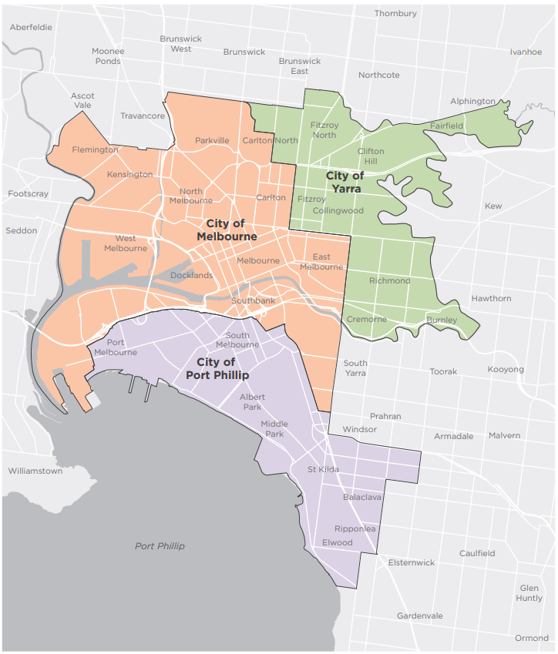
Bayside is located to the south of Port Phillip so is adjacent to the boundary of the current e-scooter trial. The three trial Council areas are very high-density residential and commercial areas, and the e-scooters are promoted as a transport option that will support short trips in low-speed environments. The population density of Bayside is much lower than these areas, with different travel behaviours, trip distances and mode splits. For a similar trial to have success in Bayside, it needs to consider the role that e-scooters/e-bikes would have in supporting the travel needs of the Bayside community. Trips that could be supported by these modes include recreational trips along the foreshore via the Bay Trail shared path, connecting Bayside to the network of shared paths in the City of Port Phillip and beyond, as well as commuter trips to and from the Melbourne CBD along this same route. Trips between the foreshore and busy trip attractors such as railway stations and activity centres could also be supported.
Based on this proposed role, the locations for docking stations could include foreshore areas such as Middle Brighton, Dendy Beach, Brighton Beach and Sandringham, as well as railway stations and activity centres which support the commuter usage. These e-scooter hubs should be located clear of pedestrian thoroughfares and such items as mailboxes, pedestrian crossings, parking meters, footpath dining and emergency access points. They should also not be located too close to bus zones and stops.
Appropriate locations would include along park frontages, adjacent to buildings away from the main pedestrian areas or in protected locations within off-street car parks.
Council will support the legal and safe use of E-bike and/or E-scooter schemes to be operational in Bayside. Council will collaborate with City of Melbourne, City of Port Phillip and City of Yarra to understand the results of the E-bike and E-scooter trials in their Council areas, to apply any learnings to a similar scheme in Bayside.
Action 14: Council will support the legal and safe use of E-bike and/or E-scooter schemes in Bayside, based on the findings of the scheme trials in neighbouring Councils and State legislative requirements.

Bicycle Parking
Adequate cycling infrastructure must be provided to increase the uptake of cycling as a primary form of transport across the municipality. This not only includes safe and accessible bike paths and lanes, but also bike parking options at destinations.
Traditionally, bicycle parking infrastructure in Bayside has been installed along the road reserve (back of kerb) at locations where there is known demand. This includes activity centres, parks, the foreshore and tourist destinations. Where areas exist with competing demand for footpath space (for example, due to outdoor dining and street trading), an on-road bicycle storage corral may offer pragmatic solutions for the following reasons:
- Reduces the need to place bicycle parking on footpaths
- Limit impacts on pedestrian movements
- Provides high storage capacity for bicycles (ten bikes in one car space)
Research shows that bicycle corral parking generates more business revenue per square metre than the car parking space it replaces.
Figure 11.5: Example of an on-street bike corral
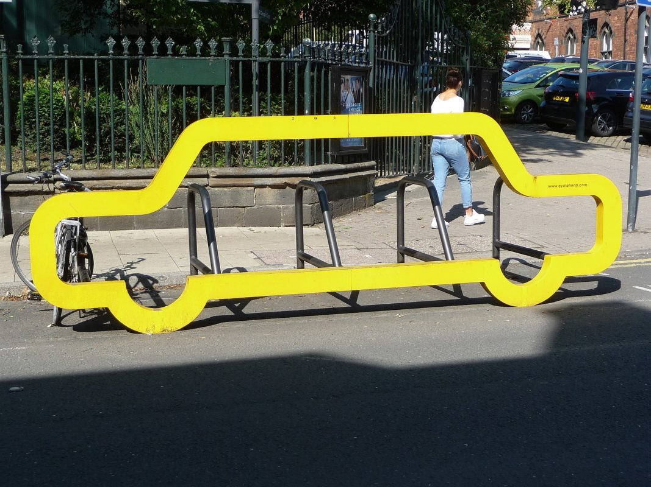
The implementation of bicycle corrals needs to be carefully considered against the parking management on-street user hierarchy, land use type, the availability of bicycle parking in the area and where there is known current or potential future demand.
Action 15: Investigate opportunities and implement bicycle corrals at locations where there is known current or potential future demand, with consideration of the parking management on-street user hierarchy, land use type and availability of bicycle parking in the area.

Development Parking Provision

Car Parking Rate Requirements
The provision of parking in new developments is guided by Clause 52.06 of the Bayside Planning Scheme.
Clause 52.06 identifies minimum car parking requirements that are mandated for developments. Table 1 to the Clause, identifies car parking rates for new or expanded land uses in two columns being Column A and Column B rates. Column A rates apply statewide and in general across Bayside, whilst Column B rates are applicable only within the 400m of the Principal Public Transport Network (PPTN).
Column B rates are also typically considered to represent the parking needs of a mixed-use precinct at the typical time of peak operation of the precinct (middle of the day on a weekday). These rates reflect an activity centre-based approach which incorporates consideration of:
- Sharing of parking between multiple land uses
- Linked and multipurpose trips
- Different land use peaks
- An element of improved access to public transport.
This is compared with the rates specified by Column A of Clause 52.06 of the Bayside Planning Scheme which are applied state-wide, and typically represent the parking needs of a land use at its peak operating time assuming that all of its parking will be accommodated on its own individual site.
Standard minimum parking requirements that currently apply can, however, have unintended negative consequences on quality urban design outcomes, development viability and property affordability, particularly in activity centres. Minimum parking requirements for developments can result in people paying for parking they do not need and can impact on the commercial viability of developments or changes of land use. Further, the provision of car parking can increase the ease of car use, countering Council’s sustainability objectives.
This must be balanced with the earlier parking principles, which require parking to be provided fairly ensuring that parking is available for those who need it, without unduly impacting those who do not or the quality of our activity centres and streets.
In response to individual circumstances, reductions to the statutory car parking requirements of Clause 52.06 can be (and are at times) approved by Council and the Victorian Civil and Administrative Tribunal (VCAT) through consideration of a series of Decision Guidelines set out within Clause 52.06 of the Planning Scheme.
Alternate specific car parking rate requirements for local areas can also be formally introduced through a Parking Overlay at Clause 45.09 of the Bayside Planning Scheme. The Parking Overlay provides the opportunity to realign the expectations of Council, developers and the community on what is an appropriate provision of car parking for new developments within a particular area.
The role of this strategy is not to define individual land use car parking rates, however it is acknowledged that consideration of development car parking precinct plan requirements requires further investigation. This will be undertaken at a local level at the time of preparing individual parking precinct plans for specific areas. This enables full consideration to be given to the local accessibility characteristics, existing parking demands and needs of users of the centre.
Acknowledging the context of Bayside (its demographics and level of accessibility), it is likely that should changes to car parking rate requirements be made that they would most likely reflect reduced minimum car parking requirements (to that of Column A and B of Table 1 to Clause 52.06 of the Bayside Planning Scheme). This is particularly relevant when recognising that a majority of housing and commercial (retail and office) growth is expected to occur within or surrounding activity centres where public transport access is good and access to key services will be within acceptable walking and cycling distances.
This does not preclude the adoption of a maximum car parking rate approach within specific areas of the municipality should this be determined appropriate during the preparation of a specific parking precinct plan; however, it is acknowledged that such an approach may not be applicable at this time.
Action 16: Council will consider preparing individual parking overlays to identify appropriate car parking rates to be applied to new developments having regard to local accessibility characteristics, existing parking demands and user needs. The delivery of this action is dependent on Action 2.

Green Travel Plans
A Green Travel Plan (GTP) outlines actions and initiatives to promote sustainable, non-motorised modes of transport such as walking, cycling and public transport.
The main features of GTPs are:
- Aim/Purpose: What is the aim of the plan? What are they trying to achieve? These should be linked with the targets and actions in the plan.
- Background: Provides context and discusses sustainable transport opportunities.
- Targets: Targets in GTPs are usually mode share increases in the desired modes of transport. These targets should be SMART (Specific, Achievable, Measurable, Relevant and Time-based).
- Actions: This is the most important section of the plan. It includes what actions are to be taken, who is responsible and the associated timing.
- Monitoring: The GTP should be monitored to ensure that it is working and on course to meet the targets. Ideally, this should be done annually.
Some of the ways in which GTPs can be beneficial include:
- Increases awareness of transport modes other than the private car
- Encourages the use of sustainable and active transport modes
- Provides staff/residents with relevant information to facilitate the uptake of sustainable forms of transport
GTPs can be prepared and introduced for existing developments, such as workplaces and large residential developments, and provide information and encouragement to consider alternate modes of transport. However, they can be most effective when implemented during the planning stages of a development where transport mode choice and routines have not yet been established for travel to and from a land use.
Councils can include a statutory requirement as part of the planning process which requires developers to issue a GTP as part of their planning permit application, for both residential and commercial land uses. These are typically set out in the environmentally sustainable development (ESD) policy clauses of the planning scheme.
Developers should be required to include a GTP in their permit application outside of any statutory requirement to support their proposal when, for example, the proposal includes less parking than the statutory requirement.
Case Study – Council Green Travel Plan requirements
Councils that currently have the preparation of GTPs as a requirement within their planning system include City of Melbourne, City of Port Phillip, City of Kingston, City of Yarra and City of Stonnington. The types of developments that trigger a statutory requirement for a GTP for these Council areas are summarised below:
- City of Melbourne:
Specific development areas are identified, namely the public housing renewal project in Abbotsford Street, North Melbourne (Schedule 12 To Clause 43.04 Development Plan Overlay) and the comprehensive development zone at 550 Epsom Road, Flemington (Schedule 4 To Clause 37.02 The Comprehensive Development Zone)
- City of Port Phillip:
All non-residential developments with gross floor area of more than 1,000m²
- City of Kingston:
All residential / mixed used development with 10 or more dwellings
All non-residential developments with gross floor area of more than 2,499m²
- City of Stonnington:
All non-residential developments with gross floor area of more than 1,000m²
- City of Yarra:
All non-residential developments with gross floor area of more than 1,000m²
Specific development areas are also identified, namely 64 Alexandra Parade, Clifton Hill (Schedule 19 To Clause 43.02 Design And Development Overlay), Jaques Development Site Richmond (Schedule 4 To Clause 43.04 The Development Plan Overlay), Amcor Site at Heidelberg Road, Alphington (Schedule 11 To Clause 43.04 The Development Plan Overlay) and 81-95 Burnley Street And 26-34 Doonside Street, Richmond.
Action 17: Council will support existing developments seeking to prepare Green Travel Plans.
Action 18: Council will investigate the statutory mechanisms to require the preparation of Green Travel Plans for new developments.

Place-making and Car Parking
The Department of Transport’s Movement and Place framework creates a new emphasis on not just providing space for the movement of people but also the creation of ‘place’ within our city. It is important to create ‘places’ within our activity centres and communities to support people being able to dwell, shop, live, mingle, relax and enjoy. Some simple examples include creating improved pedestrian space and connections, parklets to support outdoor dining and public dwelling places. Examples can also be extended to include creating larger scale public parks or community facilities.
To support creating place outcomes the implications on car parking can be considered from two perspectives – removal and consolidation.
‘Removing’ parking typically involves the loss of a small number of parking spaces to achieve small place outcomes such as parklets or improved pedestrian facilities.
‘Consolidating’ parking can enable larger change outcomes through the consolidation of multiple public off-street parking facilities into a single often multi-level car park however enabling larger change outcomes on the sites where parking has been removed.
Bayside’s suburban form and accessibility needs mean many people will continue to rely on publicly available parking in activity centres. However, Council should be considerate of urban space improvement opportunities as they arise and weigh up the improved place outcomes with the removal or consolidation of public parking.
Action 19: Council will consider opportunities to remove and/or consolidate public parking facilities where place making opportunities arise that can provide better community outcomes.

Ownership of Parking (unbundling)
Unbundled car parking refers to the unbundling of the ancillary parking spaces from a development, whereby the parking spaces are on separate titles to the individual dwellings or commercial units and as such can be purchased, sold or leased separately.
This means that under a scenario without any minimum parking requirements, new developments that choose to provide parking would be able to sell individual parking spaces to purchasers of units or dwellings in the development (or even third parties) separate to the sale of those units or dwellings. Owners of those parking spaces would subsequently be able to on-sell or lease parking spaces to other parties in the same way as other types of real estate.
This alternative framework is in contrast to the traditional bundling of parking spaces with a development where parking is attached to an individual dwelling or commercial unit and in a situation with minimum parking requirements, had to be provided irrespective of need. This bundling, which is enforced via the minimum parking regulation, does not allow the owner/occupant of a dwelling or commercial unit to sell or lease that parking space should the need for parking no longer arise.
The unbundling of parking assists to highlight the true cost of car parking and assists purchasers to make an informed decision on the need for car ownership.
Unbundled parking should be considered as part of private development applications to assist in supporting the parking principle of protect the environment and amenity.
Council’s role is to consider unbundled parking proposals in new developments on a case-by-case basis, where the applicant has provided expert traffic analysis and advice. This will take into consideration relevant data such as car ownership rates and access to alternative modes of transport.
Action 20: Council will consider developments seeking to unbundle car parking from land use.

Action Plan
Strategic Objective 1: Parking Management
The management of on-street parking resources will be maximised so that sufficient parking opportunities are available for those who need it.
Strategy |  | Actions |  | Timeframe |  | Costs |  | Responsible
Ensure that sufficient parking opportunities are available for those who need it now and in the future. |  | - Implement the on-street parking hierarchy to guide the allocation of parking spaces where competing demands exist. |  | Ongoing |  | Officer time |  | Traffic Engineering
 |  | - Develop an assessment criterion to establish when a specific Parking Precinct Plan is required to manage existing and future parking demands of a specific local area. |  | 2023/24 |  | Officer time |  | Strategic Planning, Traffic Engineering and Transport Planning
Ensure adequate supply and layout of accessible parking |  | - Review and audit the location and design of on- and off-street publicly provided parking spaces for persons with a disability to ensure that these spaces are appropriately located to meet user needs and designed to provide safe and appropriate access. |  | 2023/24 |  | Officer time |  | Traffic Engineering and Community Wellbeing
 |  | - Support parking for persons with disabilities through the provision of on- and off-street accessible parking having regard to appropriate influencing factors. |  | Ongoing |  | Approx: $600k |  | Traffic Engineering, and Community Wellbeing
Implement permit schemes which support the parking needs of local residents whilst also aligning with sustainable transport goals to reduce the reliance on private vehicle travel and car ownership |  | - Council will prepare an updated resident permit scheme that:  - Continues to provide access to parking permits for residential properties. Multi-unit developments (3 units or more) constructed after 1 July 2007 will not be eligible to obtain parking permits.  - Introduce paperless electronic permits to limit potential misuse. |  | 2023/24 |  | Officer time |  | Traffic Engineering and Local Laws
 |  | - Council will support provision of trader parking as follows:  - In locations where there is strong demand and the need for trader parking is justified and supported by the community, Council will develop a Trader Parking Permit Scheme at a cost to traders  - If Council proceeds to enable a Trader Parking Permit Scheme, Council will develop a trader parking permit scheme policy  - Encourage employers to allocate on-site parking for customers and employees with specific needs where possible  - Provide safe and inclusive parking areas, including pedestrian routes to and from car parking.  - Ensure that on-site parking within businesses is not repurposed into storage or additional floor space. |  | Ongoing |  | Officer time |  | Traffic Engineering, Economic Development, Local Laws and Communications & Engagement
Strategic Objective 2: Efficient Operations
Ensure parking operates efficiently through enforcement, signage and smart technology.
Strategy | Actions |  | Timeframe |  | Costs |  | Responsible
Manage the efficient use of parking facilities through the provision of parking enforcement services | - Continue to provide parking enforcement services which promote safety, compliance and respond to community parking needs. |  | Ongoing |  | Officer time |  | Local Laws
 | - Increase enforcement activity in the vicinity of worksites to ensure that workers are abiding by the restrictions of the area and meeting the conditions of the road occupancy permit. |  | Ongoing |  | Officer time |  | Local Laws
Use technology to support parking management and enforcement | - Subject to implementation requirements being met, Council will install smart parking technology (including in-ground vehicle detection sensors and dynamic and static wayfinding signage) at activity centre locations including Bay Street, Hampton Street, Sandringham Village, Martin Street, Beaumaris and Black Rock, in both on- and off-street spaces. |  | 2025/26 and ongoing |  | Approx. $320k - $653k per centre |  | Traffic Engineering and Transport Planning
Use technology to support parking management and enforcement | - Make use of smart parking technology to enhance enforcement operations. |  | 2023 and ongoing |  | Officer time |  | Local Laws

Strategic Objective 3: Emerging Technologies
Consider the impact that existing and emerging technologies will have on public parking and make provision for incorporating these technologies across the municipality, including electric vehicles, car share, driverless cars and E-scooter/E-bike sharing.
Strategy | Actions | Timeframe | Costs | Responsible
Support the introduction of low-carbon and sustainable transport modes through support for infrastructure requirements and updates to planning controls | - Support the use of electric vehicles as follows:  - Explore the feasibility of installing recharging facilities at Council buildings and other public locations  - Initiate an Expression of Interest (EOI) processes for market interest to install EV charging infrastructure on Council managed land  - Advocate for a state-wide approach to EV charging infrastructure requirements for new developments  - Encourage all new commercial/industrial/large scale residential developments to include an appropriate standard of EV charging infrastructure  - Develop an Electric Vehicle Charging Policy to provide clarity in respect of the provision of electric charging facilities within public spaces and how Council can support the opportunities on both public and private land  - Seek to encourage Environmentally Sustainable Development (ESD) targets for new development – outcomes from the CASBE project Elevating ESD Targets Planning Policy Amendment. | 2023 and ongoing | Officer time | Climate, Environment and Sustainability, and Transport Planning
 | - Trial the introduction of a car share scheme across strategic locations | 2022/23 | Officer time | Transport Planning
 | - Providing the car share trial is successful, support the introduction of car share schemes through the preparation of a car share policy that sets out the framework for managing car share parking, including the eligibility criteria for allocation of on and off-street parking for such schemes. | 2023/24 and ongoing | Officer time | Transport Planning
 | - Support the legal and safe use of E-bike and/or E-scooter schemes in Bayside, based on the findings of the scheme trials in neighbouring Councils and State legislative requirements. | 2025 and ongoing | Officer time | Transport Planning
 | - Investigate opportunities and implement bicycle corrals at locations where there is known current or potential future demand, with consideration of the parking management on-street user hierarchy, land use type and availability of bicycle parking in the area. | Ongoing | Investigation: Officer time  Implementation: Approximately $8k per site | Transport Planning and Economic Development

Strategic Objective 4: Development Parking Provision
Ensure that new developments provide appropriate levels of parking whilst also having consideration for other modes of travel, including access to e-vehicle charging stations.
Strategy | Actions | Timeframe | Costs | Responsible
Ensure development car parking rates are appropriate for a specific area that meets the needs of an area whilst avoiding the promotion of car ownership and car-dependant travel. | - Consider preparation of individual parking overlays to identify appropriate car parking rates to be applied to new developments having regard to local accessibility characteristics, existing parking demands and user needs. The delivery of this action will be dependent on Action 2. | Dependent on Action 2 | Approximately $250k per overlay | Strategic Planning, Traffic Engineering and Transport Planning
 | - Support existing developments seeking to prepare Green Travel Plans. | Ongoing | Officer time | Transport Planning
 | - Investigate the statutory mechanisms to require the preparation of Green Travel Plans for new development. | 2024/25 | Officer time | Strategic Planning and Transport Planning
Promote local amenity by considering the place-making benefits of reallocating car parking spaces in high-value public spaces. | - Consider opportunities to remove and/or consolidate public parking facilities where place making opportunities arise that can provide better community outcomes. | Ongoing | Officer time | Strategic Planning and Transport Planning
 | - Council will consider developments seeking to unbundle car parking from land use. | Ongoing | Officer time | Strategic Planning and Transport Planning

Cost to Deliver Strategy
The indicative costing to deliver this strategy is approximately $5.1 million, excluding Officer time. This consists of:
- Action 4: Approximately $600k
- Action 9: Approximately $2.6 million
- Action 15: Approximately $40k ($8k per site, total for eight sites)
- Action 16: Approximately $1.75 million (7 Major Activity Centres x $250,000)
- Biennial parking surveys and data analysis: Approximately $75,000
Appropriate funding and resources are required to enable the successful delivery of this Strategy.

Monitoring and Evaluation
There are several variables that influence car parking, including demographics, travel characteristics and land use development. These items will continue to change and evolve over coming years. As such the effectiveness and appropriateness of this strategy must also continue to be reviewed and updated.
The Parking Strategy implementation progress report will be presented to Council via the Integrated Transport Strategy update with the purpose of outlining the progress made against the delivery of actions.
It is proposed that Council undertake biennial parking surveys to monitor parking demand and inform parking management processes and planning decisions.
A more formal review of this strategy will be completed five years after its implementation. The Strategy review will consider the need for further parking management interventions to ensure sustainable parking practices are maintained across the municipality.

Appendix
Methodology
Research
Policy research consisted of a review of all relevant Council documents and the approach to parking included in the various documents, including:
- Council’s Plans, Strategies and Policies, including but not limited to:
  - Managing On-Street Car Parking Demand Policy
  - Residential Parking Permit Scheme
  - Foreshore Parking Permit Policy
  - Integrated Transport Strategy
  - Bicycle Action Plan
  - Climate Emergency Action Plan
  - Council Plan 2021-2025
  - Bayside 2050 Community Vision
  - Disability Action Plan 2021-2025
  - Property Strategy
  - Urban Forest Strategy
- Policies and Plans from surrounding Councils which outline their approaches to parking management
- Findings from community consultation conducted by Council, including community engagement undertaken in April 2022 and the annual Community Satisfaction Survey.
Demographic data was obtained from:
- ABS Census data, including car ownership, dwelling type, mode of travel to work and forecast growth
- Victorian Integrated Survey of Travel and Activity (VISTA) data of household travel behaviour statistics
Parking data analysed as part of the study included:
- Peak weekday and weekend demand data collected in July 2022 in seven of Council’s activity centres
- Demand and duration-of-stay data collected as part of the parking technology in the Church Street Activity Centre
Details of the key findings from the project research is provided later in the Strategy, under Heading 6.

Community Engagement
Community consultation was conducted at the commencement of the study to collect information on the needs and concerns of the community in relation to parking. Findings from other relevant community engagement and research was also considered, including the Community Satisfaction Survey. Details of relevant findings from engagement programs is provided later in the Strategy, under Heading 11.
Development of Principles and Actions
A set of principles have been developed that respond to the key themes identified during the background review stage and which are consistent with the goals and vision relating to parking across Council’s other strategic documents. Actions based on best-practice parking management techniques have been prepared to ensure that Council can meet the key objectives of this Strategy, under Heading 7 and 15. 5.
Study Area
Land Use
The City of Bayside is located 8 kilometres south of Melbourne's CBD, covering 17km of Port Phillip's coastline. Whilst more than 104,000 people live within the municipality, only 26% of these residents also work within Bayside. The majority of the remaining population work in the municipalities of Melbourne (23.6%) to the north and the neighbouring Kingston (10.4%) to the south (ABS Census, 2016).
On a strategic level in accordance with the Bayside Planning Scheme Clause 02.03-1, Bayside contains five Major Activity Centres: Bay Street in Brighton, Church Street in Brighton, Hampton Street in Hampton, Hampton East (part of the Moorabbin Activity Centre) and Sandringham.
These activity centres are clustered along the Sandringham railway line (other than Hampton East which is located on the Frankston Line), which acts as the main public transport route through the municipality, together with the Frankston Railway Line along the eastern boundary. The Nepean Highway is the main north-south arterial road within the area, running along the north-eastern boundary, whilst Beach Road follows the western coastline. Council manages approximately 357km of local roads across the municipality and approximately 700km of footpath.
Outside of the major activity centres, large neighbourhood activity centres also play a role in servicing the local retail and business needs of the Bayside community. This includes Martin Street (Brighton) and Highett, positioned around train stations, and the foreshore locations of Beaumaris and Black Rock. Many other smaller neighbourhood centres are positioned along the bus routes, predominantly in the south of Bayside.
Industrial land uses are mostly located outside the municipality to the east, except for the Bayside Business District in Cheltenham, between Sandringham in the west and Southland just outside the Council boundary in the east.
Apart from these retail and commercial land uses, Bayside is a predominantly residential area, consisting of a mix of detached houses and a small proportion of medium/high density dwellings, supported by a mix of complementary local land uses including small commercial activity centres, schools, hospitals and parks and recreational areas.
Since 2011, there has been an increase in the proportion of medium and high-density dwellings and a reduction in the proportion of detached houses. The increase in medium/high density dwellings has occurred mostly along the major rail corridors and in the activity centres, where there is access to facilities and public transport. In suburbs located in the south of Bayside, such as Beaumaris, there is a greater proportion of detached houses, access to public transport is limited to buses only and there is a greater distance to travel to a major activity centre. As a result, the requirement for travel needs to be supported by private vehicle is higher than suburbs further to the north of Bayside.
The foreshore is a key attraction for both local residents of Bayside and visitors from outside the municipality. As an important tourist destination, high visitation is experienced at various beach locations along the coastline during the summer months.
The study area is shown in Figure 11.1.

Figure 11.1: City of Bayside Study Area
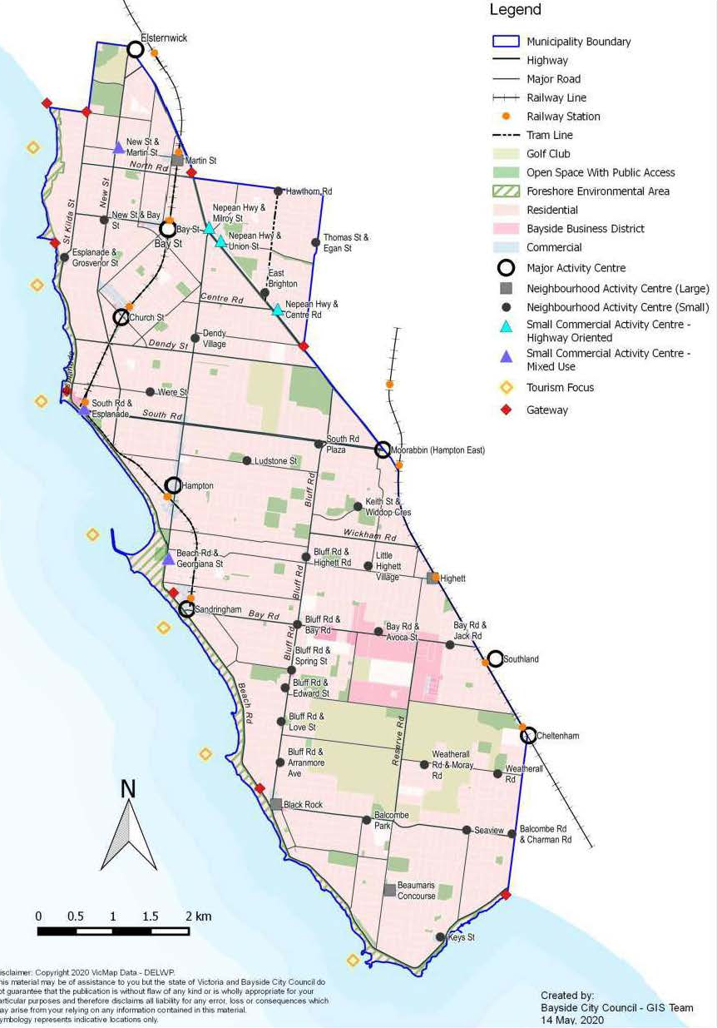

Transport Network
Road network
The Nepean Highway is the main north-south arterial road within the area, running along the north-eastern boundary, whilst Beach Road follows the western coastline. A regular grid network of arterial roads runs in both an east-west and north-south direction, as shown in Error! Reference source not found..
Public transport
Bayside is serviced by two railway lines – the Sandringham railway line links the major activity centres and services in the north, northwest and central sections of the municipality, whilst the Frankston Railway Line runs along the north-eastern boundary of the municipality. Buses run along the main arterial roadways throughout the municipality and is the sole mode of public transport servicing the southern suburbs of Bayside.
The Principal Public Transport Network (PPTN) reflects the routes where high-quality public transport services are or will be provided. It is a statutory land use planning tool that is designed to encourage more diverse and dense development near high-quality public transport to help support public transport usage.
The PPTN for Bayside is shown in Error! Reference source not found. and indicates that there are some locations within the central and northern parts of the municipality that are well serviced by high quality public transport, but most of the wider Council area is not. The PPTN is based on a 400m radius (for example, reasonable walking distance) around a railway station or bus/tram stop and therefore service quality can vary across the PPTN. The areas designated as being within the PPTN are incorporated in the Victorian Planning Provisions and must be considered by responsible authorities in decision-making.
Figure 11.2: Arterial Road Network  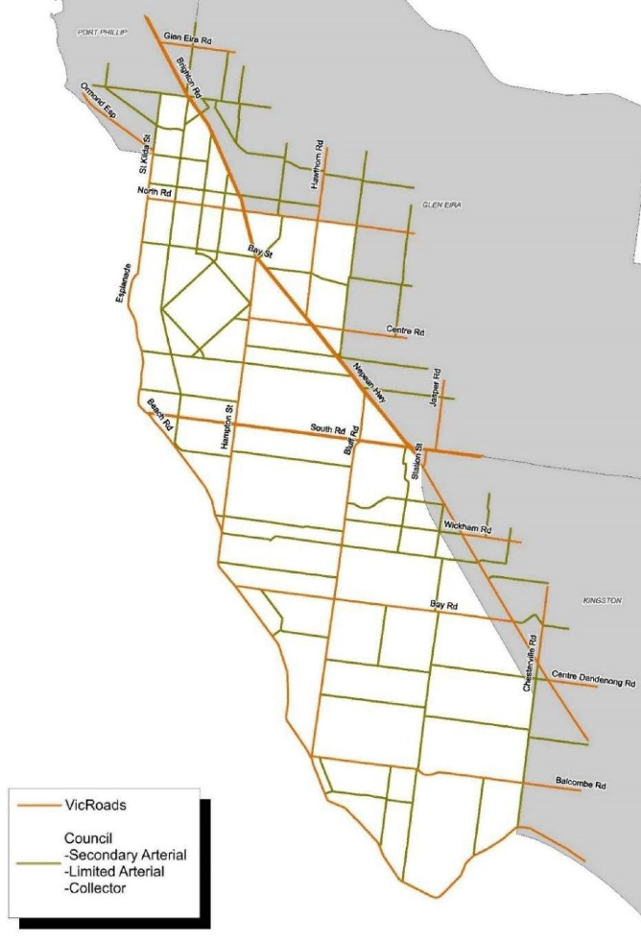  Source: Bayside Road Management Plan | Figure 11.3: Principal Public Transport Network – Bayside  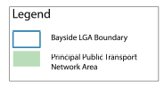  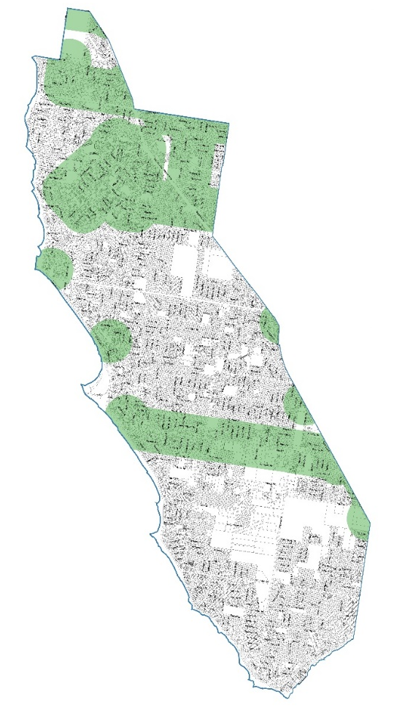
Active travel
Walking and cycling are popular recreational activities across the municipality, with Bayside’s foreshore and parks forming the basis of the network of recreational trails. The Bay Trail is an off-road trail that runs along the length of Bayside’s foreshore, consisting of a range of separated, segregated and shared bicycle and pedestrian facilities.
Outside of its popularity as recreation, walking and cycling for transport is not as well utilised for travel to school, commuting, accessing community facilities and making local shopping trips. Some identified barriers include the physical environment, safety concerns and lack of convenience and practicality.

Policy Context
State
Transport Integration Act 2010
The Transport Integration Act identifies decision making principles that are to be applied when undertaking transport planning activities and serves as the strategic framework to achieve an integrated and sustainable transport system.
The Act also includes six legislated objectives – social and economic inclusion; economic prosperity; environmental sustainability; integration of transport and land use; efficiency, coordination and reliability; safety, health and wellbeing. These objectives are underpinned by eight principles that further guide decision making.
Plan Melbourne 2017-2050
Plan Melbourne is the metropolitan planning strategy that sets out the long-term vision and strategies to guide the growth of Melbourne to 2050. The plan considers housing, transport, environment, jobs and community needs for Melbourne’s current and future population.
Movement and Place in Victoria
The Movement and Place Framework takes an aspirational future-focused, multi-modal approach to network planning. It takes into consideration the diverse role places play in planning the types of transport modes appropriate to a local road or street. In essence, the ‘movement’ function of the road or street must be balanced with the purpose of the destination, or ‘place’.
The framework offers a common language for coordinated transport planning between transport and planning agencies and local Governments. It also provides a consistent approach to assessing the performance of the road and transport network, identifying project requirements and assessing project solutions.
Planning Policy Framework
The PPF is the policy content of planning schemes. It includes part of the Victoria Planning Provisions (VPP) in the form of state and regional planning policies and local content in the form of local planning policies.
Relevant clauses and objectives are as follows:

Clause 18 (Transport)
Clause 18 recognises planning’s role in contributing to a safe, integrated, and sustainable transport system, and is consistent with the relevant strategies and policies that have been developed by the Department of Transport and its predecessors. The clause sets out planning objectives and strategies in two sub-clauses – Clause 18.01 Land Use and Transport relates to the transport system while Clause 18.02 Movement Networks relates specifically to each of the transport movement networks, including how to encourage an increase in the proportion of trips made by walking, cycling and public transport.

Clause 18.01 (Land Use and Transport)
The objective of this clause is to facilitate:
- access to social, cultural and economic opportunities by effectively integrating land use and transport
- the efficient, coordinated and reliable movement of people and goods by developing an integrated and efficient transport system
- an environmentally sustainable transport system that is safe and supports health and wellbeing.

Strategies within this clause consider transport users and how they move within a wider transport system, rather than considering each individual transport mode on its own. There is a significant focus on the requirement for urban areas and neighbourhoods to be developed in a way that supports public transport, walking and cycling transport modes, with reference to the movement and place framework prepared by the Department of Transport.
There are no specific references to car travel or parking within the strategies. However, it is noted that planning and development of the transport system is to prioritise the use of sustainable personal transport and support forms of transport that have the least environmental impact, which could include vehicles with non-combustion engines such as electric vehicles.

Clause 18.02 (Movement Networks)
Clause 18.02 sets out the objectives and strategies for each of the movement networks, including walking, cycling, public transport and roads.
Clause 18.02-3R (Principal Public Transport Network) relates to the routes where high-quality public transport services are or will be provided. It supports integrated transport and land use planning by encouraging more diverse and dense development near high-quality public transport to help support public transport usage.
From a car parking perspective, land that is within 400 metres of public transport on the Principal Public Transport Network (PPTN) will be subject to reduced car parking requirements under Clause 52.06.
Clause 18.02-4L (Car Parking) contains the following relevant strategies:
- Facilitate laneway widening, connectivity and visibility for the provision of off-street car parking where possible.
- Provide car parking to satisfy the needs of residents and their visitors and other road users.
- Preserve access to on-street car parking for shoppers, traders, disabled persons, workers, commuters and tourists in areas of high demand such as around railway stations, activity centres and the foreshore.
- Avoid development that would reduce existing numbers of public parking spaces in activity centres and along the coast.
- Provide off-street car parking and drop-off areas that are adequate to meet the needs of institutional uses.

Clause 45.09 (Parking Overlay)
The Parking Overlay enables Councils to respond to local car parking issues through the use of Schedules and can be used to outline local variations to the standard requirements in Clause 52.06.
The Bayside Planning Scheme contains Schedule 1 to Clause 45.09 ‘Public Housing Renewal - New Street, Brighton’. This Schedule acts to vary the car parking rate associated with dwellings, with specific rates associated to social and private housing on this site.

Clause 52.06 (Car Parking)
Proposed development land uses or modifications to existing land uses within Bayside City Council have associated off-street car parking requirements and rates. The car parking rates are set as a standard across Victoria with the option for local variances in car parking requirements. This clause also provides for the reduction of parking requirements as appropriate having regard to prescribed decision guidelines.
Clause 52.06 provides car parking requirements for a use listed as a product of the standard rates in Column A, or the lower rates in Column B of Table 1. The lower rates provided in Column B apply to those areas specified in a schedule to the Parking Overlay, or if any part of the land is identified as being within the PPTN.

Clause 52.34 (Bicycles)
This Clause seeks to encourage cycling and the provision of secure, accessible and convenient bicycle parking spaces and end of trip facilities. A new use must not commence, or the floor area of an existing use must not be increased until the required bicycle facilities and associated signage has been provided on the land. Subsection Clause 52.34-5 sets out the number and type of bicycle facilities required for different land use types.
Local – Municipal Planning Strategy
The Municipal Planning Strategy sets the foundation for Bayside’s local policies in the planning scheme by describing its context and setting out the vision and strategic directions for planning.

Clause 02.02 Vision
“Bayside will be a city which protects and enhances the quality and character of the natural and built environment through environmentally sustainable development and management of land.
Bayside will be an environmentally focused city in which its natural resources are valued, present needs are met, and development is responsibly managed for the benefit of current and future generations.”

Clause 02.03-1 (Settlement)
This Clause outlines Bayside’s hierarchy of activity centres, ranging from major activity centres that provide access to a wide range of goods and services through to small neighbourhood or commercial centres.
Bayside’s Major Activity Centres identified in the Clause are Bay Street, Church Street, Hampton Street, Hampton East (part of the Moorabbin Activity Centre) and Sandringham. These centres are unique when compared to other Major Activity Centres across Melbourne in that they are primarily nodes of population serving activities with considerably less supermarket or anchor floor space and much higher specialty store floor space contributing to the primarily retail focused role of the centres.
Bayside’s activity centres are examples of local activity centres performing well and providing high quality offerings.

Clause 02.03-4 (Built Environment and Heritage)
Bayside is renowned for its ‘village’ environment with distinct community precincts along the foreshore. Bayside is characterised by low rise residential suburbs, which have ample outdoor living space with predominantly tree lined streets, premium real estate and historic homes, much of it in a seaside setting. Council seeks to achieve built form and public realm design that conserves and enhances valued urban character and heritage places. Council also seeks to provide attractive pedestrian environments that are safe and accessible for people with all levels of mobility.
Council is committed to enhancing the sustainability of the built environment by encouraging development to incorporate environmentally sustainable design principles and natural resource management to benefit current and future generations.

Clause 02.03-7 (Transport)
Bayside is serviced by rail, a tram and buses; however, there are large areas of the municipality that rely principally on the private motor vehicle for transport.
Public transport use declines in suburbs south of Sandringham Station and west of the Frankston rail line. East-west connections using public transport are limited.
Bayside is largely a car-dependent municipality with the majority of households having two or more cars and the majority of residents using a motor vehicle to travel to work. Commuter parking is primarily the responsibility of Public Transport Victoria, with Council playing an advocacy role.
Providing car parking to satisfy the demands of all road users is one of the biggest challenges faced by Council. Increasing intensification of development across the municipality, has decreased the availability of on street parking and increased the number of vehicular trips on Bayside’s road network.
As part of this Clause, Council seeks to:
- Integrate transport and land use so that sustainable transport is an attractive and viable alternative to private vehicle use in Bayside.
- Support use and development that prioritises transport modes in the following order:
  - Walking
  - Cycling
  - Public transport, community transport including taxis and community run buses and demand responsive transport
  - Private vehicles
  - Commercial vehicles serving local areas.
- Improve local accessibility by prioritising walking and cycling as the preferred modes of transport for short trips in Bayside.
- Provide adequate car parking in and around shopping centres, employment areas and along the coast.
Local – Council’s Strategic Planning Framework
Figure 11.4 shows the structure of Council’s Strategic Planning Framework and the relationship between each of the strategies and plans. The Parking Strategy would sit below the Community Vision and be used to inform Council’s other Strategic Plans and Policies. The relevant local documents within this framework and their relationship to parking are discussed in more detail below.
Figure 11.4: Council’s Strategic Planning Framework
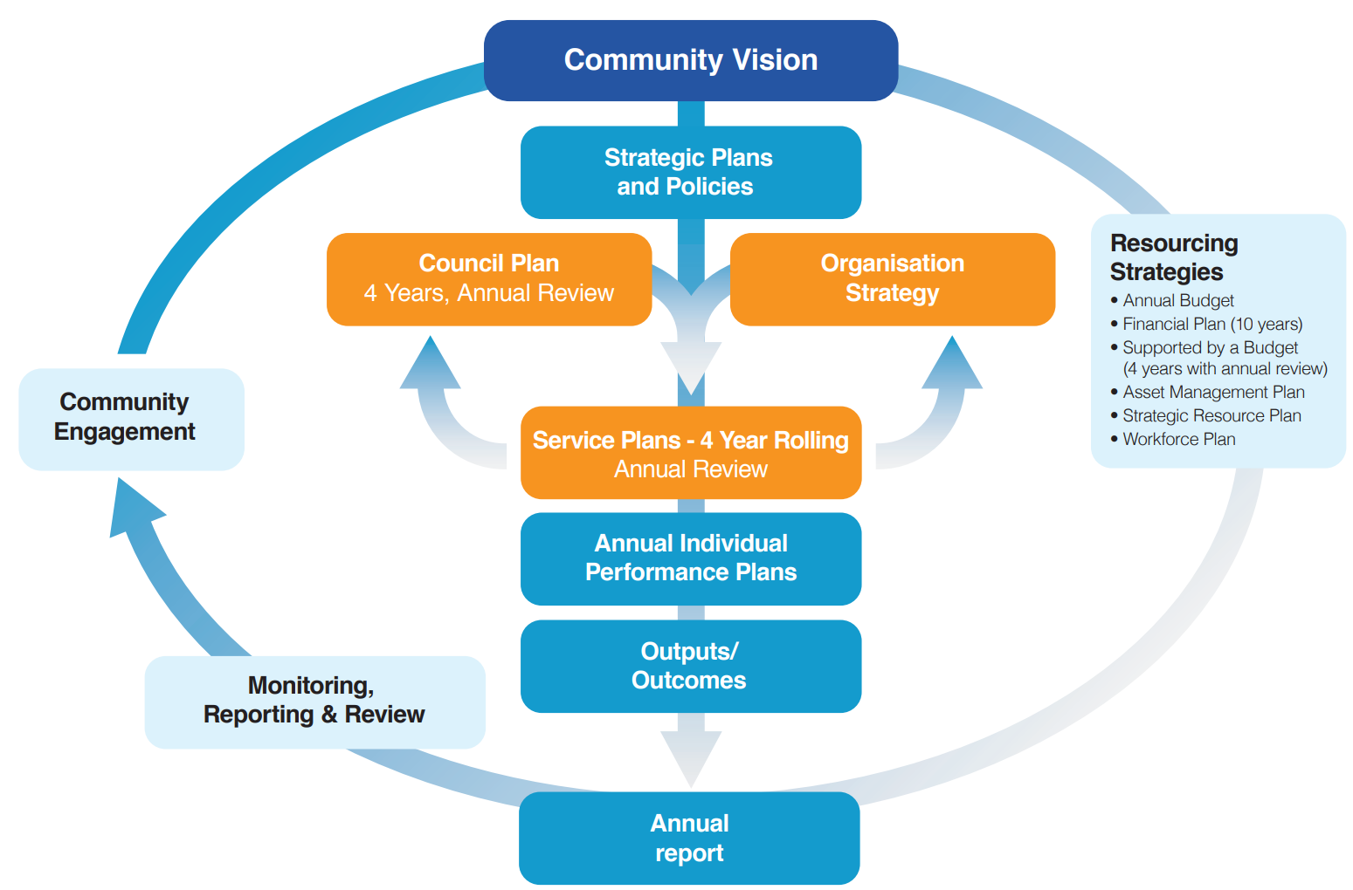
Bayside Parking Strategy

Bayside 2050 Community Vision
The Bayside 2050 Community Vision was developed by a representative panel of local residents from February to July 2020. The Vision informs Bayside’s strategic planning process, including the four-year Council Plan established at the start of each term.
The overarching Community Vision Statement is:
“Bayside in 2050 leads the way demonstrably as a diverse, healthy and liveable place. We value economic and cultural progress, environmental sustainability and protection of open spaces and coastline, and we nurture inclusiveness, safety, accessibility, community vibrancy, creativity and innovation.”
Ten vision themes were developed, covering areas such as living/natural environment, increasing and enhancing open space and access and inclusion. Within each theme, there is a list of high-level priorities to achieve the objectives of the themes. The relevant themes are considered below, including reference to priorities as they relate to parking within Bayside.
- Theme 2: Increase and Enhance Open Space
Bayside will ensure open space and its protection and amenity is a priority for 2050.
- Theme 3: Transport, Walkability and Rideability
Bayside will support provision of effective, sustainable and inclusive transport services and infrastructure.
The rationale for this theme is that there will be many benefits resulting from the provision of a high-quality integrated transport system, including reduced congestion, a decrease in the need for parking and the ability for residents and visitors to move freely within the community.
- Theme 4: Community Feel and Direction
Bayside will be a city that is greener and has more open space, and creates a community that is inclusive, respectful and accessible.
Priority 4.2 is titled Accessibility, and relates to accessibility in the built environment, including ease of travel by walking and sustainable travel modes between retail strips and neighbourhoods with consideration of all abilities and ages.
- Theme 8: Access and Inclusion
Bayside will be inclusive and accessible for all and wishes to demonstrate that they value the lived experiences of all cultures and be inclusive of people of all abilities in the community.
Priority 8.2 states that Bayside will improve accessibility to public infrastructure.
- Theme 9: The Built Environment
The built environment includes residential and commercial properties, roads and transport infrastructure and all aspects that a Council would ‘build’/’rate’ as part of the overall environment across Bayside.
Bayside will cater for multiple and varying views on how to best develop the built environment across the city to allow for future accommodation increases and protection of the liveability of Bayside.
Priority 9.1 states that land is a scarce commodity and therefore the highest value use of land must always take priority in decision making. Where property acquisition for more public space is not available, Council should consider reclaiming car parking and established road space for that purpose.
Council Plan 2021-2025
The Council Plan centres around several major initiates linked to four overarching goals, which are ‘our planet, our people, our place and our promise’. The four-year plan includes:
- protecting our open space and reserves, foreshore, natural habitats and species including increasing access to green spaces across Bayside conserving our unique places and heritage.
- managing sustainable population growth and fostering a vibrant local economy with strong transport connectivity.
- ensuring all who live and work here are able to live life to their fullest.
- building a strong relationship of trust and partnership between community and Council to address the challenges of the future together.
The Year 1 Action Plan includes Develop a new Bayside Parking Strategy as Action No. 3.4.1.5 (associated with Strategy 3.4.1 Integrate our transport planning and traffic management, and employ smart solutions to address changing demand, transport trends and community needs.)
Integrated Transport Strategy 2018-2028
The Integrated Transport Strategy (ITS) covers all forms of mobility, including public transport, walking, cycling, freight, private vehicles and the street network. The Vision for Transport contained within the strategy is:
“The transport system meets the needs of the community through provision of sustainable, well-connected, safe, accessible and convenient transport options that positively contribute to a strong economy, the health and wellbeing of the community and a low carbon future within Bayside.”
The strategy contains six complementary goals which guide Council to achieve an integrated and sustainable transport system and improve liveability and reflect the aspirations of the community. The goals are as follows:
- Goal 1: Enabling Sustainable Transport Choices
- Goal 2: Improving Local Accessibility (prioritise walking and cycling)
- Goal 3: Better Public Transport
- Goal 4: User Friendly Streets (access for a range of users, safe, accessible and efficient transport system)
- Goal 5: Integrated Transport and Land Use (supporting sustainable transport use)
- Goal 6: Optimising Parking Opportunities – Council will maximise the utilisation of existing parking space and balance the needs of drivers to ensure sufficient parking opportunities are available for those who need it.
Each goal is supported by several strategic directions and actions. The strategic directions most relevant to the parking strategy and the actions to achieve these are reproduced below:

Goal 4 User Friendly Streets
Objective: Council will treat streets as places where people live, work and play and provide access for a range of users in order to deliver a safe, accessible and efficient transport system.
- Strategic Direction 14 – Greater priority will be given to sustainable modes of transport in terms of allocating time, space and facilities on local streets.
  - Action 49: Use the road user hierarchy to manage the allocation of road space across Bayside.
  - Action 50: Develop a Street Space Management Framework that complements the hierarchy of road users to guide the management and enhancement of the road network.

Goal 6 Optimising Parking Opportunities
Objective: Council will maximise the utilisation of existing parking space and balance the needs of drivers to ensure sufficient parking opportunities are available for those who need it.
Providing additional capacity through more road space and parking is not a sustainable solution to the steady increase in parking demand as the increase in trips arising from a growing population and increasing vehicle ownership will continue to outpace road capacity. Similarly, the provision of additional car parking will also be utilised by the growth in vehicle ownership, potentially leading to a repeat of the dilemma once again.
The management of car parking is critical to achieving high levels of amenity, good accessibility and long-term sustainability to ensure that parking opportunities are available for those who need it.
- Strategic Direction 18 – Manage parking for the benefit of the whole community through the use of policy tools.
  - Action 58: Improved turnover through parking management (enforcement)
  - Action 59: Renew Residential Parking Permit Scheme
  - Action 62: Develop a municipal wide Parking Strategy
  - Action 63: Review parking provision for those with disability permits
  - Action 64: Develop precinct-based parking plans for each of the Major Activity Centres
  - Action 65: Application of Column B rates via a new Parking Overlay.
- Strategic Direction 19 – Maximise the utilisation of parking through the use of new technology (focused on improving turnover through better parking management, enforcement).
  - Action 66: Parking sensors in activity centres
  - Action 67: Electronic parking signage (subject to funding)
  - Action 70: Real time info app on available parking (subject to Action 66 being implemented).
Community engagement was initiated throughout the development of the ITS via the Have Your Say website and in-person listening posts.
The availability of parking within activity centres and an increase in the number of multi-unit developments leading to an increased demand for on-street parking were the most cited issues raised by the public in relation to parking.
Other parking-related feedback included parked vehicles in narrow residential streets causing perceived safety issues and on-street parking space being occupied by tradespeople working at nearby developments.
Climate Emergency Action Plan 2020-2025
In December 2019, Bayside City Council declared a Climate Emergency and developed a Climate Emergency Action Plan. The Plan includes actions to both minimise greenhouse gas emissions (mitigation) and reduce vulnerability (adaptation) to the impacts of climate change. The actions in this plan have been identified through an extensive gaps and opportunities assessment of Council’s 81 existing Policies, Strategies and Action Plans.
Seven themes within the action plan reflect the aspirations of the Bayside community, including a move to zero carbon transport. This entails transitioning away from internal combustion engine vehicles to sustainable transport such as walking, cycling, public transport and electric vehicles powered by renewable energy.
Disability Action Plan 2021-2025
The Disability Action Plan addresses the Disability Act 2006 and forms part of Bayside’s Municipal Public Health and Wellbeing Plan 2021-2025. The Disability Action Plan sets out a whole of Council approach for the next four years to improve disability access and inclusion in Bayside.
The Plan contains four goals, being ‘connected and thriving community’, ‘healthy and active community’, ‘respectful and safe community’ and ‘fair and inclusive community’.
Car parking matters are covered within Goal 4 – Fair and Inclusive Community, which includes Strategic Objective 4.2 ensure access to affordable, appropriate, and inclusive services and infrastructure.
Bicycle Action Plan 2019
The Bicycle Action Plan 2019 is informed by the ITS 2018-2028 and intends to guide delivery of a range of initiatives to support cycling as a convenient alternative to private vehicle trips within Bayside. It contains seven objectives which reflect the aspirations of the community and will contribute to Council’s vision for cycling:
- Objective 1: High quality on-road bicycle network
- Objective 2: High quality off-road bicycle network
- Objective 3: Effective maintenance of the bicycle network
- Objective 4: Integration of cycling with land use development, public transport and other public amenities
- Objective 5: Planning to support cycling
- Objective 6: Promotion of cycling in Bayside
- Objective 7: Education for safer cycling
Objectives 1 and 2 relate to the provision of on-road and off-road bicycle infrastructure that contributes to a safe, connected network for cycling in Bayside. In many cases, to accommodate this infrastructure, there is a need to reallocate road space that would otherwise be used for vehicle movement and car parking.
However, there is no guidance in the Bicycle Action Plan that considers how best to address this competition for road space.
Property Strategy 2022 - 2026
The purpose of this Strategy is to ensure Council property is managed for the long-term community benefit that maximises the social, cultural, recreational, environmental and economic outcomes for which the land is held.
Council’s current portfolio includes land and buildings that are used for:
- direct service delivery by Council
- the delivery of community-based services by not-for-profit organisations
- recreational and sporting pursuits
- commercial activity
- passive open space, environmental management and car parking.
The strategy is based on the following guiding principles:
- Finding a balance between community and commercial returns
- Increasing accessibility and equity
- Optimising utilisation
- Advancing Environmental Sustainability
- Ensuring assets are fit for service delivery
There are approximately 150 land parcels owned by Council excluding public open spaces, golf courses and roads, 72 are being used as car parks. There are approximately 351 buildings on these properties with uses ranging from Council administration and services, halls, clubrooms and pavilions.
In general, it is noted that any capital investment in facilities to overcome the historic renewal gap will need to maximise facility use across all age groups and cater for accessibility, easy physical access, demand for scooter paths and parking.
Council’s Implementation Policies

Managing On-Street Car Parking Policy Demand Policy 2019
The intent of this Policy is to provide consistent and transparent guidance for the introduction of new parking restrictions in areas where on-street car parking may be causing a road safety hazard and/or where on-street car parking spaces are in high demand in result of ancillary use, for example sportsground and playgrounds, and this has resulted in car parking congestion.
It is acknowledged that competition for on-street car parking is increasing throughout the Municipality. Council is faced with the challenge of balancing the competing demands of all users of the road space and is committed to providing shoppers, residents, traders, people with disabilities, workers and commuters with a reasonable likelihood of finding parking in close proximity to their destination.
This policy will be updated in line with the strategic outcomes of this Strategy.

Residential Parking Permit Scheme Policy 2019
The objective of this Policy is to provide a mechanism by which residents and their visitors are exempt from some parking restrictions to ensure a reasonable likelihood of finding car parking in close proximity to their homes, while still preserving opportunities for parking for other road users such as shoppers, traders, people with disabilities, workers and commuters.
This Policy is administered through two Procedures:
- The Residential Parking Permit Scheme Administration Procedure; and
- The Managing On-Street Car Parking Demand Procedure, for inclusion of new areas into the scheme.
Multi-unit developments (3 units or more) constructed after 1 July 2007 are not eligible to obtain residential parking permits.
This policy will be updated in line with the strategic outcomes of this Strategy.

Foreshore Parking Permit Policy 2019
The intent of this policy is to provide clear guidance for the administration of the Foreshore Parking Permit Scheme and identifies both the eligibility for permits for residents, ratepayers, council staff, Councillors, recreation clubs, approved recreation event organisers, services operating in Council owned facilities along the foreshore, and contractors required to carry out works and provide services along the foreshore, and the fee structure for these permits.
The Foreshore Parking Permit Policy aims to provide all users with convenient access to foreshore parking whilst recognising the need for users to contribute towards the costs of managing the beaches and foreshores.
This policy will be updated in line with the strategic outcomes of this Strategy.
Community Engagement
Parking Strategy
Community consultation was conducted at the commencement of the strategy development process to collect information on the needs and concerns of the community in relation to parking.
A broad community engagement program was undertaken in February – March 2022 to understand community views and priorities around parking in the City of Bayside.
More than 700 community members participated in the consultation primarily via an online Have Your Say surveys (665 respondents), via email or social media, or through key stakeholder group meetings, including Council’s Healthy Ageing Reference Group and Disability Access and Inclusion Advisory Committee. The consultation was supported by eight drop-in or pop-up sessions at major activity centres, Bayside libraries, or farmer’s markets (706 interactions), as well as an online Q&A.
A report was prepared in April 2022 which presents the findings from the analysis of the community feedback, including the following:
- Car parking profile – almost all respondents owned a car, with most households owning two cars. Most parked their cars on their property overnight, but 21% parked partly or solely on the street. Almost all respondents with a car held a Bayside parking permit, with most households holding two permits. 12% of respondents held a disabled parking permit, with the most common feedback on the disabled parking permit system being that it worked fairly or well (25%).
- Travelling around Bayside – car was the most common form of transport around Bayside, with almost all respondents (94%) having travelled by car at least some of the time, followed by walking (74%), cycling (27%), and train (15%). The most common factors that would encourage additional travel by methods other than private car were noted as improvements to public transport (38%), improvements to bike paths (13%), and more parking at stations (10%).
- Transport during the pandemic – 64% of respondents noted that their car travel had decreased substantially during lockdown periods, and walking had increased significantly for 58% of respondents. When asked whether their transport patterns would return to pre-pandemic patterns, 31% responded yes, 27% responded no, 28% responded as unsure, and 14% said their transport patterns did not change during COVID-19.
- Parking availability and ease of parking – parking availability was most important to respondents in shopping precincts (73%), followed by the beach and foreshore (49%), on the street outside their property (42%), and commuter parking near stations (36%). The average ease of parking was highest for parking at parks and reserves (6.96 out of 10), followed by beach and foreshore (5.92), residential streets (5.51), on the street outside their property (4.83), at shopping precincts (4.75), outside schools (4.32), and most difficult for commuter parking near train stations (3.25).
- Response to parking difficulties – the most common action of respondents when they can’t find parking in the areas important to them was to park further away and walk the distance (41%), or to drive around until they found a space (14%). When asked whether respondents would consider alternative transport modes if parking was unavailable, 21% responded as highly likely and 27% responded as highly unlikely to seek alternatives.
- Actions Council could do to improve satisfaction with parking – the five most common actions that respondents said that Council could do to improve their satisfaction with parking availability in the most important areas was to provide more parking spaces, car parks, and on-street parking (19%), more permits for residents / more resident only parking (17%), more time-limited parking (10%), more multi-storey or underground car parking (9%), and more parking patrols and enforcement (9%).
- Support for parking actions in Bayside – respondents were asked to rate their support for seven potential parking actions related to parking in Bayside. The average agreement (from 0 strongly oppose to 10 strongly agree) for the seven ideas is summarised as follows:
  - Moderate Support for allocating some public parking spaces in shopping precincts to people with particular needs (6.44).
  - Mild Support for increasing the number of disabled permit parking spaces in shopping precincts (5.94) and for creating pedestrian only areas in major shopping precincts (5.92).
  - Neutral to Mildly Opposed to supporting car share services (4.88), converting parking spaces to electric vehicle charging stations (4.86), and allocating public parking spaces to create protected bike lanes (4.77).
  - Moderately Opposed to converting car parking spaces into public open space (3.28).
- Other feedback – The most common feedback provided by respondents that they wanted Council to consider in the Parking Strategy was around new developments including adequate off-street parking (9.5%), more off-street parking (9.2%), more on-street parking around activity centres (7.2%), reduce the amount of parking or the number of cars (6.6%), consideration for persons with disability / special needs (5.0%), issues or suggestions around parking permits (5.0%), parking enforcement (4.4%), and change/review parking rules and restrictions (4.1%).
Community Satisfaction Survey 2022
Bayside City Council commissions a community satisfaction survey every year to better understand community perceptions, measure satisfaction with Council’s leadership and its delivery of services and facilities and identify issues of concern within the municipality. Data from Bayside’s comprehensive survey is also used to inform service planning and other strategic plans, policies and projects. In 2022, 600 representative households were interviewed face to face (60%) or telephone (40%).
The top issues residents were most concerned about in early 2022 include:
- Building, planning, housing, development
- Environment, sustainability, climate change
- Roads maintenance and repairs
- Beach and foreshore issues
- Footpath maintenance and repairs.
Concern about car parking has declined dramatically in recent years and for the first time is not a top ten issue. Instead, in the 2022 survey, there was a significant increase in concern about the environment, sustainability and climate change. This is now the second most important issue to address for the community.
The level of concern regarding car parking was found to vary by suburb – car parking is one of the top 10 issues in Beaumaris (#3), Cheltenham (#2) and Hampton East (#6) – as well as by demographic – car parking is one of the top 10 issues for senior adults aged 75+ (#5) and for older adults aged 60 to 74 (#9).
There were a mix of specific car parking issues raised, including availability (15 responses), permits (4 responses), enforcement (3 responses) and 7 responses relating to issues such as design, whether there should be parking on both sides of the street.
The 30 respondents who nominated car parking as an issue were, on average, significantly less satisfied with Council's overall performance than the average of all respondents, with an average satisfaction of 5.95 out of 10, compared to 7 out of 10.
Satisfaction with the Council service "parking enforcement" also increased in 2022, up 3.8% to 6.91, compared to an average increase with the 26 services and facilities of just 1.1%.
Church Street, Brighton, Parking Technology – Consultation
In 2020, Council introduced in-ground vehicle detection sensors in five locations in and around Church Street, Brighton. These sensors and associated electronic signs were installed to assist visitors in locating available public parking spaces. Additionally, a mobile app, UbiPark, was introduced to provide the real time parking data to peoples mobile phone.
The main community engagement on this project was undertaken between 19 January – 9 February 2022 when no COVID-19 lockdown restrictions were in place. Shopper intercept surveys were conducted on 6 January 2022. The following key themes arose in the post implementation community feedback received from 203 people:
- Electronic parking signs
  - Shoppers
    - Most shoppers (75.7%) were aware of the electronic parking signs
    - Most shoppers (53.5%) said they always or sometimes used the signage to help them find an available car park.
  - Traders
    - Most traders (83.3%) were aware of the electronic parking signs
    - Most traders (66.7%) viewed the electronic parking signs as a helpful addition to assist shoppers to locate an available car park.
  - Since the introduction of electronic parking signs, traders have not noticed:
    - A decrease in customer complaints about finding an available car park, or
    - An increase in trade/customers.
- UbiPark app
  - Most traders and shoppers were not aware of the existence of the mobile parking app, UbiPark.

Note that 2021 journey-to-work data was not available at the time of writing.
Shoup, D. (2006). Cruising for Parking. Transport Policy.
Bureau of Infrastructure, Transport and Regional Economics (BITRE), 2019, Electric Vehicle Uptake: Modelling a Global Phenomenon, Research Report 151, BITRE, Canberra ACT
Victoria’s Zero Emissions Vehicle Roadmap, Department of Environment, Land, Water and Planning, Victoria May 2021
Alison Lee & Alan March (2010) Recognising the economic role of bikes: sharing parking in Lygon Street, Carlton, Australian Planner, 47:2, 85-93

