
Domestic Animal Management Plan 2017-2021
Draft Plan (Text Version)

Table of Contents

1. Introduction and Context 3
1.1 Purpose of this Domestic Animal Management Plan 3
1.2 Process applied in developing the plan 4
1.3 Bayside profile 5
1.4 Domestic animal statistics 6
1.5 Animal management staffing and operational structure 7
1.6 Current programs and services – service levels 8
2. Statement of Purpose 9
Strategic Vision 9
Strategic Focus Areas 10
3. Strategic Directions for Domestic Animal Management 12
3.1 Animal management officer training and development 12
3.2 Encouraging responsible pet ownership – community education 13
3.3 Registration & identification 18
3.4 Compliance and enforcement – Local Laws and Orders 19
3.5 Domestic Animal Businesses 23
3.6 Managing dangerous, menacing and restricted breed dogs 24
3.7 Overpopulation and euthanasia 28
4. Performance Monitoring and Evaluation 30

Appendices 31
Appendix 1 – Domestic Animal Act 1994, Section 68A 3t1
Appendix 2 – Local Laws and Orders 33

- Introduction and context
Bayside City Council has prepared the draft Domestic Animal Management Plan 2017- 2021 to guide decision-making in relation to the management of dogs and cats in the community for the next four years. All Victorian Councils are required by State legislation to prepare a four year Domestic Animal Management Plan.

  - Purpose of this Domestic Animal Management Plan
The draft Domestic Animal Management Plan 2017-2021 (“the Plan”) describes the services, programs and activities Council will implement to support and encourage responsible (domestic) animal ownership over the next four years.
The Plan provides a framework for the planning, development, and evaluation of animal management services and programs delivered by Council and complies with the requirements of the Domestic Animal Act 1994 (“the Act”).
As required by the Act, the Plan covers the following:
- Review of animal management services, programs, procedures and policies including Council’s Local Law and ‘orders’.
- Outline of programs, services and strategies to:
  - Encourage responsible ownership of dogs and cats;
  - Ensure compliance with State legislation and Council policies;
  - Undertake the identification and appropriate management of dangerous dogs, menacing dogs and restricted breed dogs;
  - Minimise the risk of attacks by dogs;
  - Minimise over-population and minimise euthanasia rates for dogs and cats;
  - Encourage the registration and identification of dogs and cats;
  - Minimise the potential for dogs and cats to create a nuisance; and
  - Address other issues that are specific to the needs of Bayside.
Section 68A of the Act is provided as Appendix 1.

  - Process applied in developing the plan
This Plan has been prepared by:
- Evaluating the Domestic Animal Management 2012 – 2016 (what worked well and what could be improved);
- Analysing internally collected data (call centre data, complaints, registrations) to understand potential trends for consideration through research and Plan development;
- Undertaking community and stakeholder research to understand the needs and opinions regarding domestic animal management across Bayside;
- Conducting an internal review to ensure the Plan scope aligns with legislated responsibilities for local governments with regards to domestic animal management; and
- Community consultation on the draft Domestic Animal Management Plan.
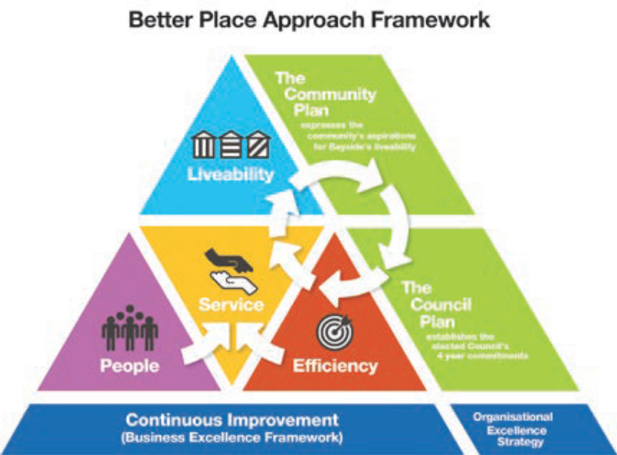

Council’s Better Place Approach provides clarity and focus for achieving our purpose of making Bayside a better place. The four key result areas – Liveability, Services, People, and Efficiency – align all of our activity and our improvements across Council.

Key considerations when aligning the Plan with other Council strategies are as follows:
Community Plan: Recognises that a priority for the entire Bayside community is to encourage and support people to lead healthier lives.
Health and Wellbeing Plan: Recognises the benefits of pets to social cohesion and expanding community networks.
Recreation Strategy: Recognises the contribution of pets to an active lifestyle.
Ageing Well in Bayside: Recognises the role pets play in keeping older adults in their home and active.
Open Space Strategy: There are challenges in providing space for dog owners alongside the recreation needs of other members of the community. This strategy recognises the benefits associated with pets and the benefits of accommodating dog walking and exercise within open space.
  - Bayside profile
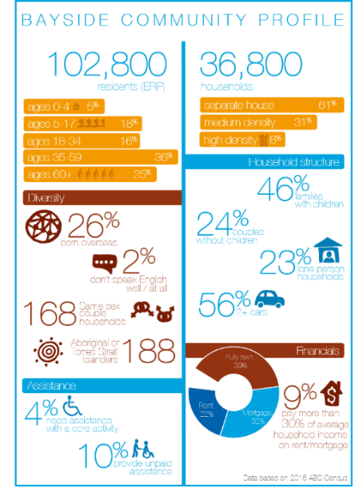
The City of Bayside is located in Melbourne’s middle southern suburbs, between 8 and 20 kilometres south of the Melbourne CBD. The City of Bayside is predominately a residential area with some small commercial and industrial areas.

It is estimated that one in four (25%) households in Bayside have a dog and/or cat (either registered or unregistered), and approximately 11% of households have a dog or cat that is not registered with Council.

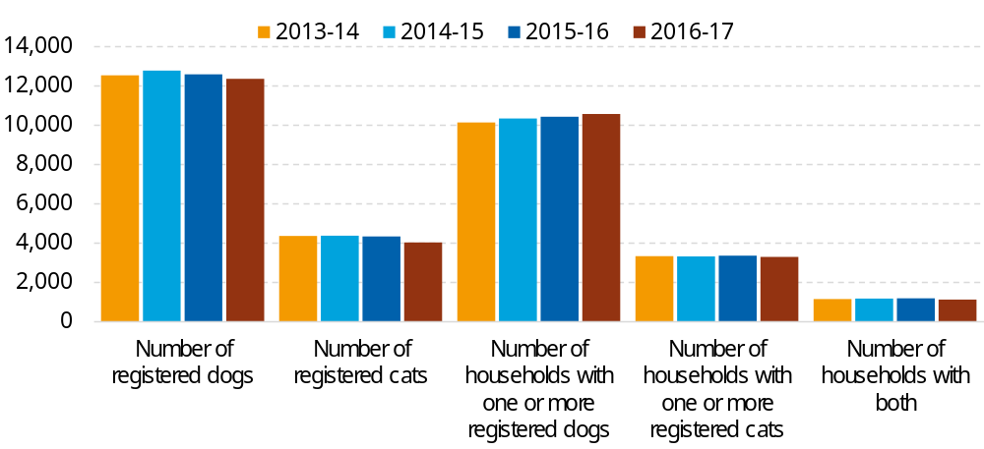
Domestic animal registrations over time
  - Domestic Animal Statistics
Dog Statistics | 2012/13 | 2016/17
Number of registered dogs | 12,561 | 12,332
Number of registered ‘declared’ dogs in Bayside | 6 | 1
Number of impounded dogs | 307 | 202
Number of impounded dogs returned to owner | 297 | 199
Number of dogs rehoused | 4 | 2
Number of dogs euthanised | 6 | 1

Cat Statistics | 2012/13 |  | 2016/17
Number of registered cats | 4411 | 4,202
Number of impounded cats | 67 | 78
Number of impounded cats returned to owner | 28 | 23
Number of cats rehoused | 17 | 14
Number of cats euthanised | 22 | 41

Service Statistics |  | 2012/13 | 2016/17
Animal infringements for dogs and cats | 672 |  | 462
Dog poo complaints received | 9 |  | 19
Animal registration enquiries | 371 |  | 699
Removal of dead animals | No data |  | 137
Cat trapping program, delivery of cat cages | 68 |  | 74
Dog attack (causing injury) | 77 |  | 91
Dog rush complaints | 6 |  | 17
Complaints relating to dog barking (causing nuisance) | 319 |  | 362
Complaints regarding dogs on foreshore (restricted or off-leash) | 14 |  | 14
Complaints regarding dog off-leash in leashed areas | 71 |  | 115
Dogs picked up by Council or pound | 216 |  | 265
Complaints relating to dogs wandering | 146 |  | 86
Feral/domestic cat to be collected | 39 |  | 47
Other general animal complaints | 127 |  | 288
Calls seeking educational information | 61 |  | 52
Number of prosecutions completed | 82 |  | 43
Number of successful prosecutions | 77 |  | 38
  - Animal Management Staffing and Operational Structure
There are four council staff dedicated to domestic animal management in Bayside. The Animal Management Team sits within the Amenity Protection Department and perform a number of roles including:
- Registration of dogs and cats and compliance through targeted door knocks to identify unregistered animals;
- Providing advice to pet owners and information to the wider community;
- Managing neighbourhood issues and complaints relating to pets;
- Ensure streets, parks and beaches are patrolled to educate and enforce responsible pet ownership;
- Inspections of domestic animal businesses and applying State legislation and Council policies to the management of pets and pet related businesses and activities;
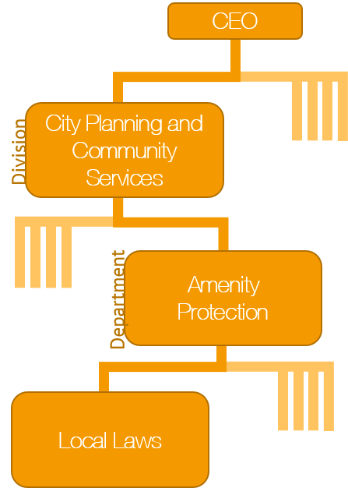
- Responding to animal welfare issues; and
- Operation of the pet day care centre (day holding facility) and liaison with Council’s pound provider.

(Including Animal Management)
  - Current Programs and Services – Service Levels
Program | Service Level
Identification and Registration | - Collection of microchip information  - Website information  - Prompt reactive enforcement  - Mandatory registration of animals prior to release from Pound  - Annual registration audit
Domestic animal complaints | - Response prioritise by risk
Dangerous Dogs complaints | - Response high priority
Routine street patrols | - Weekdays + every 3rd weekend
Pound services (outsourced) | - 10am – 6pm weekdays  - 9am – 1pm weekends
Micro-chipping | - 1 annual pet expo and microchipping day
Domestic animal business registrations | - Inspection conducted annually in March and April
Dangerous/restricted breed dog inspections | - Inspection conducted annually in March and April
Desexing voucher program | - Available at Customer Service Centres
Dogs on/off leash | - Order in place restricting dogs off leash in designated areas  - 33 dog off leash areas
Prohibited areas for dogs | - Order in place designating prohibited areas along the foreshore during designated times
Prohibited areas for cats | - Order in place for night time curfew  - Order in place for compulsory de-sexing
Prosecution for non-compliance | - Prosecute unpaid infringements or non-compliance through the court systems

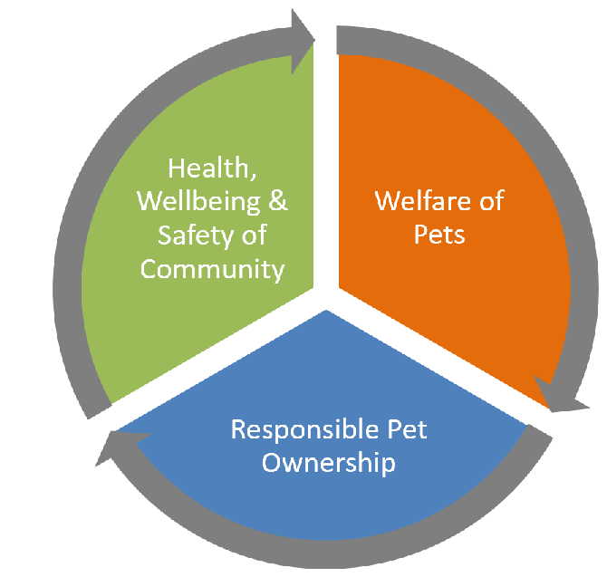
- Statement of Purpose
The Plan is designed to respond strategically to the needs of the community as a whole and will be guided by the following vision and principles.
Education
Communication
Council commits to the promotion of responsible pet ownership and benefits of pet ownership, whilst managing the impact on other members of the community, wildlife and the natural environment. This approach aims to achieve community harmony and reduce welfare and nuisance matters.
Modern Regulation
Strategic Vision
Health Wellbeing & Safety of the Community
- Pets are an important part of the Bayside community and bring significant health and wellbeing and social benefits to owners.
- There are people in our community who do not wish to have any contact with dogs or cats and this needs to be respected.
- The community needs to be kept safe and amenity protected.

Welfare of Pets
- All animals must be treated humanely.
- People caring for pets and domestic animals must:
  - Ensure these animals are kept safe and healthy;
  - Know and understand their responsibilities under the law as pet owners; and
  - Comply with relevant legislation, local laws, and codes of practice.

Responsible Pet Ownership
- Strategies are needed to manage issues associated with dogs and cats in the community, ranging from rewarding good pet owner behaviour, education and penalties.
- New services, facilities and opportunities in relation to pets will be considered in line with available resources and their sustainability.

Strategic Focus Areas
The strategic focus areas have been developed to reflect aspects such as the current performance of domestic animal management services at Bayside and the insights from the recent community survey. This analysis indicates that domestic animal management services are largely performing well:
- The strongest performance is in terms of relatively low numbers of impounded dogs, coupled with a high percentage of the dogs being returned to their owner (99%). This return rate compares to other nearby municipalities which typically have rates of 50 to 60%;
- Bayside ranks highly for Animal Management services according to Know your Council comparison data. For example, the average number of days it has taken for Council to action animal management requests is 1.7 days, in contrast to the best performing council (1.0 day) and the poorest performing council (14.8 days);
- Dogs and cats continue to have a strong positive impact on their owners wellbeing;
- Animal infringements have reduced from 2012/13 to 2016/17 by 31 %, this can be attributed to the 34% decrease in the number of impounded dogs.
The analysis also identified areas where more attention or an adjusted approach is needed:
- Complaints have increased by 41% from 2012/13 to 2016/17, with barking dogs and dog poo complaints being the greatest proportion of total complaints, but dog off-leash and dog attack/rush complaints having the most significant percentage increases;
- There appears to be an insufficient understanding within the community of the importance of ‘under effective control’ when dogs are off-leash and potentially a current inability to implement;
- Gated, off-leash areas were identified as needing further attention, with a strong demand from some dog owners, counteracted by some strong opposition due to perceptions of increased dog poo and damage;
- The bayside area has an aging population and it is increasingly important that suitable pets are selected for a person’s life stage;
- While cat registration numbers are stable, an increasing number of cats needed to be euthanised in 2016/17 compared to 2012/13.

The actions in this Plan are listed in the following sections and are aligned with the DEDJTR template. The actions build on the activities within the current Domestic Animal Management Plan (2012-2016), with several key areas of strategic focus woven through the sections:
- Increasing the community understanding of ‘Under Effective Control’ and implementing initiatives to support dog owners to effectively implement this approach;
- Increasing the community understanding of the most appropriate pets for different life stages, for example the elderly and families with small children;
- Addressing the increased rates of complaints through improved information on pet management, as well as increased proactive patrols and enforcement;
- Reducing cat euthanasia rates through increasing registration, community information and digital reporting mechanisms; and
- Leveraging new technologies to continuously improve council services.

- Actions for the next 4 years
This chapter sets out the current and future actions for animal management. The structure reflects the requirements as set out by the Department of Economic Development, Jobs, Transport and Resources (“DEDJTR”).
  - Animal Management Officer Training and Development
Objective: To ensure staff have the necessary technical and interpersonal skills to carry out their role.
Council recognises the complexity of managing often divergent community demands, opinions and expectations in relation to pets. Council has in place robust criteria to ensure authorised officers are suitably qualified and effective when carrying out their duties.
    - Current Activities
Activity | Schedule
Certificate IV in Animal Control and Regulation | Minimum requirement
Customer service training | Annual
Conflict management training | Annual
DEDJTR/Domestic Animal Branch training/information seminars | Annual
Australian Institute of Animal Management Annual Conference | As required
Animal handling training | As required
Investigation training | As required
    - Priorities for the next 4 years
Council is committed to maintaining staff training and education programs to ensure the application of best practice technical skills and customer service.
Activity | Schedule | Evaluation
Review Staff Training Calendar to ensure appropriate training opportunities are provided. | Annually | Review undertaken
All staff to be provided with Council’s Learning and Development Calendar | Annually | Calendar provided
Provide training on managing expectations of complainants | Annually | Training provided
Establish detailed customer satisfaction survey and implement an improvement program | Ongoing | Increase in customer satisfaction
3.2 Encouraging Responsible Pet Ownership – Community Education

Objective 1: To decrease complaints relating to pets.
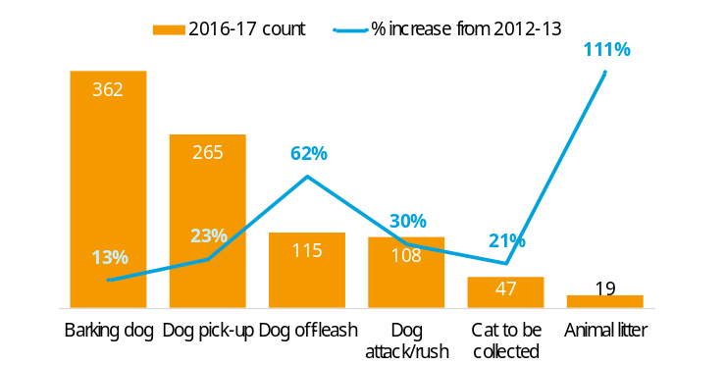
Total animal complaints have increased 52% between 2012/13 to 2016/17. In 2016/17 Council received 362 complaints about barking dogs, this rose by 13% when compared to 319 complaints in 2012/13. This is the highest area of complaints.

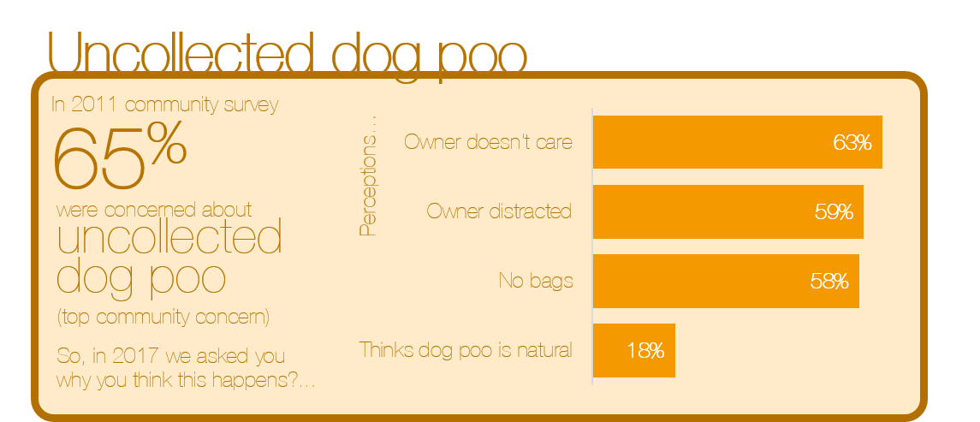
Uncollected dog poo
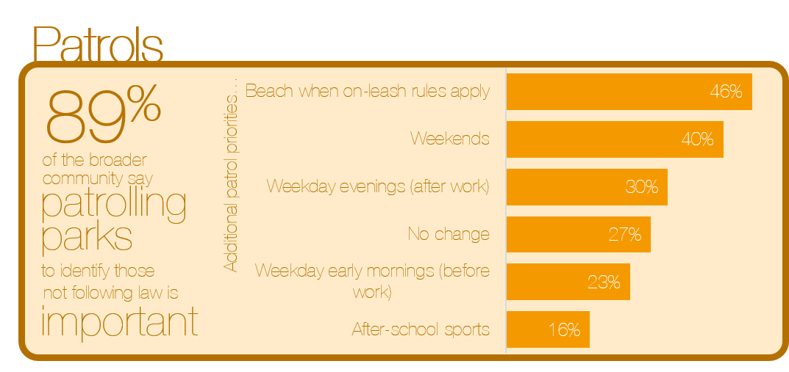
Key concern about dogs in parks and beaches is dog droppings. 79% of the community have seen uncollected dog poo in a public space. However, 87% have also observed dog owners doing the right thing and picking up their dog.

Patrols
Patrols seek to identify dog owners who are not following legislative requirements when in public places.

Cat curfew
Council has a cat curfew that requires all cats to be confined at night for the safety of cats, the protection of wildlife and to eliminate nuisance (noise) complaints. The curfew confines cats to their property between 9pm and 6am in daylight saving time and 8pm and 6am at other times of the year. 7% of owners of registered and 31% of owners of unregistered cats are unsure or unaware of the curfew.
    - Current Activities
Activity | Schedule
Liaison with community support groups | Ongoing
Information given to residents for addressing barking dog issues | Ongoing
Information given to residents for addressing cat trespass issues | Ongoing
Issue Pooch Pouch to dog owners (poo removal device) | Ongoing
Distribution of signage (A frames) to be used at sporting events to inform spectators of the requirement for dogs to be on lead | As required
Continue distributing coasters to café owners and restaurants to educate customers who use outdoor dining with their dogs of the necessary etiquette. | As required
Promote regular exercise of dogs | Ongoing
Recording and investigating all nuisance complaints | Ongoing
Issuing notice to comply/official warning/infringement notices/charges | Ongoing
Targeted patrols of ‘hot spots’ for complaints (dogs off-leash, dog droppings) | Ongoing
Liaise with Council’s Recreation Department regarding issues pertaining to dogs in parks | As required
Provision of cat cages and information given to ensure appropriate and humane trapping of cats | As required

    - Priorities for the next 4 years
Over the next 4 years Council will introduce strategies to decrease the number of pet complaints and to increase community awareness and education. We will continue to work with the community and relevant groups to promote responsible pet ownership programs.
Activity | Schedule | Evaluation
Provide a community education and awareness program targeting cat owners about the cat curfew | Year 2 | Development of an Information and promotional plan
Develop a booklet to assist dog owners in identifying and dealing with barking/nuisance complaints | Year 2 | Book developed and hard copies distributed
Promote and educate the community about choice of suitable pets for lifestyle types | Year 3 & 4 | Education program implemented

Objective 2: To enhance animal management services in response to community needs and service management imperatives
Council will focus on communicating the following messages to the general community through a range of Council owned channels:
- That dogs must be on leash within 20 metres of a playground, sporting game or picnic area;
- That dog owners must have effective control of their dog when off-leash in a designated area;
- Awareness amongst cat owners of the cat curfew and requirement that cats are to be desexed;
- That people walking their dogs are required to carry bags for the collection of dog poo.
The Pet Expo provides community members with the opportunity to register their unregistered pets, as well as receive information from Council on their responsibility as a pet owner. It is estimated that the number of attendees increased from approximately 1,000 in 2013 to 1,800 in 2016.
    - Current Activities
Activity | Schedule
Information on responsible pet ownership available on Council’s website | Ongoing
Distribution of Pet newsletter & brochures | Annual
Host a pet expo | Annual

    - Priorities for the next 4 years
Council will explore the potential for increased utilisation of social media for distribution of information about pet ownership and lost pets, and continue to provide an annual pet expo and pet newsletter.
Activity | Schedule | Evaluation
Continue providing accessible information through the pet newsletter and pet expo | Years 2-4 | Advertising for the Pet Expo is optimized and greater newsletters distributed in Bayside
Explore opportunities to develop a smart phone application for community reporting of domestic animal management issues | Year 2 & 3 | Information obtained on the feasibility of implementation.  Application implemented
Explore opportunities for extending usage of social media for community education | Year 2 & 3 | Investigated extended use with digital and extended usage implemented.

3.3 Registration & Identification
Objective: To increase and maintain high levels of pet registration and permanent identification.
All dogs and cats are required to be registered with Council at 3 months of age, which includes a requirement to be microchipped.
Importantly, registration supports the quick return of pets to their owners, which in turn minimises the distress to the pet from being confined in an unfamiliar environment waiting for their owners. It also provides insights to assist with planning local services, programs and infrastructure.
    - Current Activities
Activity | Schedule
Advertising in local media and Council’s newsletter – registration renewals | March of each year
Microchipping days | Annual
Registration reminders – SMS | March and April
Wearing of registration tags | Reminders on back of registration forms
Update animal registration database | As required
Follow up on “Pet Sale” notifications | As required

Compliance Activity | Schedule
Issuing registration renewals and reminder notices | March of each year
Animal registration Audit - Door knock | August to October
Issuing of infringement notices/’notice to comply’ and penalties relating to the non-registration of pets | Ongoing
Check registration details of all dogs encountered on the streets, parks and foreshore | Ongoing

    - Priorities for the next 4 years
Potentially up to 11% of households in the municipality have an unregistered dog or cat. Council will continue to offer the annual microchipping day and discount pet registration for pensioners and those with a health care card. Council will introduce strategies to enable user friendly options for pet registration.
Activity | Schedule | Evaluation
Develop an online process for new pet registration payment | Year 2 | Payments made online for new animal registrations
Maintain high reclaim rates for microchipped animals collected by the 24 hour holding service | Annually | Impound and lost dogs and cats don’t increase from current trend
Investigate the possibility of emailing animal renewals | Year 2 | Information obtained on the feasibility of implementation.

3.4 Compliance and Enforcement – Local Laws and Orders
Council has a Local Law and various orders in place that dog and cat owners must comply with if they own or are in charge of animals or manage animal businesses.

Dogs in public places: This order requires dogs to be on leash other than in off-leash areas, to be under effective control of their walker, and on-leash within 20 meters of a playground, sporting game, picnic area or on-leash area.

Cat confinement: This order requires cats to be confined to their property between the hours of 9:00pm and 6:00am in daylight saving time and between 8:00pm and 6:00am at other times of the year.

Desexing of cats: This order requires any cat being registered for the first time to be desexed.

Keeping and management of animals: The local law stipulates how many animals can reside at any one property and the requirement for dog walkers to carry a litter device and pick up their dog’s litter when in public places.
A summary of Bayside City Council’s local laws and orders relating to the management of domestic animals is provided as Appendix 2.

Objective: To plan and manage provision for dogs off-leash in consideration of other park and foreshore activity needs.
Off-leash areas in Bayside are frequently used by and are very important to dog owners. The majority of non-dog owners also recognise the importance of this activity.
Four key challenges with the provision of off-leash areas in the municipality are:
- The need to accommodate sports activities which are in growing demand, and are likely to increase in demand with a projected increase in the school age population (additional 600+ 5-17 year olds by 2026 compared to 2016);
- The need to keep some activities separate as it is not appropriate to co-locate for safety reasons;
- The need to restrict access to some natural habitat locations to preserve ecosystems; and
- Meeting the community expectations with regards to proactive patrols of dog off-leash parks.

Dog off-leash activities at sporting reserves and other parks
The use of sports grounds for the walking of dogs, and in particular dog off-leash activities creates a number of maintenance challenges. Council maintenance staff and seasonal sporting ground tenants report increased wear and tear because of dog activities at popular sports grounds. In addition, the incidence of dog poo at off-leash sports grounds is far greater than at on leash areas and results in ongoing complaints from sporting clubs and the community.
The removal of gates from off-leash sports grounds prompted a number of community members to call for a dedicated fenced off-leash dog park and/or the return of the gates.
The general view of the community is that gated environments keep dogs from escaping, prevent them from running on the road and dog attacks do not occur or dogs/people are safe from attack as it is presumed the other dogs are either trained and/or friendly.
The above belief, in addition to the actual maintenance concerns that coincide with sharing a sports ground, is mistaken for safety. Whilst off-leash in any environment, owners have a specific responsibility to keep their dogs ‘under effective control’. In short, this means that a dog should return to its walker immediately upon voice command.
It is imperative to educate the community on the important responsibilities and legislative requirements of ‘under effective control’ and to challenge the misconception that gated areas are safe environments for themselves and their dogs. However Council recognises that there may be benefits in the provision of a gated environment to enable individuals and their pets to learn and test effective control.

Foreshore zones for dog off-leash activities
Council has five designated levels of dog restrictions along our 17km of foreshore ranging from off-leash areas, time restricted areas to prohibited dog areas, depending on the beach and time of year. Restriction parameters were defined based on extensive consultation, environmental considerations and the areas within which animal management officers can monitor.
    - Current Activities
Activity | Schedule
Discussions with dog owners when out on patrols about responsible pet ownership expectations – dog litter collection, dog off-leash zones | Ongoing
Handing out litter bags as part of targeted promotions | Ongoing
Information handed out at pet expo | Annual
‘Responsible pet owner’ - reward dog owners who are doing the right thing | Ongoing

Compliance Activity | Schedule
Responding to complaints | As required
Verbal warnings | As required
Regular patrols of parks including leash and off-leash areas | As required
Issuing penalty notices / notices to comply / warnings | Ongoing
Targeted patrols of foreshore areas and inland parks | Ongoing

    - Priorities for the next 4 years
Council recognises the challenges in providing off leash activities, whilst managing and educating the community on the legislative requirements and definitions of dogs being ‘under effective control’.

Activity | Schedule | Evaluation
Investigate extending dog off-leash times along the foreshore | Year 3 | Identify options for sites
Continue to improve off leash dog signage | Years 1-3 | Signage upgrades to meet community need
Investigate opportunities to partner with professional dog trainers, to help owners train their dogs to be under effective control | Year 2 & 3 | Opportunities identified
Investigate methods to recognise and promote positive behaviour of dog owners who are doing the right thing | Years 2-4 | Methods investigated and program implemented
Explore opportunities to allocate Animal Management Officers to dog off- leash parks during peak periods | Years 2-4 | Rostering practices for officers
Undertake a feasibility study to assess the practicality of an additional secured dog off-leash area to enable a learning and testing environment for effective control | Years 2-3 | Feasibility study undertaken.

3.5 Domestic Animal Businesses
Objective : To provide education to domestic animal businesses to assist them to comply with legislative requirements.
Businesses such as animal shelters, pet shops, animal breeding and/or rearing establishments, and boarding and/or training facilities that are run for profit are known as Domestic Animal Businesses (DABs). There are five known DABs operating in Bayside.
    - Current Activities
Activity | Schedule
Provide DEDJTR written material | Annual
Provide advice on Code of Practice | Annual

Compliance Activity | Schedule
Registration of DABs | Annual
Auditing of DABs | Annual
Issuing / enforcement of infringement notices / notices to comply | As required
Patrols and follow-up of suspected unregistered/new DABs | As required
Uninformed ‘drop-in’ to ensure compliance generally and with relevant registrations of animals etc. | As required
Investigate complaints | As required
    - Priorities for the next 4 years
Council will continue to consult with businesses to foster positive community attitudes towards pets.
Activity | Schedule | Evaluation
Work with animal businesses to help foster positive community attitudes towards pets | Year 2 & 4 | Form stakeholders group to develop strategies to foster positive community attitudes
Ensure businesses are informed/consulted with changes or potential changes that may impact on them | Year 2 | Implementation of Strategy

3.6 Managing dangerous, menacing and restricted breed dogs
Objective 1: To effectively manage dogs classified as dangerous, menacing or of a restricted breed.

Council is responsible for declaring a dog as menacing or dangerous. Council does not prohibit the keeping of these dogs and provides information to owners to ensure they are aware of their responsibilities and the actions that can be taken to minimise the likelihood of inappropriate behaviours. Council currently has one declared dangerous dog within the municipality.

Menacing dogs: A dog that has inflicted a non-serious bite to a person or animal; shown aggressive behaviours (snarling, growling, raised hackles) when rushing up to a person; or chased a person.

Dangerous dogs: A dog that has caused serious injury or death to a person or animal by biting or attacking.
Dogs can also be declared as dangerous if the owner has received 2 or more infringement notices for the dog being menacing and hasn’t complied with restraint requirements.
A dog can also be declared dangerous under corresponding legislation in another state or territory.
A dog that is kept for the purpose of guarding non-residential premises (Guard dog) is automatically a dangerous dog under the Domestic Animals Act 1994.

Restricted breed dogs: Dogs of the following breeds are defined by Victorian State Government legislation. These dogs have not necessarily shown any dangerous behaviours, but have been classified by the State Government as a higher risk to community safety than other breeds:

American Pit Bull Terrier

Perro de Presa Canario

Dogo Argentino

Japanese Tosa

Fila Brasileiro
As of a change in State Government legislation in 2017, these dogs can now be registered by Council provided certain conditions are met.

    - Current Activities
Activity | Schedule
Information provided at pet expo | Annual
Promote Council’s available services relating to dog attack investigations including the after-hours service and contact | Annual

Compliance Activity | Schedule
Patrols of industrial properties | Part of routine patrols
Investigate complaints and take appropriate action eg; declaration, infringements, prosecution. | As required
Inspections | As required
Review and update ‘dangerous dog and restricted breed’ register | Annual
Audit of premises for ‘dangerous dog’ owners | Annual

    - Priorities for the next 4 years
Council is committed to the safety of all residents and will continue to educate and provide information to owners to ensure awareness of responsibilities and actions they can take to minimise the likelihood of inappropriate behaviours by their dogs.
Activity | Schedule | Evaluation
Educate the community on changes to State legislation regarding restricted breed dogs | Year 1 & 2 | Communication plan implemented and actioned.
Update procedures relating to the declaration of a dog as dangerous, restricted and/or menacing dog to ensure it aligns with revised State Government legislation. | Year 3 & 4 | Procedure reviewed and updated.

Objective 2: To minimise the incidence of dog attacks and rushes in the home and in public places.

From 2014-2016 the number of reported dog attacks and rushes increased, however the latest years’ data shows a decline in the annual data.
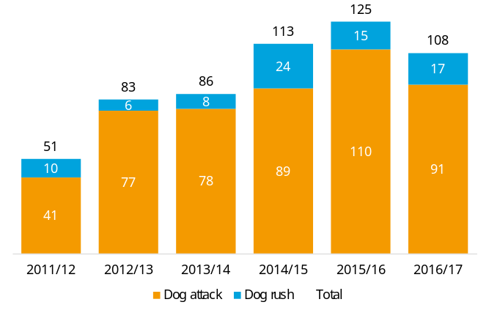
A key concern for Council is the risk of dog attacks to children. Research conducted by Kidsafe Queensland indicates that the majority of dog attacks on children occur in the person’s own home.
Council provides resources to assist families in understanding the training needs and risk factors regarding dogs, as well as how to interact with dogs and how to minimise situations that may provoke inappropriate behaviour from dogs.
Council promotes a range of strategies to the community to help minimise the risk of injury from dogs. Council encourages and supports the broader community to educate themselves on appropriate behaviour around dogs to minimise the risk of a fear response.
Council Pound Services also ensures that dogs rehomed from the pound are temperament tested to ensure they are suitable for adoption.
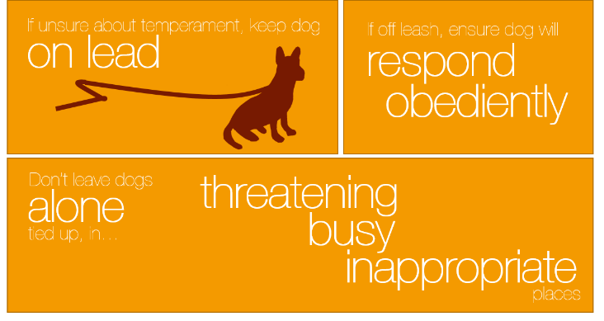
Dog attack standard operating procedures are in place to ensure safety for staff involved in responding to reports.
    - Current Activities
Activity | Schedule
Information distributed at pet expo | Annual
Information available at Council offices | Ongoing
Promotion of the need for dogs to be under effective control, at all times, including the need to ensure dogs can be effectively contained and /or fenced on their own property to ensure they cannot escape | Annual
Promote early socialisation of dogs to other animals and humans | Ongoing

Compliance Activity | Schedule
Routine patrols of parks | Ongoing
Dog attack investigation and documentation | As required

    - Priorities for the next 4 years
A vital role for Council and community is to prevent inappropriate behaviour of dogs towards people, other dogs and wildlife.
Activity | Schedule | Evaluation
Run responsible dog ownership course and highlight ways of minimising the risk of dog attacks | Years 2 - 4 | Program planned and implemented

3.7 Overpopulation and euthanasia
Objective: To minimise the number of pets surrendered, animals without homes, and animals euthanized
Unowned cats run the risk of not being desexed or carrying disease which results in unwanted litters and a poor state of health for these animals.
To reduce overpopulation and euthanasia in Bayside it is mandatory for all pet cats to be desexed and registered. There is a segment of the community who are unaware of the requirement for cats to be registered and desexed and approximately 4% of households have an unregistered pet cat.
Council places a limit on the number of animals that can reside in one household to ensure the health and wellbeing of animals, to minimise any adverse impact on neighbourhood amenity and inappropriate practices such as hoarding animals.
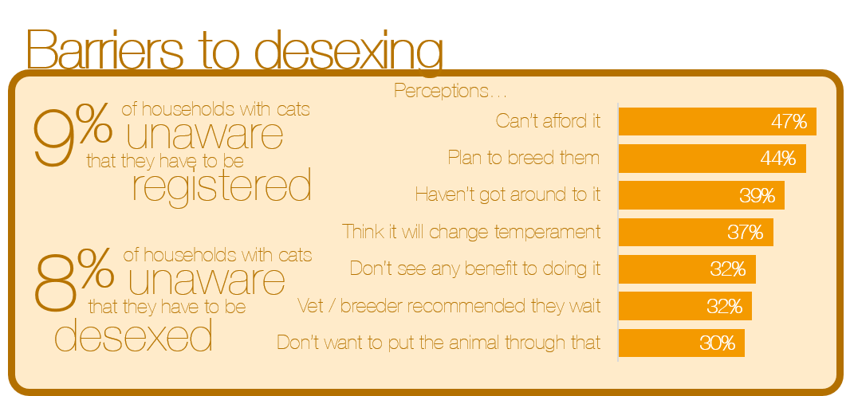
To help, the most efficient use of Council resources is through offering desexing discounts, educating the community on how it will positively impact on the pets behaviour and temperament, and encouraging consistency in advice provided by vets.
The incidence of returning lost dogs to their owners or rehoming in Bayside is very high, with less than 1% of the 202 impounded dogs in 2016-17 being euthanized (1 animal).
    - Current Activities
Activity | Schedule
Discount desexing vouchers to eligible residents | On application
Information in Council Pet Newsletter | Annual
Information handed out at Pet Expo | Annual
Provide positive information on desexing | Ongoing

Compliance Activity | Schedule
Patrols to collect stray and feral cats | As required
Enforcement of cat curfew | Ongoing
Cat trapping program for trespassing cats | As required
Investigation of backyard breeding establishments, animal hoarding in response to complaints | As required

Provide free cat traps to local residents for trapping nuisance cats trespassing on their property

    - Priorities for the next 4 years
Council is committed to reducing the number of cats being euthanized, due to a higher number of unregistered/stray cats being impounded in 2016-17.
Activity | Schedule | Evaluation
Implementation of a smart phone application that allows residents to report when they see a stray cat | Year 3 & 4 | Information obtained on the feasibility of implementation
Continue providing discount desexing options for low socio-economic groups and promote these to the community | Annually | Communication plan implemented

- Performance Monitoring and Evaluation
An annual review will be presented to Council each year, outlining the progress made against each key activity and evaluating whether the animal control services provided are adequate.
In undertaking this evaluation, Council will utilise various mechanisms including relevant data from Council systems, the Local Government Performance Reporting Framework and the ‘Know Your Council’ website and feedback from the community (including customer satisfaction results).

Appendices

Appendix 1 – Domestic Animal Act 1994, Section 68A
The following is section 68A of the Domestic Animals Act 1994. This section requires every Council in Victoria to prepare a Domestic Animal Management Plan, to show how the Council intends to address the Act.
68A Councils to prepare domestic animal management plans
(1) Every Council must, in consultation with the Secretary (of the Department of Primary Industries), prepare at 4 year intervals a domestic animal management plan.
(2) A domestic animal management plan prepared by a Council must—
(a) set out a method for evaluating whether the animal control services provided by the Council in its municipal district are adequate to give effect to the requirements of this Act and the regulations; and
(b) outline programs for the training of authorised officers to ensure that they can properly administer and enforce the requirements of this Act in the Council’s municipal district; and
(c) outline programs, services and strategies which the Council intends to pursue in its municipal district—
(i) to promote and encourage the responsible ownership of dogs and cats; and
(ii) to ensure that people comply with this Act, the regulations and any related legislation; and
(iii) to minimise the risk of attacks by dogs on people and animals; and
(iv) to address any over-population and high euthanasia rates for dogs and cats; and
(v) to encourage the registration and identification of dogs and cats; and
(vi) to minimise the potential for dogs and cats to create a nuisance; and
(vii) to effectively identify all dangerous dogs, menacing dogs and restricted breed dogs in that district and to ensure that those dogs are kept in compliance with this Act and the regulations; and
(d) provide for the review of existing orders made under this Act and local laws that relate to the Council’s municipal district with a view to determining whether further orders or local laws dealing with the management of dogs and cats in the municipal district are desirable; and
(e) provide for the review of any other matters related to the management of dogs and cats in the Council’s municipal district that it thinks necessary; and
(f) provide for the periodic evaluation of any program, service, strategy or review outlined under the plan.
(3) Every Council must –
(a) review its domestic animal management plan annually and, if appropriate, amend the plan; and
(b) provide the Secretary with a copy of the plan and any amendments to the plan; and
(c) publish an evaluation of its implementation of the plan in its annual report.

Appendix 2 – Local Laws and Orders
Section 68A of the Domestic Animals Act 1994 provides Council with the authority to make policies (‘orders in Council’) in relation to:
  - the number of dogs or cats that may be kept on any premises in the municipality
  - prohibiting or regulating the keeping of dogs or cats in areas where they may be a threat to native fauna
  - the requirement for dog owners to dispose appropriately their dogs faces when in public places.
In addition, the Local Government Act provides Council with the authority to make policies (‘local laws’).
A summary of Bayside City Council local laws and orders relating to the management of domestic animals are as follows:

Order No. 4 made under Section 26 of the Act (Effective 8/2/2012)
Key requirements under the order:
  - Dogs are allowed off-leash in ‘designated areas’ and in all other areas dogs must be on a leash. This is other than ‘prohibited areas’ where dogs are not allowed at all.
  - In dog off-leash areas they must be under effective control of their carer and must not in any way interfere with other people or dogs
  - Dogs must be on a leash when within 20 metres of a playground, sporting game, picnic area, and the boundary with an on leash area
The order provides a schedule of designated off-leash areas and hours of access that apply to these areas. Details of the order are available from Council and in the Victorian Government Gazette.

Order No. 25 made under Section 25 of the Act (Effective 8/12/11)
Key requirements under the order:
  - Cats must be confined to their property between the hours of 9.00 pm and 6.00 am in daylight saving time and between 8.00 pm and 6.00 am at other times of the year.

Order No. 10A made under Section 10A of the Act (Effective 8/11/11)
Key requirements under the order:
  - Any cat being registered for the first time must be desexed.

Bayside Local Law No. 2, sections 39-41 made under Section 111 of the Victorian LGA (Effective 8/11/11)
Key requirements under the local law:
  - • Section 39 (Keeping of Animals) stipulates the number and type of animals that can reside at any one household without the need for a permit.
  - • Section 40 (Accommodation of Animals) stipulates the requirement to adhere to accommodation requirements associated with keeping ‘excess animals’ accommodation requirements.
  - • Section 41 (Animal Excrement) stipulates that people in charge of animals must remove their animal’s litter and must carry a device for doing this.

Kidsafe Queensland inc, Fact Sheet – Dog Attacks https://www.kidsafeqld.com.au/images/stories/pdfs/inews.2773.1.pdf (accessed August 20 2017)

