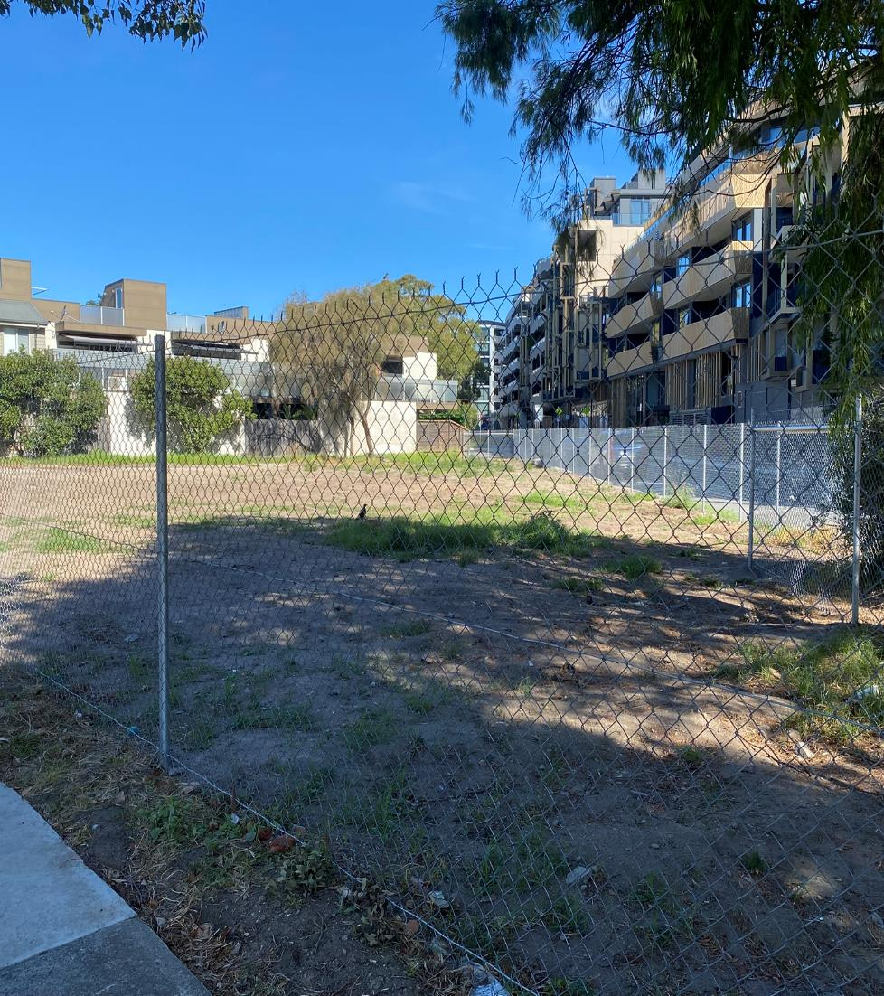
A new open space for Hampton
Engagement Outcomes Report
May 2025

About this report

This report comprises feedback received from the Bayside community and key stakeholders through the consultation period. It summarises the findings of activities hosted by Conversation Co. Information obtained via this public consultation and summarised in this document will be presented to Council in June 2025.

Contents
1. Executive Summary 4
1.1 Participation 4
1.2 Overview of engagement findings 5
1.2.1 Preferred options for pocket park 5
1.2.2 Community uses/needs 6
1.2.3 Park features and design 6
2. Introduction 7
2.1 Project Background 7
2.2 Engagement Purpose and Scope 7
2.3 Engagement objectives 8
2.4 Engagement Activities 8
2.4.1 Surveys 9
2.4.2 Community pop ups 9
2.5 Strategies to Support Participation 10
2.5.1 Potential barriers to participation 10
3. Who Participated 11
3.1 Participation by engagement method 11
3.2 Participant characteristics 11
3.3 Connection to Willis Street 13
3.3.1 Residential location 13
3.3.2 Frequency of visit 14
4. Key Findings 15
4.1 Level of support for an open space 15
4.2 Level of support by connection to Willis Street 16
4.3 Future uses for the Willis Street site 17
4.3.1 Findings by connection to Willis Street 18
4.4 Preferred park options 22
4.4.1 Findings by connection to Willis Street 23
4.5 Park features and feel 26
4.5.1 Design features 26
4.5.2 Amenity 27
5. Recommendations 28
5.1 Project recommendations 28
5.2 Process recommendations 28
6. Project Evaluation 29
7. Appendices 30
Appendix 1. Online survey questions 30

Executive Summary
Conversation Co. was engaged by Bayside City Council to support the planning, design and delivery of an engagement program to better understand the level of support for the development of a pocket park at 6A Willis St, Hampton. The engagement program focused on engaging immediate residents, Hampton traders, customers/visitors and broader Hampton residents.
The consultation period ran from 24 March to 4 May 2025 and included both face-to-face and online activities. A total of 865 participants provided feedback through face-to-face pop-up events, the online survey or made a submission to Council. A breakdown of participation by engagement method is shown in Table 1.

1.1 Participation
Engagement activities were promoted through Bayside City Council’s corporate website, social media channels, signage, and print media. Participation was supported via Bayside Have Your Say, Bayside City Council’s online engagement platform.
Table 1. Participation by engagement activity
Engagement activity | Number of Participants
Online survey | 482
Community pop-up sessions (3) | 381
Written submissions received by Council | 2
Total | 865
*Note community pop up sessions presents the total number of interactions across all three pop ups

1.2 Overview of engagement findings
Participants were asked the question; 'Is 6A Willis St a good place for a small public park?’ There were a total of 606 responses to this question. As seen in Figure 1, the vast majority of participants supported the development of the Willis St pocket park (n=562, 92.7%), 31 (5.1%) participants opposed and 13 (2.1%) were unsure.
Figure 1. Level of support for developing a pocket park
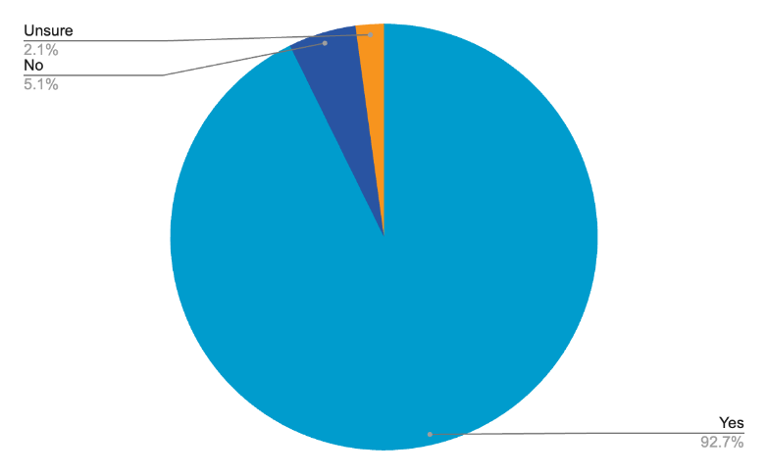
Data source: online survey, pop ups.
Level of support for a Willis St park was also analysed by participants’ connection to the site to demonstrate the views of different stakeholder groups. Key stakeholders for the project included immediate neighbours, Hampton traders and workers and participants who lived in an apartment in Hampton. Immediate neighbours (n=150, 95.5%) had the highest levels of support for the pocket park from these stakeholder groups, followed by those who travelled through Hampton (n=57, 94.6%).
Out of the participants who opposed the park (n=31, 5.1%), 15 (3.4%) were Bayside resident/ratepayers, eleven were Hampton residents specifically (2.5%), four participants were Hampton local business owners/traders and workers (6.3%) and three participants were immediate neighbours (1.9%). It must be noted at pop ups, participants were able to indicate their level of support without providing demographic information and a total of 12 participants at pop ups did so.

1.2.1 Preferred options for pocket park
Participants were asked to select their preferred style of park from three different concepts: ‘traditional park’, ‘habitat park’ and ‘dog park’. There were 585 responses to this question across both engagement methods. Traditional park had the most support overall (n=269, 46%) followed by habitat park (n=165, 28.2%) followed by dog park (n=90, 15.4%). A total of 61 respondents (10.4%) selected ‘something else’ presenting a range of different options, most commonly: a playground/place for children (n=23), a proposed alternative design (n=12), for example a Japanese Garden and preference for a mix of design options (n=12).
Preferred types of park were analysed by stakeholder groups including: immediate neighbours, Hampton traders and workers, Hampton apartment dwellers versus Hampton detached housing residents, and gender identity. There was little variation in preference across stakeholder groups apart from immediate neighbours, living in apartments who still most supported a Traditional Park (n=59) but next preferred a dog park (n=29) over habitat park (n=20).

1.2.2 Community uses/needs
Participants were asked the multi-response question: ‘What do you think the Hampton community needs most at this part of Willis Street?’ and were able to select their top three choices from a list of select options. ‘A place to sit in a quiet park’ (n=342, 29.9%) was the most popular response, followed by ‘A place to meet/socialise with friends’ (n=273, 23.9%) and ‘A place to sit down and have a picnic’ (n=217, 19%). The most common themes raised overall for participants who suggested ‘something else’ were ‘activities for young people’ (n=35) followed by ‘access to nature’ (n=24).
Identified future uses of Willis Street were analysed by stakeholder groups. All stakeholder groups followed the same trend of preferences as the overall analysis, apart from Hampton traders and workers who preferred ‘a place to meet and socialise’ (n=33) as their top need.

1.2.3 Park features and design
In regard to plant types and groundcover, participants overwhelmingly preferred a mix of the options provided. For plants, this meant a combination of traditional or exotic plantings, and native or indigenous plants (n=273, 71.8%). Participants also preferred a mix of lawn and natural mulch or bush as groundcover overall (n=307, 79.7%).
When asked to what extent participants would like to see paths in the space, a majority preferred a mix of paths and open space (n=297, 64%), followed by those that had preferred it to remain an open space exclusively (n=155, 33.3%).
Participants overall shared the top preference for bench seating, with 467 selections (20.6%). This was followed by water bubbers (380, 16.8%) and bins (371, 16.4%).

Introduction

2.1 Project background
Over the past six years, Council has been working towards creating a new centralised community precinct in Hampton, commonly known as the Hampton Hub, to connect current community services and deliver infrastructure that meets future community needs.
In 2019/2020 Council undertook significant multi-phased community engagement around the long-term direction of 13 Council-owned sites within the Hampton precinct, including the old Scout Hall site at 6A Willis Street. In June, 2021, the Hampton Public Land Masterplan was presented to Council. In June 2023, Council resolved to conduct feasibility studies for several sites following the presentation of Hampton Hub concept designs.
Although 6A Willis Street was initially flagged as a surplus site that could be sold after use as a temporary car park during Hub construction, in December 2023, Council was presented with feasibility options for the precinct after a proposal for commuter parking had funding withdrawn. One of these options was the establishment of public open space in the precinct, which aligned with the demolition of a former scout hall at 6A Willis Street.
Further feasibility studies into the former Scout Hall land’s suitability as open space took place from April-May 2024. In July 2024, Council agreed to progress plans for transitioning this site into public open space subject to community feedback. From March-May 2025, Conversation Co supported Bayside City Council to undertake a community engagement program to understand community appetite for a public open space at 6A Willis Street.

2.2 Engagement purpose and scope
The purpose of the engagement was to understand the level of support for the development of pocket park at 6A Willis Street, Hampton. This engagement was conducted with the broad community and key stakeholders including immediate neighbours and local traders and is at the ‘Inform/Consult’ levels on Bayside City Council’s application of the IAP2 Public Participation Model.
Specifically this engagement sought to:
- Understand community sentiment towards the development of a small pocket park.
- Understand community preferences from three proposed concepts for the space.
- Understand community desires for the layout and function of the space.
- Collect feedback on design elements and features of the space such as preferences for planting design and which amenities to include.
The scope of the engagement excluded the broader feedback on the future of the Hampton Hub.

2.3 Engagement objectives
The key objective of this engagement was to determine whether the approach of implementing a pocket park is welcomed by the Bayside community. Participants were asked whether they believe the site (6A Willis Street) was a good site for a pocket park. Further to this, participants in support of the park were asked a series of questions relating to the preferred design, their preferred use and their preferences for the features and design of the space.
Appendix 1 lists the survey questions for this engagement.

2.4 Engagement activities
A mixed-method community engagement program consisting of online and face-to-face activities was used to reach participants from a range of different levels of interest in the project. Table 2 outlines the community engagement activities delivered as part of this project, noting their purpose and key audiences.
Table 2: Community engagement activities
Activity | Purpose | Key audiences
Broad community pop-ups  (2 sessions) | Designed to intercept participants as they go about their day-to-day activities and capture a broad range of the community. | Local residents  Traders  Interested community members
Community and stakeholder survey via the Bayside City Council Have Your Say page | Provided an online survey with option for additional comments  Paper surveys were also made available at pop ups and through the local community centre. | Local residents  Traders  Interested community members
Locals pop up session  (1 session) | Provide an opportunity for local residents, and business owner/operators who will likely be affected by works and changes, to provide input and ask questions to the project team. | Immediate local residents, particularly apartment dwellers.
Written submissions | Provided an alternative option to typical feedback streams and a space for more detailed responses. | Interested community members, traders

2.4.1 Surveys
The online survey was hosted on the Bayside Have Your Say project page from 20 March to 5 May 2025. A hardcopy version was also provided at pop ups for participants who wished to provide more detail than the key activities.

2.4.2 Community pop ups
Two community pop up events were held on Hampton Street near Woolworths on:
- Tuesday 15 April, 11am-1pm, Hampton Street Shops
- Wednesday 23 April, 4-6pm Hampton Street Shops
A third session was held for immediate neighbours and local residents on Tuesday 15 April (5:30-7:30pm) at the Hampton Community Centre.
Pop-up activity plans were developed based on the following survey questions:
- Is 6A Willis Street a good spot for a pocket park? (Yes, No, Unsure)
- What is the reason for your response? (Free text)
- Which option would you prefer for a pocket park? (Traditional park, Habitat Park, Dog Park, No park - ball activity)
- Select your top 3 elements you would like to see in a pocket park from a list of select options (dotmocracy activity)
- Demographic postcards (Connection to Willis Street only)
All sessions were attended by the Council project team to answer any technical questions about the site and project.
Image 1. Pop up participation
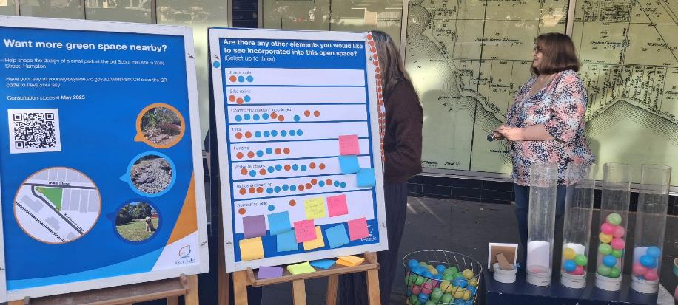

2.5 Strategies to support participation
Community participation was supported through the following initiatives:
- Communications campaign: Coordinated through Bayside City Council, included promotion through Council’s corporate channels, social media posts, signage at the site, Hampton Street shops and Hampton Train station and flyers with QR codes to the project page that were handed to commuters and local businesses. Mail outs were also sent via Australia post to households neighbouring the site including: Willis Street, Grenville Street and traders and residents along Hampton Street.
- Dedicated project page: A dedicated project page was created on Council’s Have Your Say website, to provide a consistent location for the community to access information, participate in the survey and register for the local residents’ session.
- Dedicated project contact: Participants were able to book a meeting with the project lead, through the project page, to have a more in-depth discussion and ask any questions related to the project.
- Going to the community: Pop-ups were held at the Hampton Street shops to reach anyone who visits, shops, lives, works or owns property or business in the area.
- Trader engagement: The project team utilised multiple engagement strategies to target traders and support their participation in the project. Strategies included direct emails to traders, drop ins along Hampton St; handing out flyers with QR codes to the project page and/or completing demographic cards in-store during both pop-up sessions.

2.5.1 Potential barriers to participation
- School holidays: The timing of pop-ups coincided with the school holiday period, meaning some may have been more occupied with children and other commitments.
- Computer literacy and internet access: Online formats such as the online survey and email submission options may have been a barrier for those with lower levels of computer literacy or lack of access to the internet.
- Engaging with traders: Although specific action was taken to target traders and ensure ease of participation, traders with time constraints or those required to work during engagement periods may have found it difficult to participate.

Who participated
A total of 865 people participated in this engagement program. The following section details participation in the project by engagement method, community profile, and connection to the Willis Street site. Throughout this report, the abbreviation “n=” is used to indicate the number of participants or responses.

3.1 Participation by engagement method
Participants were able to submit their feedback via the online survey, attending a community pop-up, or writing an email submission. The Have Your Say project page received 1,450 visitors and 95 signed up to receive project updates. The majority of responses to the engagement program were received via the survey, with 482 responses (55.7%), followed by community pop-ups 381 (44%), and two email submissions (0.2%). It must be noted that pop up facilitators counted the total number of interactions at each event, this number differs from the total number of demographic cards completed by pop up participants (n= 58).

3.2 Participant characteristics
Survey participants were asked to provide demographic information including their connection to Willis Street. Pop up participants were also asked to provide simplified demographics. Table 3 presents the demographic characteristics of participants, compared to the general community characteristics from the 2021 Census. Participants making submissions via email were not required to provide any demographic information.
Table 3. Demographic characteristics of participants
Selected characteristics | No. | % | 2021 Census %
Gender
Woman or female | 338 | 63.7 | 52.2
Man or male | 169 | 31.8 | 47.8
Non-binary or gender diverse | 0 | 0 | -
Prefer not to answer | 24 | 4.5 | -
Total respondents | 531 | 100
Age Group
Under 18 | 3 | 0.6 | 21.6
19-29 | 31 | 5.8 | 10.0
30-49 | 138 | 25.9 | 23.3
50-64 | 186 | 34.9 | 22.1
65-79 | 132 | 24.8 | 15.1
80 and over | 19 | 3.6 | 6.1
Prefer not to answer | 24 | 4.5 | -
Total respondents | 533 | 100
Dwelling type
I live in a free-standing house / townhouse | 349 | 65.6 | 60.4
I live in an apartment / unit | 152 | 28.6 | 38.8
Other dwelling | 0 | 0 | 0.7
Prefer not to say | 31 | 5.8 | -
Total respondents | 532 | 100
Living arrangements (multi-response question)
Lives with adults | 483 | 51.3 | -
Lives with young children | 112 | 11.9 | -
Lives with teenagers | 91 | 9.7 | -
Lives with dogs | 177 | 18.8 | -
Lives with cats | 54 | 5.7 | -
Other living arrangement | 0 | 0 | -
Prefer not to say | 25 | 2.6 | -
Note: Living arrangements was a multi-response question so the percentages shown are a % of Total Responses, not participants.

3.3 Connection to Willis Street
Participants across both engagement methods were asked to describe their connection to the Willis Street site and able to select multiple connections, as detailed in Figure 2 below. There were 818 connections selected for this question from a total of 626 respondents. A total of 436 participants indicated they were Bayside residents/ratepayers, with 157 participants indicating they were residents of the immediate area Willis Street, Hampton Street, Koolkuna Lane, Willis Lane or Railway Walk, 93 participants travelled through Hampton and 47 who worked in Hampton. A total of 11 people participated in this engagement program who lived outside of Bayside.
Figure 2. Participants connection to the proposed pocket park site 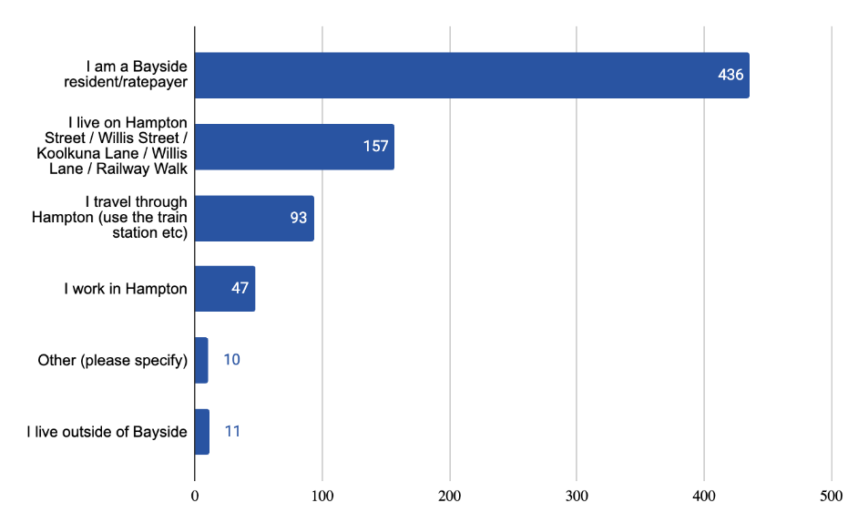Data source: Survey, pop ups
Ten participants indicated other connections to the site including: living on other streets (not named) in the local vicinity, planning to move to the area, members of the Community Centre, former Scout Hall members and participants who used to live in the neighbourhood and took an interest in the project.
Participants were asked if they owned a business in Hampton. Participation was seen from 28 Hampton business owners or traders through this engagement program. Efforts beyond the standard pop-up and online survey consultation were implemented and can be seen in section 2.5 Strategies to Support Participation.

3.3.1 Residential location
Survey participants were also asked to provide their residential location. Pop up participants who identified that they lived on Hampton Street, Willis Street, Koolkuna Lane, Willis Lane or Railway Walk were also included in the total for Hampton residents.

Residential location | No. | %
Hampton | 444 | 80.4
Hampton East | 17 | 3.1
Beaumaris | 9 | 1.6
Black Rock | 9 | 1.6
Brighton | 29 | 5.3
Brighton East | 10 | 1.8
Cheltenham | 3 | 0.5
Highett | 7 | 1.3
Sandringham | 24 | 4.3
Total | 552 | 100
Data source: survey and pop ups (Note* pop up data includes Hampton only)

3.3.2 Frequency of visit
Survey participants were asked how often they visit the Hampton Street shops. There were 535 responses to this question, with ‘daily’ being the most common response (n=322), followed by ‘weekly’ (n=164), Once of twice a month (n=32), every 2 months (n=7), rarely/never (n=6), once a year (n=3) and every 3-4 months (n=1).
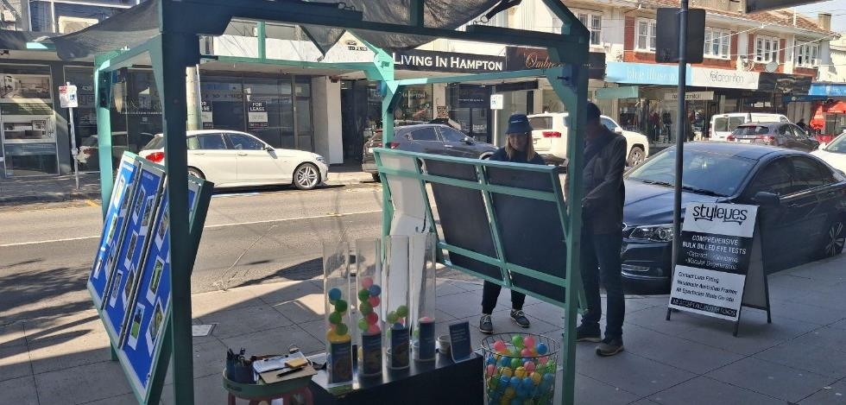
Image 2. Pop ups Hampton St

Key findings
The following sections present the findings for this community engagement project. In sections 4.3.1 Future uses by connection to Willis Street and 4.4.1 Preferred park options by connection to Willis Street, findings have been reported by stakeholder group.

4.1 Level of support for an open space
Participants were asked the question; ‘Do you think 6A Willis Street is a good spot for a small public park/pocket park?’. There were 606 responses. Figure 3. represents a graph of participants' support for the park, with the majority in favour of the park (n=562, 92.7%) followed by participants who opposed it (n=31. 5.1%) and participants who were unsure (n=13, 2.1%).
Figure 3. Level of support for a pocket park at 6A Willis Street 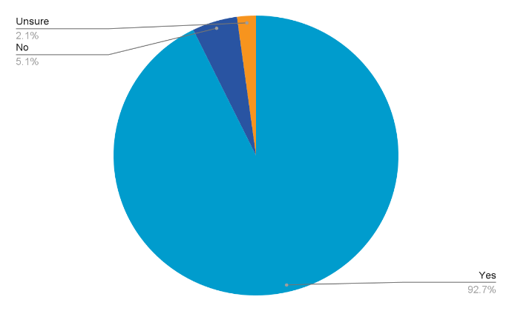
Data source: Survey, pop ups
Participants who did not support a pocket park at 6A Willis St, were asked to explain their reason for their response. There were 18 free-text responses to this question. Responses were analysed thematically using a coding framework. Participant comments often mentioned more than one theme and these responses have been counted accordingly. Table 4 presents the common themes that emerged.
Table 4. Justifications for not supporting a pocket park at 6A Willis Street
Theme | Verbatim quotes
More car parking should be priority  (9 comments) | “We are desperate for more car parking, not a token pocket park.”  “Perhaps it would be best to make an attractive parking area for the business owners or employees with a permit for the year “.
Funding should go to other community priorities  (4 comments) | “$450,000+ is too much to spend on such a small and limited usage space, with very few intake users.”  “… funds would be better spent on enhancing & maintaining existing open spaces than creating new ones in this location.”
Concerns around usage (3 comments) | “It won't be used.”
Concerns around location (2 comments) | “It’s a busy corner with cars whipping about, not a relaxing park area.”
Data source: Survey, pop ups

4.2 Level of support by connection to Willis Street
Level of support for a park was analysed by connection to the project. Figure 4. presents this breakdown. Connection to the project was a multi-response question, therefore totals do not represent the number of participants but rather the number of selections for each stakeholder group.
There was overall support for the park across all the stakeholder groups. Out of the participants who opposed the park (n=31), 25 completed the connection question, of which 15 were Bayside resident/ratepayers, eleven participants lived in Hampton specifically, four participants were workers or traders in Hampton, three participants were immediate neighbours, and two participants travelled through the area. It must be noted at pop-ups, participants were able to indicate their level of support without providing demographic information and a total of 12 participants at pop ups did so.
Figure 4. Support by connection to Willis Street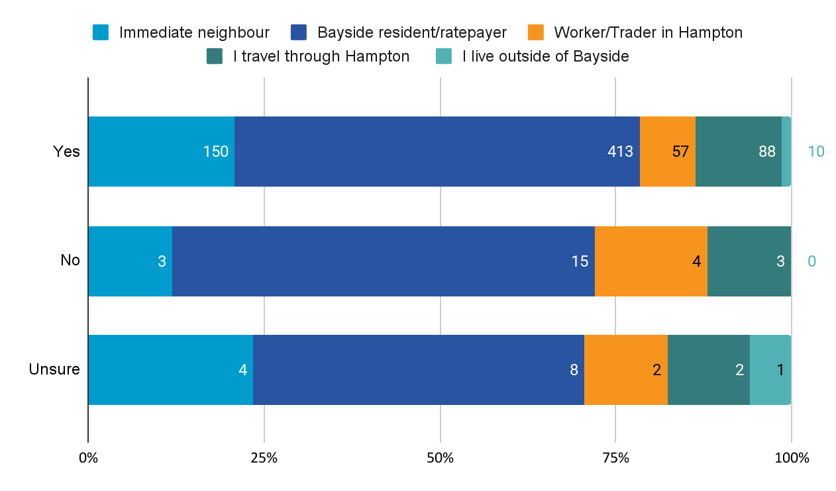
Data source: survey and pop-ups. (Note* Multi-response question)

4.3 Future uses for the Willis Street site
Survey and pop-up participants were asked the question: ‘What do you think the Hampton community needs most at this part of Willis Street?’ and were asked to choose their top three from a list provided. The purpose of this question was to understand what kind of public open space is wanted in the community and get an indication of the community’s intended use. Figure 5. shows the breakdown of participants' intended use overall.
Figure 5. Community needs for Willis St overall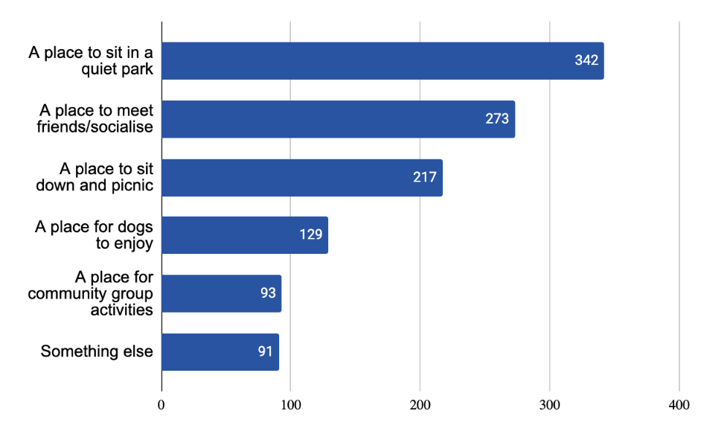
Data source: Survey and pop-ups. (Note* Multi-response question)
‘A place to sit in a quiet park’ (n=342, 29.9%) was the most popular response, followed by ‘a place to meet/socialise with friends’ (n=273, 23.8%). ‘A place for community activities’ (n=93, 8.1%) had the least selections.
There were 91 respondents (7.9%) who indicated the area was in need of ‘something else’. The most common themes raised overall for participants were ‘activities for young people’ (n=35) followed by ‘access to nature’ (n=24). Table 5 presents the common themes.
Table 5. Other community needs for the Willis St area
Theme | Description
Activities for young people  (n=35) | Playgrounds or play equipment, children's spaces, nature play, risky play.
Access to nature  (n=24) | General comments on the need for more green spaces, access to nature, gardens and shady trees. Creating habitat for local native species, edible gardens.
Social opportunities  (n=18) | Creating a nice place for people to meet and socialise to promote community connection: community spaces, activation of public space with events, community gardens, stage for performances.
Active recreation  (n=10) | A facility or space for active recreation:  Basketball courts, table tennis tables, public gym equipment, pump track, space to kick a ball.
Passive enjoyment  (n=7) | Picnic area, bbqs, tables and seating, shady and enclosed.
Other  (n=8) | Mixed responses:  Commemorate the Scout Hall  A mixture of all the uses  A place for traders to park/ create a trader permit scheme  Support for hostile architecture to manage people camping in the neighbourhood  Cost effective open space  Sale of Willis St land instead
Data source: survey, pop-ups

4.3.1 Findings by connection to Willis Street
Identified future uses of Willis Street have been analysed by key stakeholder groups. The following analysis shows the different priorities for Willis Street according to: connection to the project, immediate neighbours, Hampton traders and workers, apartment dwellers versus detached housing dwellers in Hampton, and gender identity.
Figure 6. shows a breakdown of community needs according to connection. Connection to the project was a multi-response question, therefore totals do not represent the number of participants but rather the number of selections for each stakeholder group.
Figure 6. Community needs by connection to Willis Street
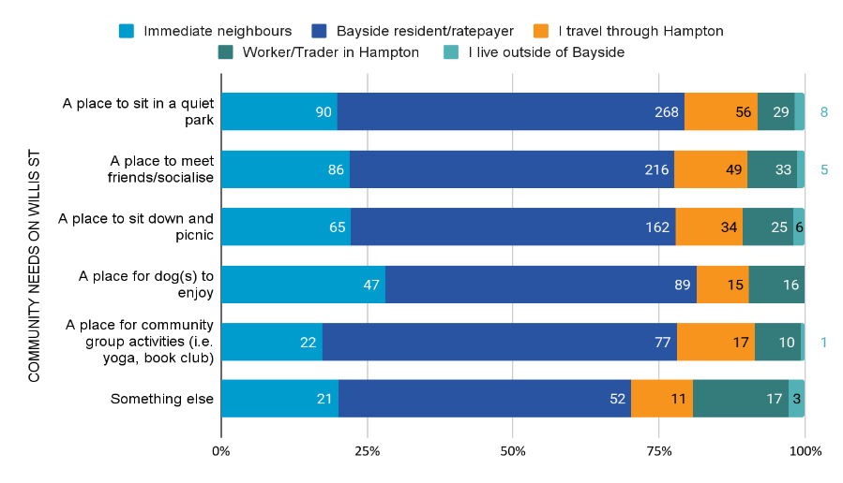
Data source: survey and pop-ups. (Note* Multi-response question)
Across all stakeholder groups the preference for this area was ‘a place to sit in a quiet park’ followed by ‘a place to meet and socialise’ and ‘a place to sit down and picnic’ apart from Hampton traders, who selected ‘a place to meet and socialise’ (n=33) the most. Traders and workers were more likely to select ‘something else’ (n=17) than other stakeholder groups, suggesting in free text that this area needs more car parking. ‘A place for dogs to enjoy’ was selected more for immediate neighbours (n=47) than other stakeholder groups.
Figure 7. Immediate neighbours
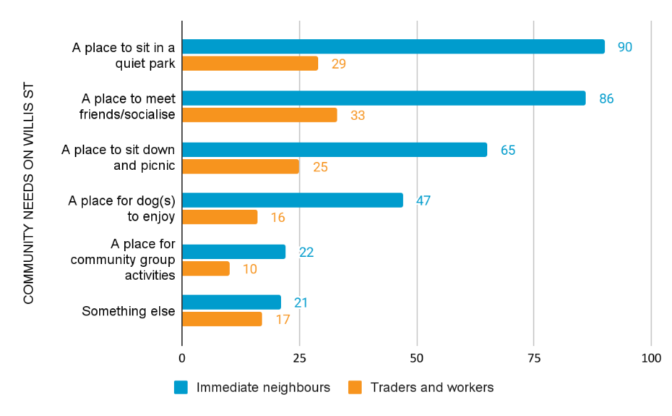
Data source: survey and pop-ups.
Figure 7 compares the community needs of participants who are immediate neighbours of the site with the needs of traders and workers in the area. Again, the data follows the same trend as in the previous graph with ‘a place to sit in a quiet park’ (n=90) being the most popular response for immediate neighbours, followed closely by ‘a place to meet/socialise with friends’ (n=86). Out of the 21 participants who selected ‘something else’, the most common themes were: ‘activities for young people’ (n=10) followed by ‘access to nature’ (n=9). The following are some of the verbatim quotes from these categories:
‘We definitely lack green open space in this dense area with so many high rise apartments now (even though this small area will definitely support all the items listed above).’
‘Kids playground similar to the one near Southland. So many little kids close by with no playground nearby.’
Traders and workers selected ‘a place to meet and socialise’ (n=33) the most. This could be a reflection of conversations with traders demonstrating a preference for spaces that encourage people to interact, slow down and utilise the local businesses or a desire for a place for staff to enjoy on their lunch break or coming to and from work. Out of ‘something else’ (n=17), ‘access to nature’ (n=6) was the most popular theme, however, ‘passive enjoyment’ (n=3) and ‘parking’ (n=2) were themes raised more specifically to the experience of workers and traders. The following verbatim comments encapsulate this sentiment:
‘Trader car parking is important. Trader permit. All day car parking for traders if we can get that instead.’
‘Place for traders to park - nowhere else to park- table and chairs at the beach.

Figure 8. Apartment dwellers vs. detached houses in Hampton
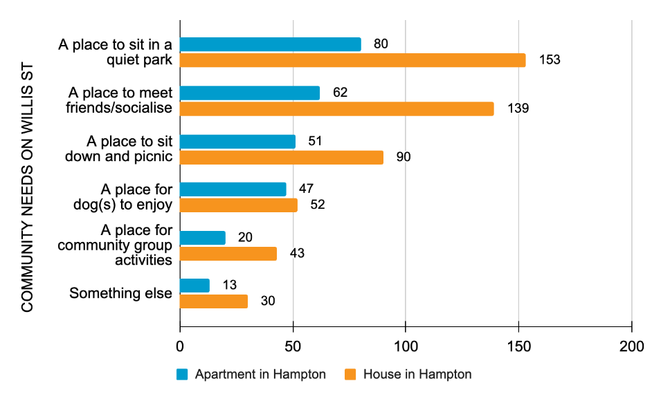
Data source: survey
Figure 8. compares the community needs of participants who live in Hampton in an apartment versus those who live in Hampton in a detached house. ‘A place to sit in a quiet park’ (n=80, n=153) was seen as the overall priority for both apartment and house dwellers. This was followed by ‘a place to meet/socialise with friends’ (n=62, n=139).
Apartment dwellers were more likely to suggest ‘a place for dogs to enjoy’ (n=47, n=50) likely, requiring public green space to take their dog in the absence of a backyard.
A total of 13 participants selected ‘something else’ in the apartment group, with the following verbatim quotes demonstrating the sentiment of this stakeholder group:
‘Just a tranquil spot with trees for shade and keep the neighbourhood green and cooler in summer!’
‘Park for everyone with a swing, garden area and seats to sit on.’

Figure 9. Gender
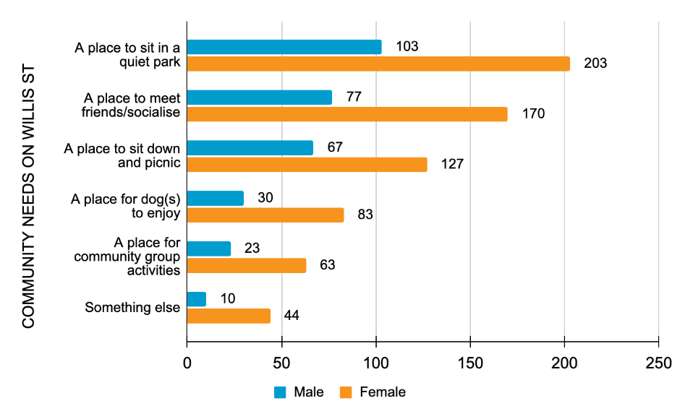
Data source: survey
Figure 9. compares the community needs of participants according to their gender identity. ‘Non-binary’ was omitted from this analysis as there were no participants who selected it as an option. While there were more female than male participants in the engagement, both groups followed a similar trend in needs for Willis Street. ‘A place to sit in a quiet park’ (n=103, n=202) was seen as the overall priority for both groups while ‘a place for community group activities’ (n=23, n=63) was the least prioritised other than ‘something else’. ‘Activities for young people’ (n=22) was the most commented on theme by women.
The following quotes are from the free text responses answered by participants who identified as women:
‘Kids open grass and play areas made from natural materials as there isn’t anything close to the shop district for kids to just run around when we’ve done some shopping.’
‘A gathering place to meet a variety of needs/ be flexible.’

4.4 Preferred park options
Participants were asked to select their preferred style of park from three design options: Traditional Park, Habitat Park and Dog Park. There were 585 responses to this question across both engagement methods. Figure 10. shows the breakdown of responses overall.
Figure 10. Participants preferred park options overall
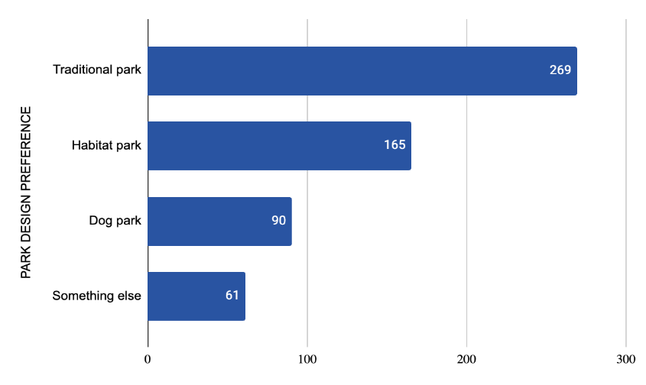
Data source: online survey, pop-ups.

Of the 61 participants who selected ‘something else’ a number of common themes emerged from free text comments. Table 6 outlines these themes with verbatim quotes. Participant comments often mentioned more than one theme and these responses have been counted accordingly
Table 6. Other suggestions for the Willis Street pocket Park
Theme | Verbatim quotes
Playground/place for children (n=24) | ‘A children's playground - there's nowhere near the Hampton shops for kids to play and parents to meet - it's such an easy location to meet up.’  ‘Garden with children’s playground. Support young families in the area and grandparents with their grandchildren.’
Alternative design (n=16) | ‘Traditional park with community garden area which includes a sharing table of excess produce.’  ‘I think it would be good to offer allotments or planter boxes for local residents. As more apartments are built, people are losing opportunities to grow food and connect with the land.’  ‘A plaza type space with lots of greenery and seating - grass areas to sit on etc’
Mix of designs (n=11) | ‘A traditional park but with native flora but set up in a way that children can explore with path ways , natural tunnels made from trees, logs to sit and climb, don’t put play playground, use trees to climb , rocks, etc, sensory plants , etc.’  ‘Mix of quiet space but allow dogs to use too. Not all dogs are social and they and their owners need a place to enjoy together.’
Sports equipment (n=8) | ‘Exercise park with exercise equipment.’  ‘Specifically designed for kids' play and adult exercise.’
No dogs (n=4) | ‘A space which is fenced to allow families to relax while children can play safely… definitely don’t need more dog parks.’
Other  Mixed responses (n=4) | ‘It’s hot, shiny and windy, no shade. What sort of park is the new one near the station?’  ‘As Council has done in Wells Street, Brighton’
Data source: survey & pop ups

4.4.1 Findings by connection to Willis Street
Participants’ preference for the type of park was analysed by stakeholder groups. Figure 11 presents the breakdown of preferred design options by connection to the project.
Figure 11. Preferred design options by connection to Willis St 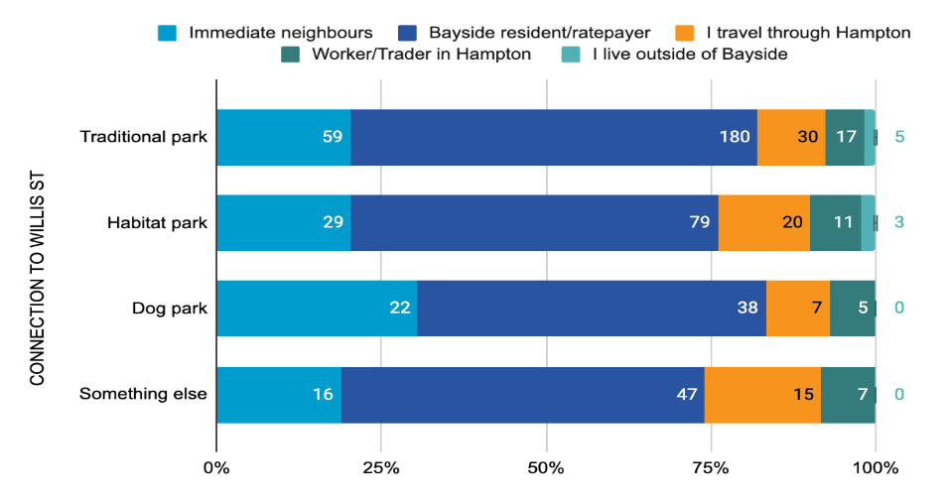
Data source: Survey, pop ups

Across all stakeholder groups the top preference for design option was ‘traditional park’, followed by ‘habitat park’. Immediate neighbours more commonly selected ‘dog park’ than other stakeholder groups, however this was still their least preferred option. Participants who travelled through Bayside and traders and workers selected ‘something else’ the most with the bulk of these two stakeholder groups suggesting a place for kids to play. Figure 12. presents the breakdown of preferences across these stakeholder groups.
Figure 12. Preferred design options- trader vs. immediate neighbours 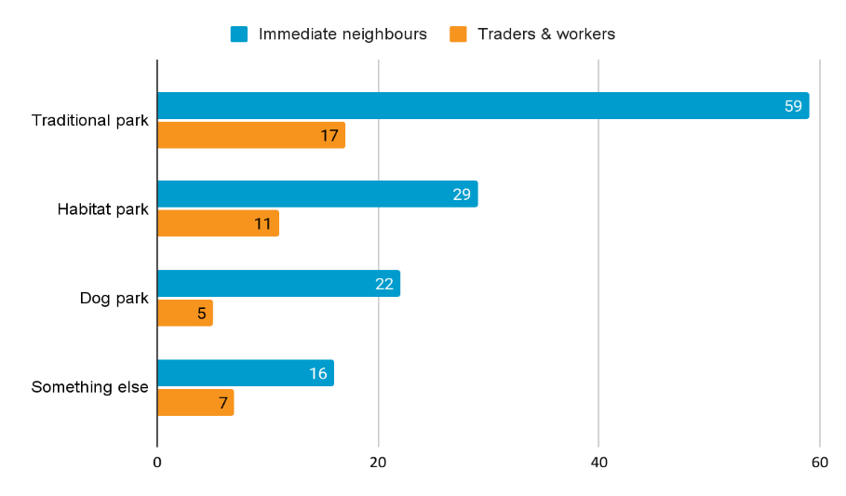
Data source: survey and pop-ups.

‘Traditional park’ was the top preference for the immediate neighbours (n=59) and ‘dog park’ was the least popular option (n=22). There were 16 participants in the immediate neighbours group who selected ‘something else’, with mixed themes raised in the responses. a desire for ‘sports equipment’ (n=4) was more represented in this particular stakeholder group with the following verbatim quote encapsulating the sentiment:
‘I can see the feasibility study suggested no equipment, courts etc but think this should be reconsidered or at least a compromise - there are lots of mid to late primary school kids around who would love to see a b'ball key/backboard, or at the very least a table tennis table, or a couple of bits of outdoor gym equipment. Who was surveyed as part of the residents? I am in Hampton Quarter and would love something like this.’
‘Traditional park’ was again the preference for traders and workers (n=16) with ‘dog park', the least popular option (n=6). Out of the traders and workers who specified ‘something else’, ‘playground/place for children’ was the most popular theme (n=4). The following is a verbatim quote encapsulating the sentiment:
‘A small sitting and play area, very little choice in Hampton compared to neighbouring suburbs to take a toddler out for half an hour.’
Figure 13. Apartment dwellers vs. detached house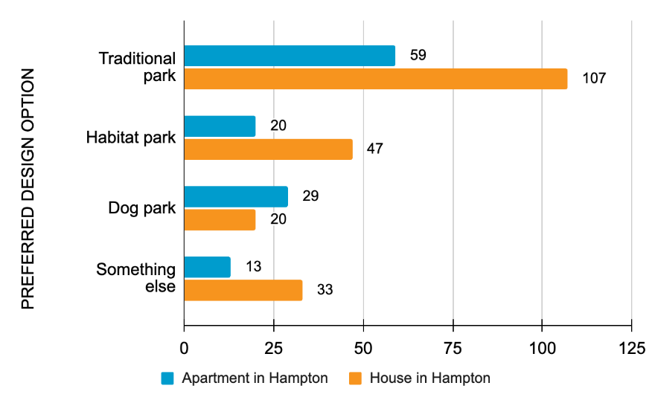
Data source: survey
Figure 13. shows a breakdown of how participants who live in apartments versus participants who live in detached houses in Hampton. ‘Traditional park’ was the preferred type for both stakeholder groups (n=37, n=142). ‘Dog park’ was the second preference for apartment dwellers (n=21) but the last preference for house dwellers (n=25).
‘Playground/place for children’ (n=4, n=18) was the most raised theme in the ‘something else’ free text response from both apartment dwellers and house dwellers. The following verbatim quotes encapsulates the sentiment of the comments from the apartment dwellers:
‘Maybe a few playground items for the children while parents are meeting friends!’

Figure 14. Gender
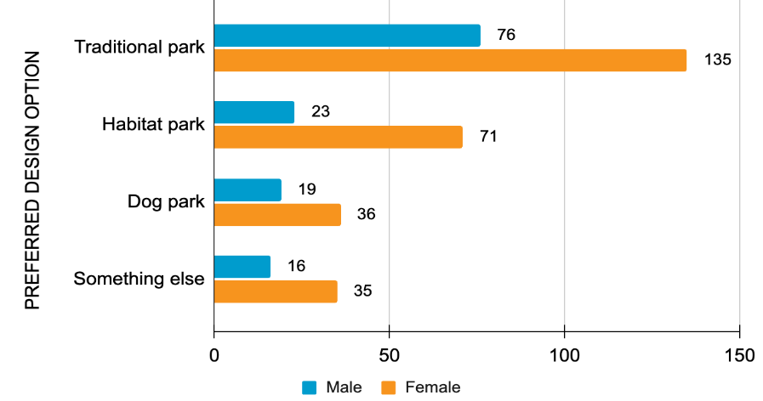
Data source: survey
Figure 14. shows a breakdown of how participants preferenced parks according to their gender identity. Traditional park was the preferred type for males and females (n=76, n=135) followed by habitat park (n=23, n=71). ‘Sports equipment’ (n=5) was the most frequently raised theme for males while ‘playground/place for children’ (n=17) was the most common theme in the female stakeholder group. The following verbatim quote encapsulates the sentiment from the female sub group of the free text comments:
‘A children's playground - there's nowhere near the Hampton shops for kids to play and parents to meet - it's such an easy location to meet up’
‘Garden with children’s playground. Support young families in the area and grandparents with their grandchildren’.

4.5 Park features and feel
Online survey participants were extended the opportunity to provide feedback on their preferred design features and amenity of the space. Preferred design features most often included a mix of the options provided, and amenity responses focused primarily on bench seating, water bubblers and bins.

4.5.1 Design features
Participants were prompted to provide their preference for three significant design features of the space. These included their preferred plant types, groundcover and the extent to which paths are incorporated into the space.
In regard to plant types and groundcover, participants overwhelmingly preferred a mix of the options provided. For plants, this meant a combination of traditional and exotic, and native / Indigenous plants (n=273, 71.8%). Participants often preferred a mix of lawn and natural mulch / bush as groundcover (n=307, 79.7%).
When asked to what extent participants would like to see paths in the space, a majority preferred a mix of paths and open space (n=297, 64%), followed by those that had preferred it to remain an open space exclusively (n=155, 33.3%).

4.5.2 Amenity
Participants were asked to select which elements they would like to see incorporated into the open space. Figure 15 shows of the 2262 selections made under this multiple choice question, the highest preference was bench seating, with 467 selections (20.6%). This was followed by water bubbers (380, 16.8%) and bins (371, 16.4%).
Figure 15. Which elements would you like to see incorporated into this open space? 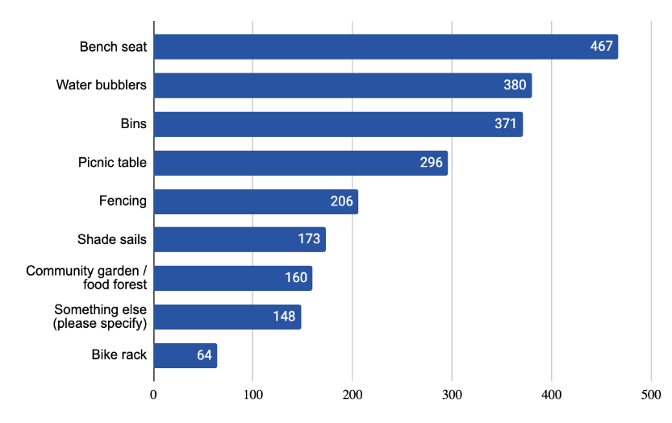
Data source: Survey, pop ups

Recommendations

5.1 Project recommendations
Based on conversations with the community and key stakeholders and the feedback they provided, this engagement program can conclude that there is overwhelming community support for a public open space at the 6A Willis Street site, with a preference for a ‘traditional park’ design option overall, followed by ‘habitat park’. Participants indicated a mix of planting design and groundcover, and pathways with a slight preference for ‘open area’ to be incorporated into the design. Participants most commonly suggested including amenities with the top preferences being for: bench seats, water bubblers, picnic tables and bins.

5.2 Process recommendations
Engagement on this project has already created significant interest and aspirations for the Hampton community, for those who participated, read a post online or were engaged at a pop-up.
- Thanking participants: Issue a statement and update the council project page thanking participants for participating in the project and sharing their ideas and contributions towards the proposed ideas for Hampton.
- Keeping people updated: As we move into the next phase of the project we need to keep the broader community updated about the progress of this project.
- Share the data: We have collected a substantial level of data that may be used by other departments to plan the delivery of services. Consider ways you can share this data such as creating a snapshot of the engagement data, to bring the data to life with infographics to help participants digest the information in an easy form.
- Adherence to the Local Government Act 2020: Keeping participants informed in engagement and the project is called ‘closing the loop’ - the information loop is currently open. Participants have shared their ideas and feedback through the engagement process and are waiting to see what happens next.

Project evaluation
Table 7. Project evaluation
Success measure | Data collection point | Evaluation
Did the engagement or research reach the stakeholders identified during the project planning stage? | Online survey and pop-up demographic collection. | All stakeholder connections to the site within Hampton have been reached, including a further 11 visitors.
How satisfied were participants with the consultation process? | Online survey. | The majority of participants found the information easy or very easy to find and understand (n=511, 96.6%).
Was outrage prevented / contained through the process? | Online survey, pop ups | Good reception for the project at both pop ups and online survey.  A total of 17 negative comments were received with key complaints: inappropriate location, inappropriate allocation of funds, preference for car parking.

Appendices

Appendix 1. Online survey questions
- Do you think 6A Willis St is a good spot for a small public park/pocket park?
- Yes
- No (skip to Q.2 and end)
- Unsure at this stage

- What is the reason for your response? [Open ended]
If yes,
- What do you think the Hampton community needs most at this part of Willis Street? (Select your top three)
- A place to sit in a quiet park
- A place to meet friends/socialise
- A place to sit down and picnic
- A place for dog(s) to enjoy
- A place for community group activities (i.e. yoga, book club)
- Something else (free text)

- Which type of park would you prefer?
- Option A: Traditional Park – examples from Well St
- Option B : Habitat Park – examples from Corp Centre
- Option C: Dog Park – example from Wishart
- None of these options

- What types of landscape design do you prefer? Use the slider to select your preference.
- Native/Indigenous plants OR Traditional/exotic plants
- Lawn OR natural mulch/bush
- Walking paths OR open area

- Which elements would you like to see incorporated into this open space? Select your top three priorities
- Shade sails
- Bike racks
- Bench seating
- Tables
- Community garden/ food forest
- Bins
- Fencing
- Water bubblers
- Tables and seating
- Wayfinding and signage
- Undercover area
- Something else (please specify)

About you
These questions help us to understand the sections of our community who have provided feedback. Your responses will also help us to design a space to meet the needs of the demographics who are most likely to use it.
What is your connection to the Willis Street site? Please select all that apply
- Hampton trader/business owners > On which street is your business located? (short text field)
- I live on Hampton Street / Willis Street / Koolkuna Lane / Willis Lane / Railway Walk
- I live in Hampton
- I work in Hampton
- I travel through Hampton (use the train station etc)
- I am a Bayside resident/ratepayer > Which suburb? [Multi-choice]
- I live outside Bayside.

How often do you visit Hampton Activity Centre?
- Daily
- Weekly
- Once or twice a month
- Every two months
- Every 3-4 months
- Once a year
- Rarely/Never

What is your gender?
- Female
- Male
- Non-binary
- Prefer to self-identify
- Prefer not to say

What type of home do you live in?
- I live in a free-standing house/townhouse
- I live in an apartment/unit
- Prefer not to say
- Other (please specify)

Who’s part of your household? (please select all that apply)
- Adult(s)
- Teenager(s)
- Young child/ren
- Dog(s)
- Cat(s)
- Prefer not to say
- Other
How did you hear about this consultation?
Was this survey easy to complete/understand?

