
New open space for Hampton

6A Willis Street, Hampton
With Hampton’s new centralised community precinct, the Hampton Public Land Masterplan, still a few years away, we’re looking at creating a pocket park at the former Scout Hall site at 6a Willis Street if it’s supported by the local community.

This pocket park would realise previous community feedback expressing a desire for more open spaces, reclaiming space for parks, and providing more opportunities for community connection in natural places.

Tell us what you think about a little park for Willis Street by completing the short survey below.

Your feedback will help us decide next steps for this project and the design of the park.

Surveys must be returned by 4 May 2025 by email: yoursay@bayside.vic.gov.au or post to Willis Park Engagement, Bayside City Council, PO Box 27, Sandringham 3191.

Your contact details ^{Required}
We are asking for your name and address to ensure unique responses to this survey. This information will not be recorded with your responses. Your responses are confidential and anonymous.

Your name ___________________________________________________

Residential Street _____________________________ Postcode ________

Email address (if you wish to receive updates about this project)

____________________________________________________________

6A Willis Street site

Do you think 6A Willis St is a good spot for a small public park/pocket park? ^{Required}
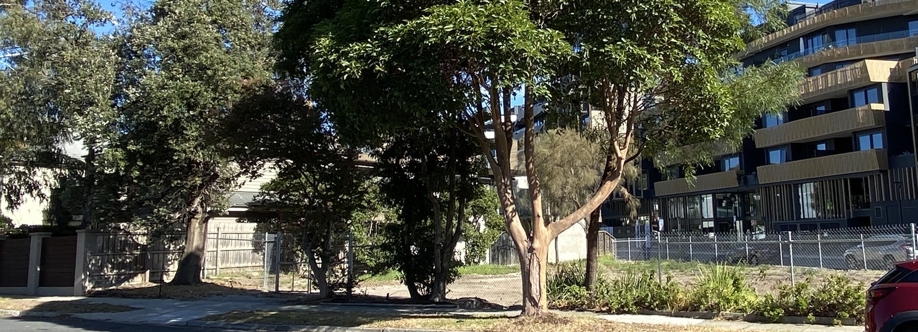
Vacant land at 6A Willis Street
Select all that apply

Yes
No
Unsure at this stage

What is the reason for your response?
Required for those answering NO to Q1. Then skip Q3 – Q8 and go to Q9 About you.

Park concept

What do you think the Hampton community needs most at this part of Willis Street?
Select up to three options

A place to sit in a quiet park
A place to meet friends/socialise
A place to sit down and picnic
A place for dog(s) to enjoy
A place for community group activities (i.e. yoga, book club)
Something else (please specify)

Which type of park would you prefer?
Select one answer only
Traditional park
Habitat park
Dog park
Something else (please specify)

Landscape elements

What types of plants do you prefer?
Place an X along this slide to show your preference.

Native / Indigenous plants Mix of both Traditional / Exotic plants

What groundcover do you like?
Place an X along this slide to show your preference.

Lawn Mix of both Natural mulch / bush

To what extent would you like to see paths?
Place an X along this slide to show your preference.

Walking paths Mix of both Open area

Park features

Which elements would like to see incorporated into this open space?
Select 3 answers
Shade sails
Bike rack
Bench seat
Picnic table
Community garden / food forest
Bins
Fencing
Water bubblers
Something else (please specify)

About you
These questions help us to understand the sections of our community who have provided feedback. Your responses will also help us to design a space to meet the needs of the demographics who are most likely to use it.

What is your connection to the Willis Street site? (Tick all that apply) ^{Required}
Select all that apply
I live on Hampton Street / Willis Street / Koolkuna Lane / Willis Lane / Railway Walk
I am a Bayside resident/ratepayer
I work in Hampton
I travel through Hampton (use the train station etc)
I live outside of Bayside
Other (please specify)

Which suburb do you live in?
Select one answer only
Beaumaris
Black Rock
Brighton
Brighton East
Cheltenham (Bayside)
Hampton
Hampton East
Highett (Bayside)
Sandringham

Are you a Hampton business owner/ trader?
Select one answer only
Yes
No
Prefer not to say

Which street is your business located on?
Skip this question if
- your answer to question to Q11 is No or Prefer not to say

How often to you visit Hampton shops?
Select one answer only
Daily
Weekly
Once or twice a month
Every 2 months
Every 3-4 months
Once a year
Rarely/Never

What is your gender?
Select one answer only
Female
Male
Non-binary
Prefer to self-identify
Prefer not to say
Other (please specify)

What is your age group?
Select one answer only
Under 18
19-29
30-49
50-64
65-79
80 and over
Prefer not to say

What type of home do you live in?
Select one answer only
I live in a free-standing house / townhouse
I live in an apartment / unit
Prefer not to say
Other

Who’s part of your household?
Select all that apply
Adult(s)
Teenager(s)
Young child/ren
Dog(s)
Cat(s)
Prefer not to say
Other

- Did you have the information you needed to provide your feedback
Select one answer only
Information was very easy to find and understand
Information was mostly easy to find and understand
Information was mostly hard to find and understand
Information was very hard to find and understand
Not sure

Surveys must be returned by 4 May 2025 by email: yoursay@bayside.vic.gov.au or post to Willis Park Engagement, Bayside City Council, PO Box 27, Sandringham 3191.

Privacy Statement: We handle any personal information you provide in this survey form in accordance with the Privacy and Data Protection Act 2014. For more information, see our Privacy Policy at bayside.vic.gov.au/privacy

