Community Engagement Policy review
Community engagement summary report
June 2025

Contents
1 Background 2
2 Consultation process 2
2.1 Consultation purpose 2
2.2 Consultation methodology 2
2.2.1 Engagement activities 3
2.2.2 Communications activities 3
3 Participant profile 4
4 Consultation findings 5
4.1 Support for actions 5
4.2 Engagement findings 5
4.2.1 When we will engage 5
4.2.2 When we won’t engage 7
4.2.3 Who we engage with 8
4.2.4 Previous engagement experience 9
4.3 Project evaluation 11

Background
The Local Government Act 2020 (The Act) requires all Victorian councils to develop and maintain a community engagement policy (Section 55). Bayside City Council’s Policy is updated every 4 years and is due for renewal.
The Act guides the way Council is expected to engage its community. This includes deliberative engagement requirements for key strategic plans, and meeting principles when planning and delivering engagement programs.
The Community Engagement Policy 2025 outlines how Council will achieve the Act’s requirements as well as meet the needs of Council and our community.
The Policy is designed to:
- provide clarity on when, why and how Council will engage with the Bayside community and stakeholders to inform decisions
- promote and encourage public participation
- strengthen trust and confidence in Council to make evidence-based decisions that benefit the Bayside community
- support the consistent application of transparent, accessible community engagement processes.
The Community Engagement Policy was significantly reviewed in early 2020 in response to Act requirements. The current Policy is generally viewed as working well, with 74% or “very good” community satisfaction with Council’s online and in-person engagement services (Community Satisfaction Survey 2024).
This report outlines the methodology of our engagement approach and summarizes the responses we received from the broader community regarding the proposed amendments to the Community Engagement Policy.
Next steps
Council will consider this Community Engagement report and a proposed Community Engagement Policy 2025 for adoption at its 29 July 2025 meeting.

Consultation process

Consultation purpose
Proposed changes to the Community Engagement Policy were considered relatively minor, with the aim to increase transparency and clarity for the community and Council officers regarding the Policy’s scope and implementation.
We sought feedback from the community to ensure that the Community Engagement Policy remains reflective of current community needs and aspirations.
We wanted to understand community sentiment regarding the draft Policy, in particular how it defines when, why and how we’ll engage our community to inform Council decisions.

Consultation methodology
The primary method of engagement involved an online survey hosted on the Have Your Say website (8 May – 9 June 2025). Printed copies of the survey were also distributed to Bayside libraries and available at the Corporate Centre Customer Service desk.

Engagement activities

Table 1: Engagement activities
Details | Activity
8 May – 9 June 2025  - 25 contributors  - 25 contributions  - 15 project subscribers | Have Your Say engagement website  yoursay.bayside.vic.gov.au/engagement  - Survey form (24 submissions)  - Written feedback (1 submission)  Print version of the survey was downloaded

Communications activities
It is estimated that communications via Council channels reached more than 13,000 community members.

Table 2: Communications activities
Details | Activity
Have Your Say engagement website  877 views  769 visits  652 visitors | - Project information on Community Engagement Policy  - Information on engagement process:  - Who gets to have a say about Bayside(10 visitors)  - Engagement process (6 visitors)  - Participation and influence (4 visitors)  - Engagement Plan Overview (3 visitors)
Council website | - News: Engaging our community when, where and how it counts  - News: Have your say in your language  - Website homepage banner
Direct email | Have Your Say subscribers  - Sent 13 May. Subscribers:1,460 (Council budget strategic plans interest)  Opens: 773 (53%), Clicks: 54 (4%).  This Week in Bayside e-newsletter  - 4 editions: 15, 22, 29 May and 5 June  Recipients: approximately 13,000 each week.  Total emails delivered: 51,879  Total email opens: 31,955, clicks: 480
Social media  >1,100 video views  >19 comments | Facebook and Instagram posts  6 social media posts were published referencing the consultation on the engagement policy review. The posts attracted over 90 engagements. Comments on the social media posts were not considered submissions within this report.
Digital Screens | Screens in Council facilities  Consultation was promoted via images on screens at Customer Service and in libraries where hard copies of the survey were available for community members to complete.

Participant profile
Participation in this engagement process was low at just 25 participants, although this is not uncommon for consultation on a policy document. Despite a reasonable number of visits to the project webpage, less than 4% of the 653 unique visitors chose to provide feedback.
Demographically, participants aligned somewhat with the overall Bayside population, although a little older and Hampton and Sandringham residents over-represented.
The data collected included representations from traditionally marginalised demographics in engagement processes, such as individuals living with disabilities, those with caring responsibilities, persons who speak languages other than English at home, and individuals identifying as Aboriginal and/or Torres Strait Islander.
Respondents also reported previous experience with Bayside’s engagement processes with nearly all completed at least 1-5 surveys and a high number participating in pop-up events (40%) or group workshops (30%).

Table 3: Participant demographics
 | Demographic | Bayside  2021 Census | Participants (%)
Gender | Male | 47.8% | 41.5% (10)
Gender | Female | 52.2% | 46% (11)
Gender | Prefer not to say | - | 12.5% (3)
Age | 30-49 | 23.5% | 8.3% (2)
Age | 50-64 | 22.1% | 29.2% (7)
Age | 65-79 | 15.1% | 41.7% (10)
Age | 80+ | 6.1% | 8.3% (2)
Age | Undisclosed | - | 12.5% (3)
Suburb | Beaumaris | 12.8% | 8.7% (2)
Suburb | Black Rock | 6.2% | 4.35% (1)
Suburb | Brighton | 23.7% | 21.7% (5)
Suburb | Brighton East | 15.6% | 8.7% (2)
Suburb | Cheltenham | 3.9% | 4.35% (1)
Suburb | Hampton | 13.6% | 21.7% (5)
Suburb | Hampton East | 4.9% | 0
Suburb | Highett | 7.6% | 8.7% (2)
Suburb | Sandringham | 11.8% | 17.4% (4)
Suburb | Outside Bayside | - | 4.4% (1)
Diversity | Live with disability/chronic illness | 30.6% | 17.4% (4)
Diversity | Caring responsibilities | - | 8.7% (2)
Diversity | Speak Language other than English at home | 18.9% | 12.5% (3)
Diversity | Identify as Aboriginal or Torres Strait Islander | 0.4% | 4.35% (1)
Diversity | No response | - | 58.3% (14)

Consultation findings

Support for actions
Most feedback on the proposed changes to the policy was positive with around 80% of participants supporting (at moderate, good or very good levels) the Policy definitions of scope ‘when we engage’ and stakeholders ‘who we engage with’. Around 70% were also in agreement with the approach to when we won’t engage (out of Policy scope).

Engagement findings
We asked participants to rate (from extremely poor to very good) our approach and explanations for when we engage, won’t engage and who we engage with. We also asked about previous experience(s) participating in engagement programs run by Bayside City Council and how we can improve our engagement practices.

When we will engage
Most participants supported the approach outlined for when we engage, with 62% (15) indicating it was good or very good, 21% (5) selecting moderate, while 17% (3) thought it was poor or extremely poor.

Figure 1: How would you rate this approach and explanation of when we will engage?
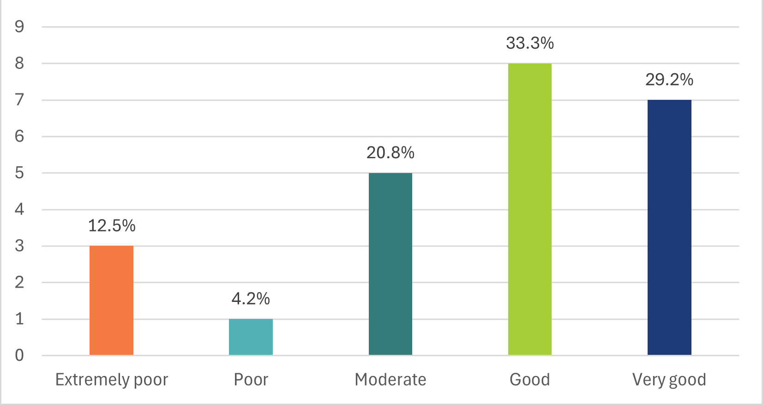
18 participants also provided comments on how our ‘when we engage’ approach could be improved, with key feedback themes summarised below.

Table 5: How could we improve “when we engage”
Topic | Community feedback
Communication  (4 comments) | - More visibility on engagement days/locations. I often find it hard to find this information unless searching for it.  - More direct information to ratepayers and people affected, via newsletter post drops.  - What’s defined as significant is unclear. How engagement happens is also unclear. Which channels and methods council use should be included.
Representation and community  (3 comments) | - Ensure that when public consultation happens that one public community group isn't overrepresented and thus pushing a particular agenda.  - Need to clearly define 'stakeholders'…. State Government authorities and departments, contractors, developers, and a whole host of other stakeholders should not have the ability to influence the Council against the wishes of the residential community.  - Increased capacity and access to online events
Disillusionment /disappointment from past experience  (3 comments) | - What is the point of community consultation when decisions are overturned and the money allocated elsewhere? It devalues the contributor's time and effort and leaves them with the feeling that community consultation is just window dressing.  - Needs to be extended to Councillor proposed changes to projects where the community has already been engaged then a substantive change is proposed at a Council meeting with no stakeholder knowledge or engagement.  - You had nothing before and purposely ignored resident concerns e.g., Netball Centre. Anything is an improvement. I’m moving out of Bayside had enough of the council.
Extended influence  (2 comments) | - Where influence and/or action by community/stakeholders are required to achieve the outcome(s). Policy should promote community action i.e., do more than seek influence.  - Goals and new paths to reach them should contemplate a set of values, norms and policies that prioritizes socio-ecological objectives, human well-being, natural and built environments, the aesthetic, ethical and cultural meaning of life.
Approval  (4 comments) | - No improvements needed

When we won’t engage
While many participants also considered the explanation of when we won’t engage to be very good (29%, 7), more thought it was moderate or good (45%, 10) and several marked it as poor or extremely poor (29%, 7).

Figure 2: How would you rate this approach and explanation of when we won't engage?
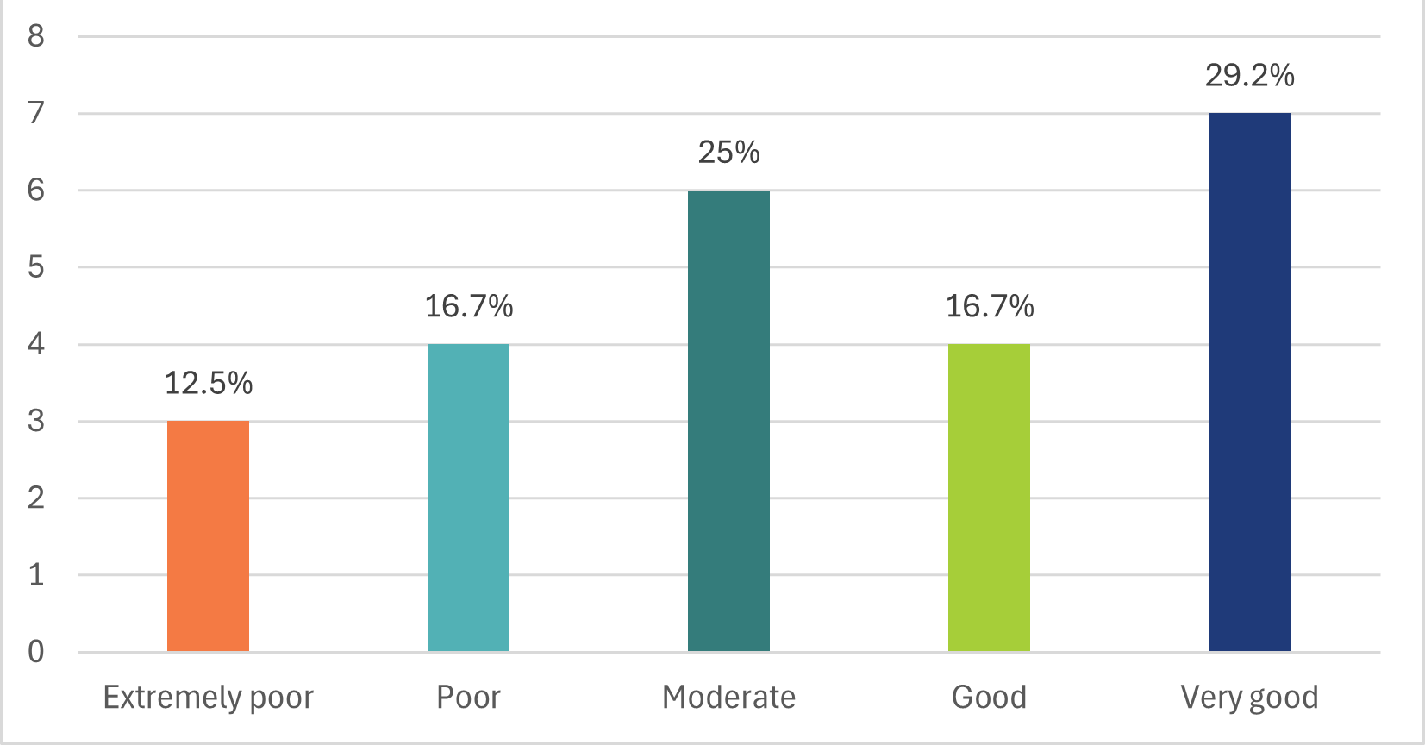
13 participants also provided comments on how our approach could be improved, with key feedback themes summarised below.

Table 5: How could we improve "when we won't engage"?
Topic | Community feedback
Communication  (3 comments) | - Needs to be some form of acknowledgement and statement on key projects, where you're not engaging, that you can't engage due to ... This just provides transparency and trust for all involved - otherwise, as they say "silence is the killer"  - It would be good to provide advice to the community on who to contact in cases where a development impacts the community but is outside the council’s jurisdiction
Use of previous and recent community engagement data  (2 comments) | - Years is not an acceptable timeframe, change to legislation, community attitudes, etc, can vary vastly in 5 years. This suggestion opens the council to potential broad criticism of 'hiding' proposals, or obscuring proposals that the community may not readily support.  - Community attitudes can change within a short time frame especially when new evidence circulates. Council must remain ready to be flexible when this occurs.
Decisions informed by other factors  (3 comments) | - Community engagement should only be excluded when there is no benefit or opportunity. "Research" is too broad and community engagement can and should be considered where evidence matters, where priorities compete, and Council needs a community response.  - Suggesting operational decisions which may include strategies or policies that have minimal to no impact on the community is suggestive of a desire to avoid scrutiny; the council should develop its engagement plans around clarity and transparency.  - Be more forceful with to the state government, with the interests of ratepayers
Distrust of approach  (4 comments) | - Well of course you decide if something doesn’t affect residents, what is different? Same old walk all over your residents  - Still sounds like council is in total control and can veto any project or issue from community consultation if it wants to  - I guess that's just a way of you saying you didn't think we should know.
Approval  (1 comment) | - No improvements needed

Who we engage with
Nearly 80% (19) of participants supported our approach to ‘who we engage with’. Only 20% (5) considered this to be poor or extremely poor.

Figure 3: How would you rate this approach and explanation of who we engage with?
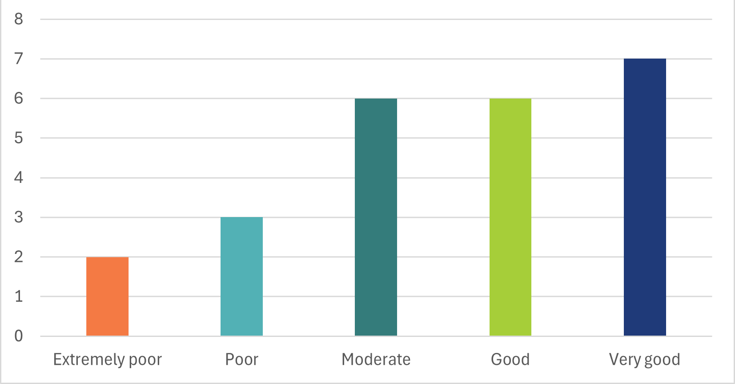
6 participants also provided suggestions for additional stakeholders to include.

Table 6: Suggestions on who we engage with
Topic | Community Feedback
Concerns over dominant influences  (3 comments) | - Suggesting that the council will approach 'identified' community members is too broad; it fails to clearly express how this will be achieved, first and foremost. How will they be identified? This comes across as a secretive approach. The impacted are the people of Bayside as a holistic community  - Policy suggests to me that on some issues you may only hear extreme views from those affected rather than the broader community.
Council process  (1 comment) | - Councillors should be required to engage with stakeholders who have contributed to projects and decisions agreed before making proposed changes to already agreed projects in Council meetings.
Defining community and stakeholders  (2 comments) | - It may be worth defining community members being residential and business.  - Rate payers and residents who are renting.

Previous engagement experience
Respondents had overwhelmingly taken part in at least one community engagement process run by Bayside City Council previously.
Nearly all survey participants had previously contributed to a Have Your Say survey. Over 40% had participated in pop-up events and almost 30% had been part of a consultation group or workshop.

Table 7: Participant engagement history
Surveys | More than 10 surveys | 4.2% (1)
Surveys | Between 6-10 surveys | 8.3% (2)
Surveys | Between 1-5 surveys | 79.1% (19)
Pop- up / drop-in sessions | Yes | 42% (10)
Pop- up / drop-in sessions | No | 58% (14)
Consultation group / workshops | Yes | 29.2% (7)
Consultation group / workshops | No | 70.8% (17)

Almost half of respondents (47.4%) described their previous community engagement experience with Bayside City Council as moderate, while a quarter (26.4%) described it as extremely or very satisfying. The same proportion indicated it was somewhat or not at all satisfying.

Figure 4: Have you been satisfied with your engagement experience with Bayside City Council in the past?
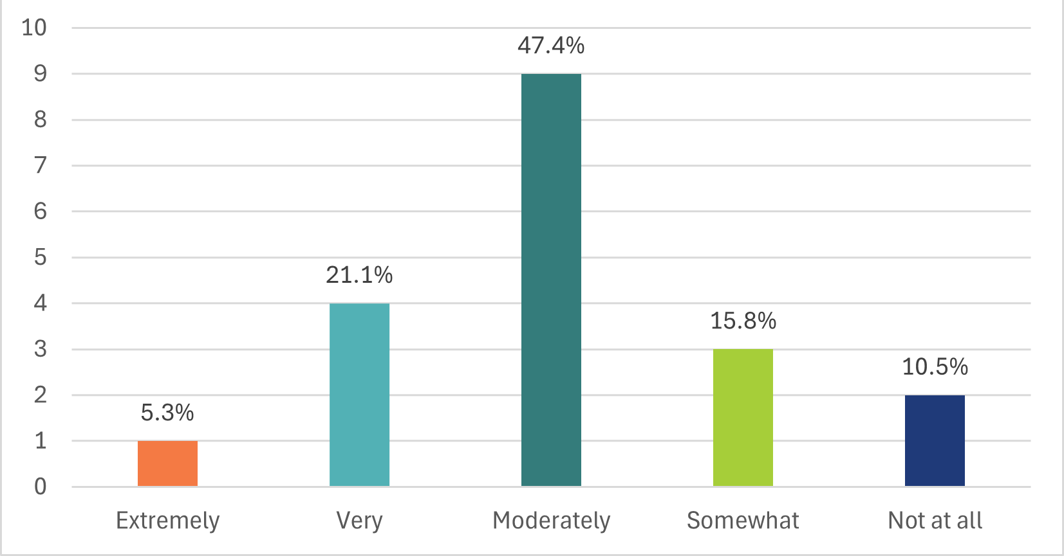
11 participants also provided general commentary on how Council could improve their community engagement experience, summarised in the table below.

Table 7: How could we improve your engagement experience?
Topic | Community Feedback
Communications  (6 comments) | - By developing a balanced communication approach which engages the community in both developmental aspects and also housekeeping.  - Make things more widely known when changes are made; follow up on them; do not forget them.  - Provide greater detail of who has participated in consultation e.g. which stakeholder organisations.  - Reassure participants that it is just not "window dressing".
Council process  (4 comment) | - By ensuring Councillors are also aware of prior project consultation and groups involved before proposing project amendments at Council meetings that blindside groups who are expecting projects to proceed.  - The re-direction of funds allocated to the warm water pool is a good example.  - I feel that my opinions aren’t taken much notice of
Service delivery and responsiveness  (6 comments) | - When phoning for information, wait time is long and you cannot always find out the information required.  - Sometimes there is resistance to simple requests to road safety such as NO Standing signs being put up to improve traffic flow.  - The current city-wide disruption to our streets by Multinet Gas has been widely disruptive without any apparent notification to residents of road closures.

Project evaluation
Although the level of participation in the engagement program was low (25 participants), the level of awareness of the engagement was reasonable with over 800 views of the Have Your Say project webpage.
The low level of participation could be due to a number of factors including low interest in and apathy around policy development (consultations about localised services and assets generally receive higher input); general satisfaction with the current approach to engagement or the changes outlined; or a sense that they have no comments/ contributions to make on this subject.
Multiple methods of participation were available including a printed survey at libraries and the Corporate Centre customer service desk, Q&A forum, direct email, phone, post or in-person meetings. A range of accessibility support was also available including an online accessibility widget to support a wide range of disabilities, and translations into 15 languages other the English.
Participants generally found project information very easy (50%) or mostly easy (33%) to find/understand.
A copy of the survey and the Engagement Plan Overview is available to view at yoursay.bayside.vic.gov.au/engagement.

