Draft Hampton Public Land Masterplan –

Community Engagement Report

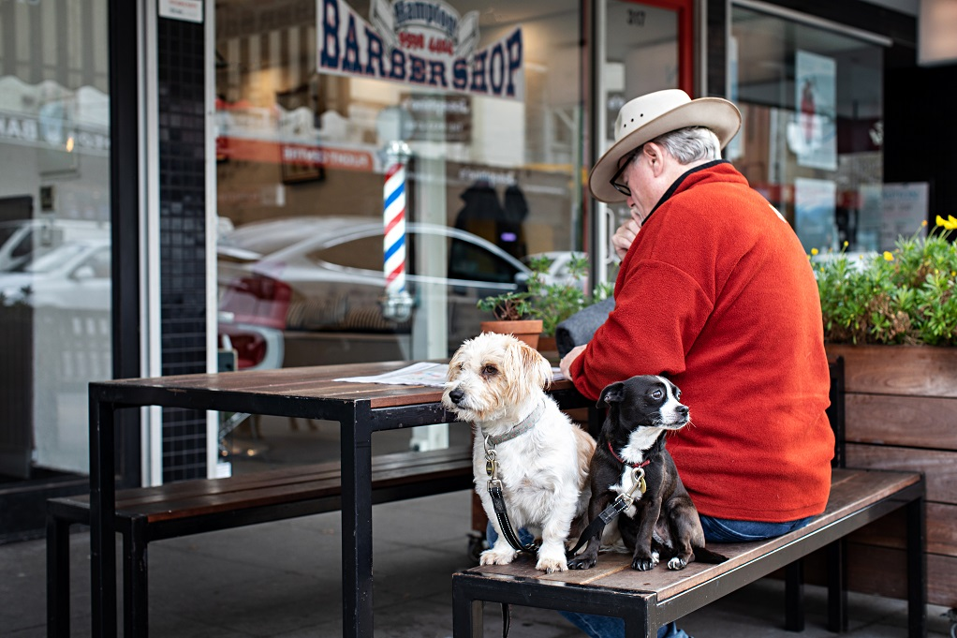

September 2020


Bayside City Council
Corporate Centre
76 Royal Avenue
SANDRINGHAM VIC 3191
T (03) 9899 4444
F (03) 9598 4474
www.bayside.vic.gov.au
Contents
Overview 3
Next steps 3
1 Background 4
2 Definitions and scope 4
2.1 Glossary 5
2.2 Related Council documents and consultations 5
3 Consultation process 6
3.1 Consultation purpose 6
3.2 Consultation methodology 7
3.3 Communication tools and channels 8
4 Participant profile 8
5 Consultation findings 9
5.1 Support for the construction of a multi deck car park (as per marked location) 9
5.2 Support for inclusion of the playhouse into the community hub 11
5.3 Support for the sale of surplus land (as outlined in Masterplan) 13
5.4 Support for further investigation of specific issues 14
5.5 Support for the location and amount of open space (as outlined in Masterplan) 14
5.5.1 Support for the transition of the Scout Hall site to open space 15
5.6 Other feedback on the draft Masterplan 16
6 Project evaluation 17

Overview

Bayside City Council has developed a draft Hampton Public Land Masterplan, which will provide long-term direction for all 13 Council-owned sites within the Hampton Major Activity Centre, including the Library, Community Centre, Playhouse, Senior Citizens Centre, Maternal and Child Health Centre, Scout Hall and car parks.

The third stage of community engagement has focused on three key aspects of the draft Masterplan, where Council has received mixed feedback at previous consultations:
- the Playhouse;
- the sale of public land; and
- the multi-deck car park.

During July-August 2020, Council conducted a four week community engagement process to collect feedback on the direction and content of the draft Action Plan, specifically focusing on the three key areas listed above. Nearly 1000 people visited the Have Your Say project page, with 154 people making contributions via the feedback survey or a question for the project team. Social media was used successfully to raise awareness of the project with 1,290 people engaged. There were 32 individuals who provided feedback via direct email to Council rather than through the on-line survey.

In summary community sentiment regarding the specific proposals and the draft Masterplan was as follows:
- polarised views regarding the construction of a multi deck car park next to the current Hampton Library (46% support/52% oppose);
- majority support for the inclusion of the Playhouse into the community hub (72% support);
- polarised views regarding the sale of the two surplus sites (44% support/54% oppose);
- majority support for Council to explore pedestrian connections between the Hub and Hampton Street (76% support);
- broad support for Council to explore increased open space adjacent to the multi-deck car park (63% support);
- mixed views about the location, and amount of open space in the Masterplan; and
- polarised views regarding the transition of the Scout Hall site to open space (39% support/34% no support).

A wide range of comments were provided on the draft Masterplan however one issue of note was the impact of the COVID-19 pandemic on the proposals.

A report noting the outcomes of this community engagement process was presented at the August 2020 Council Meeting. At the Council Meeting, Council resolved to:
- apply for Federal Government funding to undertake a detailed feasibility of the potential multi-deck car park;
- continue work on the Hampton Masterplan; and
- receive the final Hampton Masterplan at the December 2020 Ordinary Meeting of Council.

Next steps
It will be necessary to understand whether Council can secure Federal funding to move forward with consideration of the multi-deck car park. This is a key element of the Masterplan that will influence the direction of the Masterplan significantly, if Council were to be unsuccessful in its funding application.

Further work is required to determine the source of funding for the actions outlined in the draft Masterplan. Council also needs to determine its approach to property disposal given the feedback received.

Background
Bayside City Council has undertaken a series of research and strategic planning tasks to determine the future of Council-owned community infrastructure in the Hampton Activity Centre. During 2019, Council sought public comment on values for the area so that a criterion could be developed to assist with considering future options for community facilities. A set of ‘place values’ was confirmed with the community and stakeholders in May 2019. Council then developed two spatial concepts for future service provision were developed, assessed as being the most viable responses to community needs. These options were presented for community feedback in July-August 2019 (Stage 2 community and stakeholder engagement).

In September 2019 Council resolved to progress the centralised design option for community facilities. The centralised option was identified as being the community’s preference with the benefits of co-location recognised by most participants. For many people, this option offered the greatest benefits including intergenerational interaction, facilities for multiple uses and activating the ‘triangle area’.

Council is now proceeding with the development of a draft Hampton Public Land Masterplan, which will provide long-term direction for all 13 Council-owned sites within the Hampton precinct including the Library, Community Centre, Playhouse, Senior Citizens Centre, Maternal and Child Health Centre, Scout Hall and several car parks.

The Masterplan will provide the framework to inform the planning for the centralisation of community facilities into an integrated community hub. A community hub is an integrated, multi-purpose facility that provides spaces for Council, community service organisations and community groups to offer a range of services, activities and programs. The Masterplan will also inform the implementation process in both the short-term and long-term.

This document provides a summary of community feedback obtained through the third stage of engagement on the draft Masterplan, with a particular focus on the potential to incorporate the Hampton Children’s Playhouse, the sale and acquisition of public land and the multi-deck car park.

Definitions and scope
The third engagement process was open to all residents, community groups and any other interested stakeholders in the Bayside area. Key stakeholders (tenants of community buildings) were provided with information in advance to allow them to make informed decisions on the parts of the draft Masterplan they support, do not support, or wish to change. This would also ensure that committees were briefed on what was proposed in advance of the general public, if people had questions or comments they wished to discuss with stakeholder groups.

The purpose of the engagement was to collect feedback on:
- to gain support for the key outcomes of the draft Masterplan;
- to determine support for a multi-deck car park being located in the activity centre;
- incorporation of the Playhouse service into the community hub building; and
- the sale of surplus land to raise the revenue required to construct the community hub.

Stakeholders
A wide range of external stakeholders was identified as part of the initial project planning process:
- Hampton Community Centre management and their members/users;
- Hampton Children’s Playhouse Committee and their members/users;
- Hampton Senior Citizen Club members/users;
- Hampton Library users;
- University of Third Age (U3A) members;
- Hampton Neighbourhood Association;
- Hampton Street Traders Association;
- Individual traders;
- Hampton Maternal and Child Health Centre users;
- Immediate residents surrounding the facilities; and
- Broader residents of Hampton.

It is noted that the Scout Hall has been vacant since 2014/15 and there are no stakeholders associated with that facility.

As a precinct planning project, almost every Council department was identified as an internal stakeholder.

Glossary
Item | Definition
U3A | University of Third Age
MCH | Maternal and Child Health
Stakeholders | See above for stakeholder list.

Related Council documents and consultations
The development of the Masterplan has been informed by Council’s considerable policy framework to guide the land use and development outcomes for Hampton. The relevant documents include:
- Bayside Housing Strategy 2019;
- Hampton Major Activity Centre Structure Plan 2006;
- Hampton Major Activity Centre Structure Plan Review 2016;
- Hampton Willis Street Precinct Urban Design Framework 2013;
- Bayside Retail, Commercial and Employment Strategy 2016;
- Bayside Open Space Strategy 2012;
- Bayside Integrated Transport Strategy 2018;
- Early Years Infrastructure Plan 2018-2028; and
- Library Services Strategy Plan 2018-2022.

Consultation process

Consultation purpose
The project timeline below shows the current project phase of community engagement on the draft Masterplan.

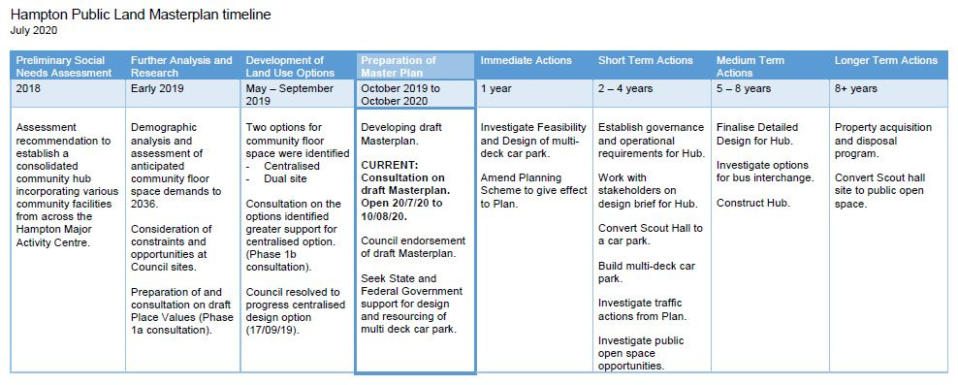

The purpose of this engagement phase was to collect feedback on:
- to gain support for the key outcomes of the draft Masterplan;
- to determine support for a multi-deck car park located in the activity centre;
- incorporation of the Playhouse service into the community hub building; and
- the sale of surplus land to raise the revenue required to construct the community hub.

The community engagement negotiables, and non-negotiables, were as follows:

Negotiable | Non-negotiable
Whether to proceed with a multi-deck car park | Location of multi-deck car park
Whether there is general support for the disposal of surplus sites (regardless of which ones) | Location of consolidated community facilities within the Willis St precinct
Whether the Playhouse should be included in the community hub | Demolition of the Scout Hall (temporary use as a car park)
Whether there is general support for the potential acquisition of land for open space/linkages | Services are to be located within the community hub. Once built, services cannot continue in existing buildings.
 | Existing planning controls in place at the Willis St precinct (may change depending on the outcome of the Masterplan process)
 | Service delivery/implementation of project
 | Building design/configuration/governance (to be determined in future stages of project)

Consultation methodology
Due to the COVID-19 pandemic, community engagement was limited to seeking on-line feedback using the Have Your Say engagement portal, and direct project promotion and awareness raising about the project.

The following engagement activities were undertaken:
- project information and survey hosted on the on-line engagement platform Have Your Say;
- display of signage and flyers at all 13 Council sites within the Activity Centre;
- various stakeholder meetings, including face to face and online platforms; and
- promotion of the project using Council communication channels, including social media.

Details | Activity
20 July 2020 – 10 August 2020  962 visitors  154 contributors  166 contributions  38 project followers | On-line engagement platform Have Your Say  Project information and survey seeking feedback on the three issues and any general feedback about the Masterplan  The 166 contributions comprised 155 survey responses and 11 Questions/Answers.  The questions posed on Have Your Say concerned the Hampton Library & car park (1), the multi-deck car park (3),  Playhouse (1), various car parks (1), and other issues (4).
20 July 2020 – 10 August 2020  1,290 people engaged with the project via social media including:  - 21 Facebook comments  - 1,180 link clicks  - 80 post ‘reactions’  - 670 views on Council’s website News story directly from social media | Social media Bayside Council Facebook, Twitter, Instagram pages  Two separate posts were made by Council alerting readers to the engagement project.
July-August 2020  25 emails  6 telephone calls  3 website enquiries  32 items in total | Correspondence to officers in Urban Strategy team  23 emails with comments were sent to Council:  – 18 emails from individuals,  – 8 emails from the following groups:  - Hampton Neighbourhood Association;  - Hampton Senior Citizens Club (hardcopy survey);  - Hampton Community Centre;  - Bayside Japan Club;  - Hampton Street Traders Association;  - Hampton Children’s Playhouse (received in September);  - U3A; and  - Bayside Russian Friendship Club.

Communication tools and channels
The project was promoted via the following communication channels:

On-line
- Council website and email subscription service – This Week in Bayside news items;
- On-line engagement platform Have Your Say project page;
- Inside Word bulletin to update Councillors on status of project

On-site signage and collateral
- Mail out to key stakeholders including hard copy survey and details of project;
- Corflute signs with brochure holder attached: signs installed at every Council owned building in Hampton (Library, Community Centre, Playhouse, Senior Citizen Centre, MCH and car parks);
- Brochure targeting general community distributed via signage;

Social media
- Facebook, Twitter and Instagram posts;

Advertising
- Facebook advertising (boosted posts);

Direct Email
- External stakeholders/organisations and community groups (as listed);
- The ‘Keep Me Informed’ Database established through Stages 1 and 2 of the project;
- Have Your Say subscribers.

Post
- Hard copy letters posted to property owners of land adjacent to Council owned sites nominated as being surplus/to be sold – Mills Street, MCH and Senior Citizens Centre

Participant profile
Participant characteristics such as age group, household type or gender were assessed as being not relevant for this phase of community engagement. Where registered Have Your Say members participated in the engagement (only 8%), limited demographic data was recorded.
However, the participant’s connection to the precinct was assessed as being relevant and the results are shown in the following table. It should be noted that this survey question was multi-response so the sum of percentages will exceed 100%.

 | Characteristics | Have Your Say participants (%)  n=155 | Correspondence received (No.)  n=32
Connection to Hampton | I visit/shop at a business in Hampton | 117 (75.5%) | 0
Connection to Hampton | I live in Hampton | 112 (72.3%) | 12
Connection to Hampton | I own property in Hampton | 100 (64.5%) | 4
Connection to Hampton | I attend the community facilities in Hampton | 72 (46.5%) | 4
Connection to Hampton | I work/volunteer at a community facility | 22 (14.2%) | 1
Connection to Hampton | I own/work in a business in Hampton | 14 (9.0%) | 4
Connection to Hampton | I go to school in Hampton | 5 (3.2%) | 0
Connection to Hampton | I own a property marked for acquisition in the Masterplan | 0 | 0
Connection to Hampton | Other connections/explanatory comments | 16 (10.3%) | 0
NB: Not all correspondence mentioned a connection to Hampton.

A large majority of the visitors/shoppers to Hampton were also Hampton residents (75.2%) or property owners (69.2%). More than half (58.1%) of the visitors/shoppers also attended the community facilities in the area. Given these multiple (and potentially competing) interests, it is likely that community sentiment will be mixed.

Consultation findings
The following section summarises the community sentiment regarding the specific proposals and the draft Masterplan overall, and the key themes from their verbatim comments. In the interest of stakeholder and community privacy, individual quotes have not been included within this public document.

Results discussed in this report were drawn from the 155 survey responses submitted to the on-line engagement platform Have Your Say, and the 32 comments/queries sent to Council via email, the website enquiries email or telephone. The total number of possible respondents therefore was 187 however totals will be smaller on individual questions as not all respondents answered every question.

Support for the construction of a multi deck car park (as per marked location)
The Have Your Say project page provided information, and an indicative map, about the potential changes to the area around the Hampton Library and car park.

Please rate your support for the construction of a multi deck car park in the identified location | No. | %
I strongly support this option | 44 | 27.2%
I somewhat support this option | 31 | 19.1%
Total Support | 75 | 46.3%
I do not have an opinion | 3 | 1.9%
I am somewhat opposed to this option | 23 | 14.2%
I am strongly opposed to this option | 61 | 37.7%
Total Opposed | 84 | 51.9%
TOTAL | 162 | 100.0%

Respondents made 140 comments to explain their view on the multi-deck car park:

View on proposal | Themes from verbatim comments  (listed in descending order of frequency)
Strongly support | - Recognise the need to provide more parking (majority)  - Mixed view on access for commuters (small numbers)
Somewhat support | - Want height to be 2 above ground and 1 underground level  - Needs to be attractive as possible – vegetation, design  - Recognise the need to provide more parking  - Should be free parking
Somewhat opposed | - Do not want above ground structure, should be underground or low scale  - Concern about traffic congestion resulting from use  - Should be located near Willis Street
Strongly opposed | - Concern about traffic congestion, access for vehicles and pedestrian/driver safety  - Should be located near Willis Street, or south of railway line  - No justification for additional parking  - Residential amenity/appearance will be unattractive  - Do not want above ground structure, should be underground  - Concern about tree removal, loss of vegetation/open space  - Should be focusing on sustainable transport options
NB: The respondents who had “no opinion” (n=3) have not been included in this table.

Given the similar percentage of support and opposition to this proposal, it is important to examine any differences in community sentiment based on their connection to Hampton (e.g. it is feasible that residents would have a different view to community facility users or shoppers).

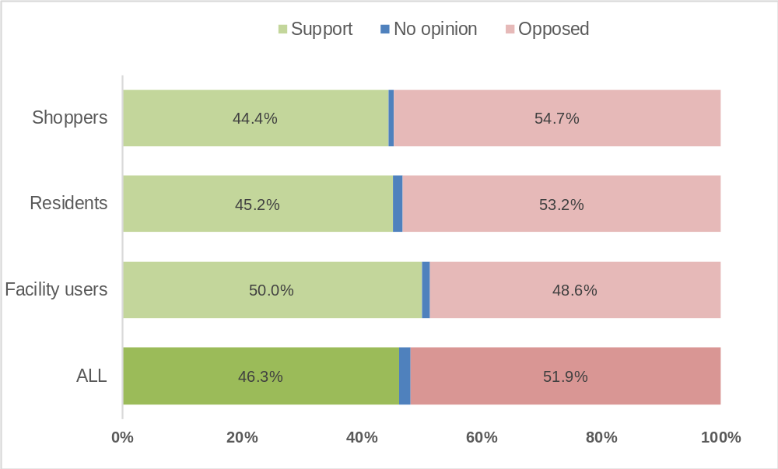

Level of support for the construction of a multi-deck car park in the identified location | Residents/  Property Owners  % | Visitors/  Shoppers  % | Community facility users  %
Strongly support | 25.8 | 25.6 | 28.4
Somewhat support | 19.4 | 18.8 | 21.6
Total Support | 45.2 | 44.4 | 50.0
No opinion | 1.6 | 0.9 | 1.4
Somewhat opposed | 13.7 | 14.5 | 12.2
Strongly opposed | 39.5 | 40.2 | 36.5
Total Opposed | 53.2 | 54.7 | 48.6
TOTAL % (No.) | 100% (124) | 100% (117) | 100% (74)

Characteristics | Themes from verbatim comments (both support and opposed)  (number of comments in brackets)
Residents/  Property Owners | - Recognise the need to provide more parking (30)  - Concern about traffic congestion, access for vehicles and pedestrian/driver safety (25)  - Various design suggestions to ensure fit in neighbourhood (21)  - Should be located near Willis Street, or south of railway line (18)  - Unattractive or unsafe (12)  - Do not want above ground structure, should be underground or low scale (12)
Visitors/  Shoppers  (many of these are also residents) | - Recognise the need to provide more parking (29)  - Concern about traffic congestion, access for vehicles and pedestrian/driver safety (21)  - Should be located near Willis Street, or south of railway line (19)  - Various design suggestions to ensure attractive/maximise use (17)  - Unattractive or unsafe (12)  - Do not want above ground structure, should be underground or low scale (12)
Community facility users | - Recognise the need to provide more parking (19)  - Concern about traffic congestion, access for vehicles and pedestrian/driver safety (13)  - Various design suggestions to ensure attractive/maximise use (13)  - Should be located near Willis Street, or south of railway line (11)  - Do not want above ground structure, should be underground or low scale (9)

Support for inclusion of the playhouse into the community hub
The Have Your Say project page provided information, and an indicative map, about the potential changes to the Willis Street precinct.

Survey respondents were asked if they had a connection to the Playhouse and 147 answered this question. Half had no connection to the Playhouse (46.9%) and 15.6% had only “general interest” in the Playhouse. Just over a third of respondents were either past (31.3%), current (1.4%) or future users (4.8%) of the Playhouse.
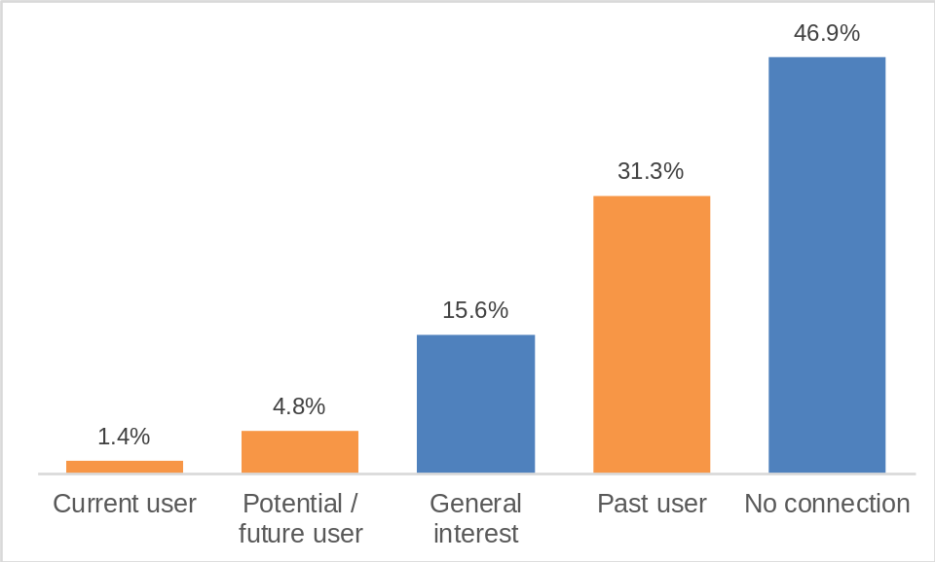

It is noted that rather than participating in the online survey, the Hampton Children’s Playhouse Committee of Management provided a separate written submission indicating their general support for inclusion in the Community Hub, subject to a range of matters. It is understood that the Committee undertook engagement with members in forming its position. The Committee emphasized the importance of having a dedicated space for the Playhouse to use, as well as the need for input into the design of the space and further confirmation of the proposed governance approach.

Please rate your support for the inclusion of the Playhouse into the community hub | No. | %
I strongly support this option | 63 | 41.4%
I somewhat support this option | 46 | 30.3%
Total Support | 109 | 71.7%
I do not have an opinion | 25 | 16.4%
I am somewhat opposed to this option | 7 | 4.6%
I am strongly opposed to this option | 11 | 7.2%
Total Opposed | 18 | 11.8%
TOTAL | 152 | 100.0%

Respondents made 81 comments to explain their view on the inclusion of the Playhouse into the community hub:

View on proposal | Themes from verbatim comments  (listed in descending order of frequency)
Strongly support | - Support for community hub model in general (co-location, multi-age)
Somewhat support | - Support for community hub model in general (co-location, multi-age)  - Support for the service (but no comment on location)
Somewhat opposed | (5 comments – various issues)
Strongly opposed | - Emotionally attached to current building/backyard  - Don’t want any changes made  - Concern about COVID risk mixing generations in community hub
NB: The respondents who had “no opinion” (n=25) have not been included in this table.

Given the majority support for the Playhouse’s inclusion, a summarised table is shown below to determine any differences in community sentiment based on their connection to the Playhouse.

Level of support for the inclusion of the Playhouse into the community hub | No connection  % | Past/current/  future user  % | General interest  %
Total Support | 65.6 | 72.8 | 82.6
No opinion | 25.4 | 10.9 | 4.3
Total Opposed | 9% | 16.3 | 13.0
TOTAL % (No.) | 100% (67) | 100% (55) | 100% (23)

Support for the sale of surplus land (as outlined in Masterplan)
The Have Your Say project page provided information and maps about the two potential surplus sites - Hampton Senior Citizens Centre at 14 Service Street, and Hampton Maternal and Child Health Centre at 483 Hampton Street. The Masterplan further referenced the potential long-term sale of the car park in Mills Street, though there was not a specific question within the survey relating to this as it is envisaged to be an action when the reliance on car parking decreases in the future (timeline to be confirmed).

Please rate your support for the sale of surplus land outlined in the Masterplan | No. | %
I strongly support this option | 25 | 15.8%
I somewhat support this option | 44 | 27.8%
Total Support | 69 | 43.7%
I do not have an opinion | 4 | 2.5%
I am somewhat opposed to this option | 25 | 15.8%
I am strongly opposed to this option | 60 | 38.0%
Total Opposed | 85 | 53.8%
TOTAL | 158 | 100.0%

Respondents made 129 comments to explain their view on the sale of surplus land outlined in the Masterplan:

View on proposal | Themes from verbatim comments  (listed in descending order of frequency)
Strongly support | - Support land sales so funds can be reinvested into the hub  - Support land sales (no justification provided)
Somewhat support | - Support land sales so funds can be reinvested into the hub  - Sell the two sites but not the carpark on Willis Street  - Sell the two sites but not to developers for apartments/height  - Support land sales (no justification provided)
Somewhat opposed | - Need to retain the sites as likely to be needed in future  - Retain and convert to open space  - Oppose the sales as assumed that developers will build apartments  - Oppose the community hub concept  - Opposition to/concern about sale of Willis Street carpark (east)
Strongly opposed | - Oppose the sales as assumed that developers will build apartments  - Need to retain the sites as likely to be needed in future  - Council has no right to sell this land/belongs to community  - Opposition to/concern about sale of Willis Street carpark (east)  - Retain and convert to open space/oppose tree removal
NB: The respondents who had “no opinion” (n=4) have not been included in this table.

Support for further investigation of specific issues

Do you support Council to further explore options to provide pedestrian connections, to connect the Hub to Hampton Street? | No. | %
I support further investigation | 118 | 76.1%
I do not support further investigation | 19 | 12.3%
Don't know/no response | 18 | 11.6%
TOTAL | 155 | 100%
Do you support Council to further explore options to provide increased open space (adjacent to multi-deck car park)?
I support further investigation | 97 | 62.6%
I do not support further investigation | 37 | 23.9%
Don't know/no response | 21 | 13.5%
TOTAL | 155 | 100%

Respondents made 93 comments regarding the future acquisition of land to support the strategic objectives of the Masterplan. Views were mixed with the following themes expressed:
- Do not acquire additional land/use what Council owns/no need (oppose, 22 comments)
- General support for more open space in Hampton (support, 20 comments)
- Other unrelated comments made about various parts of the Masterplan (neutral, 20 comments)
- Opposition to the multi-deck car park itself so opposed to associated open space proposal (14 comments).

Support for the location and amount of open space (as outlined in Masterplan)
The Masterplan proposes an integrated community hub would be adjoined by a leafy green multi-generational open space area. Pocketed plazas and outdoor seating would surround the building footprint, to facilitate community connection and integration. The Scout Hall site would be transitioned to a car park in the short term and would become additional public open space, in the longer term. The Hampton Library site could also be considered for public open space opportunities, if the adjoining properties are acquired.

 | Yes  % | No  % | Not sure/  don’t know  % | TOTAL  %
Do you support the LOCATION of open space indicated in the Masterplan? | 57.8 | 13.0 | 29.2 | 100.0
Do you support the AMOUNT of open space indicated? | 44.0 | 27.3 | 28.7 | 100.0

Support for the transition of the Scout Hall site to open space

Do you support the transition of the Scout Hall site to open space? | No. | %
I support the Scout Hall site as open space | 59 | 39.3%
Total Support | 59 | 39.3%
I do not support the Scout Hall site as open space - an alternate location should be sought | 32 | 21.3%
I do not support the Scout Hall site as open space - there is adequate open space indicated elsewhere in the Masterplan | 19 | 12.7%
Total Not Support | 51 | 34.0%
Don’t know/no answer | 40 | 26.7%
TOTAL | 150 | 100.0%

Respondents made 81 comments about the provision of open space:

View on proposal | Themes from verbatim comments  (listed in descending order of frequency)
Support Scout Hall as open space | - Supportive of the site being used for open space – suggested various enhancements/features
Oppose – need alternate location | - Site is too far away from Hampton Street, other sites proposed  - Suggested other uses for site – parking, other community facility  - Supportive of more open space in general
Oppose – adequate open space | - Suggested other uses for site – parking, other community facility  - Other unrelated comments made about various parts of the Masterplan  - Don’t need additional open space
Don’t know (neutral) | - Supportive of more open space in general  - Other unrelated comments made about various parts of the Masterplan

Other feedback on the draft Masterplan
Respondents made 102 comments about the draft Masterplan, with many comments reiterating or expanding on points made previously in the survey. The specific suggestions have been provided to the Urban Strategy team for consideration.

Broad Topic  (listed in descending order of frequency) | Themes from verbatim comments
Improvements to the draft Masterplan | - Request for further clarity on specific issues and clearer maps  - Needs more analysis on specific issues (eg. parking)  - Community hub model needs to be re-assessed due to COVID pandemic
Suggested new facilities/features | - Specific suggestions for other facilities – arts and culture, retail, community facilities  - Specific suggestions for design, landscaping
Traffic and Parking | - Increased development means greater demand for car parks, increased traffic congestion  - Mixed views on encouraging sustainable transport versus private vehicle use
Support the concept of community hub | - General support for consolidation of services and facilities  - Support for improving/updating buildings
Concerns about past/future “inappropriate” development | - Regret about approval/construction of VicTrack apartments  - Masterplan doesn’t address/alleviate impact of higher density  - Regret about changing nature of Hampton Street
Support for more sustainable approach | - Need more focus on sustainable transport  - Retain or increase trees and vegetation, open spaces
Supportive of the draft Masterplan | - General positive comments about the content or intent of the Masterplan
Funding and investment | - Concern about funding options and decisions
Multi-deck car park | - Opposition to any above ground car park

Project evaluation
In terms of stakeholder reach, it was proposed that aat least 100 contributions would be made on the on-line engagement platform Have Your Say (achieved – 166 contributions).

The conversion outcomes for visits to the Have Your Say project page are shown below:
