Proposed sale of land adjoining Raynes Park Road, Hampton
Community engagement summary report
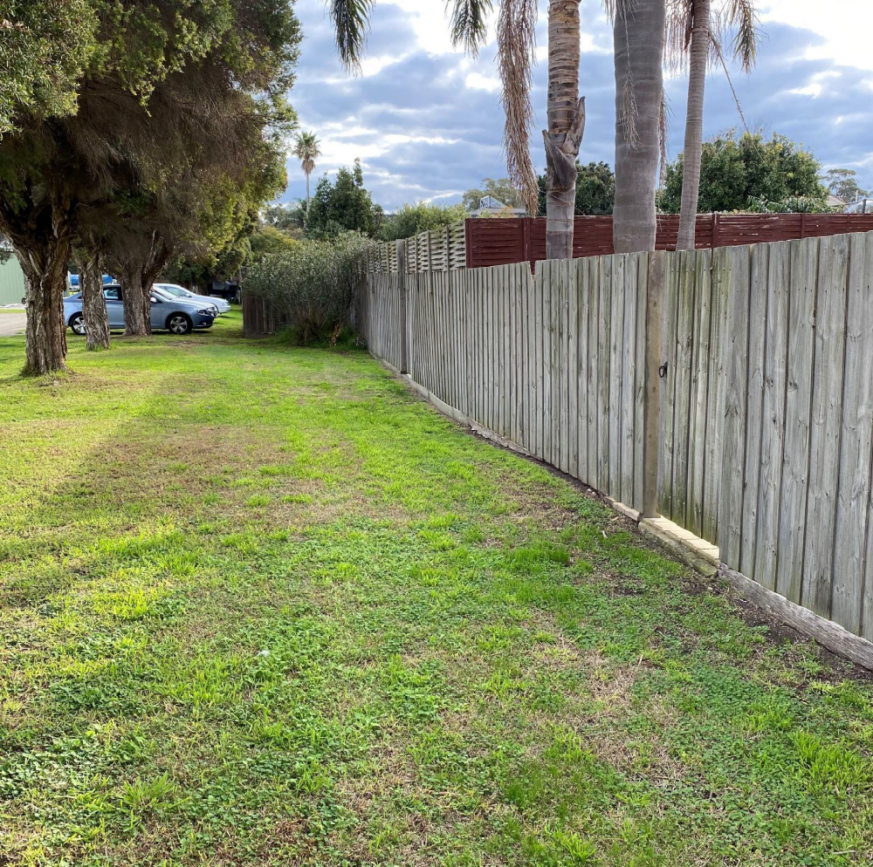

January 2023


Bayside City Council
Corporate Centre
76 Royal Avenue
SANDRINGHAM VIC 3191
T (03) 9899 4444
F (03) 9598 4474
www.bayside.vic.gov.au

Contents
2 Background 3
2.1 Next steps 3
3 Consultation process 3
3.1 Consultation purpose 3
3.2 Consultation methodology 4
4 Participant profile 5
5 Consultation findings 5
5.1 Support for actions 5
5.2 Item-specific feedback 5
5.3 Project Evaluation 6

Background
This document provides a summary of stakeholder and community feedback on the proposed sale of land adjoining 34 and 2/36 Raynes Park Road, Hampton.
Bayside City Council is proposing to sell a small piece of land (92m2) at the rear of 34 and 2/36 Raynes Park Road, Hampton to the adjoining owners of 34 and 2/36 Raynes Park Road, Hampton.
The subject land was previously a drainage reserve that is no longer required for its original purpose, located outside Hampton Bowls Club’s leased area and at the rear of 34 and 2/36 Raynes Park Road, Hampton. It contains underground sewerage and drainage easements which makes it problematic to plant trees and the size of the land is deemed too small to create a pocket park. As Council cannot use this land for any other purpose, it has asked the community for feedback on whether to sell the land.
The land has been offered to the adjoining property owners in accordance with Council’s Discontinuance and Sale of Right of Ways, Roads and Reserves Policy. Council has obtained an independent valuation of the land at the current market rate and is proposing to sell the land for a combined sum of $126,000 plus GST to the owners of 34 and 2/36 Raynes Park Road, Hampton.
The consultation was promoted to the whole Bayside community but with a particular emphasis on Hampton residents, as the proposed sale is likely to be of most interest to those living close by.

Next steps
It is expected that Council will consider the results of the community engagement program and the proposed sale of land adjoining 34 and 2/36 Raynes Park Road, Hampton at its 21 February 2023 meeting.

Consultation process

Consultation purpose
The consultation was designed to:
- present the community with the proposed sale of the subject land, the reasons for the proposed sale and to receive submission from any individual or organisation concerning that proposed sale;
- to ensure that neighbouring owners are aware of the proposed sale and to ensure they have an opportunity to provide comments;
- to comply with Section 114 of Local Government Act 2020 (2) (a) (i); and
- to enable members of the public to register comments concerning the proposed sale for Council’s consideration, prior to a decision on whether to sell the land to the proposed purchaser.

Timeline and phases for the consultation on the proposed sale of land adjoining 34 and 2/36 Raynes Park Road, Hampton:
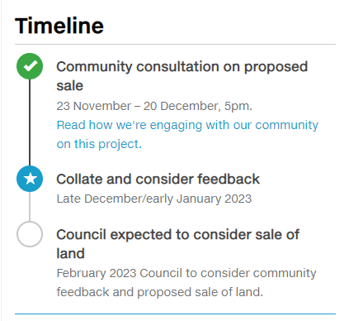

Consultation methodology
The tools and techniques selected for this project were informed by the project content,
stakeholders and type of feedback sought
Key tools for communicating the project
- Public notice on Council’s website and in The Age newspaper
- Letters distributed to neighbouring residents
- Email to Have Your Say subscribers (1,805)
- Council’s e-newsletter This Week in Bayside
- Sign on site with QR code linking to project page and survey

Key methods for gathering feedback
- online engagement through Have Your Say, including opportunity to ask questions and provide feedback
- Phone/post/email correspondence
- Printed information and feedback form available, as required
- Information available in accessible format, as required
- contact email address and phone number of Council Officer provided for interested community members to ask for further information or provide feedback.

Details | Activity
23 November – 20 December 2022  375 visitors  40 contributions  40 Contributors | Have your say website  Project information and online survey hosted on the engagement  platform Have Your Say  Online survey: 38 contributions  Q&A forum: 2 questions asked
23 November – 20 December 2022  1 questions | Correspondence  Direct feedback provided through contacting the Project Officer  for further information or to provide feedback over the phone or via email.

Participant profile
Demographic information was not requested from participants as it was not considered
relevant to this engagement.

Survey respondents (38) were asked to qualify their connection to the subject land. All participants had a connection to Bayside, with some identifying with multiple options:
- 1 indicated they were a nearby property owner
- 2 indicated they were Hampton Bowls Club members
- 1 indicated they were a visitor to Bayside

Consultation findings
The following section summarises the key themes which arose in community feedback on the proposed sale of land adjoining 34 and 2/36 Raynes Park Road, Hampton. In the interest of stakeholder and community privacy, individual quotes have not been included within this public document. Where there was more than one mention of a topic or item, the number of mentions has been specified in brackets and italics.
Participants were asked via an online survey to provide feedback on the proposed sale of land adjoining 34 and 2/36 Raynes Park Road, Hampton including their reasons for supporting or not supporting the proposal.

There were 38 contributions which are summarised as follows:

Support for actions
Community feedback received regarding the proposal was overwhelmingly positive with 71% (27 of the 38 submissions) in support.
2.6% (1 out of 38 submissions) were neutral regarding the proposal and 26.3% (10 out of 38 submissions) were opposing.
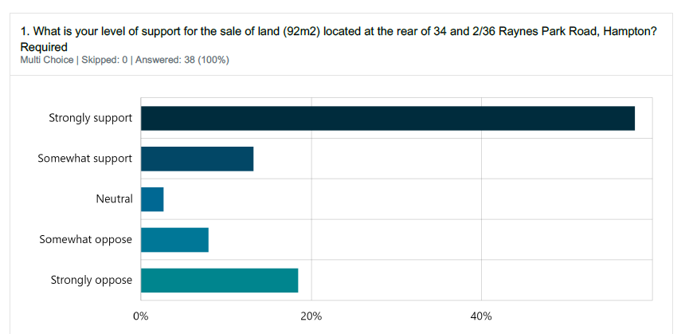

Item-specific feedback
Further detail on the specific responses received is contained in the following tables:
Table 1: Comments from respondents who expressed support or were neutral
Topic | Community feedback
Sell the land | Sensible sale (13 mentions)  No other use of the land (8 mentions)  Sale price too high (3 mentions)  Sale price too low
Other comments | Divide and pay the revenue from sale to rate payers  Use revenue to buy open space

Table 2: Comments from respondents who were opposed or expressed concerns
Topic | Community feedback
Don’t sell the land | The land should be gifted to adjoining owners  Sale price too low
Hampton Bowls Club | Give the land to the club (2 mentions)  The land should be used for parking (3 mentions)
Alternative use of the land | Plant vegetation on the land (2 mentions)  Create a small playground (2 mentions)
Other comments | Divide and pay the revenue from sale to rate payers  Open space maintenance not a big expense for Council

Project Evaluation
This report presents the findings from the analysis of the community feedback gathered during community engagement from 23 November to 20 December 2022.

The engagement program received a total of 38 direct responses, completed via survey through Have Your Say.

Communications to encourage participation attracted 375 unique visitors to the project page and were sent to key stakeholders including previous subscribers for related engagements. The communications reached over 11,000 community members via email newsletters or notifications.

Figure 3: Have Your Say project page – reach and participation:
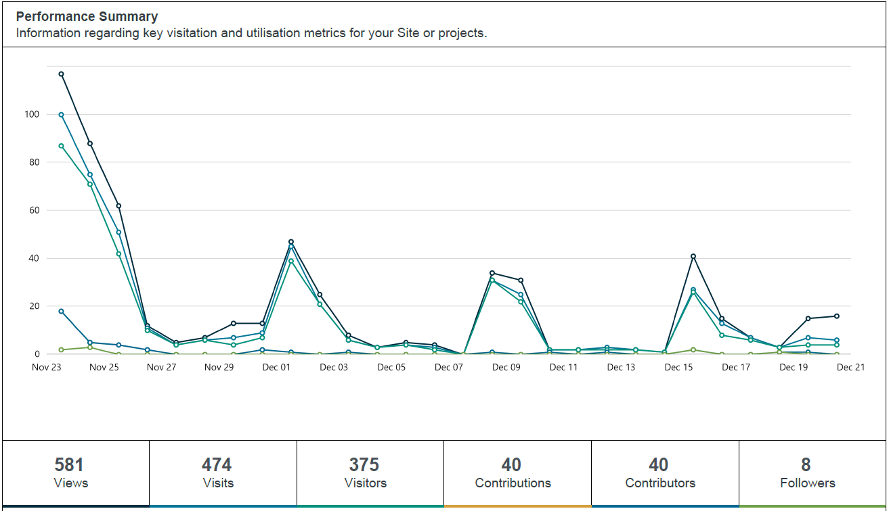

Engagement targets for the Have Your Say webpages were that:
- 20% of visits would last at least one active minute (exceeded, 44%)
- 10% of visits would have at least two actions performed, such as moving around the project page or clicking on links (exceeded, 37%)
- 5% of visits had at least one contribution made (exceeded, 7%)

Satisfaction with engagement process
Survey participants were generally satisfied with the consultation process and materials, with a majority of participants selecting they had the required information to participate, and it was very (65.7%) or mostly (17.1%) easy to find/understand. It is noted that some of participants found the information mostly hard (5.7%) and very hard (2.8%) to find/understand or were not sure (8.5%).

Engagement plan
The Engagement Plan Overview for this project was published and is available to view at:
https://yoursay.bayside.vic.gov.au/proposed-sale-land-adjoining-raynes-park-road-hampton/engagement-plan-overview-raynes

