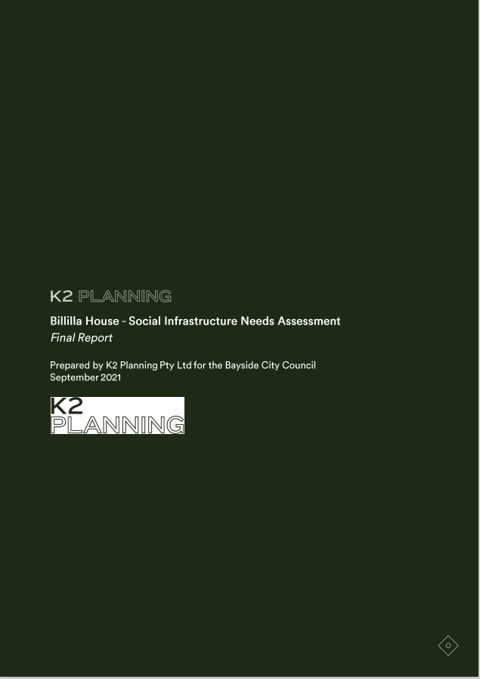

Darebin Intercultural Centre - Relocation Options
Draft Report
August 2019

Table of Contents

1. Introduction 6
2. Key Findings 8
3. Recommendations 10
4. Project Approach 13
5. Project Context 14
5.1 Relevant Policy Directions 14
5.2 Lessons from Best Practice Trends in Social Infrastructure 16
6. Billilla House 20
6.1 Council Ownership 20
6.2 Existing Condition 21
7. Relevant Social Trends 24
7.1 2011 – 2016 Population Trends 24
7.2 Population Forecasts 2021 – 2041 25
7.3 Other Indicators of Community Need 27
8. Social Infrastructure Benchmark Assessment 32
8.1 Brighton and Brighton East Overall 32
8.2 Existing Social Infrastructure – Brighton and Brighton East 33
8.3 Billilla House 40
9 Potential Role for Billilla House 41
9.1 Prior Options Considered 41
9.2 Options Identified at Project Workshop 42
10. Billilla House – Future Options 45
11. Where to Next? 49
12. Attachments 50
12.1 Brighton and Brighton East Demographic Data 50
12.2 Relevant Policy Context 68
12.3 Community Infrastructure Benchmarks 74
12.4 Co-Worker Space Examples 75

List of Abbreviations
ABS Australian Bureau of Statistics
EOI Expression of Interest
MPHW Municipal Public Health and Wellbeing Plan
NSPAC National Seniors Productive Ageing Centre
SEIFA Socio-Economic Index for Areas
VHR Victorian Heritage Register
WHO World Health Organisation

List of Tables
Table 1: Billilla House – Proposed User Groups and Design Considerations 11
Table 2: Project Approach 13
Table 3: Billilla House Condition Audit – Asset Rating 5 23
Table 4: Billilla House Condition Audit – Risk Rating 5 23
Table 5: Affordable property rental for low income over 12 months to Dec 2020 29
Table 6: Social Infrastructure Requirements Brighton, Brighton East and Bayside Overall 2041 32
Table 7: Social Infrastructure Floor Space Requirements Brighton/Brighton East 2041 33
Table 8: Brighton and Brighton East – Existing Social Infrastructure 35
Table 9: Other Non-Council and Council Social Infrastructure 36
Table 10: Brighton and Brighton East – Council Owned Infrastructure 37
Table 11: Brighton and Brighton East Social Infrastructure – SWOT Analysis 39
Table 12: Revised Social Infrastructure Requirements Brighton/Brighton East 2041 40
Table 13: Billilla House Future Uses – Evidence of Need 45
Table 14: Billilla House Future Uses and Design Considerations 47
Table 15: Potential Risks and Mitigating Strategies 48
Table 16: Service Age Groups 2011-2016 51
Table 17: Early Years Age Groups - 2011-2016 52
Table 18: Overseas Arrivals 2006-2016 53
Table 19: Level of English Proficiency 2011 - 2016 53
Table 20: Qualification Levels 2011-2016 53
Table 21: Need for Assistance with Core Activities by Age Group 2011-2016 54
Table 22: Employment Status 2011-2016 55
Table 23: City of Bayside Employment by Industry 2011 – 2016 56
Table 24: Method of Travel to Work 2011-2016 57
Table 25: Disengagement by Age 2011-2016 58
Table 26: Volunteer Status 2011-2016 58
Table 27: Household Size 2011-2016 59
Table 28: Households Type 2016 59
Table 29: Households with Children 2016 60
Table 30: Housing Tenure Overview 2011-2016 60
Table 31: Household Income Quartiles 2011-2016 61
Table 32: Age Group Forecasts 2021 - 2041 62
Table 33: Age Group Forecasts Totals 2021 - 2041 62
Table 34: Brighton and Brighton East Age Forecasts 2021 - 2041 63
Table 35: Index of Relative of Socio-Economic Disadvantage 2016 64
Table 36: Industry Sector of Employment- Arts and Recreation Services 65
Table 37: City of Bayside – Local Workers Key Statistics 2016 65
Table 38: Brighton and Brighton East –Council Owned Community Infrastructure 66
Table 39: Community Infrastructure Benchmarks – Local Level 74
Table 40: 2041 Population: Bayside Overall; Brighton and Brighton East Total Area 74
Table 41: Current Best Co-Worker Spaces in Melbourne 75
List of Figures
Figure 1: Billilla House Floorplan 22
Figure 2: Forecast Change in Age Structure Brighton 2016 - 2041 26
Figure 3: Forecast Change in Age Structure Brighton East 2016 - 2041 26
Figure 4: City of Bayside - Community Indicators 27
Figure 5: City of Bayside Volunteering by Age 2016 28
Figure 6: City of Bayside – Community Safety Indicators 28
Figure 7: Housing Stress -Brighton and Brighton East 29
Figure 8: City of Bayside – Change in Employment by Industry 2011 - 2016 30
Figure 9: Existing Social Infrastructure Brighton and Brighton East 33
Figure 10: Brighton and Brighton East - City of Bayside Property Highlights 38

Introduction
Billilla House is a Bayside City Council (Council) owned facility located at 26 Halifax Street, Brighton Victoria 3186. Constructed in 1878 by Robert Wright, a gold rush immigrant, as a ‘substantial house of thirteen rooms’, the property was later purchased by William Weatherly, an immigrant who arrived in Australia in 1860, and named the house Billilla. Weatherly undertook alterations in 1888 including the addition of a second storey and a major remodelling of the house was completed in 1907 including: a new drawing room, library, enlarged dining room and additional bedrooms.

Following its purchase by the then Brighton City Council in 1973, Billilla House was converted into a house museum and function venue. In 2006, Billilla House was leased to Xavier College and the lease was subsequently transferred to Yesodei Ha Torah College in 2012, which operates a Jewish day school for boys from the main building. The outbuildings to the rear of the main residence are individually leased as part of an artist studio program.

An independent assessment of a number Council’s key historical properties in 2019 concluded that the current use of Billilla House as a school is not an appropriate use of the facility ‘due to the ongoing impact of this use on the heritage fabric of the house (particularly the intact interior finishes) and the inability of the public to fully access the house or the grounds’ .

At a Council meeting in March 2021 Bayside City Council decided not to renew the lease agreement for the current user at Billilla House and instead to prepare a report addressing the circumstances whereby Council takes back control of Billilla House and explores the possibility of creating a new Council/community or commercially managed site that is multi use and generates positive impact for the local community. An overriding concern of Council is to return Billilla House as a Council Asset to the Community.

This Billilla House Social Infrastructure Needs Assessment will support Councils future decision making related to Billilla House by providing:
- An evidence base of the current and future social trends impacting on demand for community programs and services in the area (Section 7)
- A benchmark assessment of the social infrastructure required to support the future population of Brighton and Brighton East (Section 8)
- Analysis of best practice trends in planning of Council owned facilities such as Billilla House (Section 5.1)
- Stakeholder proposals for the future use of Billilla House (Section 9)
- Consideration of the appropriate mix of spaces and functions that could be provided at Billilla House to ensure best use of a Council owned asset (Section 10)
The Billilla House Social Infrastructure Needs Assessment is part of broader work being conducted by Bayside City Council in relation to Billilla House and including:

- Social Needs Infrastructure Assessment (research)
- Summary of Community Engagement (research)
- Conservation Management Plan (research)
- Feasibility report on preferred Options for Billilla based on research
- Council to decide on preferred option
- Development of 4 year business plan

It is also noted that Billilla House is entered on the Victorian Heritage Register (H1101) and future options for development will need to consider the permit approval requirements of Heritage Victoria under the Heritage Act 2017.

Key Findings

Relevant  Report Section | Key Finding and Relevance to Billilla House
Best Practice Approaches  (Section 5.2) | Best practice approaches to planning social infrastructure currently promote multi-purpose facilities that:  1. Build age-friendly communities  2. Respond to an aging population and support intergenerational connections  3. Support participation across all age groups in economic, social and community life  4. Encourage all people, including those who are no longer working, have a disability or are  ill, to remain actively involved in their communities  5. Optimize opportunities for health, participation, community safety and social connection
Lessons from Existing Examples  (Section 5.2) | Relevant lessons from existing examples of Heritage Buildings that operate as community facilities include:  1. Partnerships with experienced organisations or businesses supports effective facility operation and management  2. Security of tenancy for key community groups contributes to the successful activation of the facility  3. Funding opportunities can be sourced through a range of not for profit and philanthropic organisation, relevant state and federal government departments, fund raising events, tenant rent and room hire fees  4. Varied uses of a facility contribute to a successful ‘hub’ environment including; social enterprises, art gallery space, studio space, exhibition and event spaces, café, library and workshop space, makers spaces  5. Programming across the buildings and gardens can increase visitation
Billilla House Existing Condition  (Section 6.2) | Significant areas of Billilla House are currently rated high risk and requiring immediate attention including:  - Multipurpose rooms 1, 2, 4, 6 and 38; tower stairs 41  - Verandah 2 courtyard roof, hallway corridor passage 9  - This existing condition may limit the capacity of the facility to accommodate future uses
Recent Social Trends  (Section 7.1) | Recent social trends across the City of Bayside and in Brighton and Brighton East in particular, show that the following issues impact on the need for social infrastructure in the area:  1. High proportions of people volunteering – including young people aged 14 – 19 years  2. Significant numbers of young people aged 15 – 24 year who are disengaged from either  employment or education  3. Significant increases in the number of people working from home (pre and post COVID)  4. A significant loss of casual employment opportunities for young people aged 18 – 25  years
Population Forecasts  (Section 7.2) | Population forecasts for Brighton and Brighton East show that the area is aging with more people expected to live at home while they age including:  - 1,483 additional people aged 70 years and over living in Brighton and Brighton East 2041  - 426 additional young people aged 12 – 24 years by 2041  - 571 additional children aged 0 – 11 years by 2041
Future Social Infrastructure Requirements  (Section 8.1) | Industry benchmarks indicate that a range of social infrastructure will be needed to support the future population of Brighton/Brighton East by 2041 including:  - Neighbourhood House Programs  - Small community meeting spaces  - Youth facilities (small)  - Multipurpose community centres  - Multipurpose art spaces  - Spaces accommodating senior groups  Much of this social infrastructure is usually provided at a municipal scale in highly accessible locations such as Activity Centres and retail strips.  Billilla House is not located in a highly accessible area. The level of social infrastructure appropriate to Billilla House should support the needs of the local Brighton and Brighton East communities including up to 2,840m2 of flexible meeting rooms and community centre space for:  - General community programs  - Youth specific programs and events  - Intergenerational programs aimed at supporting an aging population
Existing Social Infrastructure  (Section 8.2) | A range of existing social infrastructure currently is located in Brighton and Brighton East including:  1. Brighton Town Hall - which houses the Bayside Gallery; Brighton Theatre Company;  Brighton Historical Society; and Brighton Art Society  2. Brighton Library  3. Brighton Court House – which accommodates the Brighton University of the Third Age  (U3A)  4. Brighton Recreation Centre  Most of this existing social infrastructure is located within 1.5km radius of Billilla House providing municipal level infrastructure that supports the needs of the municipality as a whole.  Future planning of Billilla House should aim to increase the connections and accessibility of Billilla House to other uses within the Brighton Activity Centre.  Planning for Billilla House should complement this existing social infrastructure by providing spaces for local community groups and activities while supporting Councils overriding policies related to increasing community access to services and facilities.

Recommendations

The future role of Billilla House should aim to:
- Increases community safety and accessibility to services and facilities
- Increases the availability of Councils heritage assets for community hire
- Improve the connections and accessibility of Billilla House to other uses within the Brighton Activity Centre

Specific Principles that should guide the future planning of Billilla House include:
- Respond to the needs of the ageing, the very young, and the municipality’s diverse cultural groups
- Support opportunities that build social networks and community connections
- Support a vibrant and connected community by promoting creativity in the arts
- Ensure opportunities that strengthen volunteerism
- Contribute to Bayside’s role as a leading business hub
- Improves access to affordable, appropriate and inclusive service
- Ensure Council assets are well utilised, well maintained and generate high levels of public value
- Improve Trail Networks and Connections
- Develop Partnerships
- Investigates opportunities to improve community engagement relating to Heritage
- Ensure future use of the Billilla House grounds comply with Council’s Environmental Sustainability Framework and Climate Emergency Action Plan
Proposed user groups that would support the future operation of Billilla House as a multi-purpose facility that responds to local community needs and increases accessibility to an important Council asset are set out in Table 1 below. A summary of the evidence that supports these proposed future uses is provided in Table 13, p. 45 .
Future Planning for Billilla House also needs to consider:
- Accessibility and storage issues
- Preservation of existing heritage value
- Employment of an Activation Officer to ensure successful use of the facility (Refer to Section 5.2 Lessons from Best Practice Examples, p. 17)
- Development of a governance model with opportunity for input from a range of user groups including young people
Possible Partnerships that would contribute to successful activation of Billilla House include:
- Negotiation with suitable organisations the about their capacity to act as a Lead Tenant providing overall property management.
- Development of a ‘Friends of Billilla’ Group to ensure ongoing community participation in the use and management of Billilla House
- Consultation with relevant community groups regarding the potential use of Billilla House to promote Brighton history, eg. Brighton Historical Society
- Consultation with a range of other existing community groups about their interest in participating in/contributing to events and activities at Billilla House, eg. Brighton Rotary
Proposed user groups for a future Billilla House are set out in Table 1. Further work is needed to determine the feasibility of each user group using the facility informing a Business Case for the programming and development of Billilla House based on the future user group feasibility study.
As a multipurpose community facility the future Billila House will need to include a range of shared spaces such as:
- Entry and Foyer Areas – can be used for arrivals, welcome and referrals, as well as events, exhibitions and informal gatherings
- Flexible and Adaptable Meeting Rooms – can be used for large, medium and smaller events and can be designed to support a range of user groups with appropriate information technology (IT) such as large screen displays allowing group meetings and training opportunities via the internet
- Kitchen and Refreshment Spaces – shared spaces that encourage connection between various user groups
Table 1: Billilla House – Proposed User Groups and Design Considerations
Facility User | Role/Activities | Location/Design Considerations
Co- Worker Hub | Anchor tenant ensuring activation of the facility and providing:  - Shared Office Spaces  - Modern amenities  - Lightning-fast internet  - Industry-relevant events  - Like-minded individuals and intellectuals  - A local and international network of fellow collaborators | Many rooms can be turned into rented office space with the use of adjacent rooms for a kitchenette
Youth Hub | Youth services including:  - Job ready skills  - Social enterprise opportunities  - Internship opportunities at the Co-worker space  - Activities that promote young people to take ownership/develop a sense of community with the facility | Dedicated youth space to promote a sense of ownership of the facility  Ensure opportunities for youth involvement in the future governance model of the facility
Flexible and Adaptable Community Meeting Rooms | Community programs supporting intergenerational opportunities and knowledge sharing possibly with:  - Rotary Groups  - U3A Programs  - Food donation volunteer groups  - Brighton Pool Club  - Bayley House Day Centre opportunities for work and volunteering placement | Flexible and adaptable community meeting rooms  Access to Kitchen  Potential provision of wet areas to support activities
Community Arts Studios and Program Spaces | - Live music venues  - Arts installations  - Art/craft markets  - Artist in residency program run  - Artist studios | Use of the external buildings  Use of external areas markets  Potential provision of wet areas to support activities
Social Enterprise Opportunities | - Repair café - sustainable, cross generational, community connecting see St Kilda example  - Social enterprise café  - Commercial kitchen – use food donation programs, opportunities for volunteer groups to use | Potential use of external buildings for repair café  Kitchen and training area for social enterprise café
Commercial Opportunities | - Wedding and events venue  - Mobile coffee cart  - Indoor and outdoor dining  - Small businesses  - Arts Retail Store  - Flower/Plant Stall  - Health and Wellness Centre  - Tourism/creative focused retail  - Boutique accommodation | Use of previous reception centre area  Commercial kitchen
Garden Use | - Horticultural tours of the gardens  - Events such as jazz events that used to be offered with a reception centre | Cannot encourage major activity as these are formal gardens  Ensure future use complies with Council’s Environmental Sustainability Framework and Climate Emergency Action Plan

Project Approach
The following tasks were undertaken to complete the Billilla House Social Infrastructure Needs Assessment:
Table 2: Project Approach
Task |  | Approach | Output
Relevant  Policy Context and  Prior work | Desktop summary of relevant:  - Federal and State Government legislation  - Bayside City Council policies  - Prior research conducted by Bayside City Council |  | - Identified policy context guiding the planning of social infrastructure across Bayside City Council and in particular Brighton/Brighton East  - Any documented social infrastructure challenges and opportunities in the area
Demographic Analysis | Detailed demographic analysis of the Billilla house catchment area including:  - Bayside overall  - Brighton  - Brighton East |  | - Recent social trends 2011 – 2016 including: age profile; household types; household size;  income levels; other relevant data impacting on the need for social infrastructure including  indicators of social connection.  - Population age group forecasts 2016 – 2041
Social Infrastructure Benchmark Assessment | Assessment of the short, medium and longer term need for social infrastructure  in the area |  | Evidence based of the demand for social infrastructure in Brighton/Brighton East short,  medium and longer term including:  - community meeting spaces; planned activity groups; artist spaces; performance spaces
Prior Engagement Findings | Review the findings of prior community engagements conducted by the City of Bayside  related to Billilla House |  | Summary of comments received through prior engagement with Bayside Community Groups including:  - Council Officers  - U3A  - Friends of Black Rock House  - Highett Neighbourhood House  - Brighton Historical Society  - Freeza Youth Committee  - Bayside Healthy Ageing Reference Group  - Bayside Arts and Gallery Advisory Committee
Current Community  Infrastructure Provision | Desk top summary of current social infrastructure in the area |  | Map and summary of current facility utilisation data available for existing community facilities in the Project area
Project Workshop | Internal Council Officer Workshop |  | Council Officer input to determine:  - current provision and utilisation levels of community services and facilities in area  - anticipated role and future uses of Billilla House
Billilla House Future Roles | Desktop summary and analysis of the findings of all previous Tasks |  | - Summary of -Brighton/Brighton East community needs 2016 – 2041  - Capacity of existing infrastructure to respond to these needs  - Gaps and potential services, programs and required floor space for future use of Billilla house  - Client meeting to discuss Draft Report

Project Context
This section provides a context for the Billilla House Social Infrastructure Needs Assessment including:

- Principles for the future planning of Billilla House taken from the existing policy context guiding social infrastructure planning across Victoria and at Bayside City Council in particular
- Key lessons for the planning of social infrastructure taken from best practice examples
- Key issues about the future role of Billilla House taken from prior relevant work conducted by the Bayside City Council

Relevant Policy Directions

State Government of Victoria
Key issues emerging from the State Government policy context related to community services and social infrastructure include:
1. Local Government Act 1989, Section 3E; 1 The functions of a Council include:
(b) planning for and providing services and facilities for the local community
(c) providing and maintaining community infrastructure in the municipal district
2. Planning and Environment Act 1987 (‘The Act’) Section 4 (1) sets out the objectives of the Act, including:
to provide for the fair, orderly, economic and sustainable use, and development of land;
(c) to secure a pleasant, efficient and safe working, living and recreational environment for all Victorians and visitors to Victoria
3. The Public Health and Wellbeing Act 2008 outlines specific directions for local government in relation to health and wellbeing. This includes ‘creating supportive environments for health and strengthening the capacity of the community and individuals to achieve better health’
4. The Victorian Government also supports current policies that promote co-located or integrated service delivery within integrated community facilities, encouraging increased community access to services, improved service referral opportunities and shared facilities use
5. Plan Melbourne sets out the Victorian Government’s vision for how Melbourne will grow to 2050.
Key directions in Plan Melbourne include:
- Government land is an important resource for delivering services to Victorians
- Ensure that infill development is sequenced to encourage productive use of existing infrastructure
- 20 minute neighbourhoods - Creating accessible, safe and attractive local areas where people can access most of their everyday needs within a 20-minute walk, cycle or local public transport trip
- Infrastructure is vital for the social, economic and environmental wellbeing of the city

Bayside City Council
A range of policies guide the planning of social infrastructure across the Bayside City Council area including:

- Bayside City Council - Council Plan 2017–2021
- Bayside 2050 Community Vision
- Bayside Property Strategy 2018-2021
- Buildings Service Driven Asset Management Plan June 2016
- Bayside Retail, Commercial and Employment Strategy 2016
- Bayside Heritage Action Plan June 2020
- Bayside Early Years Infrastructure Plan 2018-2028
- Bayside Arts Strategy 2018-2022
- Bayside Arts Strategic Plan 2018-2022, p. 8
- Bayside Open Space Strategy: Suburb Analysis and Action Plan 2012
- Bayside Library Services Strategic Plan 2018 - 2022
- Bayside Tourism Strategy 2013

Key principles drawn from this policy context that should inform future planning for Billilla House include:

Plan for community Infrastructure that:
- Meets future service needs
- Is fit for purpose, adaptable and innovative, and
- Increases community safety and accessibility to services and facilities
- Increases the availability of Councils heritage assets for community hire
Specific Principles that should guide the future planning for Billilla House include:
- Respond to the needs of the ageing, the very young, and the municipality’s diverse cultural groups
- Support opportunities that build social networks and community connections
- Support a vibrant and connected community by promoting creativity in the arts
- Ensure opportunities that strengthen volunteerism
- Contribute to Bayside’s role as a leading business hub
- Improves access to affordable, appropriate and inclusive service
- Ensure Council assets are well utilised, well maintained and generate high levels of public value
- Improve Trail Networks and Connections
- Develop Partnerships
- Investigates opportunities to improve community engagement relating to Heritage
- Ensure future use of the Billilla House grounds comply with Council’s Environmental Sustainability Framework and Climate Emergency Action Plan

5.2 Lessons from Best Practice Trends in Social Infrastructure

Age Friendly Communities
Globally, nationally and at the state government level, best practice approaches to planning social infrastructure adopt an age friendly model that designs facilities and spaces to support active aging, improved community health and increased opportunities for social connection across all age groups. Key policy directions include:
- National guidelines for planning, designing and creating sustainable communities that encourage healthy living and active ageing
- The State Government of Victoria is commitment to build the age-friendly capacity of local communities and creating opportunities for senior Victorians to fully participate in economic, social and community life
- Making cities and communities age-friendly is an effective local policy approach for responding to population ageing
- Active ageing is the process of optimizing opportunities for health, participation and security in order to enhance quality of life as people age
- Healthy and active ageing encourages all people, including those who are no longer working, have a disability or are ill, to remain actively involved in their communities

In 2007 the World Health Organisation (WHO) developed a Global Age Friendly City Guide and Age Friendly Communities Model to provide direction on how to create age friendly cities around the world. The guide recognises that healthy and active ageing is dependent upon a variety of influences including material and social environments. To achieve healthy ageing, careful consideration of policies, services, settings and structures as well as infrastructure from the perspective of an older person is paramount to address the way in which people live and age. All planning for age friendly communities should allow opportunities not just for older people but for the whole community.

Furthermore, WHO recognise in their Healthy Ageing Framework (2002) that the giving and receiving between generations which contributes to intergenerational solidarity, is fundamental in active ageing. The value of intergenerational connections is stressed as a key component of community health as ‘yesterday’s child is today’s adult and tomorrow’s grandmother or grandfather’ (WHO 2002). Intergenerational connections are important to consider when planning services and facilities for older people who may live alone and may experience isolation from family and friendship networks. Intergenerational connections are also fundamental to overall social connections and cohesion.

Creating age friendly communities and facilities
Many cities and communities are already taking active steps towards becoming more age-friendly. A dedicated website, ‘Age-friendly World’, supports these endeavours by providing a one-stop-shop on age-friendly action at the local level including: guides and tools, age-friendly practices and information on hundreds of city and community initiatives around the world. A global data base on age-friendly practices lists a range of age friendly initiatives including:
- Community connection programs
- Age friendly businesses
- Age friendly shopping centres
- Intergenerational models
- Design initiates and retrofit initiatives that increase the age friendly characteristics of urban environments.
(See http://apps.who.int/datacol/custom_view_report)

Multipurpose facilities are a central component of age friendly communities. Best practice approaches to planning social infrastructure currently promote the development of multipurpose community facilities that:
- Increase community access to a range of services
- Support increased social connection and civic participation opportunities amongst residents of all ages
- Ensure opportunities for health, participation and security in order to enhance quality of life as people age
- Provide opportunities not just for older people but for the whole community
- Contribute to intergenerational connections
- Ensure participation through economic, cultural, spiritual or civic perspectives
- Operate under sustainable governance models that support the civic participation of all residents.
(Source: Adapted from WHO ‘Global Age Friendly City Guide and Age Friendly Communities Model)

In Australia, the National Seniors Productive Ageing Centre (NSPAC), Melbourne provides a Fact Sheets for effective planning for Active Ageing which recommends the following approaches to facility design:
- Provide peaceful and striking environments with an important place for art and gardens
- Emphasise the landscape features when designing centres
- Ensure spacious, barrier-free areas ideal for strolling with views to the garden
- Communal spaces (kitchen/dining/meeting room, a laundry and community room) should take up 20% of the floor space (in residential developments)

Activation Officers
Contemporary planning for community infrastructure across Victoria aims to ensure active use of Council owned facilities through the employment of Activation Officers, whose role it is to welcome, connect and refer visitors to the centre. The City of Melton, in Melbourne’s west, for example, is currently planning 40 new community facilities and has committed to staffing Activation Officers to ensure successful programming and use of these new facilities. One Activation Officer may work across multiple facilities.

Current Examples
A number of existing properties located across Victoria provide examples of historic properties that are owned by local government, provide a range of functions and operate under a range of management models. Relevant lessons for Billilla House that can be taken from the examples listed below including:
- Partnerships with experienced organisations such as the National Trust of Australia supports effective facility operation and management
- Security tenancies for key community groups contribute to the successful activation of the facility
- Funding opportunities can be sourced through a range of not for profit and philanthropic organisation, relevant state and federal government departments, fund raising events tenant rent and room hire fees
- Varied uses contribute to a successful ‘hub’ environment including; social enterprises, art gallery space, studio space, exhibition and event spaces, café, library and workshop space, makers spaces
- Programming across the buildings and gardens can increase visitation

- Ripponlea Estate – 192 Hotham Street Ripponlea operates as a historic home, exhibition centre and functions venue with a range of programming in the house and across the gardens. Visitation to the site is in excess of 50,000 people per annum.
- Glenfern – 417 Inkerman Road St Kilda East (Glen Eira City Council) is a Victorian Gothic villa built in 1857. From 1876 to 1901, it was home to the Boyd family and was given to the National Trust in 1984. Glenfern is a base for three community groups Team of Pianists, Writers Victoria, and the Hand Tool Preservation Association of Australia. The Team of Pianists works closely with the National Trust of Australia (Vic) to present recitals in historic venues in and around Melbourne and have established educational programmes for primary and secondary school age students, professional development events as well as presenting masterclasses by Australian and overseas artists. Writers Victoria administer the Glenfern Writers Studios which was established 14 years ago following renovations carried out with financial assistance from the Pratt Foundation, the Helen Macpherson Smith Trust, the Victorian Government (Arts Victoria and Heritage Victoria) and the National Trust of Australia (Vic.) Glenfern provides nine studio spaces and licence agreements are granted for periods of either 3, 6, 9 or 12 months.
- Bundoora Homestead Art Centre is the public art gallery for the City of Darebin which is housed in a magnificent Queen Anne-style Federation mansion that was built in 1900. In 2001, with the help of La Trobe University and the Commonwealth Government, Darebin City Council restored Bundoora Homestead and opened it to the community as an arts and cultural space. The house and gardens are registered by Heritage Victoria and certified by the National Trust. The Homestead is a creative hub which holds contemporary art exhibitions, art and craft workshops, artist talks, heritage resources, and creative clubs. A café, gallery shop, community library and makers space can also be found in the building. in Darebin.
- The Abbotsford Convent - 1 St Heliers St, Melbourne (City of Yarra) describes itself as “A living place for curiosity and collaboration, meeting and meaning. The heart of a creative community. A precinct of art, culture and learning.” It is a not-for-profit social enterprise limited by guarantee under the Corporations Act and registered with the Australian Charites Not-for-profits Commission. The Foundation is responsible for the management and stewardship of the Abbotsford Convent precinct, and its diverse assets and activities. Income is generated by a range of activities included tenants rent, Car Park income, room hire and grants and donations.
- Osborne House – 51A Swinburne Street North Geelong (City of Greater Geelong) was built in North Geelong 1858, is an important community and heritage asset that’s of regional significance to Greater Geelong. The building was leased to a number of community groups in the past and in 2012 The Osborne Park Association put forward an Os Artz Proposal to the Geelong City Council to make Osborne Park into a Culture and Community Centre for Arts, Education and Tourism. In 2013-15 the Geelong Council voted to retain the status quo with community groups as tenants. In 2018 Councillors voted to retain Osborne House, the Stables and environs in community ownership. Geelong Council recently agreed to enter into an EOI process to seek potential investors to partner with Council, guided by sustainable development parameters and principles it adopted in 2020. The development of the EOI documentation and process has been carried out in consultation with the Osborne House Project Control Group, which includes representatives from the City, Heritage Victoria, National Trust of Australia (Victoria) and the Osborne Park Association.
- Miller’s Homestead – Dorrigo Dr and Melrose Crt Boronia (Knox City Council) is a heritage-listed homestead located in Melbourne’s outer east. The Homestead was built around 1888 for James John Miller, who became the first president of the Shire of Ferntree Gully. The single-storey brick homestead features a cast iron verandah trim, marble fireplaces, etched glass panels, and original joinery (Heritage Council Victoria, 2005). Council has determined that Miller’s Homestead be used for proactive programming, an art and history centre, and be managed by a community or not-for-profit group. Council has recruited a project officer to focus on the work required, including finding a community or not-for-profit tenant and getting the facility ready for its new use.

This section has identified key directions for future planning of Billilla House including
- Principles for the future planning of Billilla House taken from the existing policy context guiding social infrastructure planning across Victoria and Bayside City Council
- Key lessons for the planning of social infrastructure taken from best practice examples
- Key issues about the future role of Billilla House taken from prior relevant work conducted by the Bayside City Council

Billilla House
This section provides a brief summary of the existing condition of Billilla House based on:

- Bayside City Council facility condition audits
- Relevant prior work conducted in relation to Billilla House

6.1 Council Ownership
Billilla House was purchased by the City of Brighton in 1975 for $308,000 using funds available from the Recreational Lands Act subdivisional fees at no direct cost to ratepayers. The property was rezoned for public purposes and the City of Brighton Council redeveloped it for use as an Art, Craft Cultural Centre.
A Committee of Management was created in 1990’s which included a Councillor representative and was autonomous of Council and had its own bank account. The Committee of Management financed the interior renovation of Billilla House using rentals and income from private functions. The exterior of the building was the responsibility of the City of Brighton and following amalgamation in 1994 Bayside City Council spent $250,000 repairing parts of the building.
In 1991 the ‘Friends of Billilla’ was formed with the following Statement of Purpose:
- To make recommendations to the Billilla Committee of Management on any matter relating to Billilla and the use of the facility.
- To carry out research into aspects of Billilla, the Weatherly family and the social history of Brighton
- To assist the Billilla Committee of Management in the promotion of Billilla
- To present Billilla to the public by means of conducted tours

Around 1995 it was mutually agreed to wind up the Committee of Management and transfer management of Billilla to a professional body. A planning permit was obtained as a private operator would be involved with the building going out to tender. The successful tenderer ran a catering and function business at Billilla for several years.

Bayside City Council created the ‘Bayside Heritage Committee’ in 1999 which advises Council on heritage matters, including Billilla.

In 2004 an Expression of Interest (EOI) was issued for use of Billilla House and in 2005 the City of Bayside signed a 15 year lease with Xavier College which was subsequently transferred to Yesodei Ha Torah College in 2012, which operates a Jewish day school for boys from the main building. The outbuildings to the rear of the main residence are individually leased as part of an artist studio program, although this use has currently lapsed.
Council currently runs the Billilla Homestead Artists Studio Program which is part of the Bayside Arts Strategic Plan 2018-2022 and offers free studio space for artists from across Victoria and Bayside. The program supports artists from diverse practices and across career stages. The vision of the Bayside Arts Strategic Plan 2018-2022 is for Bayside City Council to offer inspiring, creative, artistic and cultural experiences for its community and visitors to enjoy. The Billilla Homestead Artists Studio Program supports this strategic vision to: Deliver an innovative creative program and Support people to develop their creative pursuits.

6.2 Existing Condition

Billilla Homestead is entered on the Victorian Heritage Register (VHR) (H1101) meaning any future options for the property will need to consider the permit approval requirements of Heritage Victoria under the Heritage Act 2017.

Billilla is identified as HO188 in the Schedule to the Heritage Overlay of the Bayside Planning Scheme. The Heritage Overlay listing reflects the VHR extent of registration. Billilla is located in a Public Use Zone – Local Government (PUZ6)

The property was identified in the City of Bayside Heritage Review, as follows:

Billilla, at 26 Halifax Street, Brighton, is of outstanding aesthetic and historical significance. Billilla, its outbuildings and garden are of cultural significance for the outstandingly intact nature of the Edwardian and Victorian fabric, services and fittings and in the manner in which they display the lifestyle and working of a wealthy Edwardian household.

Billilla House comprises the following:
- Billilla Homestead (Figure 1)
- Outbuildings to the rear of the main residence (also shown in Figure 1 No’s 43 – 54)
- Public gardens which remain open to the public in the present circumstances

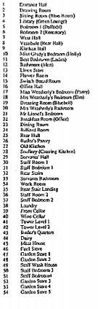
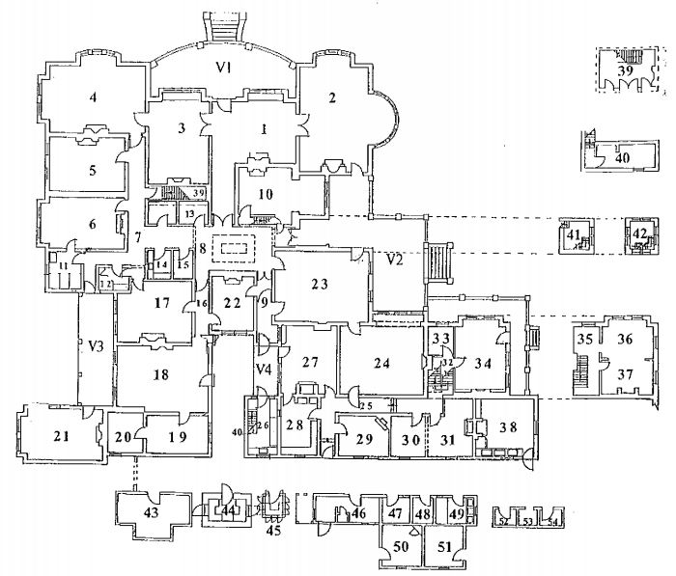
Figure 1: Billilla House Floorplan

Source: GJM Heritage 2019 Bayside Historical Buildings Strategic Plan: Heritage Report Billilla 26 Halifax Street Brighton, p. 2

Bayside City Council’s Building Condition Audit rates Council assets according to the following building condition ratings:

1 = New/No Risk
2= As New/ very low risk
3=Good/ low risk
4= Minor issues/ Medium risk – will need attention when able
5= Major issue / High risk – immediate attention required

Current building condition audit data identifies a range of areas of Billilla House that have a building audit asset rating of 5 Major Issue. These areas are listed in Table 3, including their Risk Factor Rating and their Priority.

Table 3: Billilla House Condition Audit – Asset Rating 5
Building Area |  | Risk Factor | Issue/ Defect | Priority
Multi Purpose Room | Room 6 | 5 | Handle broken off | 2 - High
Multi Purpose Room | Room 2 | 4 | Damage | 2 - High
Multi Purpose Room | Room 4 | 3 | Multiple areas damaged | 2 - High
EXT-Area | Verandah 2 | 5 | Missing globe
Multi Purpose Room | Room 38 | 5 | Fittings damaged
Multi Purpose Room | Room 1 | 5 | Missing extinguisher | 2 - High
Stairs | Tower Stair 41 | 5 | Not working missing cover | 2 - High
Source: Bayside City Council Partial Condition Report Billilla House 2020 – 2021 adapted by K2 Planning Sept 2021

Other areas of Billilla House, listed in Table 4, have also been identified as having a Risk Rating of 5.

Table 4: Billilla House Condition Audit – Risk Rating 5
Building Area | CTM | CM | Issue/ Defect
Multi Purpose Room 6 | Internal/External Doors | Door Hardware | Handle broken off
EXT-Area Verandah 2 | Lighting | Light - Globe (Standard) | Missing globe
Multi Purpose Room 38 | Special | Pendant Lighting | Fittings damaged
EXT- Courtyard roof | Access Systems | Safety Ladder  Attachment Point | Portable toilet blocks access point
Multi Purpose Room 1 | Fire Fighting Equipment | Fire Extinguisher | Missing extinguisher
Hallway/Corridor Passage 9 | Internal/External Doors | Door - Solid | Boarded up
Tower Stair 41 | Lighting | Light - Globe (Standard) | Not working missing cover
Source: Bayside City Council Partial Condition Report Billilla House 2020 – 2021 adapted by K2 Planning Sept 2021

Relevant Social Trends
This section provides an analysis of recent social trends impacting on the need for social infrastructure in the Brighton and Brighton East areas including:

- Recent trends from the 2011 – 2016 census of population and housing
- Other relevant indicators of community connection and participation
- Anticipated population changes 2021 – 2041

7.1 2011 – 2016 Population Trends
Australian Bureau of Statistics (ABS) census data shows that overall, the City of Bayside, Brighton and Brighton East are advantaged areas.

According to the socio-economic index for areas (SEIFA) index of relative advantage all three areas are above the national SEIFA average of 1.000 and are therefore relatively advantaged:

- City of Bayside 1097
- Brighton East 1099.7
- Brighton 1107.3

Other social indicators also highlight this level of socio-economic advantage including:

- Most residents live in households that earn the highest income quartile: Brighton 51%; Brighton East 45.4% (2016)
- A majority of residents fully own their own homes - Brighton 42.2%; Brighton East 49.8% (2016)
- A high proportion of residents hold a bachelor degree or higher: Brighton 43.5%; Brighton East 40% (2016)
- Low rates of unemployment: Brighton 2.5%; Brighton East 3.1%; Bayside 2.5% (2016)

However, there is also evidence of significant pockets of need in the community including significant increases between the 2011 – 2016 census in the number of:
- Young people aged 15 – 24 year who are disengaged from either employment or education: Brighton 79 young people, 41.1% increase; Brighton East 4.5% increase 3 additional young people
- People aged 65 years and over who are disengaged from either employment or education: 3,593 people in Brighton 16.6% increase with 511 additional people; Brighton East 13.2% increase 247 additional people who are disengaged
- People who are unemployed: Brighton 111.5% increase 146 additional people who are disengaged; Brighton East 85% increase 108 additional people who are unemployed
- People in need of assistance due to a disability; Brighton 0- 64 year age group; Brighton East 0 – 64 year age groups and 75 years and over age groups
- Residents with no qualifications: Brighton 29.9% (5,767 people); Brighton East 31.5% 3,885 people
A City of Bayside Youth Resilience Survey (2019) conducted with students in years 7 – 12 also found evidence of social needs amongst young people including:

- 32% feel nervous, anxious or on edge
- 37% do not feel good about themselves
- 39% don’t forgive themselves when they mess up

Like many other areas across Australia, Bayside, and Brighton and Brighton East in particular, are experiencing an aging of the population. During the 2011 – 2016 census period there has been a decline in the number of young people including:

- Children aged 0 – 4 years (149 fewer children in this age group)
- Primary school age children aged 5 – 11 years (242 fewer children in this age group)
- Parents and homebuilders aged 35 – 49 years (230 fewer people in this age group)
(Refer to Table 16 and Table 17 p. 52)

Concurrently Brighton and Brighton East have experienced an increase in the number of older people who are:
- Older workers and pre-retirees aged 50 – 59 years (438 additional people)
- Seniors 70 – 84 years (628 additional people)
- Elderly aged 85 years and over (183 additional people)

It is also noted that there are significantly high proportions of lone person households in Brighton 24.5% and Brighton East 20.3% (
Table 28, p. 59).

7.2 Population Forecasts 2021 – 2041
Brighton and Brighton East are anticipated to experience high levels of population growth between 2016 – 2041 with significant increases forecast in the following age groups:
- Brighton 2021 pop = 24,979 people; 2041 pop = 29,463 – i.e. 4,484 additional people 17.9% increase
- Brighton East 2021 pop = 16,488 people; 2041 pop = 18,323 – i.e. 1,835 additional people 11.1% in crease

Brighton East
- 70 – 84 year olds 34.5% increase 631 additional people;
- 85 years and over 28.5% increase 218 additional people

Brighton
- 14.5% increase in the 0–4-year-old age group (185 additional children)
- 14.5% increase in the 5 – 11 year old age group (298 additional children)
- 25 – 34 year old’s 13.9% increase (340 additional people)
- 35 – 49 year old’s 15.1% increase (743 additional people)
- 70 – 84 year old’s 25% increase (793 additional people)
- 85 years and over 36% increase (331 additional people)
Brighton and Brighton East combined 2021 – 2041 change:
- 4,805 additional people
- 1,483 additional older people aged 70 years and over
- 426 additional young people aged 12 – 24 years
- 571 additional children aged 0 – 11 years
(Refer to Table 34, p. 63 for full details)

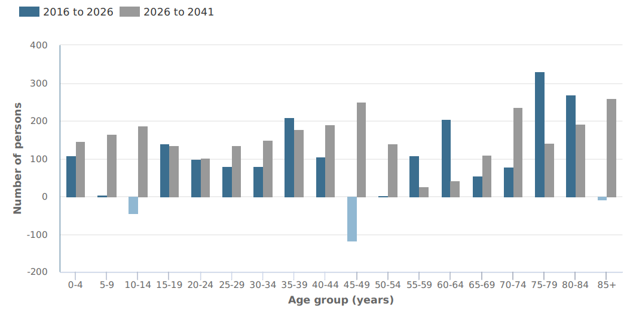

Figure 2: Forecast Change in Age Structure Brighton 2016 - 2041

Source: forecast.id.com.au

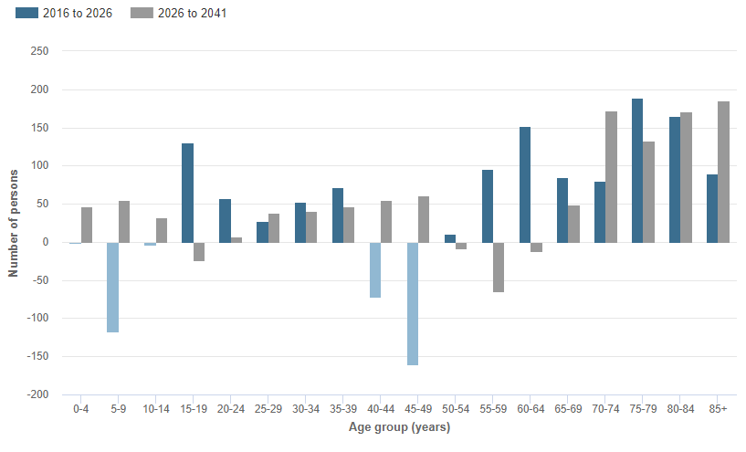

Figure 3: Forecast Change in Age Structure Brighton East 2016 - 2041

Source: forecast.id.com.au

Participants at the workshop conducted for the current project have noted an underestimation in the number of people in older age groups forecast in Brighton and Brighton East:

- Older person projections are under estimated
- Recent policy trend in aged care is encouraging people to stay at home as they age
- Forecast ID has assumed people aged 85 years and over may leave the area
- It is more likely that they will stay in the area
- More apartments are being built with universal building design standards supporting people to remain in the area longer
(Source: Project Workshop Bayside Council Officers September 2021)

Other comments received from workshop participants related to the future population of Brighton and Brighton East include:
- There are lots of new residents coming into the area
- Many new apartments being built within 1km of Billilla currently in Church Street Activity Centre
- Apartments are now becoming far more accessible
(Source: Project Workshop Bayside Council Officers September 2021)

7.3 Other Indicators of Community Need
Volunteering
Bayside residents are more likely to participate in volunteering (25.5%), compared to Greater Melbourne (19%) (Figure 4)

Bayside has significantly high proportions of people who volunteer aged 40 – 54; 70 – 74; and 15 – 19 years, compared to Victoria overall (Figure 5)

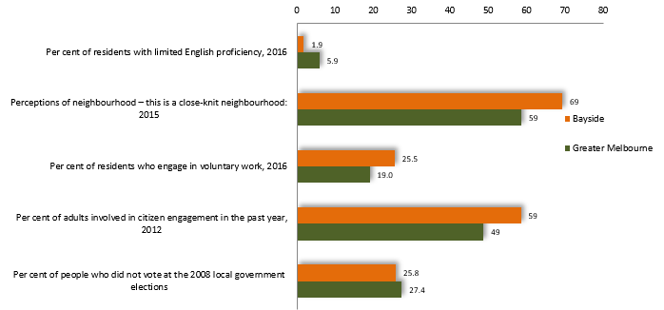
Figure 4: City of Bayside - Community Indicators

Source: socialstatistics.com

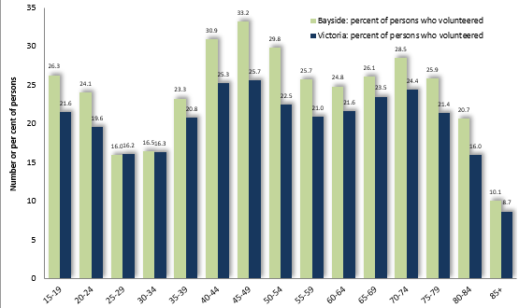

Figure 5: City of Bayside Volunteering by Age 2016

Source: profile.id.com.au

Brighton and Brighton East have experienced significant increase in the number of people volunteering 2011 – 2016:
- Brighton East 17.9% 441 additional people
- Brighton 0.2% increase 780 additional people

Community Safety
Compared to greater Melbourne overall, Bayside has:
- Significantly fewer rates of police call outs for family incidents and child protection substantiations
- Lower proportions of people who do not feel safe alone in their area at night
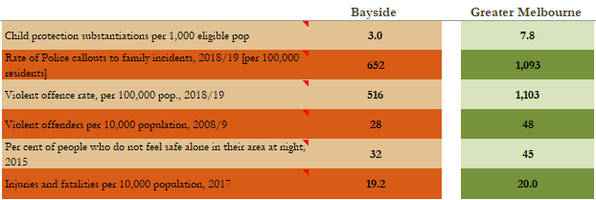

Figure 6: City of Bayside – Community Safety Indicators
Source: socialstatistics.com
Housing Affordability

- 2.8% of all households in the City of Bayside are living in housing stress
- Higher proportions in pockets of Brighton and Brighton East (up to 23.8% in the area on Centre Road)
- Over the past 12 months to December 2020, only 11.3% of all rental listings would have been affordable to average households on a low income
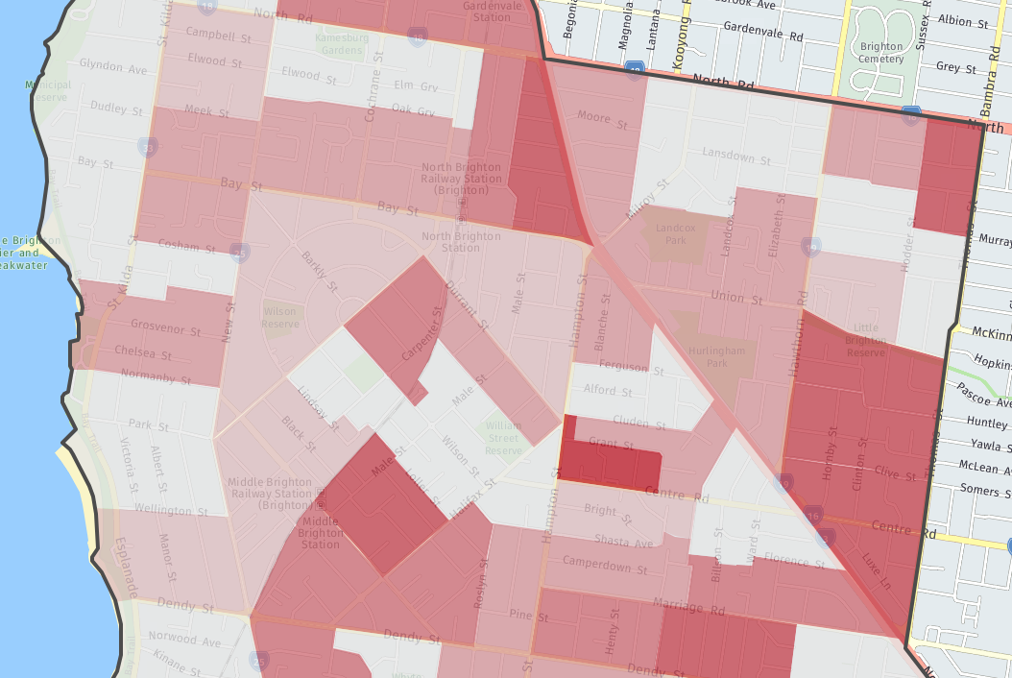

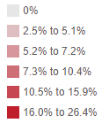



Figure 7: Housing Stress -Brighton and Brighton East
Source: profile.id.com.au
Billilla House

Table 5: Affordable property rental for low income over 12 months to Dec 2020
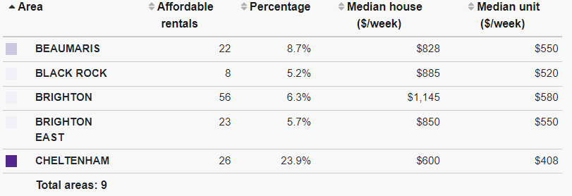

Source: housing.id.com.au/bayside

Local Workforce

In 2016 the City of Bayside local workforce comprised 29,540 workers:
- Most were aged 25 – 54 years (18,455 workers)
- Many were older workers:
- aged 55 – 64 years (16% or 4,763 people compared to 11.6% Victoria overall)
- aged 65 years and over (6.5% or 1,930 people compared to 4.2% Victoria overall)
(Table 37, p. 65)

At the time of the 2016 census 1,535 residents of Brighton and Brighton East were working from home. The increase in the number of people who work at home 2011 – 2016 was:
- Brighton East 11% increase with 55 additional people working at home
- Brighton 11.7% increase with 103 additional people working at home
(Table 24, p. 57)

This increase in the number of people working at home was confirmed by participants at the workshop conducted for the current project.

There is also a relatively high proportion of people employed in the Arts and Recreation sectors:
- City of Bayside 2.6% compared to Victoria Overall (1.9%) 2016
- Employment in this sector across the City of Bayside has increased by 216 people 2011 - 2016
- Relatively high proportions of people employed in this sector live in Brighton 2.32% 247 people 2016 and Brighton East 2.73% 195 people 2016

Participants at the workshop conducted for the current project also noted an increasing need for:

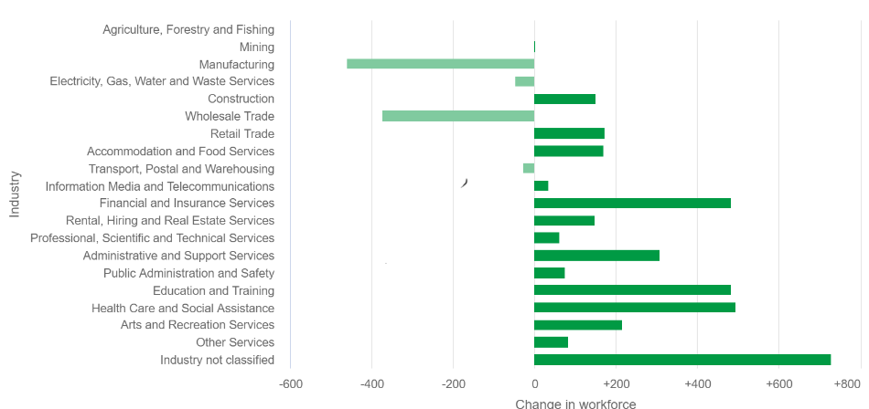
Employment opportunities for young people – COVID has had a significant impact on 18 – 25 year old’s who had casual jobs and were studying full time (Source: Project Workshop Bayside Council Officers September 2021)

Figure 8: City of Bayside – Change in Employment by Industry 2011 - 2016
Source: economy.id.com.au
Summary

The following social trends currently impact on the need for social infrastructure in Brighton and Brighton East:

- High proportions of people volunteering – including young people aged 14 – 19 years
- Significant numbers of young people aged 15 – 24 year who are disengaged from either employment or education: Brighton 79 young people, 41.1% increase; Brighton East 4.5% increase 3 additional young people
- Significant increases in the number of people working from home (158 additional people - 11% increase 2011 -2016; higher increases anticipated post COVID)
- A significant loss of casual employment opportunities for young people aged 18 – 25 years
- An anticipated ageing of the population with 1,483 additional people aged 70 years and over living in Brighton and Brighton East by 2041
- An additional 426 young people aged 12 – 24 years by 2041
- An additional 571 children aged 0 – 11 years by 2041

8. Social Infrastructure Benchmark Assessment
This section identifies the future social infrastructure needs of Brighton and Brighton East based on:

- Industry benchmarks for the provision of ‘local level’ social infrastructure (See Table 39, p. 74)
- Relevant age group forecasts for Brighton and Brighton East in 2041 (see Table 40, p. 74)
- The current provision of social infrastructure in the area (Table 8 below)

8.1 Brighton and Brighton East Overall
Industry benchmarks indicate that the following social infrastructure will be needed to support the future population of Brighton/Brighton East by 2041:
- 2.4 Neighbourhood House Programs
- 11.9 small community meeting spaces
- 6 youth facilities (small)
- Between 4.8 – 6 small multipurpose community centres
- Between 4.8 – 6 flexible multipurpose art spaces
- Between 4.8 – 6 spaces accommodating senior groups
(Table 6)

Table 6: Social Infrastructure Requirements Brighton, Brighton East and Bayside Overall 2041
Service Type | Population Projections - 2041
Service Type | Brighton/Brighton East | City of Bayside
Service Type | 47,785 | 128,170
General Community Services
Neighbourhood House Programs | 2.4 centres  Between 477.9 and 1433.6 m² floor space | 6.4 centres  Between 1281.7 and 3845.1 m² floor space
Community Meeting spaces - Small | 11.9 spaces  358.4 m² floor space | 32 spaces  961.3 m² floor space
Youth Facilities | 6 facilities  1194.6 m² floor space | 16 facilities  3204.3 m² floor space
Multi-purpose Community Centres - Small | Between 4.8 and 6 centres  2508.7 m² floor space | Between 12.8 and 16 centres  6728.9 m² floor space
Arts and Cultural Facilities
Community Art Space - Flexible, Multipurpose, Shared Use | Between 4.8 and 6 centres  2389.3 m² floor space | Between 12.8 and 16 centres  6408.5 m² floor space
Aged & Disability
Seniors’ Groups - Small | Between 4.8 and 6 spaces  1194.6 m² floor space | Between 12.8 and 16 spaces  3204.3 m² floor space
Source: K2 Planning September 2021

Table 7: Social Infrastructure Floor Space Requirements Brighton/Brighton East 2041
 |  | Raw floor space approximations |  | Considering facility audit  Table 8 below
Service Area | Benchmark m² | Brighton/Brighton East | City of Bayside | Brighton/Brighton East | City of Bayside
Neighbourhood House Programs | 200-600 | 477.9 to 1433.6 | 1281.7 to 3845.1 | 477.9 to 1433.6 | 1281.7 to 3845.1
Community Meeting spaces - Small | 30 | 358 | 961 | No additional requirement | 441
Youth Facilities | 200 | 1,195 | 3,204 | 1,195 | 3,204
Multi-purpose Community Centres - Small | 420 | 2,509 | 6,729 | 2,509 | 6,729
Community Art Space - Flexible, Multipurpose, Shared Use | 400 | 2,389 | 6,409 | 2,389 | 6,409
Seniors’ Groups - Small | 200 | 1,195 | 3,204 | 795 | 2,804
Source: K2 Planning September 2021

8.2 Existing Social Infrastructure – Brighton and Brighton East

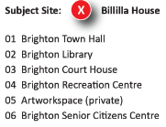

A range of social infrastructure currently exists in the Brighton and Brighton East area including:
Figure 9: Existing Social Infrastructure Brighton and Brighton East

- Brighton Town Hall - which houses the Bayside Gallery; Brighton Theatre Company;
Brighton Historical Society; and Brighton Art Society
- Brighton Library
- Brighton Court House – which accommodates the Brighton University of the Third Age (U3A)
- Brighton Recreation Centre

Most of this existing social infrastructure is located within 1.5km radius of Billilla House providing ‘municipal level’ infrastructure that supports the needs of the municipality as a whole. Details about this existing social infrastructure area provide below in:

- Table 8: Brighton and Brighton East – Existing Social Infrastructure
- Figure 9: Existing Social Infrastructure Brighton and Brighton East

The following social infrastructure should be considered in the future planning of Billilla House:
- Bayley House - 52 Middle Crescent Brighton, a day centre for people with an intellectual disability; often looking for opportunities for work and volunteering placements for clients (www.bayleyhouse.org.au)
- Men’s Sheds - two in Bayside now (Beaumaris and Brighton) both very vibrant and with waiting lists

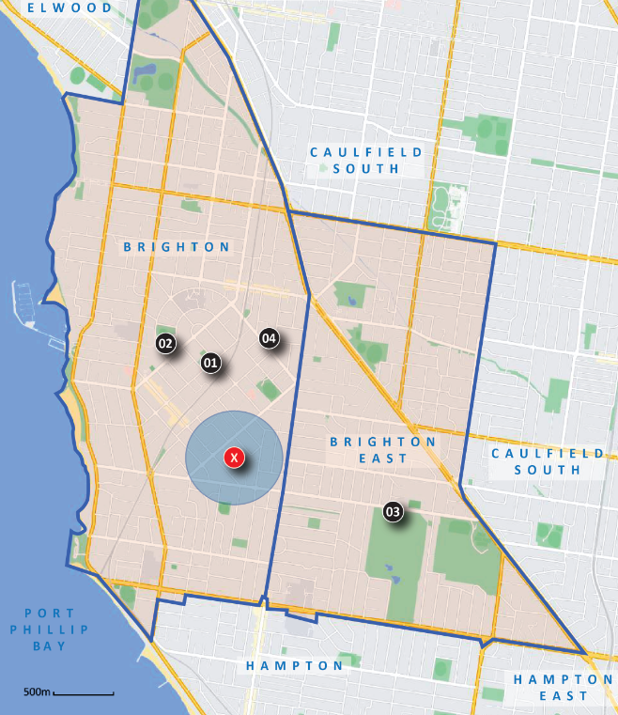

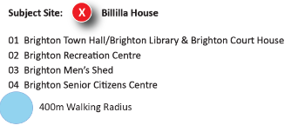

Figure 9: Existing Social Infrastructure - Brighton and Brighton East

Source: K2 Planning September 2021 based on information provided by Bayside City Council below.

Table 8: Brighton and Brighton East – Existing Social Infrastructure
Facility Name | Address | Council Own | Current Services | Current Size | Other facility Features
Brighton Town Hall |  |  | Bayside Gallery
Brighton Town Hall | Corner Carpenter St and Wilson St Brighton | Yes | Bookable spaces weddings, birthdays, performances, concerts, parties, functions or community and fundraising events | 200 seated people | Theatrical stage including a lift, piano, commercial kitchen
Brighton Town Hall | Corner Carpenter St and Wilson St Brighton | Yes | Brighton Historical Society
Brighton Town Hall | Corner Carpenter St and Wilson St Brighton | Yes | Brighton Art Society | Studios on first floor/ workshop spaces
Brighton Town Hall | Corner Carpenter St and Wilson St Brighton | Yes | Brighton Theatre Company
Brighton Library | 14 Wilson Street Brighton | Yes | Public access PCs  Wireless Hotspots  Photocopying, printing and scanning  Greek, Chinese, German, French, Japanese, Italian Language Collections  Local Area collections Computer Training Program, Pre-School Story Time, Genealogical Group at Brighton Library, Baby Rhyme Time  Book club | 1 small meeting room at the rear of the library; Art Space Exhibition space around windows of the Round; Two study spaces with several large tables; Multiple study areas/ Active Spaces or Quite Areas | Read  Meet  Study  Relax  Access information Spaces under development: 1. Gaming spaces  2. Create Play Learn ‘Maker Space’
Brighton Court House | 63 Carpenter Street Brighton | No | Youth Centre  Brighton U3A  100+ educational, recreation and social programs. These include languages, history and art, music, sports and many more | BU3A caters for retired or semi-retired adults who want to continue learning in an informal environment. Enrolments for 2017 are already close to 1,000
Brighton Recreation Centre | 93 Outer Crescent Brighton | Yes | Provide flexible and adaptable spaces to meet the changing needs of the Brighton community. Encourage people of all ages and abilities to access and use the centre.  Support gymnastics as a core function of the Brighton Recreational Centre Encourage indoor and outdoor passive activities and connections to the adjacent parkland.  Centre provides a range of physically active, creative, learning and social activities and programs. | Community access to Two x 90-100-person rooms  which could be connected to  create a flexible 200 person  space.  Access to kitchen important; four medium sized multi-purpose rooms with space for 20-40  people | Multi purpose-built pottery space is required to support the existing  well utilised pottery program; dedicated Youth Space; informal play spaces  adjacent to the Centre (e.g. half-court basketball, ball practice  wall) to encourage unstructured play.
Brighton Senior Citizens Centre | 23 Durrant St  Brighton | Yes | a place to get involved, stay active, make friends and have fun.  There are many activities and special events happening every day at the Brighton Senior Center. | We offer a safe and open environment that encourages independence by engaging, enriching, and empowering individuals.
Brighton Men’s Shed | Dendy Street Brighton | Yes | The Shed has established a modern workshop facility equipped with modern equipment. There is a strong culture of camaraderie and mutual support amongst Members, and, ‘drop in’ visitors who want to see more, are welcome. | Fully equipped workshop with a focus on woodworking and metal working; metal working area equipped with a metal working lathe and welding, cutting and other equipment; well-equipped kitchen; Shed Club Room
Source: Bayside City Council 2021 adapted by K2 Planning September 2021

A range of other social infrastructure is also available in Brighton and Brighton East (Table 9).
Table 9: Other Non-Council and Council Social Infrastructure
Capacity
- Higginbotham Hall in Bay Street Council will continue to be a ballet studio probably not suitable for community use
- A Toy Library is located in Bindy Park former Brighton Library branch
- Brighton East Men’s Shed on Dendy Street
- Brighton Sea Scouts is located between Billilla and Town Hall, on Wilson street
- Hurlingham Park Pavilion in Brighton East has had (non-sporting) groups use the space on weekday / non-sport times, but this is across the highway from Billilla
- Bayley House provides exceptional services that actively support people living with a disability to realise and reach their goals and dreams.
- Life Activities Group provides activities for older people and is struggling to find space– Council is refurbishing the Masonic Hall in Sandringham to accommodate this group –– over 300 people and growing. The activities of this group could be complemented by indoor /outdoor activities at Billilla eg. table tennis, bridge, card days for people aged 65 and up
Source: Project Consultations September 2021

Other social infrastructure provided by the Bayside City Council across Brighton and Brighton East comprises:

- Road landscape features
- Car parks
- Playgrounds
- Public toilets
- Pavilions
- Reserves
- Sheds
- Grounds

Table 10: Brighton and Brighton East – Council Owned Infrastructure
Infrastructure Type | Brighton | Brighton East | Total Area
 | Brighton | Brighton East | No. | %
Child Care Centre | 1 | 1 | 2 | 3.7
Club House | 5 | 7 | 12 | 22.2
Community Hall | 1 |  | 1 | 1.9
Council Chambers | 1 |  | 1 | 1.9
Heritage Residence | 2 |  | 2 | 3.7
Kindergarten |  | 1 | 1 | 1.9
Library | 1 | 1 | 2 | 3.7
Life Saving Club | 1 |  | 1 | 1.9
MCHC | 2 | 1 | 3 | 5.6
Office |  | 1 | 1 | 1.9
Pavilion | 8 | 6 | 14 | 25.9
Residence | 1 |  | 1 | 1.9
Scout Hall | 2 |  | 2 | 3.7
Senior Citizen Hall | 2 |  | 2 | 3.7
Town Hall/Library | 1 |  | 1 | 1.9
Workshop | 2 | 1 | 3 | 5.6
Yacht Club | 3 |  | 3 | 5.6
Youth Centre | 2 |  | 2 | 3.7
Total | 35 | 19 | 54 | 100.0
Source: Bayside City Council 2021 adapted by K2 Planning September 2021
Refer to Table 38, p. 66 for more details

This current provision of social infrastructure in Brighton and Brighton East forms part of the broader City of Bayside Property holdings across both suburbs (Figure 10).

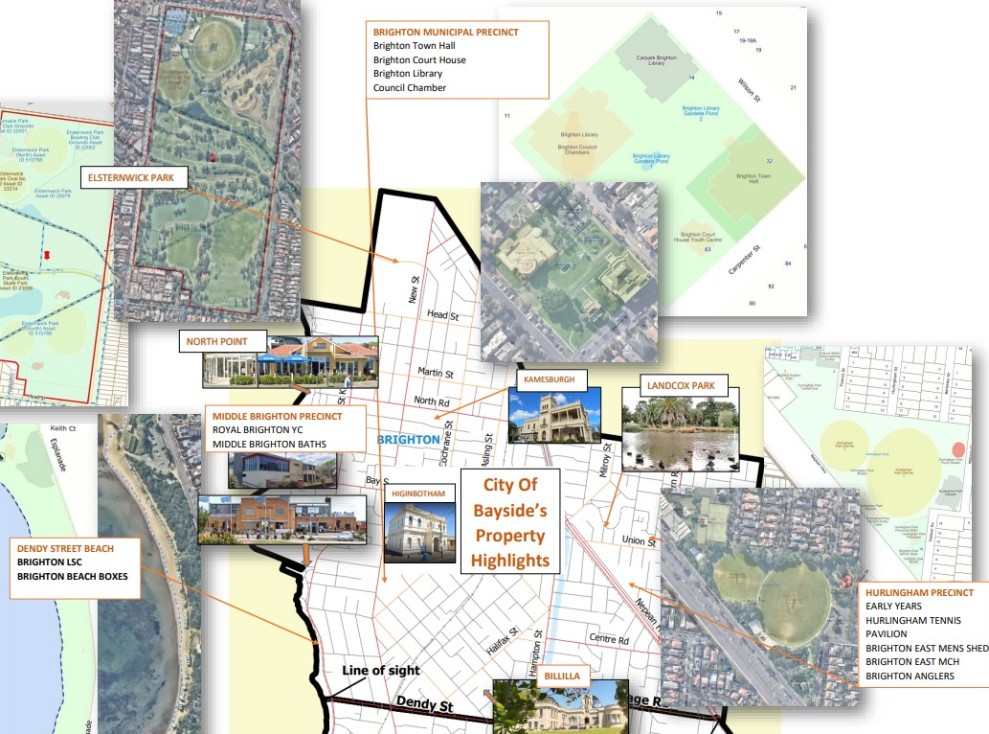
Figure 10: Brighton and Brighton East - City of Bayside Property Highlights

Source: Bayside City Council September 2021
Table 11 summarises the current strengths, weaknesses, opportunities and challenges of existing social infrastructure in Brighton and Brighton East. These issues should be considered in future planning for Billilla House.
Table 11: Brighton and Brighton East Social Infrastructure – SWOT Analysis
STRENGTHS | WEAKNESSES
- Good provision of performance space at Brighton Theatre Company (90 seats) and Gallery Space (Bayside Gallery)  - High levels of utilisation of existing meeting rooms  - An active local historical society with a potential interest in running programs/ having a presence at Billilla House  - The planned future improvement works for the Brighton Recreation Centre include a new community space with dedicated gymnastics space, occasional care space, multipurpose rooms and a pottery space  - Green Point and Dendy Street Beach Boxes are two of the most popular tourist destinations in Bayside | - Many of the existing facilities are for exclusive use by the current user group/s  - Limited community access to Public Heritage Assets as most buildings are single use occupations or in private ownership  - A dedicated youth space, recommended as part of the redevelopment of the Brighton Recreation Centre, was not included in the final facility  - Many challenges for community groups trying to meet during COVID due to lockdown and density limits  - Much of the Brighton and Brighton East community does not readily cross the ‘social borders’ to access services, eg. Nepean Highway and the Glen Eira border
OPPORTUNITIES | CHALLENGES
- Increasing demand for space for seniors’ groups such as University of the Third Age (U3A)  - Council is refurbishing the Masonic Hall in Sandringham to accommodate the Life Activities Group which provides active aging programs – there is increased demand from this group for additional sites to conduct their activities  - Dendy Street Beach Pavilion is about to begin construction and will have a multi-purpose room  - Brighton Town Hall commercial kitchen may have opportunity for increased use  - Redevelopment of Brighton Life Saving Club facility and foreshore precinct  - A number of heritage buildings in the area could be packaged as a tourism experience | - More people want to be able to work from their local community and meet others in the local community particularly post covid  - There is a big desire for small to medium spaces in the local area  - Library meeting rooms are always full indicating a high-level community need  - Members of the artist community are regularly seeking access to informal art studio spaces  - The need for a dedicated youth space, identified in prior work and recommended as part of the redeveloped Brighton Recreation Centre, has still not been addressed

8.3 Billilla House
The scale of infrastructure set out in Table 6 and Table 7 would commonly be designed to support the needs of the total municipality, or sub-municipal area, and located in highly accessible locations such as:
- Activity Centres
- Retail strips and
- Areas of significantly increasing housing density

Billilla House is not located in a highly accessible area that would support the provision of all the social infrastructure set out in Table 6 and Table 7, above. However, it is noted that Billilla House is located adjacent to the boundaries of a the Brighton Activity Centre. Future planning for the facility should aim to increase the connections and accessibility of Billilla House to other uses within the Brighton Activity Centre.

A revised social infrastructure assessment, which takes into account the location of Billilla House and the appropriate scale of infrastructure for that location, shows that planning for Billilla House should include multipurpose community centre space of 2,840m2 providing flexible meeting rooms and community centre space for:
- General community programs
- Youth specific programs and events
- Intergenerational programs aimed at supporting an aging population

Table 12: Revised Social Infrastructure Requirements Brighton/Brighton East 2041
 |  | Brighton/Brighton East Overall  2041 Benchmark Requirement | Alternate Location Options | Revised Billilla House Space Requirements
Service Area | Benchmark m² | Brighton/Brighton East Overall  2041 Benchmark Requirement | Alternate Location Options | Revised Billilla House Space Requirements
Neighbourhood House Programs | 200-600 | 477.9 to 1433.6 | Consider: Expansion of existing Brighton Neighbourhood House; provision of additional NHH space within Major Activity Centres | 600
Community Meeting spaces - Small | 30 | No additional requirement
Youth Facilities | 200 | 1,195 | Consider: Provision of spaces within Major Activity Centres and adjacent to sports and recreation venues | 600
Multi-purpose Community Centres - Small | 420 | 2,509 | Consider: Provision of spaces within Major Activity Centres | 840
Community Art Space - Flexible, Multipurpose, Shared Use | 400 | 2,389 | Consider: Provision of spaces within Major Activity Centres | 800
Seniors’ Groups - Small | 200 | 795 | Provide within multi-purpose community meeting spaces
Total |  | 6,888m2 |  | 2,840m2

Potential Role for Billilla House
This section summarises stakeholder proposals for the future use of Billilla House collected through prior work conducted by the City of Bayside including informal conversations with existing community groups, and consultations conducted for the current project.
These stakeholder proposals will be aligned with findings from previous sections to inform future options for Billilla House in Section 10, below.

9.1 Prior Options Considered
Prior work conducted by Bayside City Council identified the following alternative uses for a Council owned Heritage building:
- A function centre
- A boutique hotel such as the Lancemore Mansion Hotel (located at Werribee Park)
- A specialist training provider such as the Cranlana Centre for Ethical Leadership (located at Cranlana Mansion Toorak), or the Menzies Foundation (located at Clarendon Terrace, Clarendon Street, East Melbourne (VHR H0029); or
- Café or restaurant
Prior suggestions provided by Internal Council Officer include:
- The Glenfern model - working with arts groups to present a range of programs and activities on site. For example the Bayside Chamber Orchestra could, like the Team of Pianists take up residency at Billilla and present similar education and music programs
- Abbotsford Convent model - a bespoke centre for ideas and creativity operated by an independent community organisation
- Possible Commercial Uses - unique opportunity for a number of small businesses – rental income could contribute to operational cost of facility (market testing required)
- Co-Working Hub - Potential anchor commercial tenant creating a home-base for a range of private businesses, public, not-for-profit (NFP) and individual members; providing a range of types office accommodation – hot desks, private office, board rooms; bookable meeting rooms with IT capacity for training and virtual meetings
- Health and Wellness Centre - providing a variety of programs including yoga, meditation, wellness coaching and more traditional therapies
- Café/Restaurant - indoor and outdoor dining terrace and kitchen; on-site catering, visitor café and restaurant, events bookings; possibly social enterprise
- Arts Retail Store - opportunity for a local start-up seeking to promote the sale of local arts
- Flower/Plant Stall - unique opportunity to promote indigenous plants and/or heritage plants
using outbuildings and garden setting, could be successful if it could establish itself as a destination retailer
(Source: Adapted from bayside City Council – Council Report Reimagining Billilla October 2021)

Opportunities for the future use of Billilla House identified through the current project included:

- Meeting rooms for community organisations
- Exhibition rooms and spaces i.e the history of Bayside and Bililla
- A café or restaurant (social enterprise or commercial operator)
- A historic house open for tours
- Office and event spaces
- Home for creativity including writers studios, music concerts, painters, composers etc.
- Tourism/creative focused retail
- Boutique accommodation
- Artisan workshops
- Centre for Intergenerational activities (in an intergenerational play school for learning, connection and friendship.)
- Community garden opportunities limited by heritage listing of gardens Werribee Park has managed to do this -community will ask about this already seen requests for this

9.2 Options Identified at Project Workshop

Common themes are evident in the options for the future of Billilla House summarised above. There is a particular interest in the following uses of the facility:

A Co-Worker Hub
More people are working from home post covid, there is a potential need for co-working spaces - spaces to connect, co- working is on the rise and should be considered
A Co-Worker Hub would provide:
- Collaborative and community based shared office space with opportunities to expand start-up businesses
- A business services provision model that sees several individuals working independently or collaboratively in a shared office space
- A range of prices depending on the rent scheme; rent-by-the-day model or rent-by-the-month

Industry standard for Co-Working Spaces include:
- Modern amenities
- Lightning-fast internet
- Industry-relevant events
- Like-minded individuals and intellectuals
- An international network of fellow collaborators
(Source: adapted from manofmany.com/lifestyle/best-coworking-spaces-melbourne)
Refer to Table 41, p. 75 for a list of current best practice co-worker spaces)
Participants of the Internal Council Officer Workshop noted that ‘Rooms 24, 27, 29, 30, 31 could very easily be turned into rented office space with use of Room 28 for kitchenette’
A Youth Hub
- Prior planning for the Brighton Recreation Centre included a Youth Space, however this has not been included in the final building design
- Young people have been increasingly marginalised through COVID 19 with the loss of employment opportunities
- Residents have expressed strong views that Billilla House could be developed as a youth hub
- There is a need to design the facility so that young people take ownership – providing youth services to give a sense of community ownership

Intergenerational opportunities
The Draft Bayside Municipal Public Health and Wellbeing Plan (MPHW) promotes healthy aging and intergenerational connections
- Intergenerational opportunities would also be a consideration
- Intergenerational knowledge sharing - e.g. how to set up a turntable.
Community Groups
- Food donation volunteer groups taking turns to use the commercial kitchen, cooking clubs and cooking classes
- A Brighton Pool Club - Very large table onsite already
- Bayley House Day Centre for people with an intellectual disability can we include opportunities for work and volunteering placement
- A weekly event (Covid opening dependent) where volunteers present talks on skills or subjects that they have to pass on or want to share
Arts Venue
- Small, intimate live music venues - Covid friendly
- Arts installations and events
- Art/craft markets
- Artist in residency program run
- Artist studio spaces that are more open ended that the Gallery space
Commercial Opportunities
- Wedding and events venue
- Social enterprise opportunities
- Mobile coffee cart
- Repair café– people bring broken things and retirees fix them great way of reusing - sustainable, cross generational, community connecting - St Kilda example - https://www.stkildarepaircafe.org.au/about-us/
- Commercial kitchen – use food donation programs, opportunities for volunteer groups to use

Garden Use
- Value of the open space has increased enormously through covid as Billilla is located over 500 mt from any other open space
- Billilla gardens have had a huge increase in usage
- The garden is a formal garden not an active park - cannot encourage major activity in the gardens
- Could be used for more events: eg. jazz events used to be as a reception centre
- Horticultural tours of the gardens

Other issues

- Any facility needs to seriously look at accessibility and storage
- Real heritage value in the rooms that we will need to preserve
- Having an Activation Officer is key to the successful use of the facility
Possible Partnerships
- National Trust has met with the Bayside CEO and the Mayor in 2020 to discuss National Trust’s interest in the property
- Friends of Billilla Group - Friends of Black Rock House are very keen to be involved
- Brighton Historical Society may use as a space to promote Brighton history and conduct tours – There would be a domino effect if they choose to relocate to Billilla
- Brighton Rotary are looking for a community project

Billilla House – Future Options
The evidence provided in the previous sections shows that the future of Billilla House should include the provision of a multipurpose community centre comprising up to 2,840m2 of floor space and including flexible meeting rooms and community centre space for:
- General community programs
- Youth specific programs and events
- Intergenerational programs aimed at supporting an aging population
The appropriate mix of spaces and functions that could be provided at Billilla House to ensure best use of a Council owned asset includes:
- Co- Worker space
- Youth Hub
- Flexible and Adaptable Community Meeting Spaces
- Community Arts Studios and Program Spaces
- Social Enterprise Opportunities
- Commercial Opportunities

Evidence of the need for this range of uses has been drawn from the previous sections and is summarised in Table 13 below.
Details of the potential role and location of each of these future uses of Billilla House is provided in Table 14.
Table 13: Billilla House Future Uses – Evidence of Need
Co-Worker Space/s | Youth Hub | Community Spaces | Community Arts and Craft Venue | Social Enterprise Opportunities | Commercial Opportunities
Prior Work Conducted by Bayside City Council
Potential anchor commercial tenant; home-base for a range of private businesses, public, not-for-profit (NFP) and individual members | A youth space was to be included in the refurbished Brighton Recreation Centre however this has not been included in final design | Bespoke centre for ideas and creativity operated by an independent community organisation | Arts education and event program  Artists Studio Program Bayside Chamber Orchestra | Specialist training provider - Ethical Leadership | Function Centre Boutique Hotel Café or Restaurant Indoor and outdoor dining Small businesses Arts Retail Store Flower/Plant Stall Health and Wellness Centre
Prior Community Group Consultations
Meeting rooms for community organisations | Residents have expressed strong views that Billilla House could be developed as a youth hub | Centre for Intergenerational activities (in an intergenerational play school for learning, connection and friendship.) Historic house open for tours Community garden opportunities | Home for creativity including writers studios, music concerts, painters, composers etc. Exhibition rooms and spaces  Artisan workshops | Café or restaurant (social enterprise or commercial operator) | A café or restaurant (social enterprise or commercial operator)  Tourism/ creative focused retail  Boutique accommodation
Social Trends and Social Infrastructure Needs Assessment
City of Bayside local workforce comprised 29,540 workers in 2016  1,535 residents of Brighton and Brighton East were working from home in 2016 | Significant numbers of young people in the area are disengaged from either employment or education | Identified need for the following social infrastructure in Brighton and Brighton East 2041:  - Neighbourhood House Programs  - Small community meeting spaces  - Youth facilities (small)  - Small multipurpose community centres  - Flexible multipurpose art spaces  - Spaces accommodating senior groups | At the 2016 census 442 residents of Brighton and Brighton East worked in arts and recreation | Brighton and Brighton East have high proportions of:  - People volunteering – including young people aged 14 – 19 years  - People employed in Arts and Recreation | The Bayside economy is continuing to shift towards the professional services  Population growth is also likely to result in an increase in demand for retail services and non-retail commercial businesses that serve consumers  Bayside Retail, Commercial and Employment Strategy 2016
Consultations Conducted for the Current Project
More people are working from home post covid  Increasing need for co-working spaces to connect  Rooms 24, 27, 29, 30, 31 could very easily be turned into rented office space with use of Room 28 for kitchenette | Young people have been increasingly marginalised through COVID 19 with the loss of employment opportunities  There is a need to design the facility so that young people take ownership | The Draft Bayside Municipal Public Health and Wellbeing Plan (MPHW) promotes healthy aging and intergenerational connections | Identified need for:  - Small, intimate live music venues  - Arts installations and events  - Art/craft markets  - Artist in residency  - Artist studio spaces | Repair café idea similar to the St Kilda example | Weddings and event venue  Mobile coffee cart  Repair café  Commercial kitchen

Table 14: Billilla House Future Uses and Design Considerations
Facility User | Role/Activities | Location/Design Considerations
Co- Worker Hub | Anchor tenant ensuring activation of the facility and providing:  - Shared Office Spaces  - Modern amenities  - Lightning-fast internet  - Industry-relevant events  - Like-minded individuals and intellectuals  - A local and international network of fellow collaborators | Smaller rooms could be turned into rented office space with the use of an adjacent room as a kitchenette
Youth Hub | Youth services including:  - Job ready skills  - Social enterprise opportunities  - Internship opportunities at the Co-worker space  - Activities that promote young people to take ownership/develop a sense of community with the facility | Dedicated youth space to promote a sense of ownership of the facility  Ensure opportunities for youth involvement in the future governance model of the facility
Flexible and Adaptable Community Meeting Rooms | Community programs supporting intergenerational opportunities and knowledge sharing possibly with:  - Rotary Groups  - U3A Programs  - Food donation volunteer groups  - Brighton Pool Club  - Bayley House Day Centre opportunities for work and volunteering placement | Flexible and adaptable community meeting rooms  Access to Kitchen  Potential provision of wet areas to support activities
Community Arts Studios and Program Spaces | - Live music venues  - Arts installations  - Art/craft markets  - Artist in residency program run  - Artist studios | Use of the external buildings  Use of external areas markets  Potential provision of wet areas to support activities
Social Enterprise Opportunities | - Repair café - sustainable, cross generational, community connecting see St Kilda example  - Social enterprise café  - Commercial kitchen – use food donation programs, opportunities for volunteer groups to use | Potential use of external buildings for repair café  Kitchen and training area for social enterprise café
Commercial Opportunities | - Wedding and events venue  - Mobile coffee cart  - Indoor and outdoor dining  - Small businesses  - Arts Retail Store  - Flower/Plant Stall  - Health and Wellness Centre  - Tourism/creative focused retail  - Boutique accommodation | Use of previous reception centre area  Commercial kitchen
Garden Use | - Horticultural tours of the gardens  - Events such as jazz events that used to be offered with a reception centre | Cannot encourage major activity as these are formal gardens  Ensure future use complies with Council’s Environmental Sustainability Framework and Climate Emergency Action Plan
A range of risks associated with the proposed uses of Billilla House, above, are set out below, including some suggested approaches to mitigating or reducing each risk.
Table 15: Potential Risks and Mitigating Strategies
 | Potential Risks | Possible Mitigation Strategies
1 | Feasibility of proposed uses | Conduct further work into the feasibility of each of the proposed uses set out in Table 14 above  Develop Billilla House Business Plan to ensure viability of facility and future user groups
2 | Resources required for successful operation of the facility | Forthcoming Billilla House Business Plan needs to include potential staffing model and costs  Consider inclusion of an Activation Officer or a custodian charged with ensuring successful programming, use and activation of the facility
3 | Security of the building  Security of future user groups | Ensure detailed and appropriate Security Planning is considered in Billilla House Business Plan
4 | Parking issues impact on residents | Ensure detailed Traffic Management Plan including provision of sufficient parking space for anticipated uses
5 | Protection of significant heritage features of the building and gardens | Ensure all future planning is compliant with Heritage Controls and the forthcoming Billilla House Conservation Management Plan
6 | High maintenance costs related to retaining a building of this size and age | Forthcoming Billilla House Business Plan should consider a mix of commercial uses and potential contribution to building maintenance costs
7 | Non-compliance with Disability Discrimination Act 1992 (DDA) | Forthcoming Billilla House User Group Feasibility Study to consider accessibility requirements and ensure future uses comply with DDA requirements and improve accessibility of Billilla House
8 | Underuse of out buildings | Forthcoming Billilla House User Group Feasibility Study to consider the role and function of existing outbuildings
9 | Uses with a fixed life span and not ongoing | Forthcoming Billilla House Business Plan should consider governance models that support ongoing use, participation and activation of the facility
10 | Exclusive Use of the Facility | Forthcoming Billilla House User Group Feasibility Study and Billilla House Business Plan should ensure future uses are flexible and generate ongoing and shared community uses
11 | Building layout separates future uses | Forthcoming Billilla House User Group Feasibility Study and Billilla House Business Plan should identify areas for shared and flexible use including: foyer and entry areas; flexible and adaptable meeting rooms; garden areas etc.

Where to Next?

This report provides an evidence base of current issues impacting on the demand for social infrastructure in Brighton and Brighton East. The evidence suggests that future planning for Billilla House should respond to the need for the following social infrastructure in the area:

- A Co- Worker Hub
- A Youth Hub
- Flexible and Adaptable Community Meeting Rooms
- Community Arts Studios and Program Spaces
- Social Enterprise Opportunities
- Commercial Opportunities
(Refer to Table 1, p. 11 for further details)

As a multipurpose community facility the future Billila House should also provide a range of shared spaces such as:
- Entry and Foyer Areas
- Flexible and Adaptable Meeting Rooms
- Kitchen and Refreshment Spaces

The future role of Billilla House should aim to:
- Increases community safety and accessibility to services and facilities
- Increases the availability of Councils heritage assets for community hire
The Billilla House Social Infrastructure Needs Assessment is part of broader work being conducted by Bayside City Council in relation to Billilla House and including:

- Social Needs Infrastructure Assessment (research)
- Summary of Community Engagement (research)
- Conservation Management Plan (research)
- Feasibility report on preferred Options for Billilla based on research
- Council to decide on preferred option
- Development of 4 year business plan

These ongoing projects will ensure that future planning for Billilla House is informed about:

- Resident and broader community aspirations and interests
- A business case/ market testing analysis of any proposed uses of Billilla Housing including future commercial activities
- Any activity or use that may negatively impact existing residential precincts around Billilla
- A Vision and proposed governance model for the facility
- The permit approval requirements of Heritage Victoria under the Heritage Act 2017

Attachments

12.1 Brighton and Brighton East Demographic Data

Table 16: Service Age Groups 2011-2016
Service Age Group (years) | 2011 |  |  |  |  | 2016 |  |  |  |  | Brighton change 2011 to 2016 |  | Brighton East change 2011 to 2016
Service Age Group (years) | Brighton no. | Brighton % | Brighton East no. | Brighton East % | City of Bayside % | Brighton no. | Brighton % | Brighton East no. | Brighton East % | City of Bayside % | No | % | No | %
Babies and  pre-schoolers (0 to 4) | 1,208 | 5.5 | 915 | 6.1 | 6 | 1,084 | 4.6 | 790 | 5.1 | 5.1 | -124 | -10.3 | -125 | -13.7
Primary schoolers  (5 to 11) | 1,959 | 8.9 | 1,527 | 10.1 | 9.7 | 2,030 | 8.7 | 1,698 | 11 | 9.7 | +71 | 3.6 | +171 | 11.2
Secondary schoolers  (12 to 17) | 1,658 | 7.5 | 1,245 | 8.3 | 7.7 | 1,893 | 8.1 | 1,329 | 8.6 | 8.2 | +235 | 14.2 | +84 | 6.7
Tertiary education  and independence  (18 to 24) | 1,675 | 7.6 | 1,218 | 8.1 | 7.7 | 1,767 | 7.6 | 1,119 | 7.2 | 7.4 | +92 | 5.5 | -99 | -8.1
Young workforce  (25 to 34) | 1,676 | 7.6 | 1,076 | 7.1 | 7.8 | 1,959 | 8.4 | 1,084 | 7 | 8.2 | +283 | 16.9 | +8 | 0.7
Parents and  homebuilders (35 to 49) | 4,692 | 21.4 | 3,434 | 22.8 | 22.9 | 4,549 | 19.5 | 3,347 | 21.6 | 21.3 | -143 | -3.0 | -87 | -2.5
Older workers and  pre-retirees (50 to 59) | 3,250 | 14.8 | 2,169 | 14.4 | 14.2 | 3,535 | 15.1 | 2,322 | 15 | 14.9 | +285 | 8.8 | +153 | 7.1
Empty nesters and  retirees (60 to 69) | 2,769 | 12.6 | 1,591 | 10.6 | 11 | 2,913 | 12.5 | 1,640 | 10.6 | 11.5 | +144 | 5.2 | +49 | 3.1
Seniors (70 to 84) | 2,164 | 9.9 | 1,336 | 8.9 | 9.3 | 2,651 | 11.3 | 1,477 | 9.6 | 9.9 | +487 | 22.5 | +141 | 10.6
Elderly aged  (85 and over) | 916 | 4.2 | 561 | 3.7 | 3.6 | 1,006 | 4.3 | 654 | 4.2 | 3.7 | +90 | 9.8 | +93 | 16.6
Total | 21,972 | 100 | 15,077 | 100 | 100 | 23,391 | 100 | 15,465 | 100 | 100 | +1,419 | 6.5 | +388 | 2.6

Table 17: Early Years Age Groups - 2011-2016
Location | Single Year of Age | 2011 |  | 2016 |  | Change 2011 - 2016
Location | Single Year of Age | No. | % | No. | % | No | %
Brighton | 0 | 242 | 1.1 | 183 | 0.8 | -59 | -24.4
Brighton | 1 | 194 | 0.88 | 206 | 0.91 | 12 | 6.2
Brighton | 2 | 244 | 1.11 | 188 | 0.83 | -56 | -23.0
Brighton | 3 | 243 | 1.11 | 215 | 0.94 | -28 | -11.5
Brighton | 4 | 284 | 1.29 | 235 | 1.04 | -49 | -17.3
Brighton | 5 | 274 | 1.25 | 209 | 0.92 | -65 | -23.7
Brighton East | 0 | 139 | 0.93 | 126 | 0.83 | -13 | -9.4
Brighton East | 1 | 154 | 1.03 | 129 | 0.86 | -25 | -16.2
Brighton East | 2 | 182 | 1.21 | 155 | 1.03 | -27 | -14.8
Brighton East | 3 | 200 | 1.33 | 174 | 1.15 | -26 | -13.0
Brighton East | 4 | 237 | 1.58 | 194 | 1.28 | -43 | -18.1
Brighton East | 5 | 196 | 1.3 | 197 | 1.31 | 1 | 0.5
City of Bayside | 0 | 956 | 1.04 | 857 | 0.88 | -99 | -10.4
City of Bayside | 1 | 1,033 | 1.13 | 967 | 1 | -66 | -6.4
City of Bayside | 2 | 1,138 | 1.24 | 1,002 | 1.03 | -136 | -12.0
City of Bayside | 3 | 1,171 | 1.28 | 1,039 | 1.07 | -132 | -11.3
City of Bayside | 4 | 1,254 | 1.37 | 1,126 | 1.16 | -128 | -10.2
City of Bayside | 5 | 1,281 | 1.4 | 1,202 | 1.24 | -79 | -6.2

Table 18: Overseas Arrivals 2006-2016
Year of arrival in Australia | Brighton no. | Brighton % | City of Bayside % | Brighton East no. | Brighton East % | City of Bayside %
2011 - 9 August 2016 | 1398 | 23.3 | 18.8 | 735 | 17.1 | 18.8
2006-2010 | 697 | 11.6 | 12.9 | 510 | 11.8 | 12.9

Table 19: Level of English Proficiency 2011 - 2016
English Proficiency | 2011 |  |  |  |  | 2016 |  |  |  |  | Brighton change 2011 to 2016 |  | Brighton East change 2011 to 2016
English Proficiency | Brighton no. | Brighton % | Brighton East no. | Brighton East % | City of Bayside % | Brighton no. | Brighton % | Brighton East no. | Brighton East % | City of Bayside % | No | % | No | %
Speaks English only | 17949 | 81.6 | 11652 | 77.3 | 82.4 | 18531 | 79.2 | 11696 | 75.4 | 80.2 | 582 | 3.2 | 44 | 0.2
Speaks another language,  and English well or very well | 2557 | 11.6 | 2536 | 16.8 | 11.9 | 3158 | 13.5 | 2771 | 17.9 | 13 | 601 | 23.5 | 235 | 9.2
Speaks another language,  and English not well or not at all | 334 | 1.5 | 313 | 2.1 | 1.5 | 430 | 1.8 | 309 | 2 | 1.8 | 96 | 28.7 | -4 | -1.2
Not stated | 1145 | 5.2 | 580 | 3.8 | 4.2 | 1289 | 5.5 | 728 | 4.7 | 5 | 144 | 12.6 | 148 | 12.9
Total population | 21987 | 100 | 15081 | 100 | 100 | 23411 | 100 | 15506 | 100 | 100 | 1,424 | 6.5 | 425 | 1.9
Table 20: Qualification Levels 2011-2016
Qualification level | 2011 |  |  |  |  | 2016 |  |  |  |  | Brighton change 2011 to 2016 |  | Brighton East change 2011 to 2016
Qualification level | Brighton no. | Brighton % | Brighton East no. | Brighton East % | City of Bayside % | Brighton no. | Brighton % | Brighton East no. | Brighton East % | City of Bayside % | No | % | No | %
Bachelor or Higher degree | 7,519 | 41.4 | 4,415 | 36.6 | 34.9 | 8,403 | 43.5 | 4,930 | 40 | 39.1 | 884 | 11.8 | 515 | 11.7
Advanced Diploma or Diploma | 1,865 | 10.3 | 1,300 | 10.8 | 10.9 | 1,857 | 9.6 | 1,285 | 10.4 | 10.7 | -8 | -0.4 | -15 | -1.2
Vocational | 1,228 | 6.8 | 1,139 | 9.4 | 10.1 | 1,518 | 7.9 | 1,193 | 9.7 | 10.3 | 290 | 23.6 | 54 | 4.7
No qualification | 5,647 | 31.1 | 4,033 | 33.4 | 33.9 | 5,767 | 29.9 | 3,885 | 31.5 | 31.4 | 120 | 2.1 | -148 | -3.7
Not stated | 1,888 | 10.4 | 1,173 | 9.7 | 10.2 | 1,769 | 9.2 | 1,037 | 8.4 | 8.6 | -119 | -6.3 | -136 | -11.6
Total persons aged 15+ | 18,149 | 100 | 12,063 | 100 | 100 | 19,316 | 100 | 12,332 | 100 | 100 | 1,167 | 6.4 | 269 | 2.2

Table 21: Need for Assistance with Core Activities by Age Group 2011-2016
Assistance needed by age group (years) | 2011 |  |  |  |  | 2016 |  |  |  |  | Brighton change 2011 to 2016 |  | Brighton East change 2011 to 2016
Assistance needed by age group (years) | Brighton no. | Brighton % | Brighton East no. | Brighton East % | City of Bayside % | Brighton no. | Brighton % | Brighton East no. | Brighton East % | City of Bayside % | No. | % | No | %
0 to 4 | 0 | -- | 6 | 0.8 | 0.8 | 8 | 0.7 | 7 | 0.8 | 0.8 | 8 | Undefined | 1 | 16.7
5 to 9 | 3 | 0.2 | 0 | -- | 1.3 | 3 | 0.3 | 11 | 1.1 | 1.4 | 0 | 0.0 | 11 | Undefined
10 to 19 | 11 | 0.4 | 21 | 1 | 1.4 | 28 | 1 | 38 | 1.9 | 1.2 | 17 | 154.5 | 17 | 81.0
20 to 59 | 20 | 0.2 | 65 | 0.9 | 1.5 | 83 | 0.8 | 107 | 1.4 | 1.3 | 63 | 315.0 | 42 | 64.6
60 to 64 | 13 | 1 | 17 | 2.1 | 2.9 | 30 | 2 | 25 | 3 | 3 | 17 | 130.8 | 8 | 47.1
65 to 69 | 37 | 2.6 | 18 | 2.5 | 4.2 | 35 | 2.8 | 27 | 3.9 | 3.9 | -2 | -5.4 | 9 | 50.0
70 to 74 | 44 | 3.8 | 46 | 7.4 | 6.3 | 42 | 4.9 | 38 | 7.3 | 6.6 | -2 | -4.5 | -8 | -17.4
75 to 79 | 74 | 9 | 56 | 11.7 | 11.9 | 63 | 9.5 | 62 | 16.4 | 11.6 | -11 | -14.9 | 6 | 10.7
80 to 84 | 95 | 16 | 101 | 28.3 | 21.4 | 135 | 20.4 | 131 | 31 | 20.9 | 40 | 42.1 | 30 | 29.7
85 and over | 444 | 49.5 | 316 | 54.9 | 46.2 | 458 | 51.7 | 230 | 43.2 | 42.4 | 14 | 3.2 | -86 | -27.2
Total persons needing assistance | 980 | 4.2 | 818 | 5.3 | 4.3 | 890 | 4.1 | 681 | 4.5 | 4 | -90 | -9.2 | -137 | -16.7

Table 22: Employment Status 2011-2016
Employment status | 2011 |  |  |  |  | 2016 |  |  |  |  | Brighton change 2011 to 2016 |  | Brighton East change 2011 to 2016
Employment status | Brighton no. | Brighton % | Brighton East no. | Brighton East % | City of Bayside % | Brighton no. | Brighton % | Brighton East no. | Brighton East % | City of Bayside % | No | % | No | %
Employed | 10,218 | 97.3 | 7,315 | 96.5 | 96.2 | 10,753 | 95.6 | 7,185 | 94.5 | 95.4 | 535 | 5.2 | -130 | -1.8
Employed full-time | 6,082 | 57.9 | 4,273 | 56.4 | 57.7 | 6,491 | 57.7 | 4,230 | 55.6 | 57.2 | 409 | 6.7 | -43 | -1.0
Employed part-time | 4,002 | 38.1 | 2,831 | 37.4 | 36.9 | 4,099 | 36.5 | 2,853 | 37.5 | 36.9 | 97 | 2.4 | 22 | 0.8
Hours worked not stated | 133 | 1.3 | 210 | 2.8 | 1.6 | 163 | 1.4 | 101 | 1.3 | 1.4 | 30 | 22.6 | -109 | -51.9
Looking for full-time work | 279 | 2.7 | 261 | 3.5 | 3.8 | 490 | 4.4 | 418 | 5.5 | 4.6 | 211 | 75.6 | 157 | 60.2
Looking for part-time work | 147 | 1.4 | 134 | 1.8 | 1.9 | 213 | 1.9 | 183 | 2.4 | 2.1 | 66 | 44.9 | 49 | 36.6
Unemployed  (Unemployment rate) | 131 | 1.3 | 127 | 1.7 | 1.9 | 277 | 2.5 | 235 | 3.1 | 2.5 | 146 | 111.5 | 108 | 85.0
Total labour force | 10,497 | 100 | 7,577 | 100 | 100 | 11,244 | 100 | 7,604 | 100 | 100 | 747 | 7.1 | 27 | 0.4

Table 23: City of Bayside Employment by Industry 2011 – 2016
City of Bayside | 2016 |  |  | 2011 |  |  | Change
Industry | Number | %. | Victoria | Number | %. | Victoria | 2011 - 2016
Agriculture, Forestry and Fishing | 63 | 0.2 | 2.2 | 62 | 0.2 | 2.2 | 1
Mining | 26 | 0.1 | 0.3 | 23 | 0.1 | 0.3 | 3
Manufacturing | 1350 | 4.6 | 7.8 | 1809 | 6.7 | 10.7 | -459
Electricity, Gas, Water and Waste Services | 52 | 0.2 | 1.1 | 99 | 0.4 | 1.1 | -47
Construction | 2158 | 7.3 | 8.3 | 2006 | 7.5 | 8.3 | 152
Wholesale Trade | 672 | 2.3 | 3.2 | 1045 | 3.9 | 4.5 | -373
Retail Trade | 3111 | 10.5 | 10.2 | 2939 | 11 | 10.8 | 172
Accommodation and Food Services | 2371 | 8 | 6.6 | 2202 | 8.2 | 6.1 | 169
Transport, Postal and Warehousing | 536 | 1.8 | 4.7 | 563 | 2.1 | 4.7 | -27
Information Media and Telecommunications | 319 | 1.1 | 1.9 | 283 | 1.1 | 2 | 36
Financial and Insurance Services | 1231 | 4.2 | 3.9 | 746 | 2.8 | 4.1 | 485
Rental, Hiring and Real Estate Services | 757 | 2.6 | 1.6 | 608 | 2.3 | 1.4 | 149
Professional, Scientific and Technical Services | 3105 | 10.5 | 7.9 | 3042 | 11.3 | 7.8 | 63
Administrative and Support Services | 1000 | 3.4 | 3.4 | 693 | 2.6 | 3.3 | 307
Public Administration and Safety | 850 | 2.9 | 5.3 | 775 | 2.9 | 5.3 | 75
Education and Training | 3480 | 11.8 | 8.7 | 2996 | 11.2 | 8 | 484
Health Care and Social Assistance | 5100 | 17.3 | 12.5 | 4605 | 17.2 | 11.6 | 495
Arts and Recreation Services | 778 | 2.6 | 1.9 | 562 | 2.1 | 1.7 | 216
Other Services | 1191 | 4 | 3.6 | 1108 | 4.1 | 3.6 | 83
Industry not classified | 1383 | 4.7 | 4.7 | 654 | 2.4 | 2.4 | 729
Total persons | 29533 | 100 | 100 | 26821 | 100 | 100 | 2712

Table 24: Method of Travel to Work 2011-2016
Main method of travel | 2011 |  |  |  |  | 2016 |  |  |  |  | Brighton change 2011 to 2016 |  | Brighton East change 2011 to 2016
Main method of travel | Brighton no. | Brighton % | Brighton East no. | Brighton East % | City of Bayside % | Brighton no. | Brighton % | Brighton East no. | Brighton East % | City of Bayside % | No | % | No | %
Train | 1,530 | 14.9 | 875 | 12.1 | 12.6 | 1,915 | 18 | 950 | 13.5 | 15.3 | 385 | 25.2 | 75 | 8.6
Bus | 11 | 0.1 | 16 | 0.2 | 0.7 | 45 | 0.4 | 24 | 0.4 | 0.7 | 34 | 309.1 | 8 | 50.0
Tram or Ferry | 0 | 0 | 100 | 1.4 | 0.3 | 0 | -- | 50 | 0.7 | 0.2 | 0 | Undefined | -50 | -50.0
Taxi | 11 | 0.1 | 27 | 0.4 | 0.2 | 9 | 0.1 | 8 | 0.1 | 0.2 | -2 | -18.2 | -19 | -70.4
Car - as driver | 5,656 | 55.1 | 4,340 | 59.9 | 58.9 | 5,787 | 54.3 | 4,281 | 60.7 | 57.6 | 131 | 2.3 | -59 | -1.4
Car - as passenger | 326 | 3.2 | 211 | 2.9 | 3.1 | 266 | 2.5 | 221 | 3.1 | 2.8 | -60 | -18.4 | 10 | 4.7
Truck | 3 | 0 | 20 | 0.3 | 0.3 | 4 | 0 | 6 | 0.1 | 0.2 | 1 | 33.3 | -14 | -70.0
Motorbike | 36 | 0.4 | 19 | 0.3 | 0.5 | 16 | 0.2 | 12 | 0.2 | 0.3 | -20 | -55.6 | -7 | -36.8
Bicycle | 225 | 2.2 | 114 | 1.6 | 1.6 | 193 | 1.8 | 76 | 1.1 | 1.5 | -32 | -14.2 | -38 | -33.3
Walked only | 342 | 3.3 | 117 | 1.6 | 2.4 | 304 | 2.9 | 94 | 1.3 | 2.3 | -38 | -11.1 | -23 | -19.7
Other | 108 | 1.1 | 83 | 1.2 | 1.1 | 118 | 1.1 | 103 | 1.5 | 1.3 | 10 | 9.3 | 20 | 24.1
Worked at home | 877 | 8.6 | 500 | 6.9 | 6.8 | 980 | 9.2 | 555 | 7.9 | 7.9 | 103 | 11.7 | 55 | 11.0
Did not go to work | 1,025 | 10 | 714 | 9.9 | 10.2 | 939 | 8.8 | 630 | 8.9 | 8.9 | -86 | -8.4 | -84 | -11.8
Not stated | 100 | 1 | 108 | 1.5 | 1.3 | 79 | 0.7 | 34 | 0.5 | 0.7 | -21 | -21.0 | -74 | -68.5
Total employed  persons aged 15+ | 10,256 | 100 | 7,249 | 100 | 100 | 10,661 | 100 | 7,051 | 100 | 100 | 405 | 3.9 | -198 | -2.7

Table 25: Disengagement by Age 2011-2016
Age group | 2011 |  |  |  |  | 2016 |  |  |  |  | Brighton change 2011 to 2016 |  | Brighton East change 2011 to 2016
Age group | Brighton no. | Brighton % | Brighton East no. | Brighton East % | City of Bayside % | Brighton no. | Brighton % | Brighton East no. | Brighton East % | City of Bayside % | No | % | No | %
15 to 24 years | 56 | 2.3 | 66 | 3.6 | 4.3 | 79 | 3 | 69 | 3.9 | 4.1 | 23 | 41.1 | 3 | 4.5
25 to 54 years | 1,285 | 16.1 | 780 | 13.8 | 14.3 | 1,294 | 15.4 | 782 | 13.8 | 13.4 | 9 | 0.7 | 2 | 0.3
55 to 64 years | 966 | 32.1 | 524 | 28.6 | 29.5 | 873 | 28 | 526 | 27.4 | 27.6 | -93 | -9.6 | 2 | 0.4
65 years and over | 3,082 | 71.3 | 1,872 | 72.1 | 74.7 | 3,593 | 70.5 | 2,119 | 71.8 | 73.1 | 511 | 16.6 | 247 | 13.2
Total aged 15+ | 5,391 | 30.3 | 3,244 | 27.2 | 28.6 | 5,841 | 30.2 | 3,498 | 28.4 | 28.6 | 450 | 8.3 | 254 | 7.8

Table 26: Volunteer Status 2011-2016
Volunteer status | 2011 |  |  |  |  | 2016 |  |  |  |  | Brighton change 2011 to 2016 |  | Brighton East change 2011 to 2016
Volunteer status | Brighton no. | Brighton % | Brighton East no. | Brighton East % | City of Bayside % | Brighton no. | Brighton % | Brighton East no. | Brighton East % | City of Bayside % | No | % | No | %
Volunteer | 4,017 | 22.3 | 2,462 | 20.4 | 21.3 | 4,797 | 24.8 | 2,903 | 23.5 | 23.9 | 780 | 0.2 | 441 | 17.9
Not a volunteer | 12,640 | 70 | 8,788 | 73 | 71.9 | 13,216 | 68.4 | 8,672 | 70.3 | 69.7 | 576 | 0.0 | -116 | -1.3
Volunteer work not stated | 1,388 | 7.7 | 794 | 6.6 | 6.8 | 1,312 | 6.8 | 755 | 6.1 | 6.4 | -76 | -0.1 | -39 | -4.9
Total persons aged 15+ | 18,045 | 100 | 12,044 | 100 | 100 | 19,326 | 100 | 12,330 | 100 | 100 | 1,281 | 0.1 | 286 | 2.4

Table 27: Household Size 2011-2016
Number of usual residents | 2011 |  |  |  |  | 2016 |  |  |  |  | Brighton change 2011 to 2016 |  | Brighton East change 2011 to 2016
Number of usual residents | Brighton no. | Brighton % | Brighton East no. | Brighton East % | City of Bayside % | Brighton no. | Brighton % | Brighton East no. | Brighton East % | City of Bayside % | No | % | No | %
1 person | 1,935 | 24.3 | 1,157 | 22.1 | 24.1 | 2,177 | 25.5 | 1,141 | 21.4 | 24.4 | 242 | 12.5 | -16 | -1.4
2 persons | 2,732 | 34.4 | 1,574 | 30 | 32.3 | 2,860 | 33.4 | 1,536 | 28.8 | 31.6 | 128 | 4.7 | -38 | -2.4
3 persons | 1,138 | 14.3 | 859 | 16.4 | 14.8 | 1,279 | 15 | 943 | 17.7 | 15.2 | 141 | 12.4 | 84 | 9.8
4 persons | 1,422 | 17.9 | 1,132 | 21.6 | 19.4 | 1,469 | 17.2 | 1,215 | 22.8 | 19.7 | 47 | 3.3 | 83 | 7.3
5 persons | 560 | 7 | 418 | 8 | 7.7 | 611 | 7.1 | 390 | 7.3 | 7.4 | 51 | 9.1 | -28 | -6.7
6 or more persons | 162 | 2 | 99 | 1.9 | 1.7 | 157 | 1.8 | 99 | 1.9 | 1.7 | -5 | -3.1 | 0 | 0.0
Total classifiable households | 7,953 | 100 | 5,241 | 100 | 100 | 8,556 | 100 | 5,327 | 100 | 100 | 603 | 7.6 | 86 | 1.6

Table 28: Households Type 2016
Households by type | Brighton |  | Brighton East |  | City of Bayside
Households by type | Number | % | Number | % | %
Couples with children | 2,988 | 33.4 | 2,278 | 41.4 | 36.5
Couples without children | 2,347 | 26.2 | 1,275 | 23.2 | 24.2
One parent families | 701 | 7.8 | 505 | 9.2 | 8.5
Other families | 48 | 0.5 | 24 | 0.4 | 0.8
Group household | 204 | 2.3 | 97 | 1.8 | 2.0
Lone person | 2,187 | 24.5 | 1,115 | 20.3 | 23.3
Other not classifiable household | 373 | 4.2 | 170 | 3.1 | 3.9
Visitor only households | 91 | 1.0 | 36 | 0.7 | 0.9
Total households | 8,942 | 100.0 | 5,503 | 100.0 | 100.0

Table 29: Households with Children 2016
Households with children by life stage | 2011 |  |  |  |  | 2016 |  |  |  |  | Brighton change 2011 to 2016 |  | Brighton East change 2011 to 2016
Households with children by life stage | Brighton no. | Brighton % | Brighton East no. | Brighton East % | City of Bayside % | Brighton no. | Brighton % | Brighton East no. | Brighton East % | City of Bayside % | No | % | No | %
Couples with children | 2,845 | 33.8 | 2,219 | 40.9 | 36.3 | 2,988 | 33.4 | 2,278 | 41.4 | 36.5 | 143 | 5.0 | 59 | 2.7
Couples with young children | 1,472 | 17.5 | 1,211 | 22.3 | 19.7 | 1,501 | 16.8 | 1,222 | 22.2 | 19.2 | 29 | 2.0 | 11 | 0.9
Couples with mixed-age children | 374 | 4.5 | 274 | 5.1 | 4.7 | 400 | 4.5 | 291 | 5.3 | 4.8 | 26 | 7.0 | 17 | 6.2
Couples with older children | 999 | 11.9 | 732 | 13.5 | 11.9 | 1,086 | 12.2 | 763 | 13.9 | 12.6 | 87 | 8.7 | 31 | 4.2
Single parents with children | 691 | 8.2 | 520 | 9.6 | 9.1 | 701 | 7.8 | 505 | 9.2 | 8.5 | 10 | 1.4 | -15 | -2.9
Single parents with young children | 191 | 2.3 | 130 | 2.4 | 2.6 | 205 | 2.3 | 154 | 2.8 | 2.5 | 14 | 7.3 | 24 | 18.5
Single parents with mixed-age children | 63 | 0.8 | 58 | 1.1 | 0.8 | 69 | 0.8 | 33 | 0.6 | 0.8 | 6 | 9.5 | -25 | -43.1
Single parents with older children | 435 | 5.2 | 330 | 6.1 | 5.7 | 426 | 4.8 | 318 | 5.8 | 5.1 | -9 | -2.1 | -12 | -3.6
Total households with children | 3,536 | 42.1 | 2,739 | 50.5 | 45.4 | 3,690 | 41.3 | 2,783 | 50.6 | 45 | 154 | 4.4 | 44 | 1.6
Total households | 8,406 | 100 | 5,423 | 100 | 100 | 8,942 | 100 | 5,503 | 100 | 100 | 536 | 6.4 | 80 | 1.5

Table 30: Housing Tenure Overview 2011-2016
Tenure type | 2011 |  |  |  |  | 2016 |  |  |  |  | Brighton change 2011 to 2016 |  | Brighton East change 2011 to 2016
Tenure type | Brighton no. | Brighton % | Brighton East no. | Brighton East % | City of Bayside % | Brighton no. | Brighton % | Brighton East no. | Brighton East % | City of Bayside % | No | % | No | %
Fully owned | 3,685 | 43.9 | 2,199 | 40.6 | 40.8 | 3,790 | 42.2 | 2,198 | 39.8 | 39.1 | 105 | 2.8 | -1 | 0.0
Mortgage | 2,164 | 25.8 | 1,810 | 33.4 | 31.8 | 2,441 | 27.1 | 1,879 | 34 | 31.6 | 277 | 12.8 | 69 | 3.8
Renting - Total | 1,914 | 22.8 | 1,117 | 20.6 | 21.4 | 2,119 | 23.6 | 1,077 | 19.5 | 22.3 | 205 | 10.7 | -40 | -3.6
Renting - Social Housing | 168 | 2 | 72 | 1.3 | 2.9 | 140 | 1.6 | 67 | 1.2 | 2.5 | -28 | -16.7 | -5 | -6.9
Renting - Private | 1,699 | 20.2 | 1,013 | 18.7 | 18 | 1,950 | 21.7 | 999 | 18.1 | 19.4 | 251 | 14.8 | -14 | -1.4
Renting - Not stated | 47 | 0.6 | 32 | 0.6 | 0.5 | 29 | 0.3 | 11 | 0.2 | 0.4 | -18 | -38.3 | -21 | -65.6
Other tenure type | 89 | 1.1 | 50 | 0.9 | 0.8 | 64 | 0.7 | 75 | 1.4 | 0.8 | -25 | -28.1 | 25 | 50.0
Not stated | 538 | 6.4 | 236 | 4.4 | 5.3 | 576 | 6.4 | 295 | 5.4 | 6.2 | 38 | 7.1 | 59 | 25.0
Total households | 8,393 | 100 | 5,413 | 100 | 100 | 8,991 | 100 | 5,526 | 100 | 100 | 598 | 7.1 | 113 | 2.1

Table 31: Household Income Quartiles 2011-2016
Household income quartiles | 2011 |  |  |  |  | 2016 |  |  |  |  | Brighton change 2011 to 2016 |  | Brighton East change 2011 to 2016
Household income quartiles | Brighton no. | Brighton % | Brighton East no. | Brighton East % | City of Bayside % | Brighton no. | Brighton % | Brighton East no. | Brighton East % | City of Bayside % | No | % | No | %
Lowest group | 1,150 | 16.5 | 823 | 17.8 | 18.7 | 1,161 | 15.5 | 827 | 17.6 | 18.4 | 11 | 1.0 | 4 | 0.5
Medium lowest | 1,105 | 15.9 | 785 | 17 | 17.6 | 1,086 | 14.5 | 794 | 16.9 | 17.2 | -19 | -1.7 | 9 | 1.1
Medium highest | 1,193 | 17.1 | 900 | 19.5 | 19.5 | 1,416 | 19 | 939 | 20 | 19.8 | 223 | 18.7 | 39 | 4.3
Highest group | 3,524 | 50.5 | 2,113 | 45.7 | 44.1 | 3,807 | 51 | 2,128 | 45.4 | 44.6 | 283 | 8.0 | 15 | 0.7
Total Households | 6,973 | 100 | 4,623 | 100 | 100 | 7,472 | 100 | 4,689 | 100 | 100 | 499 | 7.2 | 66 | 1.4

Table 32: Age Group Forecasts 2021 - 2041
Age group | City of Bayside |  |  |  | Brighton |  |  |  | Brighton East
Age group | 2021 | 2041 | Change 2021 - 2041 |  | 2021 | 2041 | Change 2021 - 2041 |  | 2021 | 2041 | Change 2021 - 2041
Age group | No | No | No | % | Number |  | No | % | No | No | No | %
0 to 4 years | 5929 | 6805 | 876 | 14.8 | 1280 | 1465 | 185 | 14.5 | 880 | 933 | 53 | 6.0
5 to 11 years | 9757 | 10988 | 1231 | 12.6 | 2057 | 2355 | 298 | 14.5 | 1672 | 1707 | 35 | 2.1
12 to 17 years | 8899 | 9573 | 674 | 7.6 | 2063 | 2204 | 141 | 6.8 | 1526 | 1474 | -52 | -3.4
18 to 24 years | 8505 | 9709 | 1204 | 14.2 | 2043 | 2297 | 254 | 12.4 | 1285 | 1368 | 83 | 6.5
25 to 34 years | 10421 | 12123 | 1702 | 16.3 | 2452 | 2792 | 340 | 13.9 | 1375 | 1453 | 78 | 5.7
35 to 49 years | 21975 | 25122 | 3147 | 14.3 | 4935 | 5678 | 743 | 15.1 | 3415 | 3535 | 120 | 3.5
50 to 59 years | 16176 | 17160 | 984 | 6.1 | 3834 | 3983 | 149 | 3.9 | 2501 | 2417 | -84 | -3.4
60 to 69 years | 12556 | 14826 | 2270 | 18.1 | 3153 | 3476 | 323 | 10.2 | 1825 | 1991 | 166 | 9.1
70 to 84 years | 11771 | 17054 | 5283 | 44.9 | 3177 | 3970 | 793 | 25.0 | 1829 | 2460 | 631 | 34.5
85 and over years | 3388 | 4810 | 1422 | 42.0 | 912 | 1243 | 331 | 36.3 | 766 | 984 | 218 | 28.5
Total | 109,377 | 128,170 | 18,793 | 17.2 | 25,906 | 29,463 | 3,557 | 13.7 | 17,074 | 18,322 | 1,248 | 7.3
Table 33: Age Group Forecasts Totals 2021 - 2041
Age group | Total Brighton and Brighton East 2021 |  | Total Brighton and Brighton East 2041 |  | Total Brighton and Brighton East
Age group |  |  |  |  | Change 2021 - 2041
Age group | No | % | No | % | No | %
0 to 4 years | 2160 | 5.0 | 2398 | 5.0 | 238 | 11.0
5 to 11 years | 3729 | 8.7 | 4062 | 8.5 | 333 | 8.9
12 to 17 years | 3589 | 8.4 | 3678 | 7.7 | 89 | 2.5
18 to 24 years | 3328 | 7.7 | 3665 | 7.7 | 337 | 10.1
25 to 34 years | 3827 | 8.9 | 4245 | 8.9 | 418 | 10.9
35 to 49 years | 8350 | 19.4 | 9213 | 19.3 | 863 | 10.3
50 to 59 years | 6335 | 14.7 | 6400 | 13.4 | 65 | 1.0
60 to 69 years | 4978 | 11.6 | 5467 | 11.4 | 489 | 9.8
70 to 84 years | 5006 | 11.6 | 6430 | 13.5 | 1424 | 28.4
85 and over years | 1678 | 3.9 | 2227 | 4.7 | 549 | 32.7
Total | 42980 | 100.0 | 47785 | 100.0 | 4805 | 11.2
Table 34: Brighton and Brighton East Age Forecasts 2021 - 2041
Age group | Total Brighton and Brighton East  2021 |  | Total Brighton and Brighton East  2041 |  | Total Brighton and Brighton East  Change 2021 - 2041
Age group | No | % | No | % | No | %
0 to 4 years | 2160 | 5.0 | 2398 | 5.0 | 238 | 11.0
5 to 11 years | 3729 | 8.7 | 4062 | 8.5 | 333 | 8.9
12 to 17 years | 3589 | 8.4 | 3678 | 7.7 | 89 | 2.5
18 to 24 years | 3328 | 7.7 | 3665 | 7.7 | 337 | 10.1
25 to 34 years | 3827 | 8.9 | 4245 | 8.9 | 418 | 10.9
35 to 49 years | 8350 | 19.4 | 9213 | 19.3 | 863 | 10.3
50 to 59 years | 6335 | 14.7 | 6400 | 13.4 | 65 | 1.0
60 to 69 years | 4978 | 11.6 | 5467 | 11.4 | 489 | 9.8
70 to 84 years | 5006 | 11.6 | 6430 | 13.5 | 1424 | 28.4
85 and over years | 1678 | 3.9 | 2227 | 4.7 | 549 | 32.7
Total | 42980 | 100.0 | 47785 | 100.0 | 4805 | 11.2

Table 35: Index of Relative of Socio-Economic Disadvantage 2016
Area | 2016 index | %
Beaumaris | 1,117.40 | 99
Beckett Ward | 1,116.90 | 99
Black Rock | 1,115.80 | 99
Brighton | 1,107.30 | 98
Castlefield Ward | 1,107.20 | 98
Dendy Ward | 1,106.20 | 98
Ebden Ward | 1,104.80 | 97
Hampton Activity Centre | 1,102.60 | 97
Sandringham | 1,100.80 | 97
Brighton East | 1,099.70 | 97
Boyd Ward | 1,099.20 | 97
Church Street Activity Centre | 1,098.80 | 96
Bleazby Ward | 1,098.10 | 96
City of Bayside | 1,097.00 | 96
Bay Street Activity Centre | 1,095.10 | 96
Hampton | 1,094.70 | 95
Cheltenham | 1,090.50 | 94
Southland Activity Centre | 1,087.30 | 94
Sandringham Activity Centre | 1,076.70 | 90
Hampton East (Moorabbin) Activity Centre | 1,073.00 | 89
Highett | 1,060.90 | 82
Ivison Ward | 1,047.60 | 75
Highett Activity Centre | 1,028.40 | 63
Greater Melbourne | 1,021.00 | 57
Hampton East | 1,019.30 | 57
Victoria | 1,010.00 | 51
Australia | 1,001.90 | 46

Table 36: Industry Sector of Employment- Arts and Recreation Services
Area | 2016 |  | 2011
Area | No. | % | No. | %
City of Bayside | 1,240 | 2.70 | 979 | 2.24
Brighton | 247 | 2.32 | 219 | 2.15
Brighton East | 195 | 2.73 | 174 | 2.41

Table 37: City of Bayside – Local Workers Key Statistics 2016
Indicator | 2016
Indicator | Number | %. | Victoria
Local workers
Total local workers (Census) | 29540 | 100 | 100
Males | 13570 | 45.9 | 52.6
Females | 15967 | 54.1 | 47.4
Age structure
15 - 24 years | 4391 | 14.9 | 13.9
25 - 54 years | 18455 | 62.5 | 67.3
55 - 64 years | 4763 | 16.1 | 14.6
65 years and over | 1930 | 6.5 | 4.2
Top three industries
Health care and social assistance | 5100 | 17.3 | 12.5
Education and training | 3480 | 11.8 | 8.7
Retail trade | 3111 | 10.5 | 10.2
Top three occupations
Professionals | 7872 | 26.6 | 23.2
Community and personal service workers | 4666 | 15.8 | 10.6
Managers | 3948 | 13.4 | 13.5
Hours worked
Full time | 15386 | 52.1 | 61
Part time | 13661 | 46.2 | 37
Qualifications
Bachelor or higher degree | 11340 | 38.4 | 33.3
Advanced diploma or diploma | 3949 | 13.4 | 11.5
Certificate level | 5128 | 17.4 | 20.8
No qualifications | 8360 | 28.3 | 31.6
Individual Income
Less than $500 | 6565 | 22.2 | 18.7
$500 -$1,749 | 17315 | 58.6 | 62
$1,750 or more | 5182 | 17.5 | 17.5
Method of Travel to Work
Car | 19860 | 67.2 | 65.9
Public Transport | 1843 | 6.2 | 12.4
Bicycle | 296 | 1 | 1.2
Walked only | 875 | 3 | 3.2
Other Characteristics
Born overseas | 9728 | 32.9 | 30.8
Speaks a language other than English at home | 6706 | 22.7 | 25.3
Arrived between 2011 and 9th August 2016 | 1848 | 6.3 | 6.1

Table 38: Brighton and Brighton East –Council Owned Community Infrastructure
Infrastructure type | Brighton | Brighton East | Total
Athletics Field |  | 1 | 1
Bowling Green | 1 | 1 | 2
Bridge | 1 |  | 1
Canopy |  | 2 | 2
Carpark | 26 | 5 | 31
Child Care Centre | 1 | 1 | 2
Club House | 5 | 7 | 12
Community Hall | 1 |  | 1
Council Chambers | 1 |  | 1
Cricket Nets | 1 |  | 1
Foreshore | 4 |  | 4
Garage | 1 | 1 | 2
Garden | 3 |  | 3
Gatehouse | 1 |  | 1
Golf Course | 1 | 1 | 2
Ground | 11 | 2 | 13
Heritage Residence | 2 |  | 2
Jetty | 1 |  | 1
Kindergarten |  | 1 | 1
Lake | 2 | 4 | 6
Library | 1 | 1 | 2
Life Saving Club | 1 |  | 1
Long Jump Area |  | 2 | 2
MCHC | 2 | 1 | 3
Ocean Baths | 1 |  | 1
Office |  | 1 | 1
Outbuilding | 4 |  | 4
Oval | 7 | 2 | 9
Park | 4 | 3 | 7
Pavilion | 8 | 6 | 14
Plantation |  | 1 | 1
Playground | 10 | 10 | 20
Playing Field | 1 | 1 | 2
Pond | 3 |  | 3
Public Toilet | 18 | 6 | 24
Reserve | 12 | 4 | 16
Residence | 1 |  | 1
Road Landscape Feature | 68 | 10 | 78
Rotunda | 1 | 1 | 2
Running Track |  | 1 | 1
Scoreboard | 1 |  | 1
Scout Hall | 2 |  | 2
Senior Citizen Hall | 2 |  | 2
Shed | 13 | 15 | 28
Shelter | 8 | 5 | 13
Skate Park | 1 |  | 1
Tea House | 1 |  | 1
Tennis Club | 6 | 3 | 9
Tennis Courts |  | 2 | 2
Toilet (non-public) |  | 1 | 1
Town Hall/Library | 1 |  | 1
Workshop | 2 | 1 | 3
Yacht Club | 3 |  | 3
Youth Centre | 2 |  | 2
Total | 247 | 103 | 350
Source: Bayside City Council 2021 adapted by K2 Planning September 2021

12.2 Relevant Policy Context
Bayside City Council Council Plan 2017–2021
Bayside City Council’s vision is to work together with the community to ‘make Bayside a better place’
The structure of the Bayside Community Plan and the Council Plan is based on the ‘domains of liveability’, that is what would make Bayside a great place to live, work and visit. These domains are drawn from the World Health Organisation’s Age Friendly Cities Framework and other guidelines

- The seven domains of liveability are:
- Infrastructure
- Transport
- Housing and neighbourhoods
- Open space
- Environment
- Local economy and activity centres
- Community health and participation

Goal 1 Infrastructure Council will work together with the Bayside community to plan and deliver community infrastructure that responds to the changing needs of the Bayside community
Strategic objectives
We want a Bayside where infrastructure:
• Is fit for purpose for today and into the future.
• Is innovative, environmentally sustainable, and reflects the local character of the area.
• Is safe, accessible, adaptable and is highly utilised, providing high levels of value.
Strategies include:
Provide modern library services that meet the needs of the community
Provide fit for purpose, modern multi-use facilities that are effectively utilised for our children’s early year
Plan for the future of recreation centres, senior centres, U3A and similar community facilities to ensure the assets meet future service needs and deliver strategies for renewal

Bayside 2050 Community Vision
Theme 4: Community Feel and Direction
Bayside will be a city that is greener and has more open space, and creates a community that is inclusive, respectful and accessible. Rationale Bayside wants to encourage all residents to participate and feel part of the local community. This leads to social cohesion and hence less crime, cost savings, increased standard of living and achieving community goals.
Priority 4.4 Involvement:
That Bayside City Council encourages and nurtures resident interaction, friends’ groups, community organisations and volunteer groups.
Priority 5.1
Bayside will nurture a vibrant and connected community by promoting creativity in the arts in all its forms.
Priority 5.2
Making use of public areas and infrastructure to encourage all people to be involved.

Wellbeing for All Ages and Abilities Strategy 2017 – 2021
Bayside is an ‘older’ community compared to metropolitan Melbourne with the average age of 44 years compared to 36 years in metropolitan Melbourne. There is also a substantially higher percentage of frail aged persons in Bayside (85 years and over) when compared to metropolitan Melbourne. It is anticipated that there will be an increase in the number of people with a disability over the next four years in Bayside.
Relevant goals and actions include:
Goal 1 - An engaged and supportive community
Support opportunities that build social networks and community connections
Strengthen volunteerism
Improve access to affordable, appropriate and inclusive service
Goal 2 – Health and Active Community
Increase physical activity opportunities

Property Strategy 2018-2021
This Strategy is based on the following guiding principles:
1. Council property is to be used to deliver the highest possible community value
2. Property assets are to be fit for purpose, well maintained and financially sustainable
3. Property occupied by community and not for profit groups will have high levels of utilisation and generate demonstrable benefits to the broader community
4. Decisions on the future use of property will be transparent and deliver equitable outcomes
5. Council property will be used to leverage strategic outcomes and commercial return where appropriate
Vision statement
Council’s property portfolio is strategically aligned with its service delivery objectives and community needs. Council properties are well utilised, well maintained and generate high levels of public value.
Relevant goals and actions include:
Goal 1. The service needs of the community are supported by property now and into the future
  - The Property portfolio is well planned to meet current and future service needs
  - Utilisation of property assets is maximised through colocation of services in multi use facilities
Goal 2. Use of Council property by community groups delivers maximum public value
2.1 Decisions on property use consider the broader public benefit
2.2 User contributions to support ongoing management of property are equitable and linked to capacity to pay and public value contribution
2.3 Utilisation of property is increased through colocation of community groups and decommissioning of buildings that are nor delivering strong public value
2.4 Innovative funding models and strategic partnerships are explored as a way of delivering asset enhancement
Goal 3. Commercial property holdings deliver sustainable return to the community
3.1 Council’s property holdings are used to leverage strategic outcomes
3.2 Commercial properties have long term management and renewal plans in place
Goal 4. Open and transparent management systems & reporting
4.1 Robust Property data and analysis supports transparent decision making
4.2 Transparent reporting on property utilisation is regularly provided

Buildings Service Driven Asset Management Plan June 2016
Improvement Plan
This B-AMP includes an improvement plan (Section 7) with actions to address limitations in the scope of this Plan and to drive improvements in asset management processes to ensure future versions of this document continue to support Council’s commitment to the provision of affordable long term infrastructure-based services that meet the needs of the Bayside community. Improvements listed include:
Continue to develop Asset Upgrade Strategies and undertake Strategic Service Reviews and develop longterm (10 year) capital works programs based on these plans.
• Develop Service Strategies for all services inclusive of asset requirements.
• Examine the current extent of utilisation of Council’s buildings and document the service gap or surplus based on the demand from the community for building floor area.
• Review criteria involved with internal building fit-outs to facilitate better financial modelling than the current process.
• Develop risk criteria for key buildings to assist work programming and capital works prioritisation.
• Review buildings contract specification and update to include asset management issues at least six months prior to tendering.
• Clarify maintenance and renewal arrangements for all lease and other tenancy agreements (eg Pavilions) relating to Council owned buildings and assess their impact on Moloney Modelling and the B-AMP (p. 6)
Asset based building services must be managed to ensure they effectively support the changing community needs and priorities. The community in Bayside has several specific demographic attributes. An increasing proportion of the community is aging, there is also a significant and growing representation of the very young. It is critical that building services will adequately support these communities. P. 10
Levels of Service
The target levels of service for building assets aim to reflect industry standards and are based on stakeholder consultation, Council Plan goals and priorities, the Long Term Financial Plan (LTFP), the 4 Year Capital Works Program and legislative requirements. P. 14

Facility Benefit Model has been developed that assesses the value of the asset against agreed community benefit performance indicators that are based on asset management, community service, financial utilisation and environmental performance, which involve:
1. Meeting community needs and service objectives
2. Financial (operating and life-cycle costs, commercial potential, rate of return)
3. Design and functionality
4. Utilisation (compared with max capacity)
5. Future demand – ability to cope with growth and demographic changes (Note: Each performance criterion is weighting based on its strategic importance.)
- Lease and Licence Policy 2018
- Property Strategy 2018-202
- Use of Council owned facilities
- Community Infrastructure Planning
- Aged, Youth, Library, Arts and Culture etc
2050 Community Vision

Retail, Commercial and Employment Strategy 2016
Vision A vision has been developed for Bayside’s retail, commercial and employment lands as follows:
“Bayside’s retail, commercial and employment lands will continue to provide a variety of employment opportunities and services for local residents in the 21st Century. Possessing some of the best local strip centres in Victoria, Bayside will seek to further enhance its local economy through incremental growth in its Activity Centres to address evolving services needs. An innovative reimagining of its ex-industrial lands will provide a focus for high quality jobs locally in a high amenity and well connected environment.”

- The economy is continuing to shift towards the professional services.
- Demographic change. More specifically, an ageing population.
- Population growth is also likely to result in a commensurate increase in demand for retail services and non-retail commercial businesses that serve consumers.

Strategy 1 – Present the spatial economic structure and clearly articulate the vision for each location
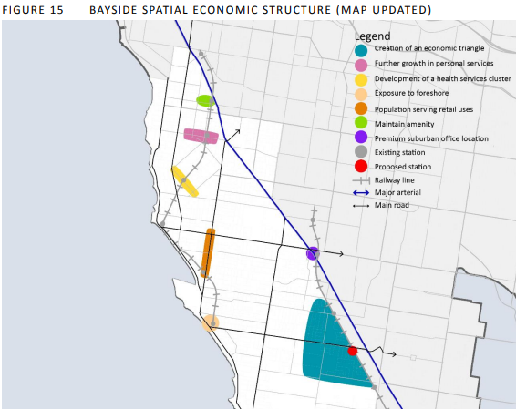

Strategy 3 – Expand the commercial and retail offering of activity centres beyond core business hours. The night time economy of suburban Activity Centres should rarely be confused with that of a CBD or major entertainment precinct. The key differences here lie in peak time periods, reasons for visitation and economic activity
Strategy 5 – Support the trending shift in the economy towards professional services.
Better employment opportunities and economic engagement for local residents that prefer to work close to home, such as single parents, carers and older workers entering semi-retirement.
Strategy 6 – Respond to demographic change and the needs of an aging population…an opportunity to strengthen Activity Centres through co-locating all types of health services with centre

Heritage Action Plan June 2020
Heritage Interpretive and Communications Plan
Prepare a Heritage Interpretive and Communications Plan that:
- Promotes walks and trails, Council owned heritage properties, events, interpretive signage, cultural heritage, Indigenous and post-contact history, planning and heritage (i.e. Heritage Overlays), and the exhibition of Council owned heritage objects including the use of mobile technologies, social media and traditional media.
- Investigates how a library/online repository of publications, guidelines and other material on heritage conservation for use by the community could be established.
- Investigate how to strengthen relationships with community organisations and key stakeholders related to heritage.
- Investigates opportunities to improve community engagement relating to Heritage.
- Develops a plan to inform community organisations and residents of grant programs run by State and Commonwealth agencies.
- Consolidate and improve access to heritage knowledge within the organisation, including use of systems, legislation/statutory requirements, process mapping, identify training opportunities and informal briefings.

Early Years Infrastructure Plan 2018-2028
The Infrastructure Plan is aimed at providing a suite of Council owned early years facilities that:
- Satisfy existing demand and have the capacity to cater for additional demand;
- Comply with relevant legislation and building codes;
- Are fit for purpose and highly functional;
- Are conveniently located and equitably distributed across the municipality;
- Are optimally used;
- Promote service integration;
- Are accessible to and suitably designed for children with disabilities and other additional needs;
- Are sustainable in terms of maintenance;
- Provide safe environments for staff, children and families; and
- Support the implementation of the National Quality Standard (NQS) for early childhood care and education.

Arts Strategy 2018-2022
Vision
Bayside City Council offers inspiring, creative, artistic and cultural experiences for its community and visitors to enjoy.
Key principles
The key principles that have informed the Strategic Plan are:
- Making art accessible – promoting art as part of daily life including in our streets, foreshore as well as purpose-built infrastructure.
- Making art inclusive – ensuring a wide range of activities are developed.
- Developing knowledge and data – using information and research gathered from the community to assist with the development of arts programs.
- Building strong partnerships – work with community organisations to provide the Bayside Community with a comprehensive program of arts activities and events.

Community’s expectations around arts and culture.
- Broaden the range of activities to include more family friendly events.
- Increase the number of outdoor activities.
- Develop and implement a Marketing Plan to increase awareness of existing and future programs
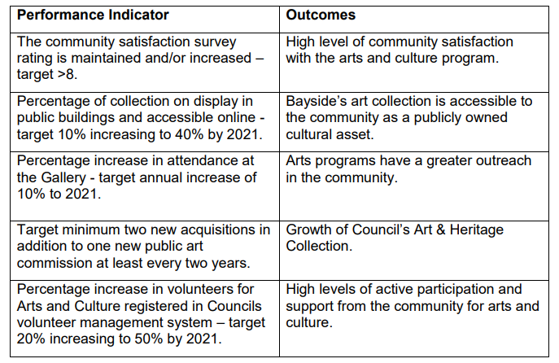

Source: Bayside Arts Strategic Plan 2018-2022, p. 8

Bayside Open Space Strategy: Suburb Analysis and Action Plan 2012
Opportunities to improve trails in Brighton East
Improve trail connections

Library Services Strategic Plan 2018 - 2022
The key principles that underpin this plan are;
1. 24/7 access for library members
2. A place to gather, work, live and play
3. Seamless user experiences
4. Opportunities for learning
5. Increasing literacy
6. Digital inclusion
Vision: Enriching the community Purpose: The library service provides access to information, resources, programs and spaces for all ages to learn, imagine, create and connect; contributing to a sense of belonging, enriched social life, wellbeing and liveability in Bayside
Strategic goals and objectives
Strategic goal one: Supporting Lifelong Learning and Enhancing Literacy We will provide resources and programs that promote, engage and support learning and literacy to people of all ages and abilities within the community.
1.1 Develop an approach to support literacy and learning within the community
1.2 Ensure programs and collections are right for our community.
Strategic goal two: Providing access to information We will provide modern library facilities and services that meet the needs of the community.
2.1 Ensure Infrastructure supports service delivery.
2.2 Provide systems that support access and service delivery. 6 2.3 Ensure that programs and services are promoted to the community.
Strategic goal three: Strengthening Community Connection We will promote and support the health and wellbeing of our community through increasing opportunities for social connectivity.
3.1 Support opportunities that build social networks and community connections.
3.2 Improve access to affordable, appropriate and inclusive services.
3.3 Develop approaches to encourage community volunteering, including opportunities to reward and recognise community leaders and volunteers.
Strategic Goal four: Customer First We will put our customers first in the design and delivery of our services.
4.1 Develop an approach that ensures customers are a central consideration in decision making and policy development.
4.2 Adopt existing organisational methodologies for service design that incorporates the appropriate tools to improve end to end service delivery.
4.3 Provide workforce and resources that meet service level requirements
4.4 Assess and develop staff competencies to meet customer needs.
4.5 Measure customer satisfaction to improve service delivery
Bayside Tourism Strategy 2013
The Tourism Strategy addresses the draft Council Plan 2013 – 172 Goal Six – A thriving local economy. This Strategy outlines the measures to be undertaken to achieve the Council Plan’s vision that Bayside will be recognised as a leading business hub and a prominent coastal tourist destination.
Arts, Heritage and Culture Bayside has a rich art and cultural heritage, notably its historic buildings, and has a significant local arts and entertainment scene. There is also a rich Indigenous heritage from the Boon wurrung Nation. - Products such as the Bayside suite of Walks and Trails can be distributed to visitors and residents alike to encourage exploration of new cultural assets such as multimedia and exhibitions at The Gallery @ Bayside Arts and Cultural Centre
Community support for tourism and volunteering This potential for direct participation is indicated by the Bayside 2020 Community Plan and the ABS 2011 Census which showed a high level of volunteering among Bayside residents (21%, compared to the Melbourne LGA average of 16%
VISION FOR TOURISIM IN BAYSIDE IN 2018 Bayside is a vibrant seaside community where residents enjoy showing its attractions to their guests. Community members are ‘in the know’ about exciting local events and exhibitions; new cafes and boutiques; and feel inspired to create something new and different. Visitors recognise the Brighton Bathing Boxes, major local sporting events and Bayside’s beaches and know that nearby lies other exciting experiences including: premium public and private sand belt golf courses, shopping villages with boutique shops and lively restaurants and cafes, a bustling arts, architectural and creative scene, and a quality cycling and sporting culture. Many of these guests to Bayside often feel inspired to stay a little longer
6.2 STRATEGIC ACTION AREA 2 - DEVELOP NEW TOURISM OPPORTUNITIES
6.2.1 Goals
- Develop products which enhance existing and create new visitor experiences based on Bayside’s strengths Develop new products to maximise visitation and/or yield, with minimal environment and amenity impacts
- Develop one or more new major events held locally over the lifetime of the Tourism Strategy
- Develop and interpret tourism and orientation products over a variety of mediums to inspire exploration of Bayside’s attractions
6.4 STRATEGIC ACTION AREA 4 - FOSTER COMMUNITY AND INDUSTRY OWNERSHIP OF TOURISM DEVELOPMENT
6.4.1 Goals
- Bayside’s residents to host visiting friends and relatives with exciting products and experiences
- Tourism businesses in Bayside to adopt industry best practices and collaborate effectively to enhance the visitor experience
- Develop a community tourism volunteer program developed with supporting infrastructure

12.3 Community Infrastructure Benchmarks

Table 39: Community Infrastructure Benchmarks – Local Level
Service Type | Trigger
General Community Services
Neighbourhood House Programs | 1 Neighbourhood House per 20,000 people. The floor area would depend on whether a dedicated space is required for the service and the complexity/breadth of the service. For a dedicated service, the floor area could range from 200-600 square metres.
Community Meeting spaces - Small | 1 1-20 people venue per 4,000 people. The floor areas could range from 30 square metres for small group activities through to 400 square metres for large functions of more than 200 people.
Youth Facilities | Youth friendly spaces designed as part of Level 1 multi-purpose council community centres (1 Centre per 8,000 people). Incorporated within proposed Level 1 and community centres. Will depend on the final planning and design phases undertaken by growth area councils on a case-by-case basis, taking into account the design preferences indicated in the next column.
Multi-purpose Community Centres - Small | 1 Level 1 or 2 multi purpose community centre per 8,000 to 10,000 people. A minimum of 0.8 ha of land, approximately 420 square metres for facility.
Arts and Cultural Facilities
Community Art Space - Flexible, Multipurpose, Shared Use | Spaces to be provided within Level 1 Multi-Purpose Community Centre (1 per 8,000 to 10,000 people). Incorporated within proposed primary school, neighbourhood house or neighbourhood community centre. 400 square metres.
Aged & Disability
Seniors’ Groups - Small | Access to 1 large multi-purpose meeting space per 8,000 to 10,000 people (within designated Level 1 multi-purpose community centre).
Source: ASR 2008 Planning for Community Infrastructure in Growth Areas

Table 40: 2041 Population: Bayside Overall; Brighton and Brighton East Total Area
2041 | City of Bayside | Total Brighton and Brighton East
Age group | No | No
0 to 4 years | 6805 | 2398
5 to 11 years | 10988 | 4062
12 to 17 years | 9573 | 3678
18 to 24 years | 9709 | 3665
25 to 34 years | 12123 | 4245
35 to 49 years | 25122 | 9213
50 to 59 years | 17160 | 6400
60 to 69 years | 14826 | 5467
70 to 84 years | 17054 | 6430
85 and over years | 4810 | 2227
Total | 128170 | 47785
Source: forecasted.com adapted by K2 Planning 2021

12.4 Co-Worker Space Examples
Table 41: Current Best Co-Worker Spaces in Melbourne
Name | The Cluster | HUB Australia – Melbourne | The Circle Collingwood | The Arcade
Features | The Cluster provides over 2500m² of office space (which includes Australia’s first co-working Penthouse) with both shared work areas and private offices, venue spaces, beautiful boardrooms and meeting rooms, reliable fast internet, social and networking events, investor networks, receptionists, telephony, IT support and incredible views. After spending a brief time on it’s website, it is understandable to see why Huffington Post named The Cluster “Australia’s Leading Co-Working Space”. | Hub’s Southern Cross location in the Melbourne CBD offers potential members the largest co-working space in the capital. Opposite Southern Cross train station and walking distance from Flinders Street, you’ll find everything you need at HUB Australia. Whether you’re working solo or as part of a larger team, you’ll enjoy printing facilities, bike racks, shower facilities, on-site cafe and a fully-equipped kitchen | The Circle Collingwood is a community for dreamers and doers, we deeply believe being in the right circle of people is the key for any business to succeed. With everything on offer, watch your business thrive in this fun and modern environment. This centre is conveniently located in central Collingwood. Break a sweat at the on-site gym, settle a score with a colleague in the arcade area, or chill out in the zen room. This creative new site also boasts a dedicated photography room and is pet friendly! | The Arcade, as the name might suggest, is a place for video games and their designers. This Melbourne shared office space is a Not-For-Profit, collaborative workspace created specifically for game developers and creative companies using game methodologies and technologies. Establishing in 2013, The Arcade offers meeting rooms, Wi-Fi access, full kitchen facilities (including 3 group head coffee machine) and a communal lunch area for residents.
Address | Address: 17/31 Queen St, Melbourne VIC 3000  Hours: Mon-Fri 9am-5:30pm  Price: from AU$130/Week  YBF Ventures  Address: 520 Bourke St, Melbourne VIC 3000  Hours: Open 24 hours  Price: Dedicated desks starting at $584/Month, Private Offices starting at $800/Month | Address: Level 7/180 Flinders St, Melbourne VIC 3000  Hours: Mon-Fri 9am-5pm  Price: AU$425-912/ month  Located in: The Georges Building  Address: Level 3/162 Collins St, Melbourne VIC 3000  Hours: Mon-Fri 9am-5pm  Price: AU$400-850/ month  Located in: Orica House  Address: 1 Nicholson St, East Melbourne VIC 3002  Hours: Mon-Fri 9am-5pm  Price: AU$350-850/ month  Located in: Mail Exchange Hotel  Address: 696 Bourke St, Melbourne VIC 3000  Hours: Mon-Fri 9am-5pm  Price: AU$100-735/ month | Address: 4 Bloomburg St, Collingwood VIC 3066  Hours: Mon-Fri 9am-5pm  Price: AU$370-$730/month | Address: 164 Kings Way, South Melbourne VIC 3205 Price: Hot Desk rental starts at $36/Day
Name | Spaces Melbourne | The Commons | The Thrive Network | United Co.
Features | Spaces is a co-working brand with over 425 locations around the globe. Melbourne is home to five of such, all located within reach of the city’s creative districts. Its contemporary designer interiors offer a unique yet comfortable working environment to suit the needs of your business. Through Spaces Business Club members can gain access to some of the best industry and business-relevant events, which focusses heavily on network building. | Located in an expansive, open-plan warehouse space in the heart of Melbourne’s oldest suburb, Collingwood, The Commons provides like-minded creatives with a wide array of perks, those being a beautifully tranquil open-air garden, state of the art photography studio and an impressive event space featuring a video wall. | You won’t find a table tennis table or arcade games at Thrive, but you will find a range of private and shared spaces for you to grow your business, network with like-minded professionals and foster new opportunities while we take care of the details. High speed Wi-Fi, a range of small to medium-sized meeting rooms, board rooms and conference facilities Thrive shared office spaces allows businesses to exist in a professional communal, creative and collaborative environment. | Located in the heart of bustling Fitzroy, United Co. is a business centre that houses inspired spaces that embrace work/life balance. Here, you can choose from a private office, a co-working space, a virtual office or simply for a meeting or event hire. United Co. also features a welcome concierge, an on-site licenced cafe, on-site gym & yoga studio, table tennis and in-house IT support.
Address | Address: 699 Collins St, Docklands VIC 3008  Price: from AU$384-600/ month  Located in: InterContinental Melbourne, an IHG Hotel  Address: 525 Collins Street Ground Floor, Rialto, West Podium, Melbourne VIC 3000  Hours: Open 24 hours  Price: AU$348-585  Address: Level 1/580 Church St, Richmond VIC 3121  Hours: Open 24 hours  Price: AU$348-550  Address: 161 Collins Street Levels 1 & 2, Melbourne VIC 3000  Hours: Open 24 hours  Price: AU$348-580 | Located in: QV Melbourne Address: 3 Albert Coates Ln, Melbourne VIC 3000  Hours: Mon-Fri 8:30am–6pm  Price: AU$55-1650  Address: 80 Market St, South Melbourne VIC 3205  Hours: Open 24 hours  Price: AU$45-1600  Address: 36-38 Gipps St, Collingwood VIC 3066  Hours: Mon-Fri 8:30am–6pm  Price: AU$45-1500  Address: 10-20 Gwynne St, Cremorne VIC 3121  Hours: Mon-Fri 8:30am–6pm  Price: AU$45-1800  Address: 11 Wilson St, South Yarra VIC 3141  Hours: Mon-Fri 8:30am–5:30pm  Price: AU$45-1700 | Address: 52 Albert Rd, South Melbourne VIC 3205  Hours: Open 24 hours  Price: Day Passes from $45/Day, Flexible membership from $300/Month. | Address: 425 Smith St, Fitzroy VIC 3065  Hours: Mon-Fri 8:30am-5:30pm  Price: Co-working starts from $99/mont
Name | Inspire9 | JustCo | Rotson Studios | DeskPlex – Unique Designer Offices
Features | Inspire9 is the original community-led co-working space for Melbourne’s start-ups, freelancers and creative entrepreneurs. With a mission to empower individuals and small teams to achieve big things by generating connections between members of our entrepreneurial and creative community; locally, nationally and globally. The Inspire9 Group is comprised of two spaces, both engineered to meet the needs of the community they support | With a number of great locations and generous desk offerings, JustCo co-working spaces in Melbourne gives you everything you want and more from your workspace. Built on the idea that connectivity leads to more business opportunities, JustCo’s coworking spaces in Melbourne are modelled to support professional productivity, flexibility and business operations. Whether you are a startup, a freelancer, or a well-established company, you’ll love JustCo’s inspiring workspaces, modern facilities, and prestigious business addresses with a number of packages that suits your needs. End-of-trip facilities are also available for every working professional’s convenience. | This charming and quaint office is located in the equally charming and quaint suburb of Fitzroy, that’s right, Hipster country. Don’t let the beards and activated charcoal deter you, Rotson Studios provides young creative entrepreneurs a place to build and foster their workplace endeavours and hopes to shape a community around their members. | Launching in 2019, DeskPlex Hawthorn took the traditional co-working space Melbourne was used to and turned it on its head. Featuring a camo carpet, a lot of timber, black walls and exposed ceilings, the innovative space certainly stands out. Even more so, when you throw in the fully equipped gym, pool, sauna (coming end of this year), massive outdoor deck with sunbeds, full-size billiards table and real wood-burning fireplaces. Even better, DeskPlex is expanding, with construction underway for a second co-working space in Ballarat, and plans for a third in Albury to service regional Victoria.
Address | Address: Level 1/41-43 Stewart St, Richmond VIC 3121  Hours: Mon-Thur 9am-4pm, Fri 9am-3:30pm  Price: $40 Day Pass, $69 hotdesk, $699 dedicated desk | Address: Level 19/15 William St, Melbourne VIC 3000  Hours: Mon-Fri 8:30am-6pm  Price: from AU$100/ month  Address: Level 5/447 Collins St, Melbourne VIC 3000  Hours: Mon-Fri 8:30am-6pm  Price: from AU$100/ month  Located in: Collins Arch  Address: Levels 4–5, 447 Collins Street, Melbourne VIC, 3000  Hours: Mon-Fri 8:30am-6pm  Price: from AU$100/ month | Address: Level 2, 105 Victoria Street, Fitzroy, Melbourne VIC 3065  Hours: 24 hours, 7 days  Capacity: 18 People  Price: $350 per month, enquires to contact Rotson directly below. | Address: 16-22 Church St, Hawthorn VIC 3122  Hours: Mon-Fri 6:30am-10pm  Price: Hot desks start from $550/Month
Name | Space&Co. | Revolver Lane | CreativeCubes.Co | Framework Melbourne
Features | Established in 2014, Space&Co. offers flexible workspace solutions for businesses looking to work smarter. Prime CBD locations put people at its centre with all-inclusive access to luxury amenities, a passionate management team and the chance to connect with like-minded leaders from a wide range of industries. Comfort is key, Space & Co certainly delivers on this. | Formerly the Revolver Music Arcade, this cavernous 1,000m² space has been converted into one of Melbourne’s most unique workspaces. With 15 offices of various sizes, casual lounges, gallery space, event space and private meeting rooms. After office hours, Revolver Lane turns into a versatile hub hosting everything from seminars, workshops, parties and launches, as well as featuring a range of regular entrepreneurial events. | Focusing on creating a working environment that is both welcoming and enjoyable, Creative Cubes has a wealth of great spaces in and around Melbourne’s prime office locations. The community-minded business has spaces in Richmond, Hawthorn, South Melbourne and Carlton. Each co-working space comes with fast internet, 24/7 access, dedicated meeting rooms, full kitchen and shower facilities, and concierge services as standard. | The newly renovated and revitalised Framework, which began back in 2015, provides Melbourne’s creative industry community a fun, convenient and collaborative area for development and advancement. With artwork adorned walls and game facilities on point, Framework is sure to be one of the best Co-Working Spaces in Melbourne.
Address | Address: Level 3/530 Collins St, Melbourne VIC 3000  Hours: Mon-Fri 8:30am-5pm  Price: AU$50-900  Located in: Melbourne Central  Address: Level 12/360 Elizabeth St, Melbourne VIC 3000  Hours: Mon-Fri 8:30am-5pm  Price: AU$50-700  Located in: Collins Place  Address: Level 22/8 Exhibition St, Melbourne VIC 3000  Hours: Mon-Fri 8:30am-5pm  Price: AU$50-700  Address: level 19/2 Southbank Blvd, Southbank VIC 3006  Hours: Mon-Fri 8:30am-5pm  Price: AU$50-600 | Address: 231 Chapel St, Prahran VIC 3181  Hours: Mon-Fri 8am-5pm  Price: Casual from $300/Month, Permanent from $500/Month and Offices from $2750/Month | Located in: South Melbourne Central  Address: Level/5/111 Cecil St, South Melbourne VIC 3205  Hours: Mon-Fri 8:30am-5pm  Price: AU$70-700/ month  Address: 534 Church St, Richmond VIC 3121  Hours: Mon-Fri 8:30am-5pm  Price: AU$70-700/ month  Address: 600 Glenferrie Road REAR, Hawthorn VIC 3122  Hours: Mon-Fri 8:30am-5pm  Price: AU$70-700/ month | Address: Suite 1, Level 1/458 Swanston St, Carlton VIC 3053  Hours: 9:30am-6:30pm  Price: Casual starting at $35/Day, Part-Time from $170 to $460/Month, and Full-Time $600/Month
Source: manofmany.com/lifestyle/best-coworking-spaces-melbourne

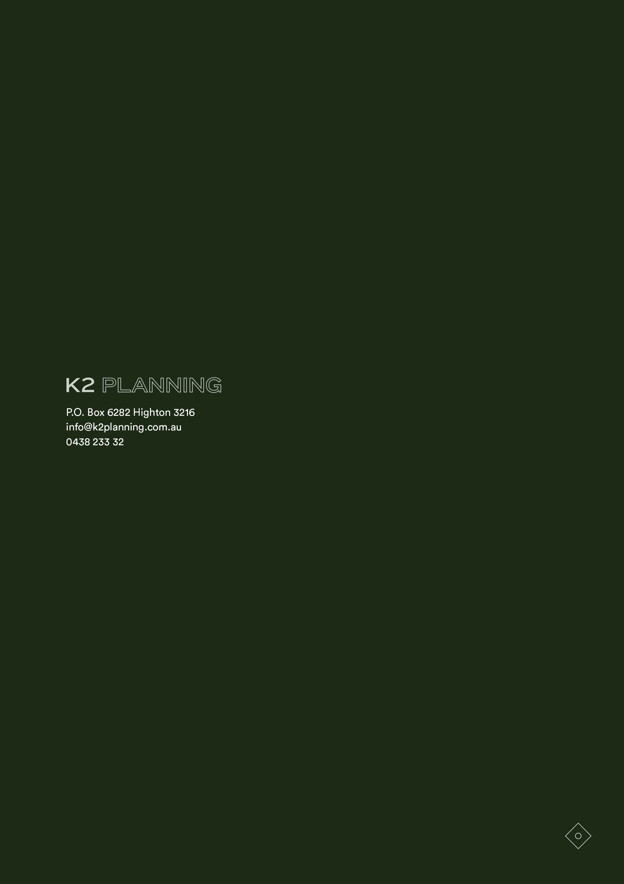

Council records suggest that the property was named Billilla after an area in NSW where the Weatherly’s originally lived (Source: Notes received through the Project Workshop conducted for the current Project).
Adapted from GJM Heritage 2019 Bayside Historical Buildings Strategic Plan: Heritage Report Billilla 26 Halifax Street Brighton, p. 5-6.
GJM Heritage 2019, p. 14.
Refer to Attachments for a list of Project Workshop Attendees.
State Government of Victoria Plan Melbourne – Metropolitan Planning Strategy 2017 - 2050
Material in this section is taken from the WHO Age Friendly Cities web site http://www.who.int/ageing/age-friendly-world/en/.
This section is based on material provide by Bayside City Council September 2021.
This section is based on material provide by Bayside City Council September 2021.
Allom Lovell & Associates ‘Billilla House Statement of Significance’ in Bayside Heritage Review 1999 cited in GJM Heritage 2019 Bayside Historical Buildings Strategic Plan: Heritage Report Billilla 26 Halifax Street Brighton, p. 10-12.
GJM Heritage 2019 Bayside Historical Buildings Strategic Plan: Heritage Report Billilla 26 Halifax Street Brighton, p. 15
Preliminary conversations with a number of Bayside community groups and Council officers; U3A, Friends of Black Rock House, Highett Neighbourhood House, Brighton Historical Society; Freeza Youth Committee ; Bayside Healthy Ageing Reference Group; Bayside Arts and Gallery Advisory Committee have all been enthusiastic about Billilla being available for community use.

