Property Strategy
2022-2026
Table of Contents
PART A. 3
1. Executive Summary 3
PART B. 4
2. Purpose 4
3. Scope 5
4. Council’s Strategic Planning Framework 5
5. Methodology 6
Key issues 6
Principles 7
Vision statement 8
Goals and Strategic objective 8
Community Engagement 9
6. Background 10
Previous strategy 10
Key trends 11
7. Action Plan 13
8. Asset Information 25
9. Glossary 29
10. Legislation and policy 29

PART A.

Executive Summary
Introduction

This strategy will guide Council’s property decision-making over the next four years through innovative actions which deliver sector-leading outcomes.

The current property portfolio includes land and buildings that are used for:
- direct service delivery by Council
- the delivery of community-based services by not-for-profit organisations
- recreational and sporting pursuits
- commercial activity
- passive open space, environmental management and car parking

Property is a high value asset to Council, unique in its ability to support and deliver Council’s vision and strategic objectives. Property includes things like sporting pavilions, community houses and recreational facilities. These properties are central to Bayside as places to gather, have fun and foster a sense of community. The Property Strategy is Council’s way of ensuring that our plans for Property reflect the community’s aspirations and needs into the future.

Council has a range of roles in managing property. These roles include planning for the long-term delivery of Council services, land and property maintenance, management of tenancy arrangements with community and commercial tenants and the strategic use of property assets to achieve broader community benefit.
The role of the Property Strategy in this context is to see where and how property forms part of Council’s projects and aspirations. Over the life of this Strategy, Council will continue to focus on core property areas such as utilisation, community outcomes and sustainability while also establishing and strengthening organisation links and competency to support and advance Council Plan initiatives.

Vision statement
Council’s property portfolio is strategically aligned with its service delivery objectives and community needs. Council properties are well utilised, well maintained and generate high levels of public value.

PART B.

Purpose
The purpose of this Strategy is to ensure Council property is managed for the long term community benefit that maximises the social, cultural, recreational, environmental and economic outcomes for which the land is held.
The Property Strategy is an overarching and linking strategy. While it contains standalone actions, it also interacts with other strategies and policies of Council that contain actions or objectives that effect Council owned or managed Property. For example, a particular strategy might relate to a recreational or sporting activity. The sites where that activity happens are leased by Council and therefore effected by this strategy. Likewise, strategies concerning environmental sustainability or major activity centres will intersect with this Strategy when discussing acquisitions or repurposing of Council land.
The following is a non-exhaustive list of Council strategies, policies and plans with which this Strategy will interact:

- Buildings Service-driven Asset Management Plan 2016 | - Bayside Tennis Strategy 2019-2028
- Bayside Tourism Strategy 2013 | - Recreation and Open Space Asset Management Plan 2016
- Economic Development Strategy 2014 | - Biodiversity Action Plan 2018-2027
- Early Years infrastructure Plan 2-18-2028 | - Carbon Neutrality Action Plan 2018-2020
- Library Services Strategic Plan 2018-2022 | - Bayside Coastal Management plan 2014
- Active by the Bay Recreation Strategy 2013-2022 | - Climate Emergency Action Plan 2020-2025
- Bayside Sportsground Pavilion Improvement Plan 2013 | - Environmental Sustainability Framework 2016-2025
- Bayside Open Space Strategy 2012 | - All adopted Masterplans
- All adopted Policies | - All adopted Structure Plans

Scope
The scope of the strategy is Council Freehold land, Crown Land under Committee of Management, discontinued roads and rights of way, property that is leased, licenced or otherwise occupied by third parties, and easements.

Council’s Strategic Planning Framework
In 2021 the Bayside 2050 Community Vision document was developed in consultation with our community. The Vision comprises ten themes.

Based on these themes, the 2021-2025 Council Plan establishes a clear framework of 4 Goals that target the delivery of the long-term themes and priorities for Bayside City Council and its community, over the term of the current Council.

It is within this context that this Property Strategy sits.
The Property Strategy supports both the Community Vision and Council Plan by ensuring the service needs of Council and community expectations are supported with appropriate, fit or purpose property assets to deliver the short and long term objectives of Council.
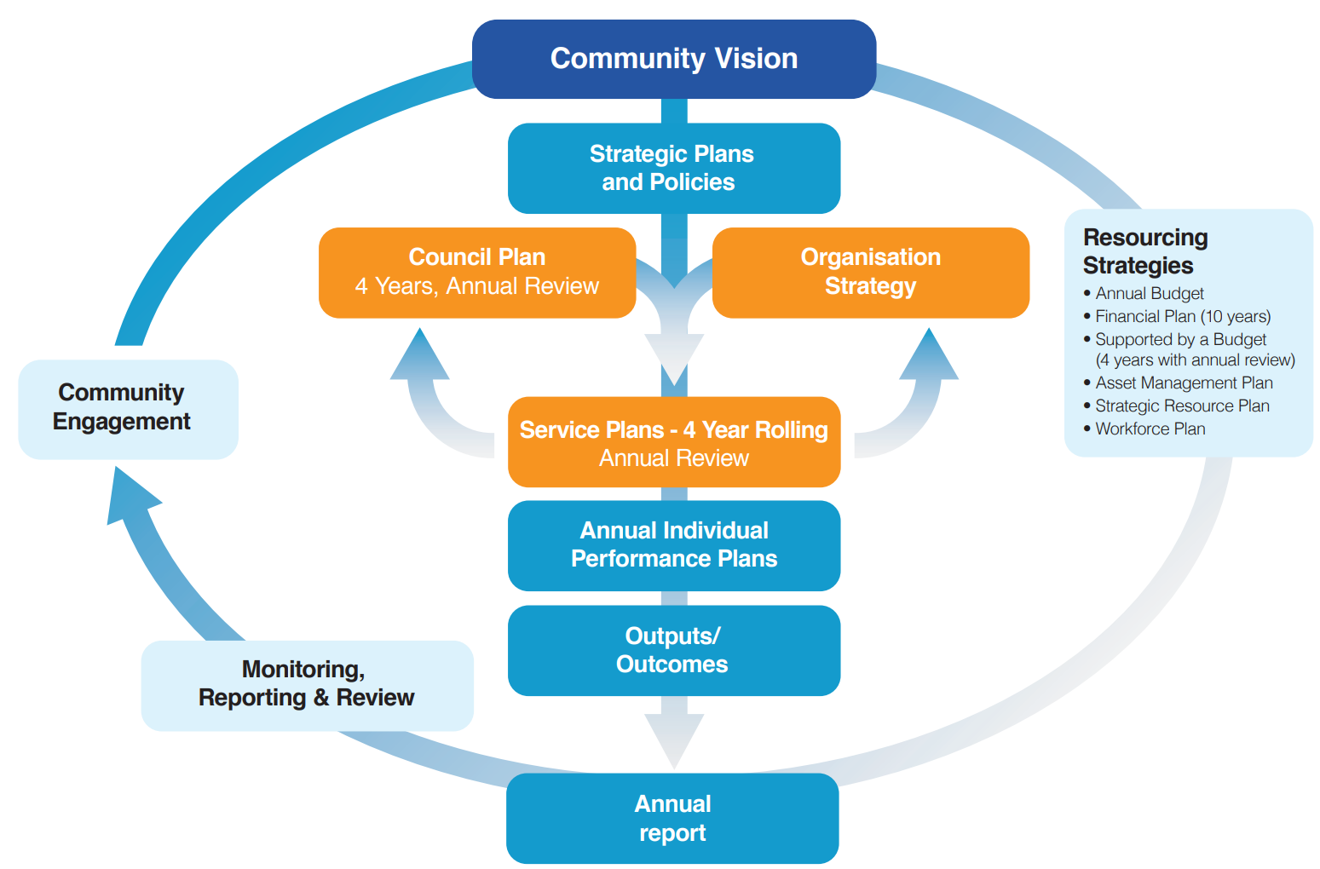

This strategy is significantly influenced by other Council strategies which provide direction for Council assets (see Part 2). That direction might include (for example) where property must be retained and managed or where changes to the property portfolio are required.

Methodology
This Strategy builds on previously adopted versions of the Property Strategy and incorporates learnings and challenges from implementing those strategies.

Key issues
Over the next five years Council has committed significant resources to a number of capital projects and strategies through its Council Plan including:
- Development of the former CSIRO site in Highett resulting in significant public open space and a Council operated community facility;
- Redevelopment of the Dendy Street Beach Pavilion;
- A warm water pool and potential third party development of a wellness centre at the Brighton Golf Course;
- Return of Billilla in Brighton to community use;
- Completion of the Bayside Netball Centre;
- Redevelopment of the Beaumaris Arts Centre;
- Completion of the Wangara Road Park Masterplan;
- Finalising the transfer of Committee of Management for Part of Hampton Beach from Parks Victoria to Council;
- Development of the Hampton Hub opportunities;
- Continuation of the Sports Pavilion refurbishment program;
- Progressing the identification and acquisition of pocket parks;
- Continuation of the Sportsground renewal program;
- Progressing the relocation of the Cheltenham Scout Hall and Cheltenham Station Reconstruction;
- Completion of the new Basketball Stadium;
- Refurbishment of the Brighton Recreation Centre;
- Trialling discontinuation of a right-of-way for planting as open space;
- Utilisation of Open Space Assessment tool for acquisition of open space;
The Strategy recognises that each of these projects are unique and require diligent attention from Council to ensure that the community receives the best possible outcome.

Principles
Taking into account the Strategic Planning Framework and context, Council has developed a set of principles that together act as a statement of the priorities and values held by Council and the ethos to which Council will work over the course of this Strategy.
Principles
- Finding a balance between community and commercial returns
- Increasing accessibility and equity
- Optimising utilisation
- Advancing Environmental Sustainability
- Ensuring assets are fit for service delivery
In addition to aligning Council’s strategic direction for its property portfolio with the Council Plan 2021-2025, the principles reflect the community’s feedback, that property means many different things to different people.
Accordingly, the principles have been prepared to encompass the most important priorities expressed by the community. This means there are actions to increase revenue, increase community benefit, as well as actions to increase open space and utilisation of Council buildings.
This Strategy is intended to set ambitious targets for Council, to increase access to and utilisation of Council property and advancing Council’s environmental objectives, while also creating opportunities for local business. It will do this by drawing together all of the distinct strategies, policies and plans of Council that effect property and finding a balance that promotes fairness, equity and good community outcomes.

Vision statement
Council’s property portfolio is strategically aligned with its service delivery objectives and community needs. Council properties are well utilised, well maintained and generate high levels of public value.

Goals and Strategic objective
Each goal addresses a central issue, associated actions required to achieve each goal and finally measurable outcomes. This is summarised as follows:
Outcomes/Deliverables
Actions
Goals
The result of the action, both from a strategic alignment perspective and in real terms
The steps required to achieve the goal (e.g. a review of current practices, the creation of a new process)
A more operational statement of intent based on the Principles.

The five goals are:
Goal 1 | Maintain and acquire open space
Goal 2 | Strive to maximise utilisation and community benefits across the property portfolio
Goal 3 | Use Council controlled property to optimise commercial returns
Goal 4 | Commit to capital investment in Council assets that are sustainable, accessible and fit-for-purpose now and for the future
Goal 5 | Align policy and process with Property Strategy principles

Background
Land owned or managed by Council including the value of land under roads makes up $2.8 billion with the balance of $600 million made up of renewable infrastructure such as roads, footpaths, drains, buildings and other plant and equipment. Many of these assets were constructed in the 1960 -1970s during the major growth phase of Bayside and are approaching the end of their useful life. The land encompasses over 1,100 individual land title parcels. The majority of these relate to public open space, golf courses and roads. There are approximately 351 buildings on these properties with uses ranging from Council administration and services, halls, clubrooms and pavilions. Council’s occupied buildings are valued (on a cost of replacement basis) at approximately $294M. Those occupied by community and sporting groups are valued at approximately $174M with commercial assets of approximately $42M.

Historically, Council has provided land to support community uses such as tennis, bowls and other not for profit community group uses. Much of the community infrastructure on Council land was initially built by specific community groups including sports clubs, Scouts groups and other organisations. The ability of community groups to meet new legislation, raise funds and maintain the infrastructure they occupy has become increasingly challenging. The condition of many of these is becoming poor with the groups not able to fund future renewal. Council has commenced a program of capital renewal to significantly improve aging, not fit for purpose infrastructure however this does not address all community buildings.
Council currently has 255 occupancy agreements with various tenants for a variety of community, social, recreational or commercial purposes on Council owned or managed land. The majority of occupancy agreements are exclusive lease arrangements with only a few shared use agreements in place. Council receives an annual rental income of $3.79 million from its leased/licenced assets.

Previous strategy
The previous Property Strategy reached the end of its life cycle in June 2021. Some of the strategies goals were:
- maximising utilisation through co-location;
- user contributions to the management of property are equitable and linked to capacity to pay;
- innovative funding models and strategic partnerships (including third party investment) to be explored as a way of delivering asset enhancement; and
- commercial properties have long term management and renewal plans in place.

An objective assessment of performance against these goals indicates success in some areas with opportunities for improvement in others. More specifically:

- Income has generally trended down over the last four years (particularly with COVID-19 rent relief). Over the same period costs to manage and maintain property have risen.
- market rent reviews for commercial tenants have yielded lower rents.
- Council’s increased focus on negotiating investment by tenants lead to significant capital renewal decisions in buildings by third parties at Ricketts Point Teahouse, North Point café and the Sandringham Golf Course.
- There is a tension with seeking greater commercial returns and any change in a building’s established use.
- Council explored opportunities related to releasing value of carparks however did not progress any projects.
- Council completed a review of its historic buildings.
- Some Council decisions have also caused changes to the commercial portfolio (including decisions to end leases at Billilla, Sandringham Golf Driving Range, Elsternwick Park North and demolition of residential property at 7 Well Street).
- Community tenants are occupying ageing buildings with significant capital renewal or maintenance costs. Many of these tenants are challenged by the costs they are obliged to cover under their leases.

Key trends
There is an increasing focus on maximising utilisation and developing a more sustainable asset base. This continues a shift away from single use single user buildings which Council has historically constructed. Key trends include:
- There continues to be an expectation that assets will be available for multiple purposes and uses. This supports a focus on maximising utilisation and developing a more sustainable asset base. This is a shift away from single use single user buildings which were historically constructed by Council.
- Changing demographics in the Community: The City of Bayside population forecast for 2022 is 110,239 and is forecast to grow to 128,169 by 2041. Council uses demographic forecasting information to plan for changes in services and how we lease our buildings to provide a place for community and commercial activities.
- Asset based building services must be managed to ensure they effectively support the changing community needs and priorities. Key changes in Bayside through to 2041 are expected to see growth in seniors aged 70-84 years and growth in 'empty nesters' and retirees in Brighton and Hampton. Conversely, more children and young families in Cheltenham, Hampton East and Highett will require more early years facilities in those areas.
- There is a greater focus on activity centres for increased population. This requires consideration of appropriate spaces and facilities to support areas where intensification is occurring.
- Market need for services: The expectation is that significant community infrastructure will be required to maintain facilities for families and mature/older adults and adapt service mix and infrastructure to cater for needs of growing population of seniors, the elderly and adults aged 25-34.
- The increase participation of females in sport is creating a need to ensure facilities cater equitably for all needs including gender participation and accessibility.
- Financial Constraints: There is currently significant capital investment in facilities to overcome the historic renewal gap. However, budget constraints due to rate capping will limit Council’s capacity to provide resources to support new and upgraded facilities in the longer term.
- Legislative Changes: The legislative requirements governing delivery of asset based building services are extensive and continually evolving. This is particularly so in the areas of Disability Access, Health and Safety and also provision of regulated services such as Child Care facilities. There is also greater pressure on maintenance of open space and physical infrastructure with increasing frequency and cost of litigation against Council.
- Climate Emergency: Climate change and the declaration of a climate emergency raises some specific issues for Council’s Building Assets. The potential impacts of rainfall, wind and lightning events as well as increased temperature and solar radiation may reduce the life of building elements. Climate change also impacts property used as land for habitat, urban forest and maintained for natural reserves.

Action Plan
Goal 1:
Strategic objective/s: Open Space and Environmental Sustainability
Strategic measures/s:
- Where there is an identified deficit, identify at least 1 opportunity for new open space in each Major Activity Centre
- Generation of new open space in activity centres
- 100 percent of new leases incorporate alignment to sustainability objectives
Strategy | Actions | Timeframe | Costs | Responsible | Outcome/Deliverable
Acquisition and disposal of property to meet current and emerging needs | Deliver open space in major activity centres by:  - Identifying preferred sites for open space informed by Council’s Open Space Strategy 2012 and relevant Structure Plan/Streetscape Masterplan documents.  - Pursuing identified sites using an approach either by:  - prioritising the creation of new open space within the public realm, through road and public space conversions;  - transitioning existing Council owned facilities to open space;  - purchasing/acquiring new land for open space; or  - Partnering with third parties (e.g. developers, nearby landowners and government). | December 2022 (TBC)  December 2022 – June 2026 | Site dependent | Lead  Open Space Recreation and Wellbeing  Partners  Urban Strategy  Commercial Services | Deliverable  A list of prioritised opportunities for open space in each Major Activity Centre and an identified approach to support creation of public open space in priority areas across the municipality  Outcome  Creating new public open space for passive recreation in activity centres
 | Pursue opportunities with third parties to create additional green space or habitat corridors (including Black Rock and Beaumaris).  This may include partnership opportunities with nearby landowners, private sector, various levels of government (e.g. Melbourne Water, Department of Transport, etc). | June 2023 | Operational Budget | Lead  Open Space Recreation and Wellbeing  Key partners  Commercial Services  Urban Strategy | Deliverable  More opportunities to link to existing open space to create habitat corridors  Outcome  Creating new open space for recreation and environmental protection
 | Review the Discontinuance and sale of Right of Ways, Roads, and Reserves Policy | December 2022 | Operational Budget | Commercial Services | Deliverable  An updated policy which protects Council’s rights over land that is illegally occupied as well as incorporating opportunities where appropriate to retain land for habitat as well as sale to abutting owners  Outcome  Revenue generated by Council can be used for acquiring open space for passive recreation and environmental protection

Goal 2:
Strategic objective/s: Maximising utilisation and community benefits
Strategic measure/s:
- Model for increased utilisation rolled out to 6 Council owned and managed Pavilions by 2026
- Once established, percentage increase in bookings made using the online portal year on year

Strategy | Actions | Timeframe | Costs | Responsible | Outcome/Deliverable
Increase utilisation of exclusively occupied buildings | Complete the pilot program at AW Oliver Pavilion trialling a cluster management model of operating community space in pavilions | June 2022 | Operational Budget | Lead  Open Space Recreation and Wellbeing  Key partners  Commercial Services  Service Areas | Deliverables  Pilot programme will provide meaningful data on whether a cluster management model will work for increasing utilisation at pavilions  Outcome  Increased utilisation of currently single use buildings
Increase utilisation of exclusively occupied buildings | Develop a sustainable model for managing pavilions to maximise utilisation outside of sporting times that balances:  - financial constraints  - security  - equity of access for potential users (i.e. underserviced groups/demographics in the community) | June 2024 | Operational Budget | Lead  Open Space Recreation and Wellbeing  Key partners  Commercial Services  Service Areas | Deliverables  Model for increasing utilisation at pavilions (and other buildings as appropriate)  Outcome  Increased utilisation of currently single use buildings
Increase visibility of available spaces for third party use | This action includes multiple sequential steps that will take place over the life of the Strategy as follows:  - Develop a profile of each major asset based on utilisation potential (e.g. available space, current amenity)  - Create and maintain a list of spaces available for increased utilisation  - Commence matching community groups with suitable spaces | January 2024  July 2024  December 2024 | Operational Budget | Lead  Commercial Services  City Assets and Presentation  Key partners  Service Areas | Deliverables  Information attached to each Council asset regarding the space and amenity of that building  List of sites where increased utilisation is possible  Outcome  Increase in utilisation through public availability of spaces for a variety of community activities

Goal 3:
Strategic measures/s: Optimising commercial returns
Strategic measure/s:
- Number of new ancillary commercial providers introduced to Council owned buildings
- Number of new commercial activations on Council land each year of the Strategy
Strategy | Actions | Timeframe | Costs | Responsible | Outcome/Deliverable
Improve activation on Council owned or managed land | Develop an Activation of Council Land policy guides:  - Locations for new economic activity (e.g. mobile vendors, long and short term trading sites  - Sustainability and environmental requirements  - Minimum financial requirements (e.g. sustainable business model)  - Criteria to support local businesses first | July 2023 | Operational Budget | Commercial Services | Deliverable  A policy which responds to ad-hoc requests for access and use of Council land  Outcome  Increased utilisation and activation of Council land as well as revenue to support Council’s strategic objectives
Increase financial sustainability of Council leased portfolio | Develop specific guidelines for Expressions of Interest that mandate a baseline:  - Community benefit  - Level of utilisation  - Amount of capital investment based on proposed length of term and proposed use | July 2023 | Operational Budget | Lead  Commercial Services  Key partner  Service Areas | Deliverables  More certainty for proponents (for commercial or community leases)  Greater financial investment into Council owned Property by Tenants  Outcome  Increased utilisation and greater investment in Council assets
 | Identify spaces in Council run buildings that are suitable for complementary commercial activity (e.g. a café space in a library) | July 2023 | Operational Budget | Lead  Commercial Services  Key partner  Service Areas | Deliverables  New revenue streams that do not require capital expenditure from Council  Outcome  More activation of Council spaces and increased revenue to support Council projects
Use property as a means of commercial investment | Undertake strategic review to determine criteria to support decision making for investment in property as a revenue generating investment (e.g. purchase, leasing) | June 2023 | Operational Budget | Lead  Commercial Services  Key partners  Strategic Planning  Finance | Deliverables  A tool for assessing and pursuing appropriate investment opportunities involving property  Outcome  Increased commercial returns to support Council’s strategic objectives
Support community tenants to partner with other community groups or local commercial operators | Work with community tenants to build more sustainable and viable networks of community organisations | June 2022 | Operational Budget | Lead  Commercial Services  Key partner  Service Areas | Deliverables  Increased financial sustainability of local groups and capacity to invest in long term future of assets  More utilisation of currently single occupancy buildings  Outcome  Increased utilisation and greater investment in Council assets

Goal 4:
Strategic objective/s: Capital investment in assets: sustainable, accessible and fit-for-purpose now and for the future
Strategic measure/s:
- Annual financial return from leased properties increased by at least the Consumer Price Index
- Overall asset condition to be maintained or improve annually
Strategy | Actions | Timeframe | Costs | Responsible | Outcome/Deliverable
Plan for fluctuations in demand for buildings into the future | Inspect each asset to be scored against condition, functionality and capacity/utilisation criteria to be used to track:  - any dedicated assets which are (or will be) surplus to requirements  - unrealised utilisation capacity | July 2024 | Operational Budget | Lead  City Assets and Presentation  Key partner  Commercial Services  Service Areas | Deliverable  Clear understanding of property portfolio, including any capacity constraints and/or spare capacity  Outcomes  Increased utilisation and targeted financial expenditure on services/assets for which demand is expected to increase
Actively monitor and plan for the future preservation and use of historical buildings | Develop program to update Conservation Management Plans for the following:  - Brighton Town Hall  - Black Rock House  - Brighton Court House  - Bayside City Council Chamber  - Higginbotham Hall | November 2022  Prioritised one per year from 2023 | Approx. $50,000 per each  (subject to budget allocation) | Commercial Services | Deliverable  Historic buildings have updated management plan to support use  Outcomes  Major historic buildings maintained to a higher standard and used for more appropriate activities
 | Ensure future plans for each of Council’s historical buildings reflects Bayside 2050 Community Vision themes to:  - provide the best use to support preservation  - include appropriate mix of commercial and community uses | July 2022 / June 2026 | Operational Budget | Lead  Commercial Services  Key partner  Libraries and Cultural Services | Deliverable  Sustainably managed and maintained historic buildings  Outcomes  Meeting Council Plan objectives by optimising utilisation and creating community benefits, increasing access to Council buildings
Ensuring Council and tenant lease obligations are met | Inspect assets to capture data including observations around lease specific obligations related to the leased asset to drive improvement in property maintenance and capital investment | July 2023 | Operational Budget | Lead  City Assets and Presentation  Key partner  Commercial Services | Deliverable  Accessible data is available which identifies current and future improvement opportunities for each leased property  Outcome  Better investment of resources into property
 | Use improved data on the condition, functionality, and capacity of each asset to ensure landlord obligations are adequately met | July 2023 | $ informed by the asset plan | Lead  City Assets and Presentation  Key partner  Commercial Services | Deliverable  Annual and cyclical planned maintenance for all Council leased buildings by Council in accordance with occupancy requirements  Outcome  Better investment of resources into property

Goal 5:
Strategic measure/s: Alignment of policy and process with Property Strategy principles
Strategic measure/s:
- Percentage of leases/licence which are current (>80%)
- Post adoption of new Leasing Policy, 100% of new leases/licences meet environmental sustainability, utilisation, community benefit and financial capacity targets
Strategy | Actions | Timeframe | Costs | Responsible | Outcome/Deliverable
Ensure Lease and Licence Policy delivers on Council property objectives | Review the Lease and Licence Policy to include:  - Revised tenant categories for different types of tenants  - a community benefit matrix based on a set of agreed weighted criteria (e.g. inclusivity, service, alignment to Council goals) and identified benefits to residents  - environmental criteria aligned to Council’s long term sustainability goals  - financial sustainability criteria to ensure tenants able to meet obligations  - business case requirements for new leases  - criteria for assessing the community benefit and specific benefit for residents of new lease proposals | February 2023 | Operational Budget | Lead  Commercial Services  Key partners  Open Space Recreation and Wellbeing  Community Services | Deliverable  Assessment criteria for occupancy agreements leading to improved lease management outcomes for new and existing tenants  Outcome  Leases and Licences aligned to Property Strategy’s principles, particularly increased community benefit, utilisation and investment in property as a resource and profitable asset
Determine full extent of current use of Council buildings | Perform a systematic audit of the property portfolio to identify any undocumented uses based in service areas | June 2023 | Operational Budget | Lead Commercial Services  Key partners  Community Services  Open Space Recreation and Wellbeing | Deliverable  Complete record of all Council obligations associated with property and written agreements for all uses where appropriate  Outcome  Capturing data is a key step in increasing utilisation and ensuring equity and accessibility by identifying and recording all current uses
Determine full extent of current use of Council buildings | Integrate occupancy agreement maintenance obligations into central Asset Management System | December 2023 | Operational Budget | Lead  Commercial Services  Key partners  City Assets and Maintenance  Information Technology | Deliverable  Improved management of tenant and Council obligations  Outcome  Better investment of resources into property and financial savings to invest in Council projects

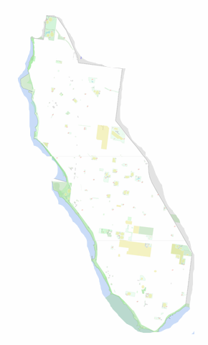
Asset Information
8.1 Nature and type of assets
Council has over 1,100 individual land title parcels. However the majority of these relate to public open space, golf courses and roads. Once these are stripped out the number of parcels is reduced to approximately 150 parcels which are mainly car parks (72) and assorted properties used for Council activities and by community groups (76).

The Open Space Strategy provides detailed information in relation to areas of open space and open space requirements.

There are 351 buildings on these properties with uses ranging from Council administration and services, halls, clubrooms and pavilions.

The image provides an indication of the location of Council land used for these purposes.

8.2 Buildings Service Driven Asset Management Plan
The Buildings Service Driven Asset Management Plan (BAMP) identifies the requirements of Council built assets. Below is an extract of key information related to Council facilities. Further extensive information can be found in the BAMP, however the key issues related remaining life and condition are noted below.
Service needs are determined through strategic plans, for example Municipal Early Years Plan and the Open Space Strategy. The identification of service driven asset requirements will determine where Council may need to invest in infrastructure upgrade, renewal, decommissioning or disposal of property. Service may be impacted by the condition of an asset, its fitness for the purpose that it is being used including capacity, configuration and the expectations of the community users of the service.
8.3 Buildings useful remaining life
The remaining life of buildings is the useful life less life consumed. The table below presents the remaining life of all buildings per asset class. The buildings have been grouped into those with less than 5 years remaining life, those between 5 and 14 years remaining, 15-29 years, 30-50 years and those with more than 50 years. It is noted that approximately 30% of the building stock classified as Child Services have less than 5 years remaining life although many of these assets include sheds or shelters.
These figures are based on asset life. It is likely that many buildings will have a shorter ‘life’ resulting from the need to improve service performance of that building.

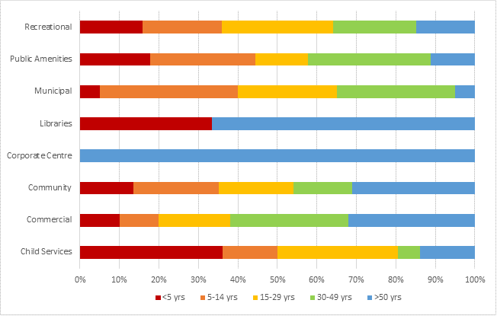

8.4 Building Component Condition
The graph below depicts the asset condition distribution for each building element type. For ease of reading, the 10 point condition scale has been translated into 5 grades, where ‘Excellent’ is anything at or below a rating of 2, ‘Good’ is 3-4, ‘Average’ 5-6, ‘Poor is 7-8 and anything above 8 is ‘Past Intervention Level’. Less than 1% of assets are beyond intervention point and are addressed by the annual building renewal program. Over 90% of building assets are rated with condition ratings of either excellent, good or average and due to the age of the building stock, no significant structural works due to asset condition are required over the next 10 years. Again, this assessment is related to the condition of the asset and not service performance.
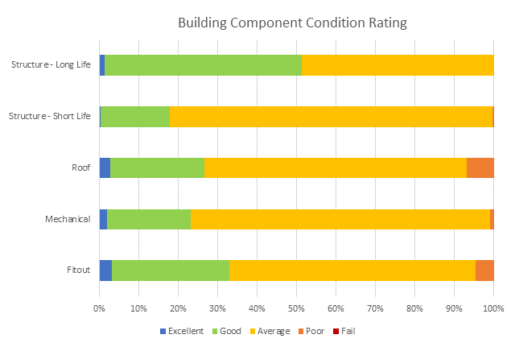
8.5 Asset Category Quantities & Replacement Costs
Council is responsible for 351 building and facility assets with a current replacement value of over $294 million. The table below shows the building categories and percentage by replacement value. It shows that recreation facilities are the most significant class of buildings in terms of number (34.764%) and replacement value (35.71%)
Building Category | No. | Replacement Cost | % by RC | % by No.
Child Services | 36 | $ 15,005,932.16 | 5.10% | 10.26%
Commercial | 50 | $ 42,889,675.68 | 14.58% | 14.25%
Community | 74 | $ 69,627,941.80 | 23.67% | 21.08%
Corporate Centre | 1 | $ 26,277,289.48 | 8.93% | 0.28%
Libraries | 4 | $ 14,507,036.55 | 4.93% | 0.85%
Municipal | 20 | $ 10,360,253.73 | 3.52% | 5.70%
Public Amenities | 45 | $ 10,484,015.60 | 3.56% | 12.82%
Recreation | 122 | $ 105,060,954.01 | 35.71% | 34.76%
Grand Total | 351 | $ 294,213,099.01
8.6 Property Income for Leased Assets
Below is a breakdown of Occupancy Uses and Income for property leased or licenced to other parties. Generally, these relate to community groups at a minimum rental set by annual fees and charges, however Council also has a number of commercial assets such as golf courses and café’s which provide a market rental return to Council.

Use | Number of Agreements | Income for 2021/2022
Arts and Culture (includes 7 artists in residence zero income) | 18 | $3,358
Kindergartens | 17 | $6,831
Life Saving Clubs and Coast Guard | 7 | $1,712
Scouts and Girl Guides | 13 | $4,943
Sporting (mixed commercial and community) | 14 | $119,449
Bowling Clubs | 7 | $16,454
Tennis (mixed commercial and community) | 10 | $215,738
Misc. Community Groups | 13 | $13,483
Council Depot | 3 | $478,060
Educational | 7 | $250,040
Golf Courses | 3 | $816,243
Leisure Centre Tenancies | 5 | $540,830
Bathing Boxes | 96 | $98,112
Boat Sheds includes commercial ones | 12 | $46,115
Foreshore Café | 5 | $569,446
Telecommunications | 15 | $549,940
Mobile food vendors | 4 | $36,374
Carparks | 5 | $13,120
Commercial (other) | 1 | $19,500
TOTAL |  | $3,799,748

Glossary
Term | Definitions
Strategic objective | A primary or high level desired outcome.
Strategic indicator | A high level measure that will tell us that we are achieving against our goal or strategic objective.
Outcome | An output of the action – usually a tangible or countable product or service.

Legislation and policy
Local Government Act 2020.
Local Government (General) Regulations 2004.
Retail Leases Act 2003.
Retail Leases Regulations 2003.
Crown Land (Reserves) Act 1978 (Vic).
Occupational Health and Safety Act 2004.
Residential Tenancies Act 1997.
Planning and Environment Act 1987.
Health Act 1958.
Children’s Services Act 1998.
National Competition Policy
Charter of Human Rights
Environment Protection Authority,
Planning permit provisions (including liquor licence provisions)
Council Leasing Policy
Council Discontinuance and sale of roads, right of ways and drainage easements Policy
Building Act 1993 & Building Regulations 2006
Building Code of Australia (BCA)
Heritage Act 1995
Planning and Environment Act 1987
Council Planning Scheme
All relevant Australian Standards
Occupational Health and Safety Regulations
All other relevant State and federal Acts and Regulations
All Local Laws and relevant policies of the Organisation
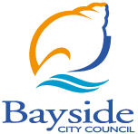
Bayside City Council
76 Royal Avenue
Sandringham VIC 3191
Tel (03) 9599 4444
Fax (03) 9598 4474 enquiries@bayside.vic.gov.au www.bayside.vic.gov.au
Bayside City Council proudly acknowledges the Bunurong People of the Kulin Nation as the Traditional Owners and Custodians of this land, and we pay our respects to their Elders past, present and emerging.

