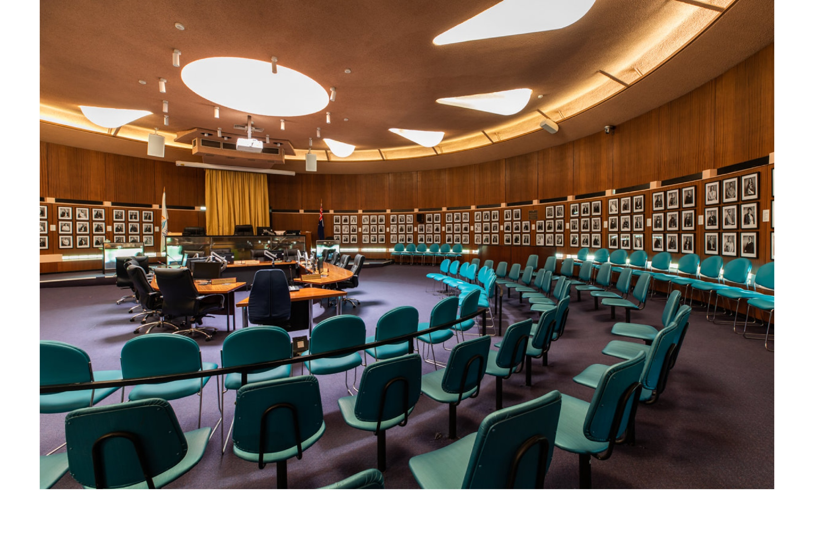

Election Period Policy 2024 Community Engagement Summary Report

July 2024
Contents
Overview 3
Key findings 3
Next steps 3
1 Background 4
2 Definitions and scope 4
2.1 Related Council documents and consultations 5
3 Consultation process 5
3.1 Consultation purpose 5
3.2 Consultation methodology 5
3.2.1 Table 1: Engagement methods 5
3.2.2 Table 2: Communication methods 6
4 Participant profile 6
5 Consultation findings 7
5.1 Written statements (uploaded to HYS online portal) 7
5.2 Written statements (direct email to Council Officers) 7
5.3 Direct contact via phone 7
5.4 Out of scope feedback 7
6 Project evaluation 8
6.1.1 Performance summary charts 8

Overview
This report provides a summary of community feedback to understand community sentiment around the proposed amendments to the Election Period Policy ahead of the October 2024 elections.
The objective of the policy is to ensure that the ordinary business of local government in the City of Bayside continues throughout the election period in a responsible and transparent manner, and in accordance with the legislated requirements. The Election Period will operate from the closure of receipt candidate nominations at 12pm, 17 September 2024, until Election Day, 6pm 26 October 2024.
The Election Period Policy prescribes actions and procedures the organisation will implement in observance of statutory requirements and established election period conventions in the interests of ensuring a fair election generally during the election period. This policy builds on the minimum statutory standards to enhance the accountability of the Council, Councillors and Council staff during the election period.
Between 15 July and 28 July 2024, we engaged with the community about the proposed policy amendments before being considered by Council for adoption at the August 2024 meeting. We highlighted details of the proposed policy amendments and asked the community to share their views.
217 community members visited the Have Your Say project webpage. We received 2 contributions, from 2 unique contributors.
Feedback gathered through the consultation included:
- 2 uploaded written statements on the project’s Have Your Say page
  - One uploaded statement was outside of the project scope
  - One uploaded statement contained demographic data but no accompanying document/ statement. The contributor was contacted to email their feedback directly; however, no response was received.
- Zero direct submissions to Council officers
- Zero phone calls to Council officers

Key findings
There was no community feedback received on the proposed policy amendments.

Next steps
Council will finalise the 2024 Election Period Policy and will present the Policy for adoption by Council at its 20 August 2024 meeting.
Interested community members can request to be heard at this meeting.

Background
Council is required by section 60 of the Local Government Act 2020 (the Act) to develop, adopt, and keep Governance Rules including an Election Period Policy (which forms part of the Governance Rules) in accordance with Section 69 of the Act.
We’ve drafted proposed amendments to the existing Election Period Policy in preparation for the 2024 Council elections. The policy prescribes actions and procedures the organisation will implement in observance of statutory requirements and established election period conventions in the interests of ensuring a fair election generally during the election period.
This policy builds on the minimum statutory standards to enhance the accountability of the Council, Councillors and Council staff during the election period. The policy will align with Goal 4: (Our Promise) of the Council Plan 2021–25 by providing a transparent and good governance approach in its decision making and aids in achieving a sustainable, high performing and well-governed organisation. The policy will also align with Theme 7: (Council Operations and Accountability) of the Bayside 2050 Community Vision, which directs that Council will serve the needs of its communities, engaging with them, reflecting their desires and aspirations in its activities.
The review will ensure transparent, fair, and equitable guidance is provided to Councillors, candidates, and Council staff in the conduct of Council business during the Election Period.
If Council were to proceed directly to considering the revised policy at a Council meeting, this would not comply with the Local Government Act requirement to conduct community consultation when amending the Council’s Governance Rules (the Election Period Policy forms part of these Rules).
Between 15 July and 28 July 2024, we engaged with the community about the proposed policy amendments before being considered by Council for adoption at the August 2024 meeting. We highlighted details of the proposed policy amendments and asked the community to share their views.

Definitions and scope
Within this document, reference is made to stakeholders. These stakeholders are:
- Councillors
- Bayside Candidates for 2024 Council elections
- Council staff
- Submitters of Public Questions
- Individuals with broad interest in the business of Council
- Community groups/associations/organisations
- General Bayside Community
Item | Definition
BCC | Bayside City Council
HYS | Have Your Say
Stakeholders | As listed above
The Act | Local Government Act 2020

Related Council documents and consultations
- Bayside 2050 Community Vision, Theme 7: Council Operations and Accountability
- Council Plan 2021 – 2025, Goal 4: Our Promise

Consultation process

Consultation purpose
The consultation was designed to provide stakeholders and the broader community with the opportunity to provide feedback on the proposed amendments to the Election Period Policy for the 2024 Council Elections.
The consultation was conducted to understand community sentiment about the proposed policy amendments before being considered by Council for adoption at the August 2024 meeting.
Community engagement was conducted in accordance with Council’s Community and Stakeholder Engagement Policy 2021. An engagement plan overview was published and is available to view on the project Have Your Say engagement page.

Consultation methodology
The tools and techniques selected for this project were informed by the project content,
stakeholders and type of feedback sought.
Community engagement was conducted between 15 July and 28 July 2024.
217 community members visited the Have Your Say project webpage. We received 2 contributions, from 2 unique contributors.
Feedback gathered through the consultation included:
- 2 uploaded written statements on the project’s Have Your Say page
  - One uploaded statement was outside of the project scope
  - One uploaded statement contained demographic data but no accompanying document/ statement. The contributor was contacted to email their feedback directly; however, no response was received.
- Zero direct submissions to Council officers
- Zero phone calls to Council officers
The communications program is estimated to have reached more than 15,000 residents.
The consultation materials were available in accessible formats on request.

Table 1: Engagement methods
Details | Activity
15 – 28 July 2024  217 Visits  242 Views  168 Visitors  2 Contributions | Have your say website  - Upload a written statement (2)  - Contact a Council officer via direct email or phone  - Public online Q&A forum (zero submissions)
15 – 28 July 2024 | Direct correspondence  - Zero direct emails  - Zero phone calls

Table 2: Communication methods
Details | Engagement activity
15 – 28 July 2024 | Council channels  - Inside Word: 7 Councillors (15 July)  - Council website: news story (15 July)  - Council social media channels (16 July) – 2 likes  - In the Loop: 760+ recipients (17 July)  - This Week in Bayside (Council weekly e-news) feature article (18 July) 11,000+ subscribers  - This Week in Bayside (Council weekly e-news), featured in projects open for feedback (25 July) 11,000+ subscribers
15 – 28 July 2024 | Direct email  - HYS topic subscribers: 3,444 unique subscribers (open rate 55.6%, 1.9% click-throughs to HYS page, 1.8% blocked)  - Beaumaris (1,125 subscribers)  - Black Rock (1,097 subscribers)  - Brighton (1,518 subscribers)  - Council budget and strategic plans (1,380 subscribers)  - Brighton East (1,040 subscribers)  - Cheltenham (885 subscribers)  - Hampton (1,194 subscribers)  - Hampton East (845 subscribers)  - Highett (964 subscribers)  - Sandringham (1,288 subscribers)

Participant profile
The table below shows a comparison between survey participant demographics and the demographic profile of the whole Bayside community.
 | Demographic | Bayside  2021 Census | Participants (%)
Gender | Male | 47.8% | 50%
Gender | Female | 52.2% | 50%
Gender | Unknown | -
Gender | Prefer not to say | -
Age | 18-24 | 7.8%
Age | 25-34 | 7.8%
Age | 35-49 | 19.4%
Age | 50-59 | 15.7%
Age | 60-69 | 12.1% | 50%
Age | 70-84 | 12.2%
Age | 85+ | 3.4%
 | Prefer not to say | - | 50%

Respondents who uploaded a written statement on the HYS platform (2) were also asked to specify their connection to Bayside. Both participants had a connection to Bayside:
- Bayside resident or ratepayer (2)
  - One from Beaumaris
  - One from Hampton

Consultation findings
The following section summarises the key themes which arose in community feedback regarding proposed amendments to the Election Period Policy.
Two written statement submissions were received during the consultation period through the online portal, however no submissions contained feedback within the scope of this consultation.

Written statements (uploaded to HYS online portal)
Two uploaded written statement submissions were received on the project’s Have Your Say page
- One uploaded statement was outside of the project scope
- One uploaded statement contained demographic data but no accompanying document/ statement. The contributor was contacted to email their feedback directly; however, no response was received.

Written statements (direct email to Council Officers)
- No direct written statements received

Direct contact via phone
- No direct phone calls received

Out of scope feedback
One uploaded written statements comments/ emails were received relating to other Council infrastructure and services outside of the scope of this project. Where relevant, these comments have been shared with the relevant departments across Council.

Project evaluation
The various consultation exercises that underpinned this community engagement were a useful set of tools to provide the community, key stakeholders, and other interested parties the opportunity to provide feedback on the proposed amendments to the Election Period Policy.
The consultation was widely promoted to the Bayside community with direct emails to HYS topic subscribers (including all Bayside suburb subscribers and Council budget and strategic plans subscribers), staff and stakeholders.
A campaign social media post, a news story on Council’s website and news promotion through Council’s weekly e-newsletter also promoted the campaign and the opportunity to provide feedback.
Of the 2 contributors who uploaded a written statement on the HYS online platform, 50% of those who provided a response reported that it was very or mostly easy to find and understand the information they needed to provide feedback on the proposed amendments to the Election Period Policy. 50% of respondents reported the information was mostly hard or very hard to find and understand.

Performance summary charts

Chart 1: Overview of visitation and contributions during engagement period
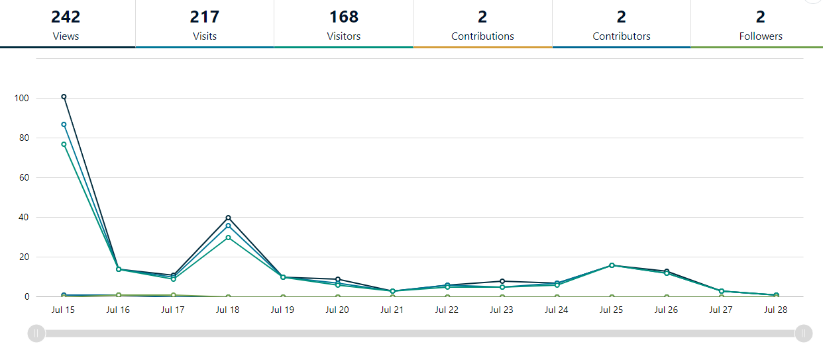

Chart 2: Conversions from visitation to engagement with the Have Your Say page
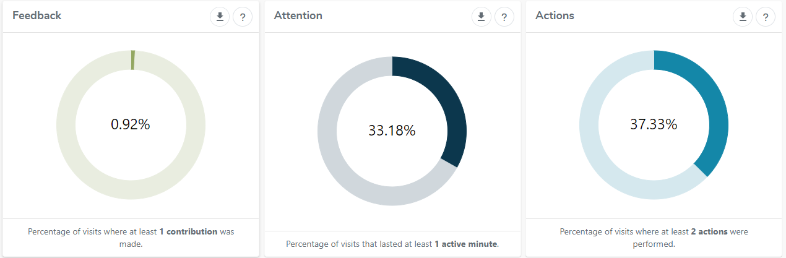
Chart 3: Acquisitions (how visitors found the Have Your Say page)
